Impacts of Economic Growth

# Starter - Recap Question

**Instructions:** Test yourself with the below quick question

What is meant by actual economic growth?

……………………………………………………………………………………………………………………………………………………………………………………

……………………………………………………………………………………………………………………………………………………………………………………

What is meant by potential economic growth?

……………………………………………………………………………………………………………………………………………………………………………………

……………………………………………………………………………………………………………………………………………………………………………………

Which type of economic growth is most strongly related to ‘demand side’ causes?

……………………………………………………………………………………………………………………………………………………………………………………

Which type of economic growth is most strongly related to ‘supply side’ causes?

……………………………………………………………………………………………………………………………………………………………………………………

# Presentation 1 – Positive Impacts

Complete the activities below so as to have a complete set of Notes:

**Logic chains:** Complete logic chains to explain how economic growth leads to the below positive impacts

*Improvements in living standards:*

……………………………………………………………………………………………………………………………………………………………………………………

…………………………………………………………………………………………………………………………………………………………………………………

.……………………………………………………………………………………………………………………………………………………………………………

…………………………………………………………………………………………………………………………………………………………………………

*More jobs:*

……………………………………………………………………………………………………………………………………………………………………………………

…………………………………………………………………………………………………………………………………………………………………………………

.……………………………………………………………………………………………………………………………………………………………………………

…………………………………………………………………………………………………………………………………………………………………………

*The accelerator effect of growth on capital investment:*

……………………………………………………………………………………………………………………………………………………………………………………

…………………………………………………………………………………………………………………………………………………………………………………

.……………………………………………………………………………………………………………………………………………………………………………

…………………………………………………………………………………………………………………………………………………………………………

*Greater business confidence:*

……………………………………………………………………………………………………………………………………………………………………………………

…………………………………………………………………………………………………………………………………………………………………………………

.……………………………………………………………………………………………………………………………………………………………………………

…………………………………………………………………………………………………………………………………………………………………………

*The “fiscal dividend”:*

……………………………………………………………………………………………………………………………………………………………………………………

…………………………………………………………………………………………………………………………………………………………………………………

.……………………………………………………………………………………………………………………………………………………………………………

…………………………………………………………………………………………………………………………………………………………………………

*Potential environmental benefits:*

……………………………………………………………………………………………………………………………………………………………………………………

…………………………………………………………………………………………………………………………………………………………………………………

.……………………………………………………………………………………………………………………………………………………………………………

…………………………………………………………………………………………………………………………………………………………………………

**Key Notes:** Benefits from growth driven by technological change.

*Productivity growth:*As worker can now produce more output per hour

Lower unit labour costs

Higher wages for workers

High profits for firms

*New Goods & Services:*Technological change means that new or better products can be made

Consumer welfare will improve

Lower real prices

Improved living standards

*Improved Health:*New technology can improve working conditions and cut negative production externalities

Healthy life expectancy rises

Labour force expands

Improved productivity

# Presentation 2 – Negative Impacts

**Logic chains:** Complete logic chains to explain how economic growth leads to the below negative impacts.

*Resource depletion:*

……………………………………………………………………………………………………………………………………………………………………………………

…………………………………………………………………………………………………………………………………………………………………………………

.……………………………………………………………………………………………………………………………………………………………………………

…………………………………………………………………………………………………………………………………………………………………………

*Pollution:*

……………………………………………………………………………………………………………………………………………………………………………………

…………………………………………………………………………………………………………………………………………………………………………………

.……………………………………………………………………………………………………………………………………………………………………………

…………………………………………………………………………………………………………………………………………………………………………

*Leisure Time:*

……………………………………………………………………………………………………………………………………………………………………………………

…………………………………………………………………………………………………………………………………………………………………………………

.……………………………………………………………………………………………………………………………………………………………………………

…………………………………………………………………………………………………………………………………………………………………………

*Price Instability:*

……………………………………………………………………………………………………………………………………………………………………………………

…………………………………………………………………………………………………………………………………………………………………………………

.……………………………………………………………………………………………………………………………………………………………………………

…………………………………………………………………………………………………………………………………………………………………………

*CA Deficit:*

……………………………………………………………………………………………………………………………………………………………………………………

…………………………………………………………………………………………………………………………………………………………………………………

.……………………………………………………………………………………………………………………………………………………………………………

…………………………………………………………………………………………………………………………………………………………………………

*Income Inequality:*

……………………………………………………………………………………………………………………………………………………………………………………

…………………………………………………………………………………………………………………………………………………………………………………

.……………………………………………………………………………………………………………………………………………………………………………

…………………………………………………………………………………………………………………………………………………………………………

# Debate Task: Economic Growth – Good or Bad?

**Instructions:**

* Using the prompts below consider your response to the debate question:

*‘IS GDP a false Beacon Steering us into the rocks?’*

* Debate your opinions with the class
* Applicable concepts: national income accounting "goods" and "bads

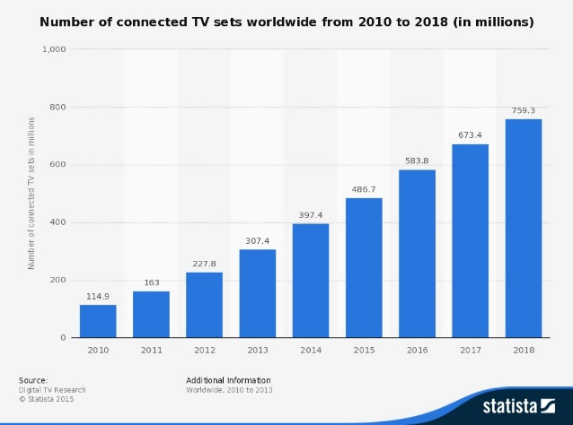Prompts

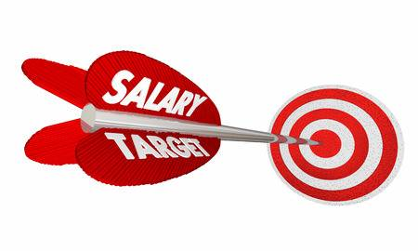

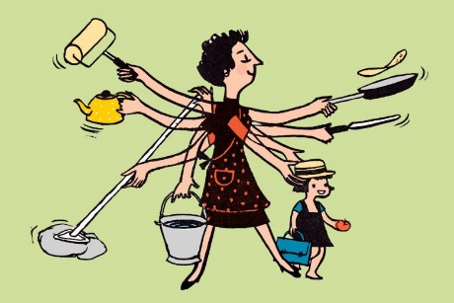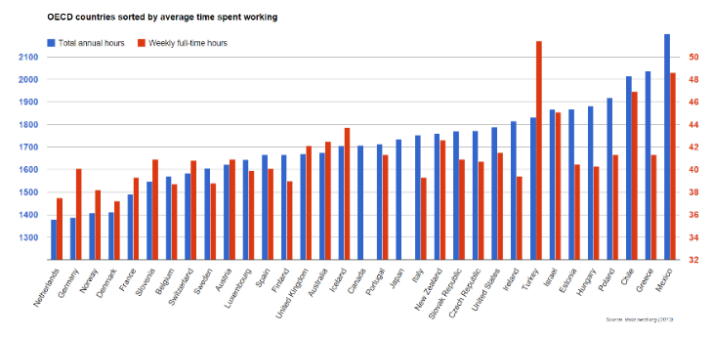



Debate Notes:

# Assignment

**Essay question (Section C)**

1. The UK’s economy grew by 2.6% in 2014, the fastest pace since 2007 and up from 1.7% in 2013.

Evaluate the benefits of economic growth for the UK. [25]

|  |  |
| --- | --- |
| **Planning Grid: Aim = 5 paragraphs - 2 KAA points (16); 2 Eval points (9) with a conclusion** | |
| **KAA Point 1 = signpost key point** |  |
| Application |  |
| Main concept & diagram |  |
| **Eval Point 1 = relate to your earlier point & re-read the title** |  |
| Context / evidence |  |
| **KAA Point 2 = signpost key point** |  |
| Application |  |
| Main concept & diagram |  |
| **Eval Point 2 = relate to your earlier point & re-read the title** |  |
| Context / evidence |  |
| **Conclusion = judgement** |  |
| Context; what does it depend on? |  |