Revenue

# Starter - Discussion Question

**Instructions:** Discuss the below quick question with a partner

What is meant by revenue?

……………………………………………………………………………………………………………………………………………………………………………………

……………………………………………………………………………………………………………………………………………………………………………………

What is the link between revenue, costs and profits?

……………………………………………………………………………………………………………………………………………………………………………………

……………………………………………………………………………………………………………………………………………………………………………………

***Extension:*** When will a firm be generating its maximum profit?

……………………………………………………………………………………………………………………………………………………………………………………

……………………………………………………………………………………………………………………………………………………………………………………

# Presentation 1 - Intro to Revenue

Complete the activities below so as to have a complete set of Notes:

**Definition:** *Total Revenue*

……………………………………………………………………………………………………………………………………………………………………………………

*Equation: ____________________*

**Definition:** *Average Revenue*

……………………………………………………………………………………………………………………………………………………………………………………

*Equation: ____________________*

**Key Question:***Why is AR = D(firm)?*

……………………………………………………………………………………………………………………………………………………………………………………

……………………………………………………………………………………………………………………………………………………………………………………

……………………………………………………………………………………………………………………………………………………………………………………

……………………………………………………………………………………………………………………………………………………………………………………

**Definition:** *Marginal Revenue*

……………………………………………………………………………………………………………………………………………………………………………………

*Recap:*Marginal refers to incremental change to one variable from an additional unit to another*.*

*Equation: ____________________*

When MR is equal to zero, total revenue is maximised

MR is a very important concept for working out how to maximise profits (more on this later)

# Maths Task: Revenue Calculations

**Instructions:** Complete the below calculations

1. Calculate total revenue of selling 90 pairs of socks for £3.99.

……………………………………………………………………………………………………………………………………………………………………………………

……………………………………………………………………………………………………………………………………………………………………………………

2. Find the average revenue from sell 6 cases of Coca Cola for a total of £93.60.

……………………………………………………………………………………………………………………………………………………………………………………

……………………………………………………………………………………………………………………………………………………………………………………

3. Calculate the marginal revenue in going from selling 7 units at £9, to selling 8 units at £8.

……………………………………………………………………………………………………………………………………………………………………………………

……………………………………………………………………………………………………………………………………………………………………………………

4. **Challenge** Calculate the total revenue generated from 52 customers who buy your newly designed trainers – half of the customers buy the standard pairs for £24.99, but half choose to customise them, and pay £32.99 per pair.

……………………………………………………………………………………………………………………………………………………………………………………

……………………………………………………………………………………………………………………………………………………………………………………

# Presentation 2 – Two Types of Firms

Complete the activities below so as to have a complete set of Notes:

**Key Notes:** *An important distinction*

It is important to note that not all firms have the same shaped demand curve, and this depends on whether they have some degree of influence over the market price, or whether they simply have to take the price determined by market supply and demand.

**Definition:** *Price setters*

……………………………………………………………………………………………………………………………………………………………………………………

**Analysis:** Given the law of demand, a firm can lower its price in order to increase quantity demanded.

In other words, an individual price setter faces a downward sloping firm demand curve.

In order for this to happen, a firm requires some level of product differentiation – this can be as simple as producing similar (but different products) or branding (**E.g**. Pepsi and Coca Cola)

**Definition:** *Price takers*

……………………………………………………………………………………………………………………………………………………………………………………

**Analysis:** In this case, the market for a product (demand and supply) determines its price and individual firms in the market can sell as many units as they wish at this price.

This often happens in markets with homogeneous (identical) goods that have small market shares (**E.g.** Supermarket cola)

Though other conditions are required, and we will examine this in more detail later.

These firms face a perfectly elastic (flat) individual demand curve

# Task: Price Taker or Price Setter

**Instructions:**

* Look at the below products.
* Determine whether you think they are price setters of price takers.
* **Challenge:** Can you think of similar products to any of these which would be the opposite

|  |  |  |  |  |  |
| --- | --- | --- | --- | --- | --- |
|  |  |  |  |  |  |
| Product | **Milk** | **Christian Louboutin Shoes** | **Gold Bar** | **Dacia Sandero** | **Petrol** |
| Price Taker  or  Price Setter |  |  |  |  |  |
| Similar product with the opposite pricing power |  |  |  |  |  |

# Presentation 3 – Total Revenue

Complete the activities below so as to have a complete set of Notes:

**Definition (Recap):** *Total Revenue*

The total income a firm gains from selling its output.

*Equation:* TR=P x Q

**Diagrams:** *Graphing total revenue – Price setters*

For firms with a downward sloping demand curve, total revenue looks like this

We can see this by considering a demand curve and the TR equation

TR = P x Q is represented by the rectangular area between a point on the demand curve and the price and quantity axes

**Key Notes:** TR and AR curve relationship

* When price is high, although AR is large, TR is low as quantity is low.
* After cutting price a little, revenue increase by a lot, there is a small proportional fall in price, but a large proportional increase in quantity
* Cuts to price continue to increase total revenue up to the midpoint of the demand curve. This is because the proportional rise in Q outweighs the fall in AR (TR is flat at this point!)
* After the midpoint though, the cuts to price are detrimental to revenue. Whilst the firm is selling more, they are now priced so low that they’d do better to have a higher price and sell a bit less

**Diagrams:** *Graphing total revenue – Price takers*

For firms with a flat demand curve, total revenue looks like this

This is because on the perfectly elastic demand curve, the firm doesn’t lower its price as quantity increases, so there is constant marginal revenue

Total revenue increases at the same rate regardless of the quantity

# Presentation 4 – Demand & Marginal Revenue

Complete the activities below so as to have a complete set of Notes:

**Definition (Recap):** *Demand Curve*

……………………………………………………………………………………………………………………………………………………………………………………

……………………………………………………………………………………………………………………………………………………………………………………

Previously, demand curves studied are graphical representations of the total demand in an entire market.

But now we must consider the demand curves for individual firms, which is the same as the individual firm’s AR curve

**Key Analysis:** The demand curve is important in understanding marginal revenue

It shows how much a firm has to lower price in order to sell one more of an item

The steeper the demand curve is, the more a producer must lower his price in order to increase the quantity demanded, and vice versa

Assuming a uniform price total revenue is visible in a firm’s demand curve as the the rectangular area between a point on the demand curve and the price and quantity axes.

Marginal revenue can then be seen as how the area of this rectangle changes as we increase quantity incrementally

MR (of going from Q=1 to Q=2) = TR2 –TR1

**Definition (Recap):** *Marginal revenue (MR)*

The addition to total revenue from selling one more unit of output.

*Recap:* Marginal refers to incremental change to one variable from an additional unit to another.

*Equation:* MR = ∆TR/∆Q , the gradient function of the TR curve!

**Diagram:** *Graphing Marginal Revenue*

The MR curve is always below the AR curve when it is downward sloping.

When a producer has to lower the price in order to sell more of an item, marginal revenue is less than price(i.e. AR), as the producer lowers the price for *all* the items they sell

(i.e. to increase sales to 5 units a firm has to sell the previous 4 units at a lower price; to increase sales to 6, it must cut the price of the previous 5)

*N.B.*In the case of straight-line demand curves, it turns out that the marginal revenue curve has the same intercept on the P axis as the demand curve but it is twice as steep, as illustrated in the diagram.

**Key Questions:**

*Why does MR go below Zero?*

……………………………………………………………………………………………………………………………………………………………………………………

The gain from selling an extra is offset by the loss from cutting the price of all previous units sold.

Eventually, the gain from the extra sale is outweighed by the loss from the previous sales.

*Where is total revenue maximised?*

……………………………………………………………………………………………………………………………………………………………………………………

With more output, MR is negative dragging down TR.

Any less output and the firm is not making units which would add to its revenue, it is missing out on output with positive MR

The area of the rectangle between the D/AR curve and the P and Q axes is maximised.

This is also the point where the demand curve is unit elastic.

(Recall PED and Revenue content from elasticities topic)

*What level of output would a firm produce?*

……………………………………………………………………………………………………………………………………………………………………………………

A revenue maximising firm would produce at the point where MR = 0.

However, revenue maximising isn’t the only objective for firms.

Most tend to be profit maximisers, but there are other objectives such as sales maximising.

High revenues are important to find where a profit maximising firm would produce, but cost considerations are very important too.

What we can determine is that any price setting profit maximising firm would produce at a quantity that is to the left of MR = 0,

It is possible to get an equal revenue from a greater level of output, but that would incur greater costs.

# Task: Graphing Revenue Curves

**Instructions:**

* Complete the following table then plot the demand (AR), the MR and the TR curves on the axes, below.
* Don’t forget to plot the MR data points in between the output levels.

|  |  |  |  |  |
| --- | --- | --- | --- | --- |
| **Average Revenue = Price (£)** | **Demand (units per week)** | **Total Revenue (£)** | **Marginal Revenue (£)** | **PED** |
| 80 | 0 |  |  |  |
|  |  |
| 70 | 1 |  |
|  |  |
| 60 | 2 |  |
|  |  |
| 50 | 3 |  |
|  |  |
| 40 | 4 |  |
|  |  |
| 30 | 5 |  |
|  |  |
| 20 | 6 |  |
|  |  |
| 10 | 7 |  |
|  |  |
| 0 | 8 |  |
|  |  |

**180**

**160**

**140**

**120**

**100**

**80**

**60**

**40**

**20**

**0**

**-20**

**-40**

**-60**

**-80**

**Revenues (£)**

|  |  |  |  |  |  |  |  |  |  |
| --- | --- | --- | --- | --- | --- | --- | --- | --- | --- |
|  |  |  |  |  |  |  |  |  |  |
|  |  |  |  |  |  |  |  |  |  |
|  |  |  |  |  |  |  |  |  |  |
|  |  |  |  |  |  |  |  |  |  |
|  |  |  |  |  |  |  |  |  |  |
|  |  |  |  |  |  |  |  |  |  |
|  |  |  |  |  |  |  |  |  |  |
|  |  |  |  |  |  |  |  |  |  |
|  |  |  |  |  |  |  |  |  |  |
|  |  |  |  | **1 2 3 4 5 6 7 8 9 10** |  |  |  |  |  |
|  |  |  |  |  |  |  |  |  |  |
|  |  |  |  |  |  |  |  |  |  |
|  |  |  |  |  |  |  |  |  |  |

**Output (Units per week)**

1. What do you notice about the relationship between the demand (AR) curve and the MR curve? Why is this occurring?

……………………………………………………………………………………………………………………………………………………………………………………

……………………………………………………………………………………………………………………………………………………………………………………

……………………………………………………………………………………………………………………………………………………………………………………

……………………………………………………………………………………………………………………………………………………………………………………

1. At what level of output is TR maximised? Why?

……………………………………………………………………………………………………………………………………………………………………………………

……………………………………………………………………………………………………………………………………………………………………………………

……………………………………………………………………………………………………………………………………………………………………………………

1. At what level of output is MR equal to zero?

……………………………………………………………………………………………………………………………………………………………………………………

1. Hence what is the relationship between the MR and TR curves, and how can this be reasoned? (Clue: look again at the written definitions of these two terms as well as the slope of the TR curve).

……………………………………………………………………………………………………………………………………………………………………………………

……………………………………………………………………………………………………………………………………………………………………………………

……………………………………………………………………………………………………………………………………………………………………………………

……………………………………………………………………………………………………………………………………………………………………………………

……………………………………………………………………………………………………………………………………………………………………………………

1. At what level of output is there unit price elasticity of demand (i.e. PED = 1)? Over which ranges of output is PED >1 or <1?

……………………………………………………………………………………………………………………………………………………………………………………

……………………………………………………………………………………………………………………………………………………………………………………

1. Hence what is the relationship between PED, TR and MR?

……………………………………………………………………………………………………………………………………………………………………………………

……………………………………………………………………………………………………………………………………………………………………………………

……………………………………………………………………………………………………………………………………………………………………………………

……………………………………………………………………………………………………………………………………………………………………………………

# Presentation 5 – Changes in Revenue

Complete the activities below so as to have a complete set of Notes:

**Key Notes:** Causes of *changes in revenue*

……………………………………………………………………………………………………………………………………………………………………………………

……………………………………………………………………………………………………………………………………………………………………………………

*Recall:*The firms AR curve is simply its individual demand curve

Any factor that changes the demand for the firm’s product will shift the AR curve

**Brainstorm:** *Factors that will shift demand*

|  |
| --- |
|  |

**Key Notes:** *Marginal Revenue Implications:*

……………………………………………………………………………………………………………………………………………………………………………………

……………………………………………………………………………………………………………………………………………………………………………………

*Recall:* The MR curve has the same intercept, but twice as gradient the AR curve

This relationship must be maintained after the AR has shifted

**Diagram:**

# Extension Presentation – Algebra of Marginal Revenue

<https://www.youtube.com/watch?v=S_C86sDSADE&ab_channel=SmoothEconomics>

Complete the activities below so as to have a complete set of Notes:

**Recap:** *For straight-line demand curves, the marginal revenue curve has the same intercept on the P axis as the demand curve but it is twice as steep, as illustrated in the diagram*

**Proof:** Add in the maths to supplement the proof of this result

MR is the derivative of total revenue - it tells us the change in TR from increasing Q

We can construct an MR curve by calculating TR as a function of quantity and differentiating

To calculate TR, we start by solving the demand curve for price rather than quantity (this formulation is referred to as the inverse demand curve)

Example demand function: ……………………………………………………………………………………………………

Rearranging (inverse demand function): ……………………………………………………………………………………………………

We then plug the inverse demand curve into the total revenue formula:

Total revenue formula: ……………………………………………………………………………………………………

MR is then calculated by taking the derivative of total revenue with respect to quantity:

Marginal revenue: ……………………………………………………………………………………………………

**Comparison:** The (inverse) demand curve vs the Marginal Revenue curve

……………………………………………………………………………………………………………………………………………………………………………………

……………………………………………………………………………………………………………………………………………………………………………………

……………………………………………………………………………………………………………………………………………………………………………………

……………………………………………………………………………………………………………………………………………………………………………………

……………………………………………………………………………………………………………………………………………………………………………………

……………………………………………………………………………………………………………………………………………………………………………………

……………………………………………………………………………………………………………………………………………………………………………………

# Test Yourself: Revenue

**Instructions:** Complete the below questions to test your understanding of revenue curves

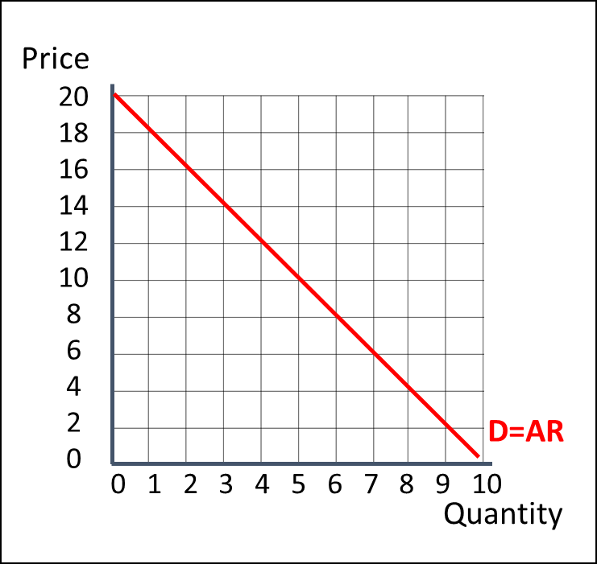

1. Annotate the above diagram to show the corresponding MR curve for this AR curve
2. At what level of output is total revenue maximised?

……………………………………………………………………………………………………………………………………………………………………………………

1. What is total revenue at this output?

……………………………………………………………………………………………………………………………………………………………………………………

1. Annotate the diagram with to show an area that represents this revenue
2. Without calculation, what is the PED for the firm at this level of output?

……………………………………………………………………………………………………………………………………………………………………………………

1. What is the total revenue of the firm when its level of output is 3 units?

……………………………………………………………………………………………………………………………………………………………………………………

1. Without calculation, is demand price elastic or price inelastic at 3 units?

……………………………………………………………………………………………………………………………………………………………………………………

1. At what level of output does the firm make equal total revenue, to the total revenue it makes when output is 3 units?

……………………………………………………………………………………………………………………………………………………………………………………

1. Without calculation, is demand price elastic or price inelastic at this quantity?

……………………………………………………………………………………………………………………………………………………………………………………

1. What is the marginal revenue of going from 1 unit to 2 units?

……………………………………………………………………………………………………………………………………………………………………………………

1. What is the marginal revenue in going from 6 to 7 units?

……………………………………………………………………………………………………………………………………………………………………………………

# Assignment

**SECTION A**

1. A light aircraft manufacturer finds that by lowering the price of its planes from £1.2 million to £1.1 million each, annual sales increase from four to five. Calculate the marginal revenue gained from the sale of one extra plane for this firm.

[3]

1. The diagram shows a firm’s total revenue as output increases.



**Panel A**

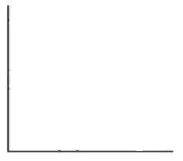

**Revenue**

**Panel B**

**Output per month**

Draw average revenue and marginal revenue for this firm. Use **Panel B** to draw your answer.

[2]

1. A pizza restaurant faces the following demand curve (D):



**Panel A**

**Total revenue**



**Panel B**

**Quantity of pizzas per week**

1. Annotate **Panel A** to show marginal revenue for this firm.

[2]

1. Annotate **Panel B** to show total revenue for this firm.

[2]

1. Calculate the total revenue made by the firm at the revenue maximising level of output.

[2]