Consumer & Producer Surplus

# Starter: Discussion Question

**Scenario:** These people all paid the same for their cinema tickets to see the latest ‘Star Wars’ Movie, but

**Questions:**

Who would have been willing to pay more (and how much do you think they would have paid)?

……………………………………………………………………………………………………………………………………………………………………………………

……………………………………………………………………………………………………………………………………………………………………………………

Why might they be willing to pay more?

……………………………………………………………………………………………………………………………………………………………………………………

……………………………………………………………………………………………………………………………………………………………………………………

# Presentation 1 – Consumer Surplus

Complete the activities below so as to have a complete set of notes:

**Definition:** *Consumer Surplus*

……………………………………………………………………………………………………………………………………………………………………………………

It is the difference between the total amount that consumers are willing and able to pay for a good or service (shown by the demand curve) and the total amount they actually pay (i.e. the market price).

CS = WTP – P

**Diagram:** *Showing CS*

Consumer surplus is indicated by the area under the demand curve and above the market price.

**Key Notes:** *Changes in Market Prices*

The level of consumer surplus changes as the market price for a good or service changes – here are two examples:

*E.g. 1:*Higher supply costs leads to a rise in market price and a fall in consumer surplus

*E.g. 2:*An increase in market demand causes consumer surplus to increase

# Presentation 2 – Producer Surplus

Complete the activities below so as to have a complete set of notes:

**Definition:** *Producer Surplus*

……………………………………………………………………………………………………………………………………………………………………………………

It is the difference between the total amount the producers actually receive (i.e. the market price) and total amount that they would have been willing and able to sell a good or service for (shown by the supply curve)

PS = P - WTS

**Diagram:** *Showing PS*

Producer surplus is indicated by the area above the supply curve and below the market price.

**Key Notes:** *Changes in Market Prices*

The level of producer surplus changes as the market price for a good or service changes – here are two examples:

*E.g. 1:*Higher supply costs leads to a rise in market price and a fall in producer surplus

*E.g. 2:*An increase in market demand causes producer surplus to increase

# Presentation 3 – Consumer & Producer Surplus in one diagram

Complete the activities below so as to have a complete set of notes:

**Diagram:** CS and PS when the market is in equilibrium

*CS at Equilibrium:*

……………………………………………………………………………………………

*PS at Equilibrium:*

……………………………………………………………………………………………

**Key Notes:** *Relevance of CS & PS*

Consumer and producer surplus are important concepts in examining society’s welfare.

**Definition:** *Allocative efficiency*

……………………………………………………………………………………………………………………………………………………………………………………

Society is producing goods to match the needs of consumers. This happens where supply equals demand.

For a given supply and demand, total welfare (CS +PS) is maximized, and allocative efficiency occurs, at equilibrium

**Key Notes:** *Changes*

Changes in S or D will bring about changes in the total of consumer and producer surplus (i.e. changes in economic welfare)

**Key Notes:** *Disequilibrium*

The total level of Welfare (CS+PS) is not maximized.

Though one party may be better off than at equilibrium.

*E.g. 1:*Excess Demand (market price is below equilibrium).

CS grows, but not by as much as PS falls, so we see less welfare than in equilibrium, a dead weight loss (DWL).

*E.g. 2:*Excess Supply (market price is above equilibrium).

PS grows, but not by as much as CS falls, so we see less welfare than in equilibrium, a dead weight loss (DWL).

# Task: Showing changes in CS and PS

**Instructions:**

On four different axis, show what happens to consumer and & producer surplus if:

1. demand at all given price levels increases,
2. demand at all given price levels decreases,
3. supply at all given price levels increases,
4. supply at all given price levels decreases.

1. 2.

3. 4.

# Assignment

**Short-answer questions (Section A)**

1. The diagram shows the market for peanuts where the initial equilibrium price is Pe and quantity Qe.



* 1. Illustrate the area of consumer surplus on this diagram.

[1]

* 1. The most likely effect of a severe drought which damages the peanut crop is for:

A Price to remain at Pe and producer surplus to increase

B Price to increase and consumer surplus to decrease

C Price to decrease and consumer surplus to increase

D Both price and producer surplus to increase

[1]

1. The diagram shows the market for music CDs.



The demand for CDs falls from D1 to D2. Illustrate the **loss in** producer surplus on this diagram.

[1]

1. Neringa is prepared to pay £2,500 for a luxury cruise to the Caribbean. If the current price is actually £2,000, which of the following might cause her consumer surplus to increase?

A An increase in wages paid to cruise holiday workers by £500 per year

B A decrease in value added tax placed on luxury cruise holidays

C An increase in the price of the cruise to £3,000

D A decrease in the number of companies offering luxury Caribbean cruises

[1]

1. The diagram shows the market for cherries. In year 1 demand is represented by D1 and supply by S1. In year 2, the supply of cherries increases to S2.



This causes consumer surplus to increase to the area:

A XYP1

B YTZ

C P1YTP2

D XZP2

[1]

1. The diagram shows the market for ice cream.



In the winter demand is represented by D1 and supply by S1, with the equilibrium price at 0P1. In the summer demand increases to D2, raising price to 0P2 and causing a gain in producer surplus equal to the area:

A P2XT

B P1P2XY

C P2XQ20

D P1YZ

[1]

**Data Response (section B)**

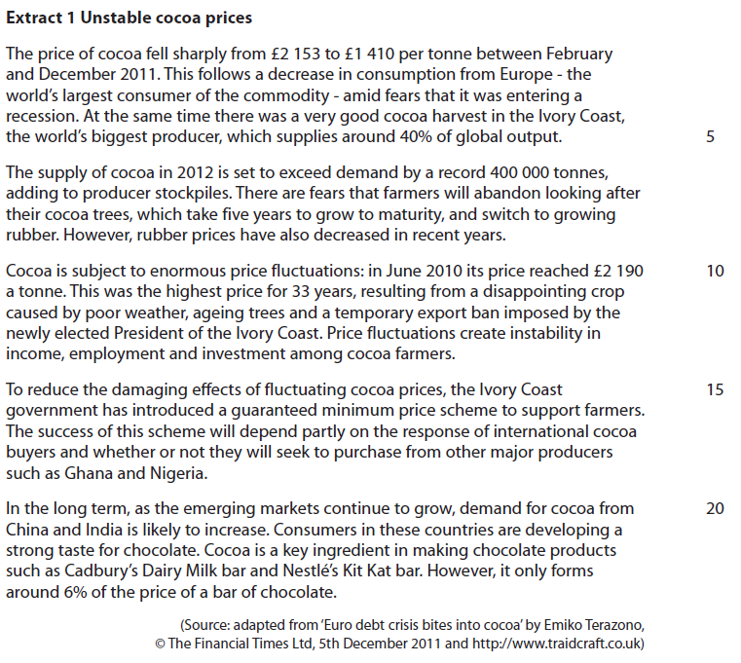

Question

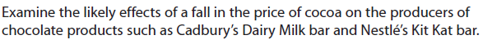

[10]

**Question:** Examine the likely effects of a fall in the price of cocoa on the producers of chocolate products such as Cadbury’s Dairy Milk bar and Nestlé’s Kit Kat bar. [10]

|  |  |
| --- | --- |
| **Planning Grid: Aim = 4 paragraphs - 2 KAA points (6); 2 Eval points (4) with a conclusion** | |
| **KAA Point 1 = signpost key point** |  |
| Application |  |
| Main concept & diagram |  |
| **Eval Point 1 = relate to your earlier point & re-read the title** |  |
| Context / evidence |  |
| **KAA Point 2 = signpost key point** |  |
| Application |  |
| Main concept & diagram |  |
| **Eval Point 2 = relate to your earlier point & re-read the title** |  |
| Context / evidence |  |