Current Account Deficits

# Starter - Recap Question

**Instructions:** Test yourself with the below quick question

Label the below tree diagram of the balance of payments

**Matching up:** Link the current account terms to the correct definitions:

*Draw lines to link the term to the correct definition*

|  |  |  |
| --- | --- | --- |
| **Term** |  | **Definition** |
| Trade in Goods |  | Income earned by domestic citizens who own assets overseas minus income earned by foreign citizens who own assets in this country |
| Trade in Services |  | The value of goods (visibles) a country sells to the rest of the world net of the value of goods they buy from the rest of the world |
| Net Income |  | Whereone country simply provides money to another country with nothing received directly in return |
| Current Transfers |  | The value of services (invisibles) a country sells to the rest of the world net of the value of services they buy from the rest of the world |

**Question:** Distinguish between a current account deficit and a current account Surplus

……………………………………………………………………………………………………………………………………………………………………………………

……………………………………………………………………………………………………………………………………………………………………………………

……………………………………………………………………………………………………………………………………………………………………………………

# Recap Presentation – BoP

Complete the activities below so as to have a complete set of notes:

**Definition:** *Balance of Payments*

……………………………………………………………………………………………………………………………………………………………………………………

……………………………………………………………………………………………………………………………………………………………………………………

It is made up of several different accounts

It always sums to zero

**Definition:** *Capital Account*

……………………………………………………………………………………………………………………………………………………………………………………

……………………………………………………………………………………………………………………………………………………………………………………

It records the movement of physical assets associated with migration or acquisition/disposal of intellectual assets.

An example of a physical asset is __________________

An example of an intellectual asset is __________________

**Definition:** *Financial Account*

……………………………………………………………………………………………………………………………………………………………………………………

……………………………………………………………………………………………………………………………………………………………………………………

It records:

Foreign Direct Investment (FDI):

……………………………………………………………………………………………………………………………………………………………………………………

Portfolio Investment:

……………………………………………………………………………………………………………………………………………………………………………………

Balance of banking flows:

……………………………………………………………………………………………………………………………………………………………………………………

**Definition:** *Current Account*

……………………………………………………………………………………………………………………………………………………………………………………

……………………………………………………………………………………………………………………………………………………………………………………

Trade in goods, trade in services, income, and current transfers

# Task: The Balance of Payments I

*A country has the following international transactions:*

1. Exports of manufactured goods £28bn

2. Food imports £16bn

3. Foreign tourists in the UK spend £5bn

4. Dividends paid to foreign shareholders £2bn

5. Profits repatriated by foreign multinationals £5bn

6. Purchase of oil from abroad £12bn

7. EU government provides agricultural subsidies to British farmers £1bn

8. Repatriated earnings of UK citizens working overseas £10bn

9. Sale of coal to foreign countries £3bn

10. Payments by foreigners to UK financial institutions for services rendered £3bn

11. UK tourists abroad spend £10bn

12. UK government provides financial aid to various African countries £2bn

a) Which of these items are:

i. Exports of goods?

……………………………………………………………………………………………………………………………………………………………………………………

ii. Exports of services?

……………………………………………………………………………………………………………………………………………………………………………………

iii. Imports of goods?

……………………………………………………………………………………………………………………………………………………………………………………

iv. Imports of services?

……………………………………………………………………………………………………………………………………………………………………………………

v. Income items (specify whether debit (-) or credit (+))?

……………………………………………………………………………………………………………………………………………………………………………………

vi. Transfer items (specify whether debit (-) or credit (+))?

……………………………………………………………………………………………………………………………………………………………………………………

b) Calculate:

i. The balance of trade:

……………………………………………………………………………………………………………………………………………………………………………………

ii. The balance of trade in goods and services:

……………………………………………………………………………………………………………………………………………………………………………………

iii. The current account balance: ……………………………………………………………………………………………………………………………………………………………………………………

……………………………………………………………………………………………………………………………………………………………………………………

c) How would your answers to b) differ if it cost the country £5bn to transport its exports:

i. In its own ships?

……………………………………………………………………………………………………………………………………………………………………………………

……………………………………………………………………………………………………………………………………………………………………………………

……………………………………………………………………………………………………………………………………………………………………………………

ii. In foreign-owned ships?

……………………………………………………………………………………………………………………………………………………………………………………

……………………………………………………………………………………………………………………………………………………………………………………

……………………………………………………………………………………………………………………………………………………………………………………

# Presentation 1 – Why does the Balance of Payments Always Sum to Zero?

Complete the activities below so as to have a complete set of notes:

**Elaborate:** Elaborate on the below explanation

*Convention:* Due to the practice of double-entry bookkeeping

……………………………………………………………………………………………………………………………………………………………………………………

……………………………………………………………………………………………………………………………………………………………………………………

……………………………………………………………………………………………………………………………………………………………………………………

……………………………………………………………………………………………………………………………………………………………………………………

……………………………………………………………………………………………………………………………………………………………………………………

**Logic Chain:** Connect the analysis steps in the correct order to answer the key question

*What is the intuition behind why the BoP sums to zero?*

A **surplus** in the Current Account must be offset by a **deficit** (receiving more assets than giving) on the Capital Account and/or Financial Account.

Goods, services, and resources traded internationally are paid for; thus every movement of products is offset by a balancing movement of money or some other financial asset.

In practical terms, if we import foreign products, then we sell our financial assets to pay for them.

**E.g.** If a U.K. retailer imports £1 million of Japanese televisions, there is a corresponding or balancing movement of assets (usually money) to the Japanese producer.

Similarly, a **deficit** on the Current Account must be offset by a **surplus** (giving more assets than receiving) on the Capital Account and/or Financial Account.

Another way to think of this is that if we export goods and services, then we accept the financial assets of the foreigners who purchased those goods and services.

# Task: The Balance of Payments II

**Instructions:**

Allocate each of the following items to either the current, financial or capital accounts. Calculate the balances for each account, and check that the total for the BoP is zero.

Trade in goods: **-81.875**  Remittance Payments: **+2.722**

Total net direct investment: **-15.357** Investment income: **+31.970**

Current transfers: -**14.765** Trade in services: **+49.852**

Transactions in reserve assets: **-5.763**  Other capital transfers: **+0.497**

Compensation of employees (i.e. wages): **-0.688**  Total net portfolio investment: **+34.835**

Other transactions in financial assets: **-8.118** Migrants’ asset movements: **+3.250**

Errors and omissions: **+3.440**

**The UK Balance of Payments 2009 (£bn at current prices)**

|  |
| --- |
| **Current Account** |
| [ ] |
| [ ] |
| [ ] |
| [ ] |
| [ ] |
| [ ] |
| **Current account balance [ ]** |
|  |
| **Capital account** |
| [ ] |
| [ ] |
| [ ] |
| [ ] |
| **Capital account balance [ ]** |
|  |
| **Financial Account** |
| [ ] |
| [ ] |
| [ ] |
| [ ] |
| [ ] |
| **Financial account balance [ ]** |
|  |
| **Errors and omissions [ ]** |
|  |
| **Overall balance of payments [ ]** |

# Presentation 2a – Factors Influencing the Current Account (Exchange Rates)

Complete the activities below so as to have a complete set of Notes:

**Recap:** Key definitions

*Balance of Payments:* A record of all transactions between one country and the rest of the world

*Current Account:*A record of all payments for trade in goods and services plus income flow.

It is divided into four parts: Trade in goods, trade in services, income, and current transfers

**Definition:** *Exchange rates*

……………………………………………………………………………………………………………………………………………………………………………………

……………………………………………………………………………………………………………………………………………………………………………………

i.e. how much foreign currency an individual can buy with one unit of domestic currency

**Key Notes:** Appreciations and Depreciations

*Appreciation:* An increase in the value of a currency compared to another – ‘strong £’

*Depreciation:* A decrease in the value of a currency compared to another – ‘weak £’

**Key Question:** Is a stronger pound or a weaker pound better for CA balances?

……………………………………………………………………………………………………………………………………………………………………………………

£1 can now ‘buy’ more foreign currency, which can then be used to buy more foreign goods. Imports rise.

Similarly, a unit of foreign currency now ‘buys’ fewer pounds, which can support the purchase of fewer British goods. Exports fall.

**Helpful Pneumonic:** *SPICED*

……………………………………………………………………………………………………………………………………………………………………………………

The reverse result, a weak pound, can be remembered by ***WPIDEC*** (not quite the same)

**Key Note:***Marshall Lerner Condition:*

For this analysis to hold the sum of the price elasticities of imports and exports must be greater than one,

Equation: …………………………………………………..

Otherwise, the monetary *value* of (X-M) won’t move in the same direction as the quantity *volume* of (X-M)

**Key Evaluation:** *The J Curve Effect*

……………………………………………………………………………………………………

The opposite of WPIDEC!

**Diagram:**  The curve looks like a ‘J’, hence the name

**Key Notes:** J Curve Analysis

Domestic firms will need time to adjust production capacity.

…………………………………………………………………………………………………

……………………………………………………………………………………………………..

Also UK customers will have existing contracts for imports.

…………………………………………………………………………………………………………………………………………………………………………………

They continue buying imports at the higher prices – hence **🠕M**

…………………………………………………………………………………………………………………………………………………………………………………

**N.B.** The same analysis can be flipped for a rapid appreciation too (SR improvement in CA)

**However:** Adjustment does take place after a time-lag, the PED of imports becomes much more elastic, leading to **🠕X** and **🠗M**, hence narrowing the CA deficit

WPIDEC wins!

# Maths Task: J-Curve proof

**Instructions:**

* Complete the calculations to get a mathematical proof of the J-curve effect

*Initially*, the exchange rate is: £1 = $2

The UK exports 5 units of ‘Good X’ for £1 each: Export earnings = £_____________

The UK imports 10 units of ‘Good Y’ for $2 each: Import Expenditure = $_____________ = £_____________

There is a trade deficit of £_____________

*Now*, the exchange rate is £1=$1, The pound has _________________

The UK initially still exports 5 units of ‘good X’ at £1 each: Export earnings = £__________

The UK initially still imports 10 units of ‘Good Y’ for $2 each: Import Expenditure = $________ = £_________

There is a trade deficit of ___________________, a widening despite the pound ___________________

# Presentation 2b – Factors Influencing the Current Account (Other factors)

Complete the activities below so as to have a complete set of Notes:

**Definition:** *Price-competitiveness:*

……………………………………………………………………………………………………………………………………………………………………………………

The less price competitive a nation’s exports, the fewer they will sell, whilst imports will be more greatly demanded instead of expensive domestic G&S

**Question:** What factors could lead to poor price competitiveness and a CA deficit?

……………………………………………………………………………………………………………………………………………………………………………………

……………………………………………………………………………………………………………………………………………………………………………………

**Definition:** *Non price competitiveness*

……………………………………………………………………………………………………………………………………………………………………………………

The less competitive a nation’s exports are in terms of product characteristics, the fewer they will sell, whilst imports will be more greatly demanded instead of lower quality domestic G&S

**Question:** What factors could lead to poor non-price competitiveness and a CA deficit?

……………………………………………………………………………………………………………………………………………………………………………………

……………………………………………………………………………………………………………………………………………………………………………………

**Definition:** *Relative stage in the business cycle*

……………………………………………………………………………………………………………………………………………………………………………………

**Question:** What phases of the business cycle, domestic and abroad, could lead to a CA deficit?

……………………………………………………………………………………………………………………………………………………………………………………

……………………………………………………………………………………………………………………………………………………………………………………

**Definition:** *Volatile raw material prices*

……………………………………………………………………………………………………………………………………………………………………………………

Countries who export will benefit when prices rise, countries who import will be worse off

Demand is often price inelastic, e.g. oil, iron ore or copper

Hence higher Prices lead to increased spending on imports for net importers (like the UK)

# Source Task: Factors affecting the Current Account Balance

**Instructions:**

* Look at the below sources, determine what effect the data shown would have on the UK CA balance

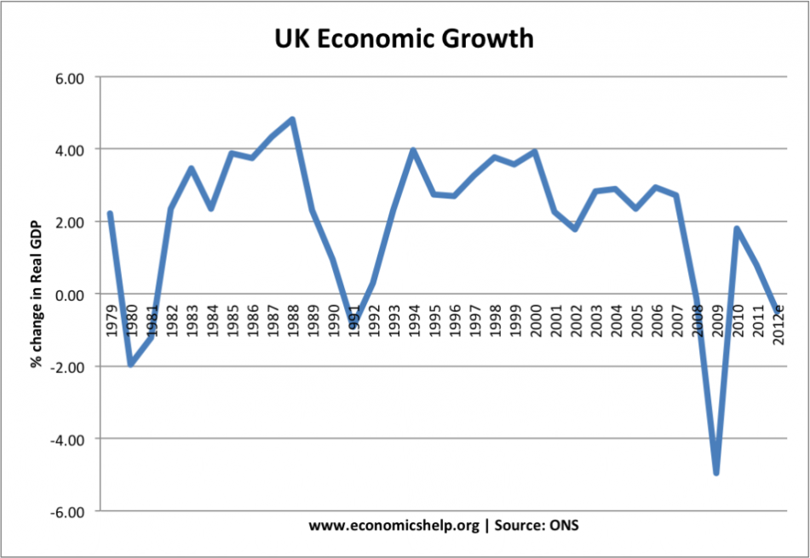**Source 1:** UK economic growth (annual, %), 1979-2012

Effect on CA balance?

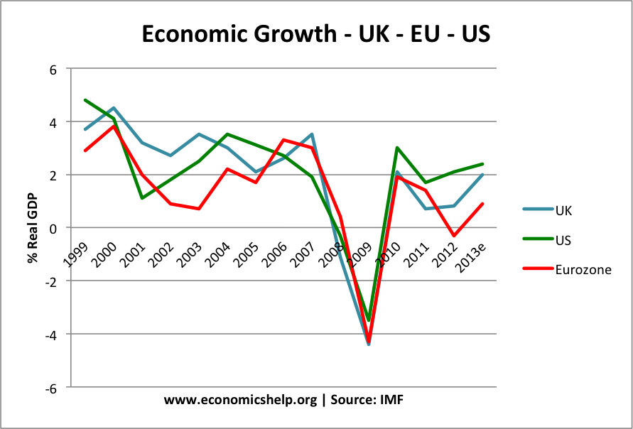**Source 2:** Economic growth (annual, %) in the UK, Eurozone and US, 1999-2013

Effect on CA balance?

**Source 3:** Brent crude oil prices, 1998-2012

Effect on CA balance?

**[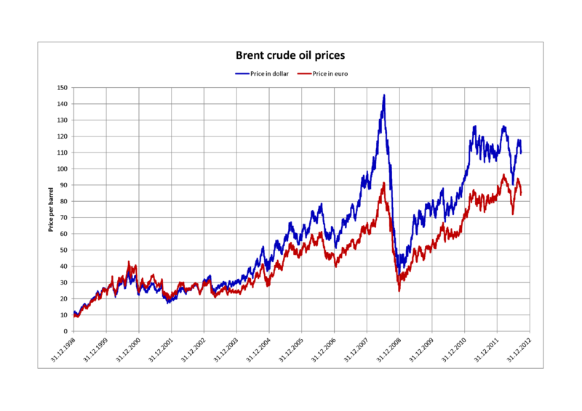](http://upload.wikimedia.org/wikipedia/commons/a/a9/Crude_oil_prices_in_dollar_and_euro.png)**

**Note:** The UK became a net importer of oil in 2005, after 25 years of being a net exporter.

[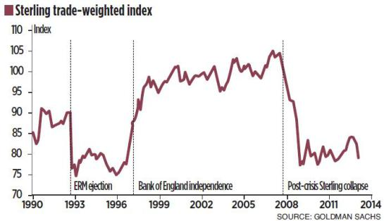](http://www.google.co.uk/url?sa=i&rct=j&q=&esrc=s&frm=1&source=images&cd=&cad=rja&docid=zUt0bNZ8jDbibM&tbnid=e3ks2t-kjOQF4M:&ved=0CAUQjRw&url=http://yogichan.wordpress.com/&ei=C2FMUqSgGebI0QXBoYHQAQ&bvm=bv.53371865,d.d2k&psig=AFQjCNGJ7EtkR-6or3xVM8cvh_Lk6BgXzg&ust=1380823666417083)**Source 4:** Sterling trade weighted index, 1990-2013

Effect on CA balance?

**Source 5:** UK average house prices (nominal, £), 1985-2009

Effect on CA balance?

[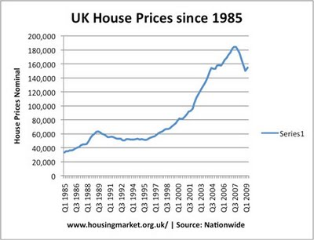](http://www.economicshelp.org/uploaded_images/house-prices-85-09-744598.jpg)

**Source 6:** GDP per hour worked (UK = 100), 1990-2011**[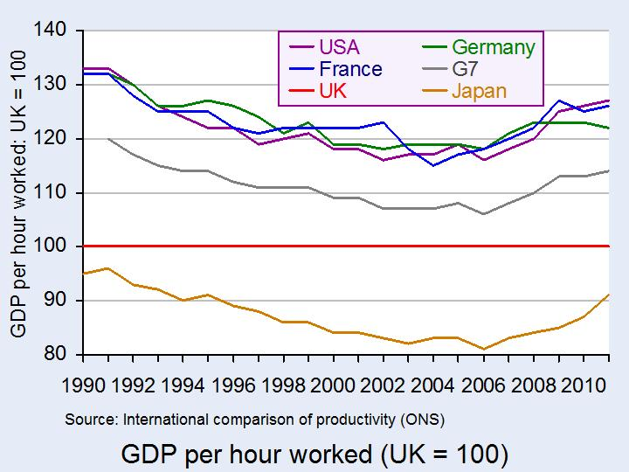](http://www.google.co.uk/url?sa=i&source=images&cd=&cad=rja&docid=TlOeT19brG8iKM&tbnid=VokaneRnUoj7-M:&ved=0CAgQjRwwADgP&url=http://pearsonblog.campaignserver.co.uk/?p%3D6828&ei=u696UpjLBqKV0AX294HwAw&psig=AFQjCNG0zZ7vzyhszvNRrK3YF0J2UeLvig&ust=1383858491150951)**

Effect on CA balance?

# Presentation 3a – Impacts of Current Account Deficits (Macro Objectives)

Complete the activities below so as to have a complete set of Notes:

**Key Notes:** *Impacts on other macroeconomic objectives*

We need to understand the effect of CA deficits on the economy, particularly in relation to the other macroeconomic objectives

**Table:** Complete the table below to quickly summarise the impact of a CA deficit on the other macroeconomic objectives

|  |  |  |
| --- | --- | --- |
| U/E | Econ Growth | Inflation |
| **↑** or **↓** | **↑** or **↓** | **↑** or **↓** |

*Unemployment:*Likely to rise if the deficit is caused by a loss of price or non-price competitiveness of UK production.

Caused by 🠗X and the suppression of AD.

*However:* If the Deficit is caused by a domestic boom, then U/E will be low

*Lower short run growth:* (X < M) = a loss of potential AD and slower growth. If sustained into the long run, slower growth will undermine the standard of living.

*However:*Imports can boost living standards in the SR as there will be more G&S being consumed by domestic households

*Cost-push inflation:*will occur if the deficit is caused by 🠕M due to rising raw material prices increasing the value of M (AKA imported inflation).

*However:*Higher M will suppress AD growth, reducing demand pull inflation

*A depreciation of sterling:*Due to 🠗D£ and 🠕S£, causes yet more imported inflation.

*However:* it may also make UK goods price-competitive again, leading to 🠕X and 🠗M, and a narrowing of the deficit

# Article Task: Current Account deficits – Good? Bad? Unimportant?

****Instructions:**

* Read, highlight, and annotate the article.
* Fill in the table with pros, cons and reasons for unimportance
* Discuss your reasoning as a class.

**Article**

*Does the UK have a £70bn deficit problem?*

As the current account deficit reaches its highest level for 25 years, does our balance of payments position really threaten the economy?

Britain's balance of payments deficit with the rest of the world is at its second highest point since WWII. The UK's current account deficit reached £72.4bn last year, its highest ever cash amount, according to the latest figures from the[Office for National Statistics](http://www.ons.gov.uk/ons/rel/bop/united-kingdom-balance-of-payments/2014/index.html). That’s 4.2pc of GDP, the second highest annual figure since WWII and the [biggest deficit of any major industrialised economy in the world.](http://www.telegraph.co.uk/finance/economics/10427783/Britain-to-have-worst-2014-trade-deficit-in-industrial-world-on-EU-forecasts.html) [Unlike the country's budget deficit](http://www.telegraph.co.uk/finance/11168941/Why-are-we-still-failing-to-reduce-the-deficit.html)- the difference between what government earns and spends - the UK’s current account, or its balance of payments in relation to the rest of world, has been subject to far less scrutiny. But with the commercial deficit figure showing no signs of shrinking, despite the fact we're [well into a recovery,](http://www.telegraph.co.uk/finance/economics/11036043/Top-of-the-world-UK-economy-winning-global-growth-race.html) is it time we started to pay more attention?

**What is the current account?**

Britain's current account is a measure of the transactions it conducts with the rest of the world.

It is calculated by subtracting the value of our imports from exports, and adding things like the flows of money we send abroad, and income earned by Brits on their foreign assets. The last time we came close to registering anything near a surplus on the current account was back in 1997. In fact, since the start of the recovery, our balance of payments deficit has actually grown from 1.7pc of GDP in 2011, to over 4pc in the most recent year (see chart).

**Does it really matter?**

Most economists will tell you that running a current account deficit is not necessarily a bad thing for any economy, but it's the specifics that matter. If a deficit is driven by high levels of debt-fuelled consumption, and reflects inadequate savings among a population, then a persistent balance of payments gap is probably evidence of serious distortions within a domestic economy. [In the words of the IMF:](http://www.imf.org/external/pubs/ft/fandd/2006/12/basics.htm)“When a country runs a current account deficit, it is building up liabilities to the rest of the world that are financed by flows in the financial account. Eventually, these need to be paid back.” But it's not only large deficits that are dangerous. The reverse, where a country runs a large surplus with the world, is also to be cautioned against. The current account deficit may allow intertemporal trade, where you import today to invest and then export tomorrow. As long as the imports add future growth a deficit can be beneficial. Also intertemporal theories suggest a current account disequilibrium can be consumption-smoothing in times of economic shocks, e.g. following a natural disaster food and shelter can be imported.

This problem has been most acute in the Euro-area where severe imbalances between southern debtors and northern creditors mean the EU has introduced a mechanism to punish large surpluses as well as deficits. Germany, [which has continued to run an external surplus throughout the crisis,](http://www.telegraph.co.uk/finance/economics/10758577/Germany-risks-EU-fines-with-record-current-account-surplus.html)is due to fall foul of the new sanctions which punish a positive balance of payments over 6pc of GDP. Some also argue that a current account deficit will have a detrimental impact on growth and unemployment due to impacting aggregate demand. However as the UK has a floating exchange rate this may be partially auto-correcting.

**So what's behind our deficit?**

Despite the Chancellor’s [hopes for an export led recovery](http://www.telegraph.co.uk/finance/budget/10697527/Blow-for-Osborne-as-exports-fall-to-lowest-in-18-months.html), Britain has always had a historically weak trading comparison in relation to the rest of the world (blue line below).

Our balance of trade, the difference in the value of our imports and exports, has shown some signs of improvement in the most recent quarters, and is now around -1.3pc of GDP. In particular, it is the strength of Britain's exports of services to the rest of the world that is managing to make up for our weak exports in other types of goods. However, sluggish demand and a poor growth outlook in Europe - Britain's biggest market for goods and services - is likely to hamper progress on reducing the balance of payments in the near future (see blue line below). Another major development that has stymied progress on the current account, is the deterioration of the income coming from overseas assets held by Brits (the green line below).

This has fallen from a surplus of around £8bn in 2011, to a deficit of £1.8bn in the most recent quarter. The reasons for this aren't immediately clear to most observers however.

**A question of trust?**

Current account deficits are probably best summarised as seemingly benign in the good times, and immediately dangerous at the onset of financial panic. In the words of one former monetary policy maker, deficits “appear not to matter until, well, they suddenly do!” While some developed economies such as Australia and New Zealand have been able to maintain deficits of 4-5pc for decades, emerging economies such as Mexico and Thailand experienced sharp reversals of their deficits after private financing withdrew in the midst of financial crises in the 90s. This was also the case for the most heavily indebted countries in the Eurozone - Spain, Greece, and Ireland - who all entered the crash with high deficits and were subsequently hit the hardest when sentiment turned in the global economy. It is this fear of "sudden stops", where a country can longer access foreign financing, that has led the likes of the European Union and the IMF to caution against persistent deficits.

**A threat to growth?**

But there are reasons to be sanguine about Britain's balance of payments position. According Ben Broadbent, one of the Bank of England's most senior policy-makers, the current account deficit [does not pose an “independent or existential threat”](http://www.bankofengland.co.uk/publications/Documents/speeches/2014/speech750.pdf) to our economic growth. In a speech delivered in July, Mr Broadbent also said it was "hard to detect a simple, linear relationship between the current account deficit and subsequent rates of GDP growth." He added that the UK was less at risk to any “sudden stops” in overseas financing, because of the country's strong underlying asset position and sound economic policy. Factors such as this means investors are more likely to continue keeping faith with Britain.

**Whither rebalancing?**

Whether or not Britain’s external position with the rest of the world poses an immediate threat to the recovery, the eye-wateringly large deficit still suggests that, a bit like the budget deficit, the UK still has a way to go before we can say we’ve reached a balanced recovery. [To quote another MPC member, Martin Weale](http://www.bankofengland.co.uk/publications/Pages/news/2013/029.aspx)"our balance of payments deficit is no smaller than it was before the depreciation; at least seen from this perspective the United Kingdom seems to have made no progress with rebalancing."

**Table:**

|  |  |  |
| --- | --- | --- |
| Advantages of a CA deficit | Disadvantages of a CA deficit | CA deficit is unimportant |
|  |  |  |

# Presentation 3b – Impacts of Current Account Deficits (Financing a deficit)

Complete the activities below so as to have a complete set of Notes:

**Key Note:** *Financing a CA deficit*

As the BOP must always sum to zero, a deficit on the current account must be made up by a surplus on the Capital Account and/or Financial Account

**Key Question:** Explain what the following look like in practice

*Capital account surplus:*

……………………………………………………………………………………………………………………………………………………………………………………

……………………………………………………………………………………………………………………………………………………………………………………

*Financial account surplus:*

……………………………………………………………………………………………………………………………………………………………………………………

……………………………………………………………………………………………………………………………………………………………………………………

**Elaborate:** Elaborate on the following issues that arise in financing a CA deficit

*Risk of capital flight:* Very high CA deficits may lead to a fall in confidence by foreign investors

…………………………………………………………………………………………………………………………………………………………………………………

…………………………………………………………………………………………………………………………………………………………………………………

…………………………………………………………………………………………………………………………………………………………………………………

**Asian crisis of 1997:** A large factor of the crisis was that countries had run up large current account deficits by attracting capital flows (hot money) to finance their deficits

But, when confidence fell, these hot money flows dried up, leading to a rapid devaluation and crisis of confidence

*Reduced national income:*financing a CA deficit requires a capital and/or financial account surpluses.

…………………………………………………………………………………………………………………………………………………………………………………

…………………………………………………………………………………………………………………………………………………………………………………

*Uncompetitive:* A CA deficit may be a signal of poor export competitiveness

…………………………………………………………………………………………………………………………………………………………………………………

*Eurozone:*This is particularly a problem for countries in the Euro – who cannot devalue to restore competitiveness. Poor price competitiveness caused very large CA deficits and contributed to recessions in 2008-13

**Key Question:** *Why might a CA deficit not be an issue?*

*FDI:*

……………………………………………………………………………………………………………………………………………………………………………………

……………………………………………………………………………………………………………………………………………………………………………………

This inward investment can create jobs and investment.

*Japan & UK:*Not only did the UK economy benefit from increased investment from Japan, but the Japanese firms also helped bring new working practices in which increased labour productivity

*Self-correcting:*

……………………………………………………………………………………………………………………………………………………………………………………

……………………………………………………………………………………………………………………………………………………………………………………

This will help automatically reduce the level of the deficit

This is known as partial auto-correct

*Indicator of Growth:*

……………………………………………………………………………………………………………………………………………………………………………………

……………………………………………………………………………………………………………………………………………………………………………………

*UK 2015-16:*the rise in deficit on UK primary incomes was a reflection that investment in the UK was giving a good return to foreign investors.

# Assignment

**Short-answer questions (Section A)**

1. The table below shows the value of £1 sterling from 2004-09, expressed in Euros and Dollars (annual averages).



* 1. Define the term *exchange rate*. [1]
  2. Using the data from the table, calculate the percentage change in the value of the pound against the Euro between 2004 and 2009. [4]

……………………………………………………………………………………………………………………………………………………………………………………

……………………………………………………………………………………………………………………………………………………………………………………

……………………………………………………………………………………………………………………………………………………………………………………

**Data response 1 (Section B)**

**Extract 1: The deficit on the current account of the balance of payments continues into the first quarter of 2012**

When sterling’s exchange rate fell 25% between mid-2007 and early 2009, economists thought that this would reduce the deficit in the trade of goods and services on the current account of the balance of payments and boost the UK’s economic growth. They were only half right. Exports of British goods have indeed recovered from the depths of recession – volumes are up 21% since 2009 – and a recent survey of manufacturers suggested activity expanding at a healthy pace. However the volume of goods imported has also increased, by 16% since 2009, and inflation has continued well above target.

David Blanchflower, a former member of the Bank of England Monetary Policy Committee, said: “We underestimated the uplift to inflation from the depreciation…but we probably overestimated the positive effect of UK manufacturers replacing imports.” In a recent paper, two Bank of England economists tried to explain these inaccurate estimates. Perhaps, they suggested, after the long contraction of UK manufacturing, some goods are no longer made in the UK, so it is impossible to replace certain imports. British manufacturers have almost entirely abandoned some markets, particularly for those products that are labour intensive. In 1997, for example, UK producers made 16% and 22% respectively of all the leather goods and clothing sold in the country. In 2009, these market shares had fallen to 6% and 8%.

Manufacturing goods in the UK also often necessitates importing raw materials, components and capital goods. This dependency on overseas suppliers is partly explained by the fact that many manufacturers agreed long-term supply contracts with cheaper overseas suppliers before the depreciation of sterling.

The Bank of England economists also noted there is still a large price differential with countries such as China and India, even after sterling’s depreciation. Furthermore, many UK manufacturers learnt long ago to compete on brand and quality rather than price, which can mean that big changes in the exchange rate have little effect on sales.

However, there are hints that things might start to change as the lower exchange rate and other factors have an impact on strategic decisions. Many manufacturers are discussing bringing parts of their production home because of high wage inflation in emerging markets, the desire for more responsive supply chains and lower shipping costs

**Questions:**

1. Examine **two** likely costs to the UK economy of a sustained deficit in trade of goods and services on the current account of the balance of payments. [8]
2. With reference to Extract 1, discuss the likely effect of a fall in the sterling exchange rate on the UK’s deficit in the trade of goods and services. [12]
3. Examine **two** likely costs to the UK economy of a sustained deficit in trade of goods and services on the current account of the balance of payments. [8]

……………………………………………………………………………………………………………………………………………………………………………………

……………………………………………………………………………………………………………………………………………………………………………………

……………………………………………………………………………………………………………………………………………………………………………………

……………………………………………………………………………………………………………………………………………………………………………………

……………………………………………………………………………………………………………………………………………………………………………………

……………………………………………………………………………………………………………………………………………………………………………………

……………………………………………………………………………………………………………………………………………………………………………………

……………………………………………………………………………………………………………………………………………………………………………………

……………………………………………………………………………………………………………………………………………………………………………………

……………………………………………………………………………………………………………………………………………………………………………………

……………………………………………………………………………………………………………………………………………………………………………………

……………………………………………………………………………………………………………………………………………………………………………………

……………………………………………………………………………………………………………………………………………………………………………………

……………………………………………………………………………………………………………………………………………………………………………………

……………………………………………………………………………………………………………………………………………………………………………………

……………………………………………………………………………………………………………………………………………………………………………………

……………………………………………………………………………………………………………………………………………………………………………………

……………………………………………………………………………………………………………………………………………………………………………………

……………………………………………………………………………………………………………………………………………………………………………………

……………………………………………………………………………………………………………………………………………………………………………………

……………………………………………………………………………………………………………………………………………………………………………………

……………………………………………………………………………………………………………………………………………………………………………………

……………………………………………………………………………………………………………………………………………………………………………………

……………………………………………………………………………………………………………………………………………………………………………………

……………………………………………………………………………………………………………………………………………………………………………………

……………………………………………………………………………………………………………………………………………………………………………………

……………………………………………………………………………………………………………………………………………………………………………………

……………………………………………………………………………………………………………………………………………………………………………………

……………………………………………………………………………………………………………………………………………………………………………………

……………………………………………………………………………………………………………………………………………………………………………………

1. With reference to Extract 1, discuss the likely effect of a fall in the sterling exchange rate on the UK’s deficit in the trade of goods and services. [12]

|  |  |
| --- | --- |
| **Planning Grid: Aim = 4 paragraphs - 2 KAA points (8); 2 Eval points (4)** | |
| **KAA Point 1 = signpost key point** |  |
| Application |  |
| Main concept & diagram |  |
| **Eval Point 1 = relate to your earlier point & re-read the title** |  |
| Context / evidence |  |
| **KAA Point 2 = signpost key point** |  |
| Application |  |
| Main concept & diagram |  |
| **Eval Point 2 = relate to your earlier point & re-read the title** |  |
| Context / evidence |  |

**Data Response 2 (Section B)**

**Figure 1 UK macroeconomic indicators**

**Extract 1 Domestic demand, exports and exchange rates**

Since 2008 domestic demand has been fragile in the UK and the savings ratio(percentage of household disposable income saved) has risen from –0.9% at the endof the boom in the first quarter of 2008 to around 6% in 2012.

Despite the weaker sterling exchange rate, imports have remained high and exports have been lower than hoped for. Lee Hopley, Chief Economist of the EEF manufacturers’ organisation, said there were fewer UK suppliers than in the past, so while a weak pound makes export sales cheaper, it raises the cost of components and raw materials, which now have to be imported. Also, many exports are of niche products, which are less price-sensitive in demand. “Large aircraft manufacturers are not going to go somewhere else to buy aircraft landing gear because the exchange rate has moved,” Ms Hopley said.

David Kern, Chief Economist at the British Chambers of Commerce, warned that a further depreciation in sterling would be damaging. “We have … reached the point where the benefits of a weaker pound for UK exports will be very small, while the potential damage to the economy because of high inflation and the squeeze it imposes on businesses and consumers is much bigger.”

1. Outline **two** main components of the Balance of Payments on Current Account.

[4]

1. Assess **two** possible problems for the UK economy of its persistent current account deficit as shown in Figure 1.

[12]

1. With reference to the information provided, assess the effect of a weakening of the sterling exchange rate on the UK Balance of Payments on Current Account.

[12]