Impacts of Economic Growth

# Starter - Recap Question

**Instructions:** Test yourself with the below quick question

What is meant by actual economic growth?

……………………………………………………………………………………………………………………………………………………………………………………

……………………………………………………………………………………………………………………………………………………………………………………

What is meant by potential economic growth?

……………………………………………………………………………………………………………………………………………………………………………………

……………………………………………………………………………………………………………………………………………………………………………………

Which type of economic growth is most strongly related to ‘demand side’ causes?

……………………………………………………………………………………………………………………………………………………………………………………

Which type of economic growth is most strongly related to ‘supply side’ causes?

……………………………………………………………………………………………………………………………………………………………………………………

# Presentation 1 – Positive Impacts

Complete the activities below so as to have a complete set of Notes:

**Brainstorm:** *Positives of Economic Growth*

**Key Notes:** Benefits from growth driven by technological change.

*Productivity growth:*As workers can now produce more output per hour

Lower unit labour costs

Higher wages for workers

High profits for firms

E.g. ___________________________________________

*New Goods & Services:*Technological change means that new or better products can be made

Consumer welfare will improve

Lower real prices

Improved living standards

E.g. ___________________________________________

*Improved Health:*New technology can improve working conditions and cut negative production externalities

Healthy life expectancy rises

Labour force expands

Improved productivity

E.g. ___________________________________________

# Presentation 2 – Negative Impacts

**Logic chains:** Complete logic chains to explain how economic growth leads to the below negative impacts.

**Brainstorm:** *Negatives of Economic Growth*

# Sources Task: Costs & Benefits of Economic Growth

**Instruction:** Examine the Sources and complete the table

**Source 1: Economic Growth & Inflation**

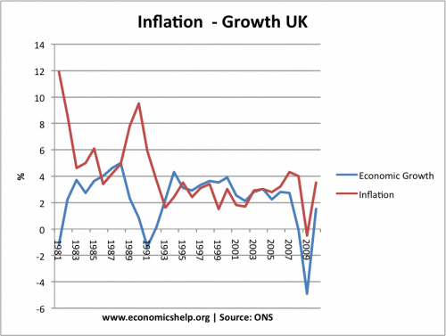

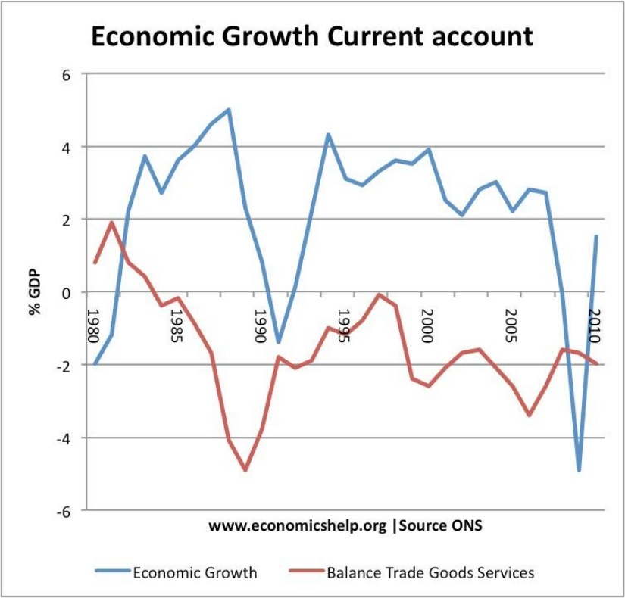**Source 2: Economic Growth & Balance of Trade (approx. Current Account)**

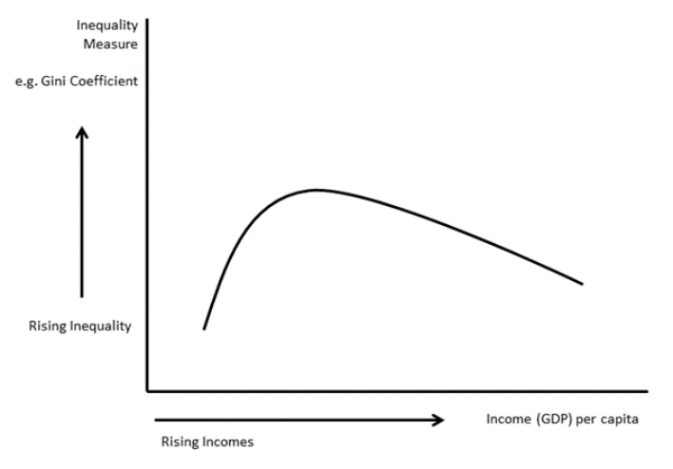**Source 3: Income Distribution**

In 1980, the per capita income of the 15 richest nations was 44 times that of the 15 poorest, by 2000, that multiple had increased to 62. However in 2009, reflecting better economic performance in several developing and transition countries; the ratio had fallen to 56. The **Kuznets Curve** was established by the economist Simon Kuznets and it dates from the 1950s. It suggests that in preindustrial societies, almost everybody is equally poor so inequality is low. Inequality then rises as people move from low-productivity agriculture to the more productive industrial sector, where average income is higher and wages are less uniform. As a society develops and becomes richer, the urban-rural gap is reduced and old-age pensions, unemployment benefits, and other components of a social safety net have the effect of lowering inequality.  The shape of a possible Kuznets Curve is shown in the next diagram. Trends over the last 30 years show income inequality increasing within countries and between them.

For emerging countries, inequality has risen in most countries – suggesting that many nations have been on the rising part of the curve. Of the BRIC countries and other leading developing countries, only Brazil has seen an eventual fall in measured income inequality. Partly this is the result of deliberate inclusive growth policies including the conditional cash transfer policy explained in our chapter on Brazil.

We can see from the table below the depth of the scale of income inequality in some low and low-middle income countries. In South Africa 84% of cumulative income is held by the richest 40% of the population whereas the poorest fifth take just 3 % of income.

|  |  |  |  |  |  |  |  |
| --- | --- | --- | --- | --- | --- | --- | --- |
| **Income Shares for the Population** | Bangladesh | India | Sri Lanka | Congo | Kenya | South Africa | Nigeria |
| Income share held by lowest 20% | 9 | 9 | 7 | 5 | 5 | 3 | 4 |
| Income share held by second 20% | 12 | 12 | 10 | 9 | 9 | 5 | 8 |
| Income share held by third 20% | 16 | 16 | 14 | 14 | 13 | 8 | 13 |
| Income share held by fourth 20% | 21 | 21 | 21 | 21 | 20 | 16 | 20 |
| Income share held by highest 20% | 41 | 42 | 48 | 51 | 53 | 68 | 54 |

*Source: World Bank*

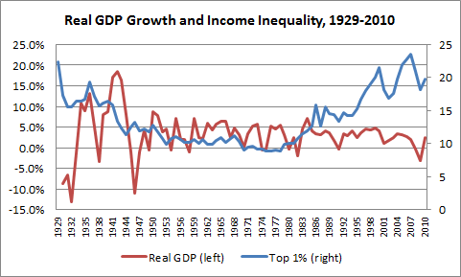

**Source 4: CO2 Emission & Wealth**

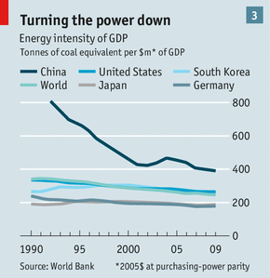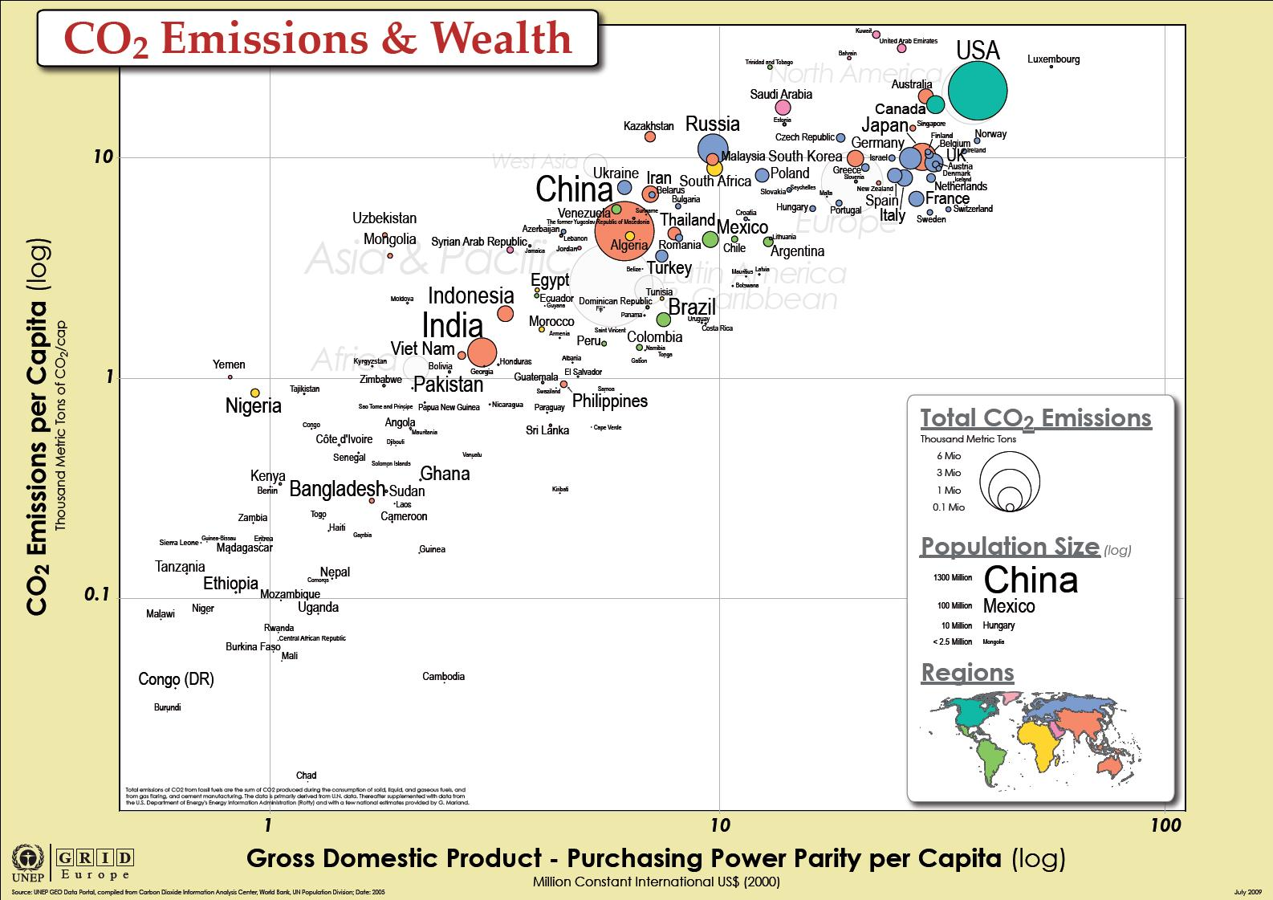

**Source 5: Economic Growth & Unemployment**

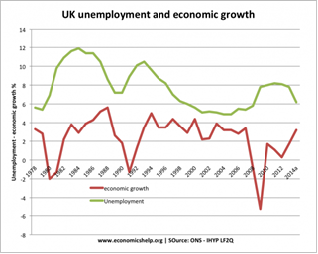

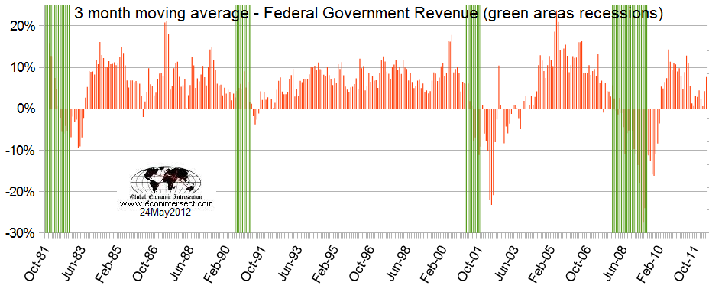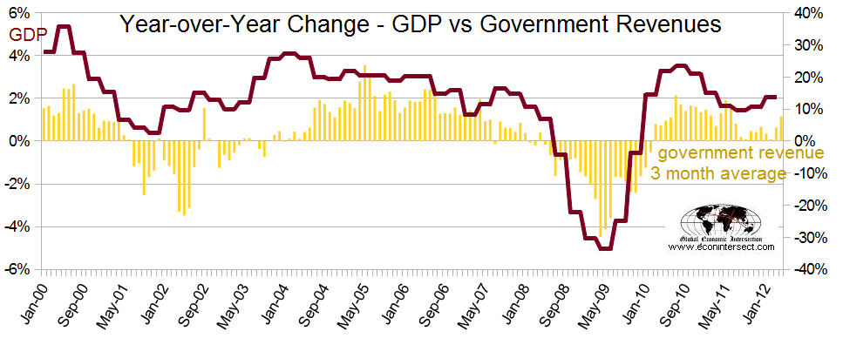**Source 6: Economic Growth & Tax Revenue (USA data, N.B. green bands show recessions)**

|  |  |  |  |
| --- | --- | --- | --- |
| **Source** | **Trends & Significant Points** | **Positive or negative impact** | **Justification & Economic Analysis (LCA 4/5 steps)** |
| Source 1: Economic Growth & Inflation |  |  |  |
| Source 2: Economic Growth & Balance of Trade (approx. Current Account) |  |  |  |
| Source 3: Income Inequality |  |  |  |
| Source 4: CO2 Emission & Wealth |  |  |  |
| Source 5:  Economic Growth & Unemployment |  |  |  |
| Source 6:  Economic Growth & Tax Revenue (USA data, N.B. green lines represent recessions) |  |  |  |

**Table:**

# Debate Task: Economic Growth – Good or Bad?

**Instructions:**

* Using the prompts below consider your response to the debate question:

*‘IS GDP a false Beacon Steering us into the rocks?’*

* Debate your opinions with the class
* Applicable concepts: national income accounting "goods" and "bads

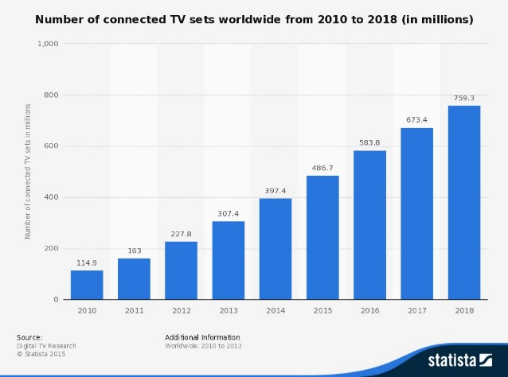Prompts

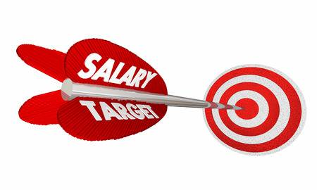

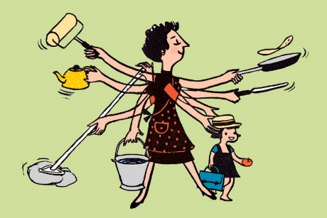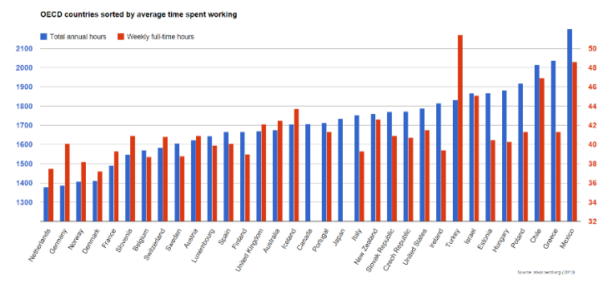



Debate Notes:

# Assignment

**Essay question (Section C)**

1. The UK’s economy grew by 2.6% in 2014, the fastest pace since 2007 and up from 1.7% in 2013.

Evaluate the benefits of economic growth for the UK. [25]

|  |  |
| --- | --- |
| **Planning Grid: Aim = 5 paragraphs - 2 KAA points (16); 2 Eval points (9) with a conclusion** | |
| **KAA Point 1 = signpost key point** |  |
| Application |  |
| Main concept & diagram |  |
| **Eval Point 1 = relate to your earlier point & re-read the title** |  |
| Context / evidence |  |
| **KAA Point 2 = signpost key point** |  |
| Application |  |
| Main concept & diagram |  |
| **Eval Point 2 = relate to your earlier point & re-read the title** |  |
| Context / evidence |  |
| **Conclusion = judgement** |  |
| Context; what does it depend on? |  |