International Competitiveness

# Starter - Discussion Questions

**Questions:** What makes a competitive sports team? Can we reconcile these ideas with economy in general?

Note Space:





# Presentation 1 - Measures of International Competitiveness

Complete the activities below so as to have a complete set of Notes:

**Definition:** *International Competitiveness*

……………………………………………………………………………………………………………………………………………………………………………………

……………………………………………………………………………………………………………………………………………………………………………………

*Price competitiveness:*The relative strengths of a country’s output based on prices and costs

*Non-price competitiveness:*The relative strengths of a country’s output based on product characteristics

**Elaborate:** Elaborate on the below measures of international competitiveness:

*Relative unit labour costs (ULC):*ULC are the cost of labour per unit of output

*Equation:* …………………………………………………………………………………

……………………………………………………………………………………………………………………………………………………………………………………

……………………………………………………………………………………………………………………………………………………………………………………

*Relative export prices:* The price of a country’s exports compared to those of their trading partners.

……………………………………………………………………………………………………………………………………………………………………………………

……………………………………………………………………………………………………………………………………………………………………………………

*Non-price measures:*These include design, quality, and reliability.

……………………………………………………………………………………………………………………………………………………………………………………

……………………………………………………………………………………………………………………………………………………………………………………

# Data Task: UK Market Share and Relative Export Prices

**Instructions:**

* Examine the below data
* Answer the questions
* Discuss your answers as a class

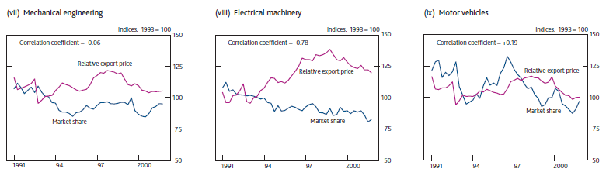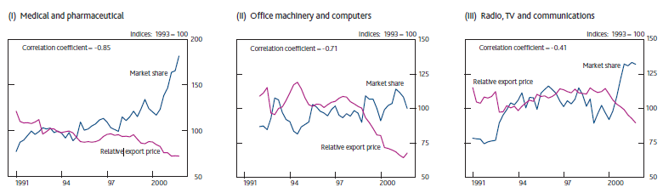**Data**

**Questions**

What does the data show about the relationship between the UK’s export prices and market share? Use the data to justify your answer.

……………………………………………………………………………………………………………………………………………………………………………………

……………………………………………………………………………………………………………………………………………………………………………………

……………………………………………………………………………………………………………………………………………………………………………………

……………………………………………………………………………………………………………………………………………………………………………………

What might demonstrate changes in non-price factors?

……………………………………………………………………………………………………………………………………………………………………………………

……………………………………………………………………………………………………………………………………………………………………………………

……………………………………………………………………………………………………………………………………………………………………………………

……………………………………………………………………………………………………………………………………………………………………………………

# Presentation 2 – Factors Influencing International Competitiveness

Complete the activities below so as to have a complete set of Notes:

**Definition:** *Real exchange rates (exchanges rates and relative inflation)*

……………………………………………………………………………………………………………………………………………………………………………………

A comparison of how much of a good you could buy in two different countries after exchanging the same amount of money into the relevant currencies

*Equation:* ………………………………………………………………………………………………………………………………………………………..

*Unit of real exchange rates:* units of foreign good per units of domestic (home country) good, since real exchange rates show how many foreign goods you can get per unit of domestic good.

If a countries real exchange rate is rising, its goods are becoming more expensive relative to its competitors.

*N.B.*when the real exchange rate is equal to 1, this means that purchasing power parity has been achieved – you can buy a good from *either* economy for the same price.

**Elaborate:** Elaborate on the below factors influencing international competitiveness

*Productivity:* A more productive workforce means firms produce more per hour

……………………………………………………………………………………………………………………………………………………………………………………

……………………………………………………………………………………………………………………………………………………………………………………

……………………………………………………………………………………………………………………………………………………………………………………

*Government intervention – taxes and regulations:*More stringent regulations or higher indirect taxes will raise costs for firms (MC and AC increase).

……………………………………………………………………………………………………………………………………………………………………………………

……………………………………………………………………………………………………………………………………………………………………………………

……………………………………………………………………………………………………………………………………………………………………………………

*Wages:*higher wages will reduce competitiveness as unit labour costs increase.

……………………………………………………………………………………………………………………………………………………………………………………

……………………………………………………………………………………………………………………………………………………………………………………

……………………………………………………………………………………………………………………………………………………………………………………

……………………………………………………………………………………………………………………………………………………………………………………

*Innovation/R&D:* Economies need to keep improving/maintaining the stock of capital equipment that they have to ensure they are dynamically efficient.

……………………………………………………………………………………………………………………………………………………………………………………

……………………………………………………………………………………………………………………………………………………………………………………

……………………………………………………………………………………………………………………………………………………………………………………

……………………………………………………………………………………………………………………………………………………………………………………

# Table Task: Policies to Improve Competitiveness

**Instructions**

* Classify the below policies as either ‘firm level’ or ‘government level’
* Explain how the policy boosts competitiveness

|  |  |  |
| --- | --- | --- |
| **Policy** | **Firm Level or Government Level** | **How does policy improve competitiveness?**  (link it back to a relevant factor and the type of competitiveness) |
| Rationalisation |  |  |
| Relocating to places where average wages are lower |  |  |
| Investment in infrastructure |  |  |
| Process innovation |  |  |
| Product innovation |  |  |
| Increasing access to finance for business |  |  |
| Sourcing from abroad where appropriate |  |  |
| Tax credits/cuts to corporation tax |  |  |
| Seeking out new market opportunities |  |  |
| Simplifying business  regulation |  |  |
| Improving relationships with suppliers and customers |  |  |
| Creating an educated  workforce |  |  |

# Policy Writing Task: The Global Competitiveness Report 2017–2018

**Instructions**

* Read, highlight and annotate the below report on the United Kingdom’s International Competitiveness
* Identify the areas where the UK is highly competitive and where it is less competitive
* State and explain three policies which could be implemented to improve UK competitiveness
* **Challenge:** State any possible limitations of your policies

**Report:**

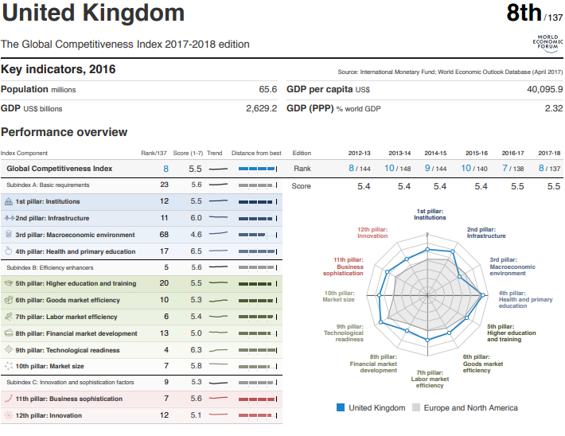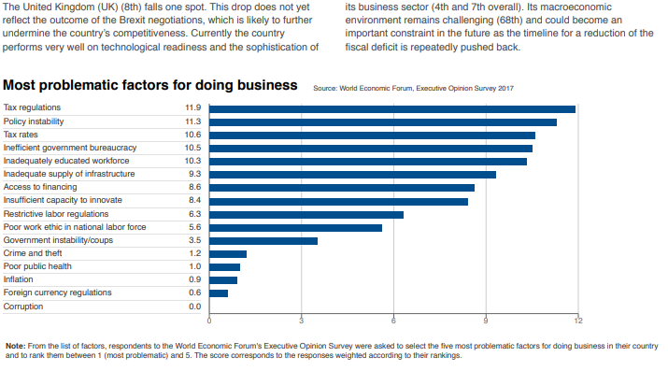

(Source: <https://www.weforum.org/reports/the-global-competitiveness-report-2017-2018>)

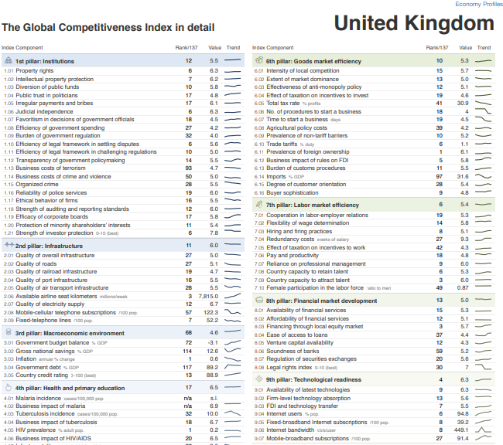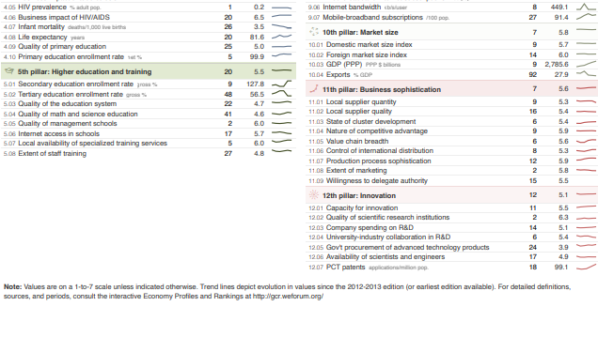

**Strengths and Weaknesses**

|  |  |
| --- | --- |
| Areas where the UK’s competitiveness is **strong** | Areas where the UK’s competitiveness is **weak** |
|  |  |

**Policy Planning**

|  |  |  |  |
| --- | --- | --- | --- |
|  | **Policy 1** | **Policy 2** | **Policy 3** |
| Policy |  |  |  |
| Explanation (LCA with application) |  |  |  |
| **Challenge:** Possible Limitations |  |  |  |

# Assignment

**SECTION B (DATA RESPONSE)**

**Figure 1 International competitiveness based on the Global Competitiveness Index 2016-2017 Rankings of selected countries**

|  |  |
| --- | --- |
| **Country** | **Ranking (out of 139)** |
| Singapore | 2 |
| United States | 3 |
| United Kingdom | 7 |
| Hong Kong SAR | 9 |
| Taiwan | 14 |
| Ireland | 23 |
| Malaysia | 25 |
| South Korea | 26 |
| China | 28 |
| Spain | 32 |
| Italy | 44 |
| Portugal | 46 |
| Greece | 96 |

**Figure 2 Unit labour costs in selected euro area countries (2000 = 100)**



1. With reference to Figure 1 and your own knowledge, explain what is meant by *international competitiveness*.

[5]

1. With reference to Figure 2 and your own knowledge, examine factors affecting a country’s unit labour costs.

[10]

1. With reference to Figure 2 and your own knowledge, examine factors affecting a country’s unit labour costs.

[10]

|  |  |
| --- | --- |
| **Planning Grid: Aim = 4 paragraphs - 2 KAA points (6); 2 Eval points (4)** | |
| **KAA Point 1 = signpost key point** |  |
| Application |  |
| Main concept & diagram |  |
| **Eval Point 1 = relate to your earlier point & re-read the title** |  |
| Context / evidence |  |
| **KAA Point 2 = signpost key point** |  |
| Application |  |
| Main concept & diagram |  |
| **Eval Point 2 = relate to your earlier point & re-read the title** |  |
| Context / evidence |  |