Intro to Market Failure

Starter: Recap Questions
Instructions: Test yourself with the below quick questions
What is meant by a market?
……………………………………………………………………………………………………………………………………………………………………………………
……………………………………………………………………………………………………………………………………………………………………………………
What diagram explains how a market allocates resources?
……………………………………………………………………………………………………………………………………………………………………………………
How is the welfare of those in the market shown in this diagram?
……………………………………………………………………………………………………………………………………………………………………………………
……………………………………………………………………………………………………………………………………………………………………………………

Presentation 1 – Intro to Market Failure
Complete the activities below so as to have a complete set of Notes:

Definition: Market Failure
……………………………………………………………………………………………………………………………………………………………………………………
……………………………………………………………………………………………………………………………………………………………………………………

Recap: Classical Economics believes that the markets maximise economic welfare as the sum of producer and consumer surplus is maximised at equilibrium
However: For a few reasons this allocation might not be socially optimal

Brainstorm: Reasons why markets might fail in practice

Reasons Markets Fail

Definition: Merit Good
……………………………………………………………………………………………………………………………………………………………………………………
Definition: Demerit Good
……………………………………………………………………………………………………………………………………………………………………………………

Discussion Task: Importance of Market Failure
Instructions:
- Individually consider the key discussion question below
- Discuss both sides of the debate with your partner/group
- Debate your overall viewpoint with the class
‘Should Economists care about Market Failure?’
Note Space:

Presentation 2 – Types of Market Failure
Complete the activities below so as to have a complete set of Notes:
Matching up: Scope of Market Failure:
Draw lines to link the scope of market failure to the correct definition, and then to the relevant types of failure
Partial Market Failure |  | when there is no market whatsoever, a missing market |  | Externalities
Complete Market Failure |  | A market exists but there is a misallocation of resources |  | Public Goods
 |  |  |  | Imperfect Market Information
Definitions:
Externalities
……………………………………………………………………………………………………………………………………………………………………………………
……………………………………………………………………………………………………………………………………………………………………………………
……………………………………………………………………………………………………………………………………………………………………………………
This can result in under or over consumption/production of the good
The spill-over can occur either when the good is made, or when the good is consumed.

Imperfect market information
……………………………………………………………………………………………………………………………………………………………………………………
……………………………………………………………………………………………………………………………………………………………………………………
……………………………………………………………………………………………………………………………………………………………………………………
Demand and Supply would be different in a free market compared to if the two parties had perfect information. Welfare is not maximised.

Public Goods
……………………………………………………………………………………………………………………………………………………………………………………
……………………………………………………………………………………………………………………………………………………………………………………
……………………………………………………………………………………………………………………………………………………………………………………
Free-rider problem: In a free market, no one would pay for public goods and so they wouldn’t be provided despite adding to society’s welfare,

Task: Test Yourself
- Define the term misallocation of resources.
……………………………………………………………………………………………………………………………………………………………………………………
……………………………………………………………………………………………………………………………………………………………………………………
……………………………………………………………………………………………………………………………………………………………………………………

- Distinguish between complete and partial market failure.
……………………………………………………………………………………………………………………………………………………………………………………
……………………………………………………………………………………………………………………………………………………………………………………
……………………………………………………………………………………………………………………………………………………………………………………
Extension: Explain whether a toll road is a public or private good.
……………………………………………………………………………………………………………………………………………………………………………………
……………………………………………………………………………………………………………………………………………………………………………………
……………………………………………………………………………………………………………………………………………………………………………………
……………………………………………………………………………………………………………………………………………………………………………………
……………………………………………………………………………………………………………………………………………………………………………………
……………………………………………………………………………………………………………………………………………………………………………………

Presentation 3 – Marginal Analysis
Complete the activities below so as to have a complete set of Notes:
Quick Question: Explain what is meant by ‘marginal’?
……………………………………………………………………………………………………………………………………………………………………………………
……………………………………………………………………………………………………………………………………………………………………………………
Definitions: Benefits
Marginal Private Benefit (MPB)
……………………………………………………………………………………………………………………………………………………………………………………
……………………………………………………………………………………………………………………………………………………………………………………
MPB falls with output due to diminishing marginal utility. Each successive unit of consumption brings less and less satisfaction than the unit prior
In a free market, consumers’ MPB is shown by the market demand curve
Consumer’s willingness to pay for each unit is determined by the utility from consuming it.
Marginal Social Benefit (MSB)
……………………………………………………………………………………………………………………………………………………………………………………
……………………………………………………………………………………………………………………………………………………………………………………
It can be considered as what the demand curve should be in order to maximise society’s total welfare
Marginal External Benefit (MEB)
……………………………………………………………………………………………………………………………………………………………………………………
……………………………………………………………………………………………………………………………………………………………………………………
It is the difference between MPB and MSB (MEB = MSB-MPB)
Key Notes: Total Benefits
The total benefits of a given quantity can be found from summing up all the marginal benefits of the consumed units
E.g. ___________________________

Diagram: Draw a diagram to show MPB, MEB and MSB in price-quantity space

Definitions: Costs
Marginal Private Costs (MPC)
……………………………………………………………………………………………………………………………………………………………………………………
……………………………………………………………………………………………………………………………………………………………………………………
MPC rises with output as higher wages are needed to attract more workers, greater profits are demanded by enterprise etc.
MPC is mostly in financial terms
In a free market, producers’ MPC is shown by the market supply curve
How much suppliers are willing to sell each unit for is determined by cost if making it
Marginal Social Costs (MSC)
……………………………………………………………………………………………………………………………………………………………………………………
……………………………………………………………………………………………………………………………………………………………………………………
It can be considered as what the supply curve should be in order to maximise society’s total welfare
Marginal External Costs (MEC)
……………………………………………………………………………………………………………………………………………………………………………………
……………………………………………………………………………………………………………………………………………………………………………………
MEC can be considered as the non-financial burden on members of the general public occurring from production
It is the difference between MPC and MSC (MEC = MSC-MPC)

Key Notes: Total Costs
The total costs of a given quantity can be found from summing up all the marginal costs of the consumed units
E.g. ___________________________

Diagram: Draw a diagram to show MPC, MEC and MSC in price-quantity space

Task: Marginal Benefits
Instructions: Complete the below questions to test your understanding of marginal benefit curves
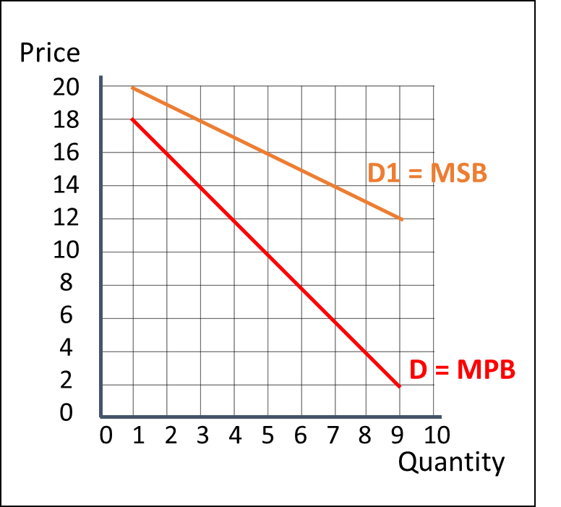
- What is the marginal private benefit of the 4th unit?
……………………………………………………………………………………………………………………………………………………………………………………
- What is the marginal social benefit of the 4th unit?
……………………………………………………………………………………………………………………………………………………………………………………
- What is the marginal external benefit of the 4th unit?
……………………………………………………………………………………………………………………………………………………………………………………
- Annotate the diagram with to show these benefits

- Calculate the total private benefit from making 3 units
……………………………………………………………………………………………………………………………………………………………………………………
- Calculate the total social benefit from making 3 units
……………………………………………………………………………………………………………………………………………………………………………………
- Calculate the total external benefit from making 3 units
……………………………………………………………………………………………………………………………………………………………………………………
- Challenge: Highlight the areas on the diagram that show the TPB, TSB and TEB of producing 3 units
……………………………………………………………………………………………………………………………………………………………………………………

Task: Marginal Costs
Instructions: Complete the below questions to test your understanding of marginal cost curves
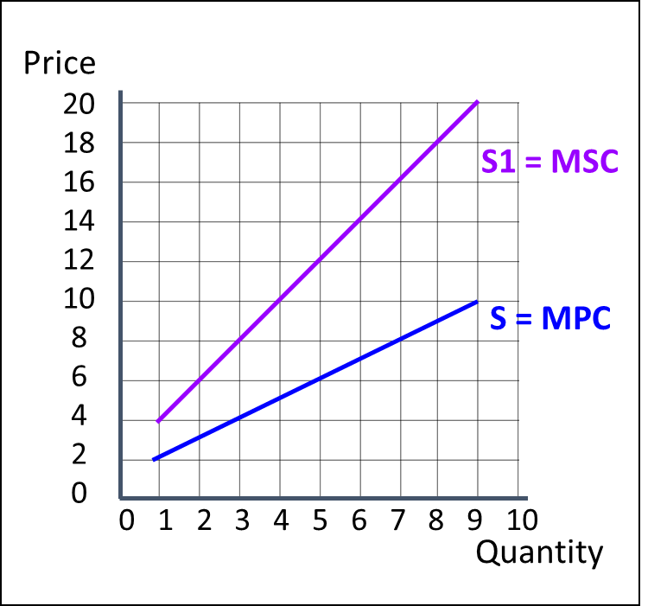
- What is the marginal private cost of the 5th unit?
……………………………………………………………………………………………………………………………………………………………………………………
- What is the marginal social cost of the 5th unit?
……………………………………………………………………………………………………………………………………………………………………………………
- What is the marginal external cost of the 5th unit?
……………………………………………………………………………………………………………………………………………………………………………………
- Annotate the diagram with to show these costs

- Calculate the total private cost from making 4 units
……………………………………………………………………………………………………………………………………………………………………………………
- Calculate the total social cost from making 4 units
……………………………………………………………………………………………………………………………………………………………………………………
- Calculate the total external cost from making 4 units
……………………………………………………………………………………………………………………………………………………………………………………
- Challenge: Highlight the areas on the diagram that show the TPC, TSC and TEC of producing 4 units
……………………………………………………………………………………………………………………………………………………………………………………

Non-Exam Essay
Title:

With reference to a market of your choice, explain why the free-market allocation might not be socially optimal AND explain how the government might intervene to improve the situation.

Things to consider
- What is the type of market failure in your market?
- What does the market failure look like in reality?
- Can you incorporate a diagram into your explanation?
- Would society be better off if more or less of the good was consumed compared to the free-market result?
- How would the government intervention lead to a ‘better’ quantity?
- Can you evaluate your analysis of the market failure and government intervention?

Rules:
- Type your essay on computer and add any diagrams by hand (don’t just copy and paste images from the internet)
- Cite your sources in a Bibliography at the end of your essay (I don’t care if you use Wikipedia, it is normally very good)
- 1000-word approximate word count (A bit either side is fine within reason)

