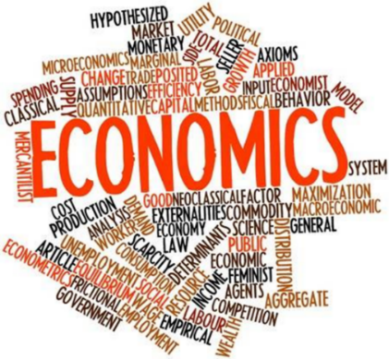Introduction to Economics - Microeconomics

# Discussion Question

**Instructions:**

* Individually consider the question
* Discuss your thoughts with a partner
* Examine your ideas with the class

*‘What is Economics?’*

**N.B.** If you have chosen to study economics, surely you must have some idea of what the subject is about?

|  |
| --- |
| Note Space (write down anything at all that comes to mind – there are no wrong answers, yet…) |

**Definition:** *Economics*

……………………………………………………………………………………………………………………………………………………………………………………..

……………………………………………………………………………………………………………………………………………………………………………………..

……………………………………………………………………………………………………………………………………………………………………………………..

# \\mtsstaff\HCO\Downloads\190571301_121445733403091_959588388321803909_n.jpgTheme Spotting

**Instructions:**

* Examine the recent covers of the economist magazine
* What themes does the magazine, and economics in general, consider
* Rank each theme in terms of what *you* consider to be the most important

**Extension:** Can you think of any other themes which economists consider?

Note space:

**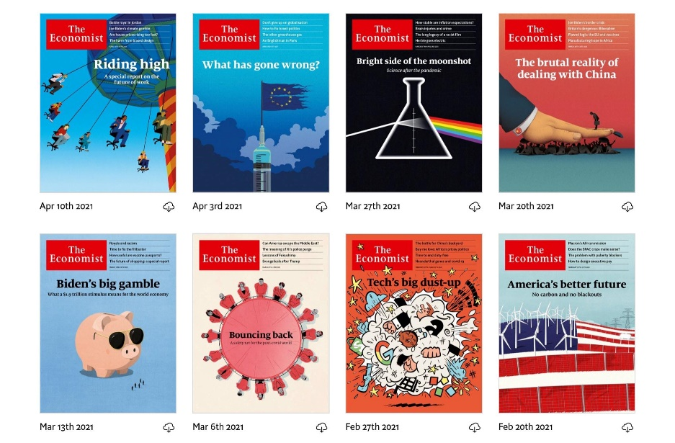**

**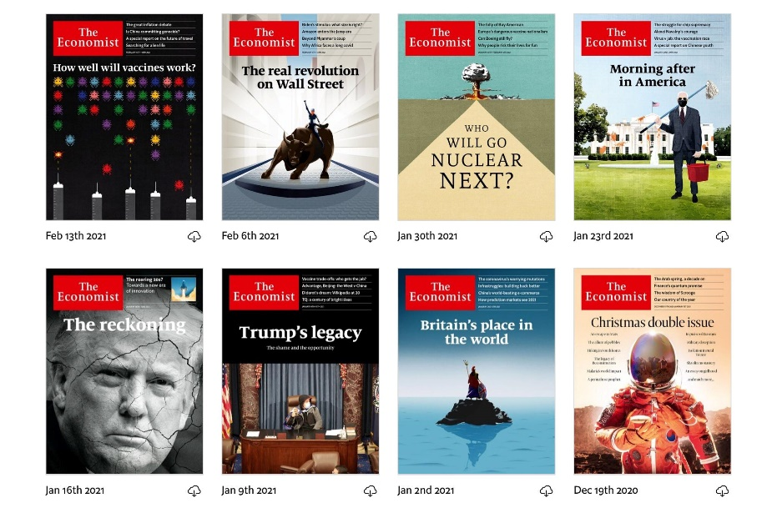**

Which themes do you consider to be most important?

……………………………………………………………………………………………………………………………………………………………………………………..

……………………………………………………………………………………………………………………………………………………………………………………..

Can you think of any other themes which economists consider?

……………………………………………………………………………………………………………………………………………………………………………………..

……………………………………………………………………………………………………………………………………………………………………………………..

# Presentation 1: What is Economics?

Complete the activities below so as to have a complete set of Notes:

**Definition:** *Economics*

……………………………………………………………………………………………………………………………………………………………………………………..

……………………………………………………………………………………………………………………………………………………………………………………..

**Definition:** *Social science*

……………………………………………………………………………………………………………………………………………………………………………………..

……………………………………………………………………………………………………………………………………………………………………………………..

**Key Notes:** *The Scientific Method*

The scientific method is a method of acquiring knowledge through proposing and testing ideas.

The method involves generating abstract models to help explain how a complex, real world operates.

3 steps:

1. …………………………………………………………………………………………………………………………………………………………………………………

2. …………………………………………………………………………………………………………………………………………………………………………………

3. …………………………………………………………………………………………………………………………………………………………………………………

**Definition:** *Models*

……………………………………………………………………………………………………………………………………………………………………………………..

……………………………………………………………………………………………………………………………………………………………………………………..

**Key Notes:** Assumptions

*The Role of Assumptions:* Make the world easier to understand

Assumptions allow Economists to make models to answer different questions

**Definition:** *Ceteris Paribus*

……………………………………………………………………………………………………………………………………………………………………………………..

An important assumption in economics because in the real world it is usually hard to isolate all the different variables

**Key Notes:** Pros & Cons of using models

|  |  |
| --- | --- |
| ***Pros*** | ***Cons*** |
| * Models forecast activities and help future analysis/ policy. They give a clear and mathematical representation of the data. They help to broaden understanding. * Models simplify otherwise complex data. Answers can then become accessible. * Models quicken the pace of analysis. They help to isolate the effect of a variable. They look at causality (helps to consider which factors are relevant and irrelevant). | * The bias of the creator of the model will then bias the results. Assumptions may not be valid in different settings. * Models assume complete rationality however individuals have bounded rationality. Humans may act in different ways despite the predictions of the model. * Output quality is determined by input quality. Data and analysis may be overly simplified. This can lead to incorrect results. |
|  |  |

# Article Task: Model Economic Models

**Instructions:**

* Highlight advantages & disadvantages of using models to establish economic truth
* Complete Questions
* Discuss answers as a group

**Article:**

In economics, a model is a hypothesis embodied by a set of relationships between a dependent variable, the cause, (x-axis) and an independent variable, the effect, (y-axis) variables. As household income increases, household expenditure increases is a hypothesis where the direct variable, which in this case is the extra income, is causing the indirect variable, the extra spending. The use of such models in economics is known as econometrics.

Economic models, which can contain many dependent variables in the explanation of a single independent variable, are thus used as a simplified framework designed to illustrate a complex process which would be otherwise impossible to examine. Another example would be in the case of the circular flow of income model. This simplifies the entirety of economic activity (as recorded by Gross Domestic Product) in a national economy as a sum of household consumption, investment, government expenditure, and net exports. This simplification allows economists to examine particular independent variables for economic growth and get at least a sense of the broader picture despite concerns about a lack of a sterile environment, ethical objections and the dispute over the existence of universal laws of human behaviour. Evaluating policies such as Brexit or nationalisation with this model allows economists to push government to making the correct polices to maximise economic growth.

This complexity can be attributed to the diversity of factors that determine economic activity; these factors include: individual and cooperative decision processes, resource limitations, environmental and geographical constraints and institutional and legal requirements. Indeed, this list is ever growing as more and more Economists identify more and more variables that impact models. The quality of economic thought and the awareness of what to include impacts the quality of the model. Increasingly models that reflect economic growth across countries are having to add increasingly more accurate definitions of “human capital” as machines replace basic human labour like mining and assembling goods.

The need to simplify to test theories is simultaneously the greatest strength and weakness of modelling. For one Economists therefore must make a reasoned choice of which variables and which relationships between these variables are relevant. Failing to account for important variables in models, perhaps due to a desire not to examine something that goes against the Economists’ political beliefs, will reduce the ability for models to explain economic phenomena. It would be of little value not to include measures of household income when discussing household expenditure because the Economist does not believe it is an important factor.

Assumptions are also very important in constructing models given that Economists assume the importance of variables and how they interact before they test them. Economists test the relationship between household income and expenditure, and not individual income and expenditure. The assumption that a household is essentially the same as a collection individuals is an assumption, which could on inspection invalidate the accuracy and usefulness of the model. If on closer inspection the expenditure of only the wage earner changed with a change in income, if would be inaccurate to say the whole expenditure of everyone in the household changes.

**Questions**

Delete where appropriate:

*‘Overall I think that models are / are not useful for economists.’*

The two most important points that convinced me are:

……………………………………………………………………………………………………………………………………………………………………………………

……………………………………………………………………………………………………………………………………………………………………………………

……………………………………………………………………………………………………………………………………………………………………………………

……………………………………………………………………………………………………………………………………………………………………………………

……………………………………………………………………………………………………………………………………………………………………………………

One point on the opposing side that looks convincing is:

……………………………………………………………………………………………………………………………………………………………………………………

……………………………………………………………………………………………………………………………………………………………………………………

……………………………………………………………………………………………………………………………………………………………………………………

……………………………………………………………………………………………………………………………………………………………………………………

……………………………………………………………………………………………………………………………………………………………………………………

# Discussion Question

**Instructions:**

* Individually consider the question
* Discuss your thoughts with a partner
* Examine your ideas with the class

*‘Why might it be hard to conduct scientific experiments in Economics?’*

|  |
| --- |
| Note Space |

# Presentation 2 - Difficulties in conducting scientific experiments in Economics

Complete the activities below so as to have a complete set of Notes:

**Match up:** Connect the different difficulty to its explanation.

|  |  |  |
| --- | --- | --- |
| *Lack of a sterile environment* |  | Some believe that due to the diversity of human beings and the diverse conditions people face there are no universal rules or laws of behaviour to discover. Economists cannot predict and create laws of how every human allocates their resources. |
|  |  |  |
| *Ethical* Objections: |  | Economists can’t pause the economy to examine a specific element and hold all other areas constant. Economic experiments can be distorted by changes to other variables. |
|  |  |  |
| *No Universal Laws Of Human Behaviour Exist:* |  | Even if economists could create a sterile economic environment, there are ethical problems in subjecting people’s lives to the whims of economists. Should economists be allowed to gamble with other people’s jobs, homes, and possessions for the sake of economic curiosity? |

# Presentation 3 - Positive and Normative Economic Statements

Definition: *Positive Economic Statements*

……………………………………………………………………………………………………………………………………………………………………………………

……………………………………………………………………………………………………………………………………………………………………………………

*Examples:*

‘Fire is hot’

‘If nurses’ salaries were raised, the greater rewards would encourage more people to go into nursing and therefore solve the NHS’s staff shortage problem’

‘The sky is green’

*An example of my own is:*

……………………………………………………………………………………………………………………………………………………………………………………

*Role:* Positive economics deals with objective explanation and the testing and rejection of theories, i.e. provable causal relationships

Identifies relationships between economic variables, which can be verified by referring to data (you can be *positive* about a *positive* statement)

*Definition:*Normative Economic Statements

……………………………………………………………………………………………………………………………………………………………………………………

……………………………………………………………………………………………………………………………………………………………………………………

*Value judgement:*an assessment of something in terms of one's standards or priorities. It is subjective.

*An Important distinction:*Opinions are not the same as value judgements.

Opinions can be tested through the scientific method. *E.g.* I think boiling point of water is 10 C.

Value judgements cannot be tested by the scientific method. *E.g.*Economic freedom is more important than ensuring an equality of living standards.

*Examples:*

‘The government ought to give free school meals to all students’

‘Nurses’ salaries should be raised immediately as they do such a good job for the NHS and deserve greater rewards’

‘Tottenham Hotspur play the most attractive football in the premier league’

*An example of my own is:*

……………………………………………………………………………………………………………………………………………………………………………………

*Role:*Often concerned with ethical issues such as ‘fairness’

Indicated by words such as ‘should’, ‘ought to’, etc. Often used when considering policy options

# Task: Positive or Normative?

**Instructions:**

* Read the statements and determine whether they are positive or normative. Circle ‘P’ or ‘N’.
* ***Extension:*** how would you flip each statement, from positive to normative and vice versa

**Statements:**

1. Ferrari produces the best looking cars in the world. *‘P’ or ‘N’?*
2. Most consumers football fans agree that Messi is better than Ronaldo. *‘P’ or ‘N’?*
3. Cigarette taxes ought to rise by 50%, as we should aim to cut smoking uptake amongst teenagers. *‘P’ or ‘N’?*
4. If alcohol taxes rose by 50%, binge drinking would fall dramatically amongst teenagers, and so would alcohol-related illnesses in later life. *‘P’ or ‘N’?*
5. There should be a windfall tax on all companies making >£1bn profit per year, since it is unfair that middle class people have to pay so much tax in the UK. *‘P’ or ‘N’?*
6. A wealth tax on companies making >£1bn profit is likely to reduce the level of inequality. *‘P’ or ‘N’?*

# Discussion Questions

**Instructions:**

* *Think about how you would answer the below discussion questions*
* *Discuss your responses partner*
* *Share your thoughts with the group*

**Questions**

Should economists only worry about positive economics?

……………………………………………………………………………………………………………………………………………………………………………………

……………………………………………………………………………………………………………………………………………………………………………………

Why are normative statements important?

……………………………………………………………………………………………………………………………………………………………………………………

……………………………………………………………………………………………………………………………………………………………………………………

Why do people like to try to make normative statements seem like positive statements?

……………………………………………………………………………………………………………………………………………………………………………………

……………………………………………………………………………………………………………………………………………………………………………………

How does the disproving of a positive and normative statement differ?

……………………………………………………………………………………………………………………………………………………………………………………

……………………………………………………………………………………………………………………………………………………………………………………

What is more scientific: positive or normative statements?

……………………………………………………………………………………………………………………………………………………………………………………