Employment & Unemployment

# Starter - Discussion Question

**Instructions:** Discuss the below question with a partner, share you ideas with the class.

***Given that the below people who are not currently working, why are they* ***NOT*** *considered unemployed?*

Note Space:

# Presentation 1 – Intro to Employment and Unemployment

Complete the activities below so as to have a complete set of Notes:

**Definition:** *The Labour Force*

……………………………………………………………………………………………………………………………………………………………………………………

……………………………………………………………………………………………………………………………………………………………………………………

LF = E + U/E

**Definition:** *Employed*

……………………………………………………………………………………………………………………………………………………………………………………

……………………………………………………………………………………………………………………………………………………………………………………

*Stat:* __________________ people were in employment in the UK in February 2020 – a record!

**Definition:** *Unemployed*

……………………………………………………………………………………………………………………………………………………………………………………

……………………………………………………………………………………………………………………………………………………………………………………

*Stat:*An estimated 1.36 million people were unemployed in the UK in February 2020.

**Definition:** *The Population of Working Age (PWA)*

……………………………………………………………………………………………………………………………………………………………………………………

*Stat:*Circa 42.93 million people made up the PWA in the UK in February 2020.

**Definition:** *Economically Inactive*

……………………………………………………………………………………………………………………………………………………………………………………

Economically inactive = PWA - LF

*E.g.*students, stay at home parents, people enrolled on training schemes, early retirement, etc.

**Venn Diagram Task:** *Labour Force Breakdown*

_____________________

= ___________________

Fill in the blank spaces to complete the Venn Diagram

UK Population

= 66.5 Million people

_____________________

= ___________________

_____________________

= ___________________

Employed

= ___________________

_______________________

= 42.93 Million people in total

**Key Question:** *Why do we measure unemployment?*

……………………………………………………………………………………………………………………………………………………………………………………

……………………………………………………………………………………………………………………………………………………………………………………

……………………………………………………………………………………………………………………………………………………………………………………

……………………………………………………………………………………………………………………………………………………………………………………

**Definition:** *Under-employment*

……………………………………………………………………………………………………………………………………………………………………………………

……………………………………………………………………………………………………………………………………………………………………………………

They are not as productive as they could potentially be.

**Key Notes:** *Employment and Unemployment rates*

*Employment rate:* the proportion of the ***________________________*** that is currently employed.

*Equation:*

*Stat:* UK employment rate = 77%

*Unemployment rate:*the proportion of the ***________________________***that is not currently employed.

*Equation:*

*Stat:* UK unemployment rate = 4.0%

*Participation rate:*the proportion of a ***________________________*** that is in the labour force i.e. economically active.

*Equation:*

*Stat:* UK participation rate = 80%

# Task: Jobseeker's Allowance (JSA) – How does it work?

**Instructions:**

* Read the explanation of JSA and consider the key questions

**Article**

1. Overview

Jobseeker’s Allowance (JSA) is at least £57.35 a week to help you while you look for work. How much you get depends on your circumstances and the type of JSA you qualify for.

To qualify for JSA you usually have to be:

* 18 or over (but below State Pension age)
* Actively seeking work (able and available for work) (Note volunteering won’t normally affect your JSA but report it before you start.)
* meet the other rules for eligibility

When you apply for JSA, you must go to an interview to complete your claim. You must go to a Jobcentre (usually every 2 weeks or when asked) to show how you’ve been searching for a job to keep getting JSA. This is known as ‘signing on’.

2. What you'll get

There are 2 types of Jobseeker’s Allowance (JSA). Jobcentre Plus will work out the type you get and how much tax will be charged.

JSA does not affect Child Benefit or child tax credit, you still receive these if you are eligible.

*Contribution-based JSA*

You can only get contribution-based JSA for 182 days (approximately 6 months). You may be able to get income-based JSA after this.

Age Weekly amount

16 to 24 £57.35

25 or over £72.40

You could get this if you’ve paid enough [Class 1 National Insurance contributions](https://www.gov.uk/national-insurance/how-much-national-insurance-you-pay) (NICs) in the last 2 tax years. Your income or savings don’t usually affect how much you get (unless you get money from a part-time job or an occupational or private pension).

*Income-based JSA*

Status Weekly amount

Single (under 25) £57.35

Single (25 or over) £72.40

Couples (both aged 18 or over) £113.70

Lone parent (18 or over) £72.40

Lone parent (under 18) £57.35

You could get this if you’ve not paid enough National Insurance as an employee and you’re on a low income. Income-based JSA is means tested. Your income and savings can affect how much you get.

*How you’re paid*

Payments are usually made every 2 weeks. All benefits, pensions and allowances are normally paid into an account, eg a bank account.

*The benefit cap*

The benefit cap limits the amount of benefit that most people aged 16 to 64 can get. Some individual benefits aren’t affected, but it may affect the total amount of benefit you get.

3. Eligibility

To get Jobseeker’s Allowance (JSA) you must:

* be 18 or over but below State Pension age - there are some exceptions if you’re 16 or 17
* not be in full-time education
* be in England, Scotland or Wales
* be able and available for work
* be actively seeking work
* work on average less than 16 hours a week
* go to a JSA interview

Also, to get income-based JSA you (and your partner if you have one):

* must usually work less than 24 hours a week (on average)
* must have £16,000 or less in savings

*Your income*

Your household income can affect how much income-based JSA you get. Income includes money from savings (if you have more than £6,000), pensions and earnings.

*Self-employed*

You can’t usually get contribution-based JSA if you’re self-employed. You must have paid enough Class 1 National insurance, and self-employed people pay Class 2 or 4. You could get income-based JSA, tax credits or Employment and Support Allowance instead.

*16 to 17 years olds*

JSA isn’t usually paid to 16 or 17 year olds or people in full-time education, except in certain circumstances. Contact your local Jobcentre Plus for advice.

*18 to 19 year olds*

You usually can’t get JSA if:

* you’re in full-time education
* your parents receive Child Benefit for you

You may be able to get [Income Support](https://www.gov.uk/income-support/eligibility). If you’ve just left education, wait until your Child Benefit ends before applying for JSA.

*Full-time students*

Full-time students can’t usually get JSA until their course has officially finished - check the date with your college or university. You may be able to claim JSA during the summer holiday if you have children. You can usually do an Open University course or short course (2 weeks or less) without it affecting your JSA - tell [Jobcentre Plus](https://www.gov.uk/contact-jobcentre-plus) before you start.

*Part-time students*

You can get JSA while studying part-time if you can combine your course with a job, or are willing to give up your course for a job.

*New or recently returned to the UK*

To get income-based JSA you must prove that you’ve been living in the UK for 3 months before you claim if you’re:

* a UK national who has recently returned from abroad and you haven’t worked since coming back to the UK
* an [EEA national](http://www.dwp.gov.uk/international/social-security-agreements/list-of-countries/) and you haven’t worked since arriving in the UK

If you’re an EEA national who has worked or been self-employed in the UK since you arrived, you may have to provide:

* evidence of your earnings
* details of employment

**Questions**

1. What are the requirements of getting JSA?

……………………………………………………………………………………………………………………………………………………………………………………

……………………………………………………………………………………………………………………………………………………………………………………

……………………………………………………………………………………………………………………………………………………………………………………

2. What incentives is the government creating through the set up of JSA?

……………………………………………………………………………………………………………………………………………………………………………………

……………………………………………………………………………………………………………………………………………………………………………………

……………………………………………………………………………………………………………………………………………………………………………………

*Extension:* How do you think it could be improved?

……………………………………………………………………………………………………………………………………………………………………………………

……………………………………………………………………………………………………………………………………………………………………………………

……………………………………………………………………………………………………………………………………………………………………………………

# Presentation 2a – Measures of Unemployment: The Claimant Count

Complete the activities below so as to have a complete set of Notes:

**Definition:** *The Claimant Count*

……………………………………………………………………………………………………………………………………………………………………………………

**Key Notes:** *Workings*

Those claiming JSA must declare that they are out of work, but capable of, available for and actively seeking work.

Only available to those aged between 16 and state pension age.

By counting the people on JSA, the government know how many people are unemployed.

*Stat:*1.20 million people claimed JSA in the UK in Feb 2020.

**Elaborate:** Elaborate on the below ADVANTAGES of the Claimant Count

*Includes everyone claiming JSA*

............................................................................................................................................................................................

............................................................................................................................................................................................

*Compiled every month*

............................................................................................................................................................................................

*Cheap to produce*

............................................................................................................................................................................................

............................................................................................................................................................................................

**Elaborate:** Elaborate on the below DISADVANTAGES of the Claimant Count

*Benefits cheats might still claim JSA*

............................................................................................................................................................................................

............................................................................................................................................................................................

*Some unemployed may be unable to claim*

............................................................................................................................................................................................

............................................................................................................................................................................................

*Some people might not want to claim JSA*

............................................................................................................................................................................................

............................................................................................................................................................................................

*Changes to conditions of claiming JSA and definition of CC unemployment*

............................................................................................................................................................................................

............................................................................................................................................................................................

For Example:

Change from those registered at job centres to those actually claiming JSA.

16-18 year olds register for a government training scheme instead of claiming benefits.

Those seeking part-time employment can no longer claim JSA.

Those seeking full-time employment but who have a part-time job can’t claim JSA, they are classified as underemployed now.

Those in their 50s and 60s who are claiming a pension from previous work are excluded, even if they are still seeking employment.

# Presentation 2b – Measures of Unemployment: The ILO LFS

Complete the activities below so as to have a complete set of Notes:

**Definition:** *The Labour Force Survey*

……………………………………………………………………………………………………………………………………………………………………………………

……………………………………………………………………………………………………………………………………………………………………………………

……………………………………………………………………………………………………………………………………………………………………………………

**Key Notes:** *Workings*

The measure is based on an extrapolation of a quarterly survey of 85,000 individuals. They state whether they are unemployed based on meeting the following criteria:

Have been out of work for 4 weeks.

Be able to start work in the next 2 weeks, (i.e. readily available for work).

Be able and willing to take on work for at least one hour per week.

So part-time unemployment is included in the measure - though these workers are unlikely to claim unemployment benefit. This tends to make ILO unemployment higher than the Claimant Count.

*Stat:* LFS estimated 1.34 million people were unemployed in the UK in Feb 2020

**Elaborate:** Elaborate on the below ADVANTAGES of the ILO LFS

*Uses an independently set methodology*

............................................................................................................................................................................................

............................................................................................................................................................................................

*Uses the ILO definition.*

............................................................................................................................................................................................

............................................................................................................................................................................................

*More inclusive measure as no requirement to be claiming benefits.*

............................................................................................................................................................................................

............................................................................................................................................................................................

............................................................................................................................................................................................

............................................................................................................................................................................................

**Elaborate:** Elaborate on the below DISADVANTAGES of the Claimant Count

*Additional cost to the ONS*

............................................................................................................................................................................................

*Only a Sample*

............................................................................................................................................................................................

............................................................................................................................................................................................

# Task: Who is Unemployed?

**Instructions:**

|  |
| --- |
| Claimant Count: |
| ILO LFS |

* Look at the individuals below. Who might be unemployed according to the Claimant Count Measure? Who might be unemployed according to the ILO LFS measure

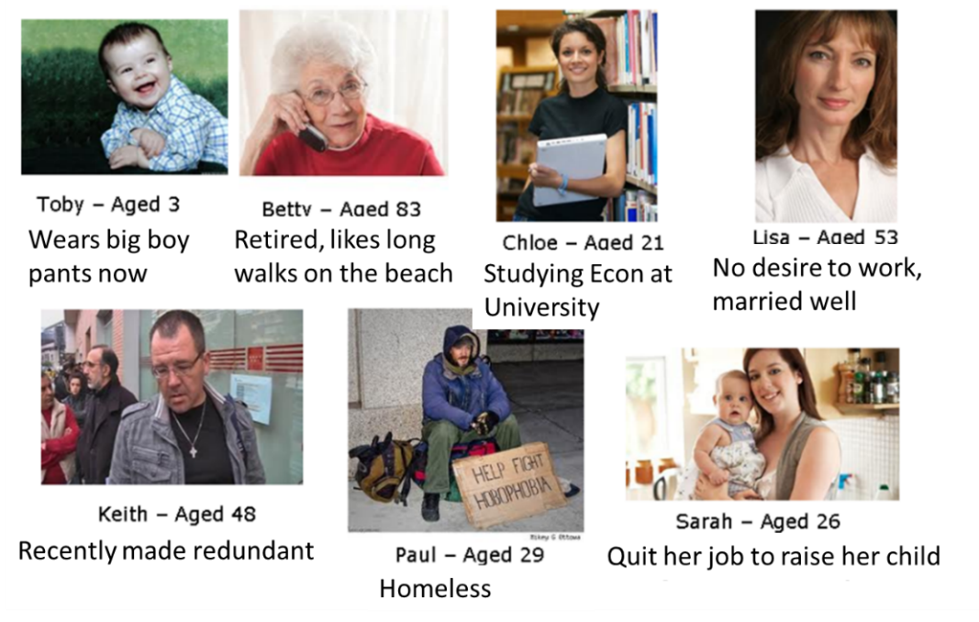

# Article Task: ONS Guide to Measuring the Jobless

**Instructions:**

* Read Highlight and annotate the ONS article
* Answer the key question

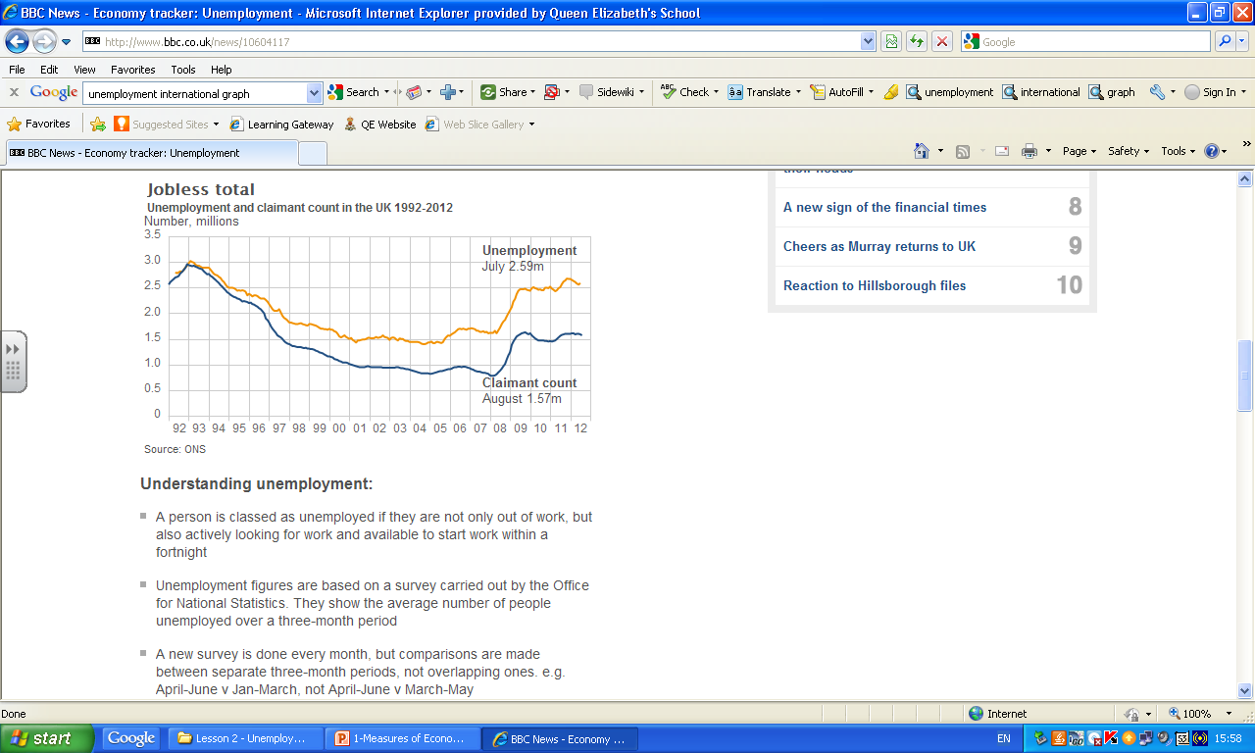**Article:**

What are unemployment and claimant count?

Official estimates of unemployment are produced by the ONS’s Labour Force Survey, which is based on the ILO (International Labour Organization) definition. A separate series - the claimant count - measures how many unemployed people are claiming unemployment-related benefits. There is a large difference between the two series, and although they move broadly in line, often one measure increases while the other falls. The reason for this is simply that they measure different things.

Unemployment is a count of jobless people who want to work, are available to work, and are actively seeking employment. The ILO definition is used internationally, so comparisons between countries can be made, and it also allows for consistent comparisons over time. Unemployment is calculated using data from the Labour Force Survey (LFS), so it is subject to sampling errors.

The claimant count measures only those people who are claiming unemployment-related benefits (Jobseeker's Allowance). It is always the lower measure because some unemployed people are not entitled to claim benefits, or choose not to do so. Benefits rules vary over time and between different countries, so it is more difficult to make comparisons. The claimant count comes from the administrative records of Jobcentre Plus (formerly Employment Service), so it is available earlier and more frequently than the LFS-based unemployment data.

When employment is high the gap between ILO unemployment and the claimant count tends to widen, as some jobless people who were not previously looking for work start to do so. By actively looking for work they may become classified as unemployed under the ILO definition. However they do not feature in the claimant count unless they also begin to claim benefits.

The difference between the two measures is wider for women than for men. Currently fewer than half of unemployed women claim unemployment-related benefits compared with around three quarters of men.  
Unemployment data are available in their current format back to 1984 (non-seasonally adjusted and seasonally adjusted). The present seasonally adjusted claimant count series goes back to 1971, and is adjusted to allow for significant changes to benefit rules.

**Key Question:**

What is the relationship between ILO/Claimant count measures?

……………………………………………………………………………………………………………………………………………………………………………………

……………………………………………………………………………………………………………………………………………………………………………………

……………………………………………………………………………………………………………………………………………………………………………………

……………………………………………………………………………………………………………………………………………………………………………………

……………………………………………………………………………………………………………………………………………………………………………………

……………………………………………………………………………………………………………………………………………………………………………………

# Presentation 3 – Quirks of Employment and Unemployment Rates & Immigration

Complete the activities below so as to have a complete set of Notes:

**Key Question:** Can there be a simultaneous increase in both the Employment and the Unemployment Rate?

……………………………………………………………………………………………………………………………………………………………………………………

……………………………………………………………………………………………………………………………………………………………………………………

……………………………………………………………………………………………………………………………………………………………………………………

……………………………………………………………………………………………………………………………………………………………………………………

……………………………………………………………………………………………………………………………………………………………………………………

……………………………………………………………………………………………………………………………………………………………………………………

……………………………………………………………………………………………………………………………………………………………………………………

**Analysis:** Fill in the blanks

*Consider the following economy:*

Population of working age = 100 people

No. of employed = 40, no. of unemployed = 10, no. of economically inactive = 50

U/E rate = _____________________ E rate = _______________________

**Immigration/Other population changes:** Present an exogenous shock to the LF

40 people of working age immigrate into the economy

23 immigrants become employed, whilst 17 become unemployed. None are economically inactive

New no. of employed = ____________

New no. of unemployed = ____________

new no. of economically inactive = __________

New U/E rate = _____________________ New E rate = _____________________

## The Significance of Immigration

**Definition:** *Net Migration*

……………………………………………………………………………………………………………………………………………………………………………………

……………………………………………………………………………………………………………………………………………………………………………………

*Stat:* Net migration to the UK was estimated to be 258,000 in 2018. This is down from a peak of 336,000 in the year ending June 2016, just before the EU referendum

There is significant debate as to whether these migrant workers add more to our employment rate or to our unemployment rate (although hypothetically it could be both), as well as the more general economic impact.

**Key Notes:** *Advantages of immigration to the Labour force often missed*

Migrant workers tend to be more flexible than British citizens (**e.g**. Polish doctor accepting a job in a pharmacy).

They find jobs quickly and are unlikely to add to unemployment figures themselves.

They often take jobs which other British citizens didn’t want anyway – so migrants are not really forcing UK workers into unemployment.

Migrant workers themselves are consumers who demand G&S which, in turn, increases the derived demand for labour in other industries.

Consequently, migrant workers tend to increase the employment figures more than they increase the unemployment figures.

Article Task: The Polish paradox

**Instructions:**

* Read, Highlight and Annotate
* In small groups: Create a table with advantages and disadvantages of immigration into the UK

**Article:**

*Britons loathe immigration in principle, but quite like immigrants in practice. For Bulgarians and Romanians, that is good news*

HALF of the foreign-language section in Corby’s public library is taken up with Polish books. “Alicja w Krainie Czarów” (“Alice’s Adventures in Wonderland”) sits near “Agresor”, a translation of a military potboiler. A decade ago this town in the East Midlands had hardly any east European bookworms to cater to. As in many other places, its residents have been surprised, and at times perturbed, by what has happened since.

Poles, who have been able to live and work in Britain since their country joined the European Union in 2004, have already become the second largest foreign-born group, after Indians. The 2011 census counted 579,000, a tenfold increase from a decade earlier. Many more have come and gone: since 2002 almost 1.2m Poles have been issued with National Insurance numbers. But that still leaves a lot of settlers. In 2012 Polish women gave birth to 21,156 children, more than any other group apart from native Britons. They have ventured to rural market towns and small cities that rarely see foreigners.

Poles and other east Europeans have also become political footballs—with almost all national politicians playing in the same, hostile, team. Jack Straw, once Labour’s home secretary, calls the decision by his party to grant them free access to Britain a “spectacular mistake”. Priti Patel, a Conservative MP, says (with many others) that they are straining public services to breaking point.

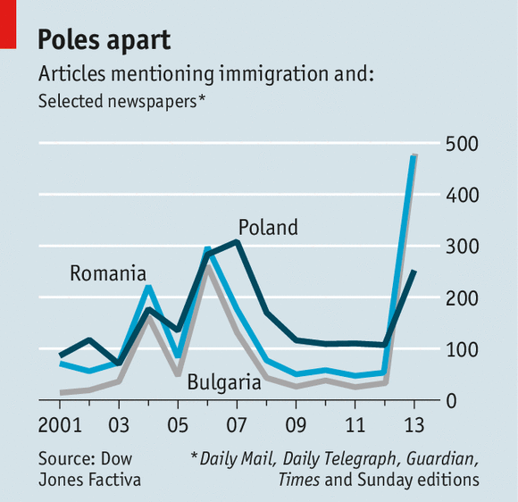Politicians are now applying the conclusions they have drawn from the Polish surge to a new group of migrants. Fearing an influx of feckless Bulgarians and Romanians, who will be allowed free access to Britain and other EU countries from January 1st, the coalition government is tightening access to welfare. David Cameron, the prime minister, insists that Britain will not see a repeat of “the Polish situation”. Bulgarians and Romanians are already attracting more press coverage—mostly hostile—than Poles ever have (see chart).

But what, really, is the Polish situation? It is much more encouraging than politicians imply. Poles and migrants from other new EU member states have been readily absorbed into Britain’s labour market. They are tolerated, even welcomed, locally. The huge imbalance between local experience and national conviction has implications for next year’s migrants.

Poles have mostly ended up in fast-growing bits of the country. Many live in London. Corby is one of the few places in NIMBYish Britain that welcomes house-building. Tom Beattie, the council leader, wants its population to double by 2030. Southampton, another city with lots of immigrants from eastern Europe, has gone from being an ageing city with declining skills to a young one with great aspirations, says John Denham, one of the city’s MPs.

Marco Cereste, the Tory leader of the council in Peterborough, another popular destination for migrants, says his magazine-distribution company was turning away business ten years ago for a lack of workers. Not any more. And Poles are moving beyond menial, letterbox-stuffing work. Britain got younger and better-educated Poles than Germany or America. Many are overqualified for their jobs, and ought to move into more appropriate ones as their English and social networks become stronger.

Some are already doing so. In the West Midlands, Polish entrepreneurs at first set up restaurants and construction firms. But later migrants, many of them women, built design firms and marketing agencies. A couple run bakeries big enough to supply leading supermarkets. Websites that once simply provided information for new arrivals have become commercial ventures that charge for access and advertising. Ilona Korzeniowska, editor of the *Polish Express*, a London-based newspaper, suggests Bulgarians and Romanians may fill jobs no longer of interest to Poles.

Parts of England and Wales with many east European migrants have seen a drop in property crime and no increase in violence, according to researchers at the LSE and University College London. Recorded crime and anti-social behaviour in Corby has fallen by more than half since 2006; in the rest of England and Wales it is down by about a third. The proportion of the town’s residents worrying about anti-social behaviour has plummeted from 56% to just 8%. A rise in knife crime in Cambridgeshire was mostly a result of workers taking home blades they used to harvest fruit and vegetables, unaware that carrying them was illegal, says Julie Spence, the area’s chief constable from 2005 to 2010.

Schools are under more pressure. Between 2008 and 2012 the number of Polish pupils in England doubled, to 54,000. Peterborough’s school population has swelled by 4,000 since 2008. Places are so scarce that some parents have four children in four different schools. But the new arrivals do not seem to be making it harder to learn. In Peterborough the share of pupils getting five good GCSEs, the exams taken at 16, rose from 37.2% in 2008 to 57.7% this year, just below the national average of 60.2%. Polish Saturday schools are springing up in Peterborough and elsewhere.

Other public services have been strained less. Corby has spent less than £300 ($490) on translation services thus far this financial year. Margot Parker, who stood as the UK Independence Party’s candidate in the town’s by-election last year, says its health services are struggling. If so, that would be unusual: east European immigrants tend to use the NHS much less than Britons. Few Poles there or in Southampton live in public-sector housing or are waiting for it; they prefer to rent privately. Nor do many claim unemployment benefits: in 2011 the number of jobless Poles in Britain was under 20,000.

**The next wave**

Dispiritingly, both for Poles and for those who will follow them to Britain, these local successes do not register nationally. Bulgarians and Romanians will arrive amid huge opposition to immigration. YouGov, a pollster, found in October that just 33% of Britons think the right of EU citizens to live and work in other member states a good thing.

This antipathy is partly due to the sheer numbers that have arrived since 2004—many more than the government predicted. Immigration has become entangled with a general mistrust of politicians, intensified by scandals over expense claims. The economic crisis has made everybody less tolerant. Without it, people would have been annoyed about immigration but got used to it, reckons Mr Denham.

The Poles’ experience is both good news and bad for Bulgarians and Romanians. It suggests that shifting public and political opinion will be hard, perhaps impossible. But, as Mr Denham was told by one of his constituents, “it’s not the migrants I don’t like, it’s the migration.” The experience of living in Britain, alongside its grumpy natives, may be happier than the rhetoric implies. It can hardly be worse.

|  |  |
| --- | --- |
| Advantages of immigration to the UK | Disadvantages of immigration to the UK |

# Assignment

**Short-answer questions (Section A)**

1. Spain is a member of the Eurozone. In the third quarter of 2013, the unemployment rate in Spain rose to almost 30%. The most likely effect of this increase in the unemployment rate is:

A An increase in wages in the Spanish economy

B An appreciation in the value of the Euro

C An increase in the rate of inflation in Spain

D A reduction in tax receipts

[1]

**Data response (Section B)**

**Extract 1: Unemployment ‘set to soar’ if economy does not recover soon**

GDP data released in July 2012 revealed that the UK economy contracted by 0.7% between April and June. This is now the third consecutive quarterly fall and the longest “double dip” recession in half a century. The situation looks unlikely to improve markedly for the rest of the year, with the Bank of England last week cutting its annual growth forecast for 2012 to zero, from 0.85%.

In August 2012, the ILO measure of UK unemployment was at 7.9% and it has remained above 6% since 2009. Moreover, in its latest report on the employment market, the Chartered Institute of Personnel and Development (CIPD) has found that one in three businesses is keeping more staff than needed to avoid losing skills, but would enforce redundancies if economic growth did not return soon. Two thirds of private sector companies told the CIPD that they would have to cut staff if the economy did not begin to recover, with large businesses more concerned about Britain’s economic outlook than smaller companies.

The opposition Labour Party suggested that the Bank of England’s report added to doubts about the government’s economic strategy of reducing the budget deficit without delaying the recovery. The Labour Party argued the strategy was already weakened by disappointing growth figures earlier this year. Rachel Reeves, opposition spokesperson, said that these figures show the government’s policies were not only causing short-term pain, but also long-term damage to the UK economy. She added that even the national infrastructure plan announced by ministers recently would not provide the expected stimulus, since most projects will not start until 2014. “We are crying out for investment that begins now,” Ms Reeves said.

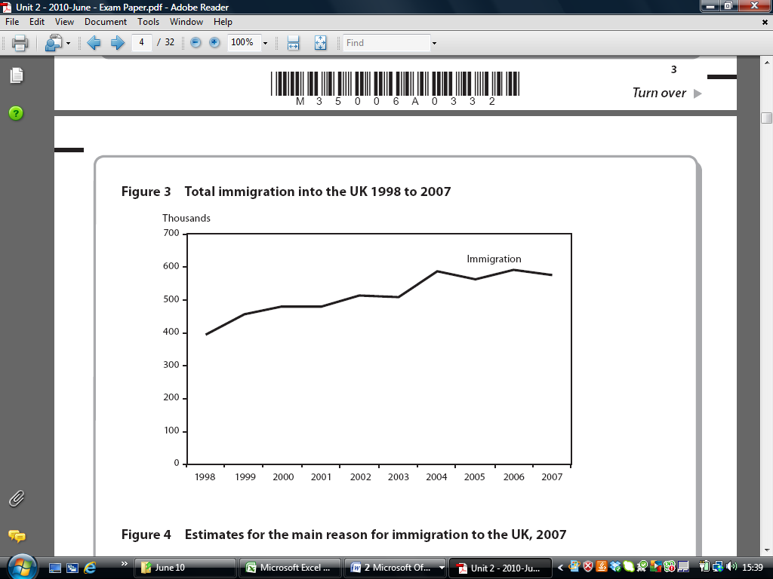**Figure 1: Total immigration into the UK 1998 to 2007**

**Figure 2: Estimates for the main reason for immigration to the UK, 2007**

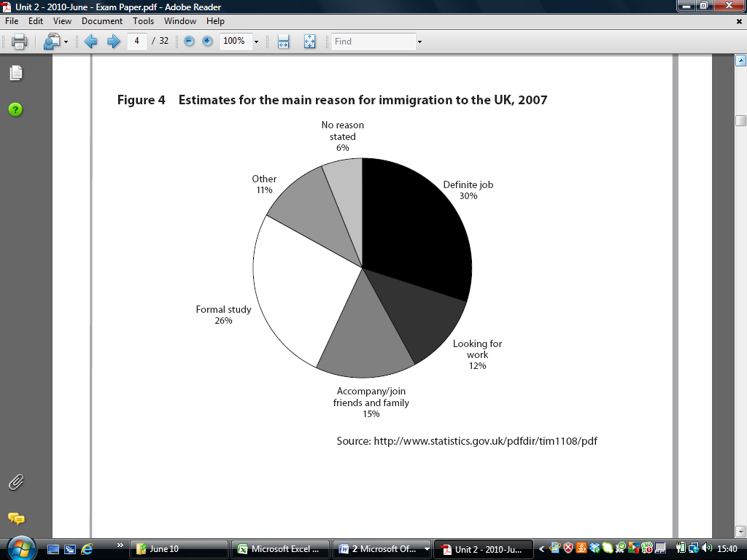

1. With reference to Extract 1, explain how ILO unemployment is measured.

[5]

……………………………………………………………………………………………………………………………………………………………………………………

……………………………………………………………………………………………………………………………………………………………………………………

……………………………………………………………………………………………………………………………………………………………………………………

……………………………………………………………………………………………………………………………………………………………………………………

……………………………………………………………………………………………………………………………………………………………………………………

……………………………………………………………………………………………………………………………………………………………………………………

……………………………………………………………………………………………………………………………………………………………………………………

……………………………………………………………………………………………………………………………………………………………………………………

……………………………………………………………………………………………………………………………………………………………………………………

……………………………………………………………………………………………………………………………………………………………………………………

……………………………………………………………………………………………………………………………………………………………………………………

……………………………………………………………………………………………………………………………………………………………………………………

……………………………………………………………………………………………………………………………………………………………………………………

……………………………………………………………………………………………………………………………………………………………………………………

……………………………………………………………………………………………………………………………………………………………………………………

……………………………………………………………………………………………………………………………………………………………………………………

……………………………………………………………………………………………………………………………………………………………………………………

……………………………………………………………………………………………………………………………………………………………………………………

1. With reference to Figure 1 and Figure 2, discuss the significance of immigration for employment and unemployment.

[10]

**Question** With reference to Figure 1 and Figure 2, discuss the significance of immigration for employment and unemployment.

|  |  |
| --- | --- |
| **Planning Grid: Aim = 4 paragraphs - 2 KAA points (6); 2 Eval points (4)** | |
| **KAA Point 1 = signpost key point** |  |
| Application |  |
| Main concept & diagram |  |
| **Eval Point 1 = relate to your earlier point & re-read the title** |  |
| Context / evidence |  |
| **KAA Point 2 = signpost key point** |  |
| Application |  |
| Main concept & diagram |  |
| **Eval Point 2 = relate to your earlier point & re-read the title** |  |
| Context / evidence |  |

[10]