Net Exports

# Starter: Discussion Question

Instructions:

* Individually consider the below questions
* Discuss your thoughts with a partner
* Share your ideas with the class

*What does the UK export? What does the UK import?*

|  |
| --- |
| Note Space: |

**Extension Question:** Why do we subtract imports from AD?

……………………………………………………………………………………………………………………………………………………………………………………

……………………………………………………………………………………………………………………………………………………………………………………

……………………………………………………………………………………………………………………………………………………………………………………

# Presentation 1 – Intro to Net Exports

Complete the activities below so as to have a complete set of notes:

**Definition:** *Net Exports*

……………………………………………………………………………………………………………………………………………………………………………………

……………………………………………………………………………………………………………………………………………………………………………………

*Stat:*Net exports made up -1% of UK GDP in 2018 (+29% for exports -30% for imports)

**Recap:** Net Exports are part of, but not all of, the balance of payments

*BoP Breakdown:*

*Capital Account:*

……………………………………………………………………………………………………………………………………………………………………………………

*Financial Account:*

……………………………………………………………………………………………………………………………………………………………………………………

*Current Account:*……………………………………………………………………………………………………………………………………………………………………………………

……………………………………………………………………………………………………………………………………………………………………………………

**Key Question:** Why is net exports (X-M) the only part of the balance of payments included in AD?

……………………………………………………………………………………………………………………………………………………………………………………

……………………………………………………………………………………………………………………………………………………………………………………

# Article task: Biden and US-UK trade

**Instructions:**

* Read, highlight and annotate the article, making notes to answer the key discussion question
* Discuss as a class

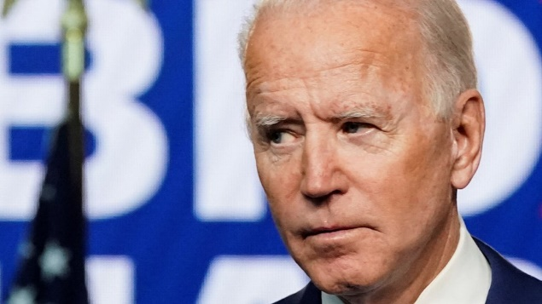**Article:**

*Chinese handbags, French wine and Scottish cashmere: all have been weaponised by President Donald Trump, the self-proclaimed tariff man.*

In his attempt to put "America first" - for jobs and profits - the president liberally applied tariffs, charges to imports, from those nations he judged as trying to give their producers an unfair advantage - with few discernible benefits to his home territory.

How much of difference will a change of guard in the White House make to American trade policy? Will that long-awaited US-UK trade deal finally be struck? And can Italian parmesan makers catch a break?

Here's five things to be aware of:

1: Joe Biden's priorities aren't that different

Joe Biden's "Buy American" slogan from his campaign has echoes of the Trump playbook. With US unemployment having more than doubled during the course of the pandemic, promises to bolster livelihoods on home soil have a potent appeal.

Mr Biden's pledges include penalising US firms that move jobs abroad. And like Mr Trump, he harbours concerns over China's ambitions and way of doing business.

2: Same dream, different means

But Mr Biden has very different ideas of how to triumph on the global stage. President Trump opted to go it alone, using tariffs and threats against China while attempting to coerce Europe into joining his battle against the likes of Huawei.

Mr Biden prefers the idea of strength in numbers - a multilateral approach - by getting traditional allies onside.

3: A reset of the EU trade relationship

That is likely to mean offering an olive branch to the EU, with an offer to pour (lower tariff) oil on troubled waters.

The spat between US aircraft maker Boeing and European rival Airbus over claims of unfair state help preceded President Trump. But it was he who decided to levy tariffs on $7.5bn (£5,7bn) worth of European luxuries in response. Analysts feel Mr Biden will, at the least, shy away from escalating the tariffs and may well remove existing ones - ditto those applied to imports of steel and aluminium.

The threat of car tariffs is also likely to recede. But the producers of Bordeaux wine may have to wait: with so much on the domestic agenda, tearing down those barriers may take a backseat.

4: A less "special relationship"?

And the UK may be even further back in that queue. Although British trade officials have been wooing Mr Biden's team for some time, they aren't likely to be in a hurry to sign a deal with the UK.

The incoming president is famously no fan of Brexit and has said that there will be no deal if the Good Friday agreement is undermined. That was after the UK's proposed Internal Market Bill risked the imposition of a physical customs border between the Republic of Ireland and Northern Ireland.

The UK government has quietly been nursing hopes that an agreement will be in place by the middle of next year, before an arrangement to fast-track a deal through Congress expires.

That might be dashed. But there could be a workaround: both Mr Biden and the UK are eyeing membership of the Comprehensive and Progressive Agreement for Trans-Pacific Partnership (CPTPP), a free-trade partnership of 11 Pacific countries.

5: It's not just goods

There is more to trade than shipping containers lining ports. For example, while President Trump viewed the World Trade Organization with suspicion and derision, there are hopes that Mr Biden will focus instead on encouraging reform and modernisation of the organisation, which policies global trade.

There will, however, be some remaining tensions: the issue of a digital services tax from Europe on the profits of primarily US tech companies remains.

Ultimately, while there is potential for a change in trade stance from a new president, his bulging domestic in-tray may distract him for some time.

**Discussion Question:**

*How might the election of Joe Biden impact UK trade, with the US and the rest of the world?*

……………………………………………………………………………………………………………………………………………………………………………………

……………………………………………………………………………………………………………………………………………………………………………………

……………………………………………………………………………………………………………………………………………………………………………………

……………………………………………………………………………………………………………………………………………………………………………………

……………………………………………………………………………………………………………………………………………………………………………………

……………………………………………………………………………………………………………………………………………………………………………………

……………………………………………………………………………………………………………………………………………………………………………………

……………………………………………………………………………………………………………………………………………………………………………………

……………………………………………………………………………………………………………………………………………………………………………………

……………………………………………………………………………………………………………………………………………………………………………………

# Presentation 2 – Determinants of Net Exports

Complete the activities below so as to have a complete set of notes:

**Elaborate:** Elaborate on the below key determinants of Net Exports

*Exchange Rates:*Changes in exchange rates can affect the attractiveness of exports to foreign households and imports to domestic households.

**Definition:** *Exchange rates*

……………………………………………………………………………………………………………………………………………………………………………………

***SPICED:*****S**trong **P**ound, **I**mports **C**heap, **E**xports **D**earer

……………………………………………………………………………………………………………………………………………………………………………………

……………………………………………………………………………………………………………………………………………………………………………………

……………………………………………………………………………………………………………………………………………………………………………………

……………………………………………………………………………………………………………………………………………………………………………………

***WPIDEC:*****W**eak **P**ound, **I**mports **D**earer, **E**xports **C**heap

……………………………………………………………………………………………………………………………………………………………………………………

……………………………………………………………………………………………………………………………………………………………………………………

*Domestic Real income:*As households get richer they buy more G&S, including imports

……………………………………………………………………………………………………………………………………………………………………………………

……………………………………………………………………………………………………………………………………………………………………………………

*Foreign Real income:*Similarly, as foreigners get richer they buy more G&S, including our exports

*Changes in the world economy:*As different economies change and develop they tend to trade different imports and exports with the rest of the world

……………………………………………………………………………………………………………………………………………………………………………………

……………………………………………………………………………………………………………………………………………………………………………………

……………………………………………………………………………………………………………………………………………………………………………………

……………………………………………………………………………………………………………………………………………………………………………………

*Degree of protectionism:*Falling protectionism means that free trade broadens, giving rise to new export opportunities

……………………………………………………………………………………………………………………………………………………………………………………

……………………………………………………………………………………………………………………………………………………………………………………

*International competitiveness***:** If domestic output becomes more competitive, they are more attractive to all buyers. This can increase exports and reduce imports

*Price Competitiveness*

……………………………………………………………………………………………………………………………………………………………………………………

……………………………………………………………………………………………………………………………………………………………………………………

*Non-price Competitiveness*

……………………………………………………………………………………………………………………………………………………………………………………

……………………………………………………………………………………………………………………………………………………………………………………

# Assignment

**Section B (Data Response)**

**Extract 1 Aggregate demand in Malaysia**

Aggregate demand is projected to increase by 9.4% in 2012, driven by strong private sector activity. Private sector expenditure is expected to maintain its growth momentum sustained by higher consumption and investment activities. Private consumption is supported by a steady increase in disposable incomes and stable labour market conditions. After registering rapid expansion in 2011, the strong growth of private sector investment continued into 2012 with an increase of 22.4% in the first half of 2012. Meanwhile, government expenditure is expected to grow by over 13% in 2012, supported by various government infrastructure projects. With a more challenging external environment, exports are expected to grow relatively slowly. Gross imports are expected to expand at a faster rate than exports because of strong domestic activity. Nevertheless, the external position remains favourable with an expected current account surplus equivalent to 6.3% in 2012 and nearly 9% of GDP in 2013.

(Source: Ministry of Finance Malaysia: economic Report 2012/2013 chapter 3 <http://www.treasury.gov.my/pdf/ekonomi/le/1213/chap3.pdf>)

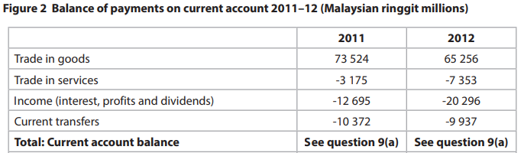

27 670

47 282

**Question:**

With reference to the information provided, assess two possible reasons for the reduction in Malaysia’s current account surplus between 2011 and 2012.

[10]

**Question:** With reference to the information provided, assess two possible reasons for the reduction in Malaysia’s current account surplus between 2011 and 2012. [10]

|  |  |
| --- | --- |
| **Planning Grid: Aim = 4 paragraphs - 2 KAA points (6); 2 Eval points (4) with a conclusion** | |
| **KAA Point 1 = signpost key point** |  |
| Application |  |
| Main concept & diagram |  |
| **Eval Point 1 = relate to your earlier point & re-read the title** |  |
| Context / evidence |  |
| **KAA Point 2 = signpost key point** |  |
| Application |  |
| Main concept & diagram |  |
| **Eval Point 2 = relate to your earlier point & re-read the title** |  |
| Context / evidence |  |