Rational Decision Making

Starter Task: Choices

**Instructions**

* Consider the below choices
* Give an examples of what you think the best choice for each decision would be and also a common, but less good choice.

|  |  |  |
| --- | --- | --- |
| **Choice** | **Best Decision** | **Common, but less good decisions** |
| How much tobacco to smoke? |  |  |
| What dessert to have at lunch? |  |  |
| How to travel to school? |  |  |
| When to do your homework? |  |  |
| An example of my own: |  |  |

***Extension:*** Why do people make these sub-optimal choices in practice?

…………………………………………….………………………………………….……….…………………………………………………………………………………..

…………………………………………….………………………………………….……….…………………………………………………………………………………..

# Presentation 1 - Intro to Rational Decision Making

Complete the activities below so as to have a complete set of notes:

**Definition:** *Rational Choice*

…………………………………………….………………………………………….……….…………………………………………………………………………………..

…………………………………………….………………………………………….……….…………………………………………………………………………………..

**Definition:** *Rational*

…………………………………………….………………………………………….……….…………………………………………………………………………………..

**Key Notes:** *Net benefit*

Net benefit is the sum of all the benefits of an outcome minus all the costs. Each economic agent maximises a different net benefit.

Consumers maximise: ________________________________________

Workers maximise: ______________________

Firms maximise: ______________________

Governments maximise: ______________________

**Key Notes:** *Rational Consumers*

Rational consumerstry to maximise their _______________ (constrained by _______________).

Behaviour is rational if it is goal-oriented, reflective, and consistent (across time and different choice situations)

**Definition:** *Homo Economicus*

…………………………………………….………………………………………….……….…………………………………………………………………………………..

…………………………………………….………………………………………….……….…………………………………………………………………………………..

…………………………………………….………………………………………….……….…………………………………………………………………………………..

# Discussion Question: Homo Economicus

**Instructions:** Consider the question individually, discuss your thoughts with a partner, share your ideas with the class

*How might Homo Sapiens differ from Homo Economicus in practice?*

|  |
| --- |
| Note Space: |

# Presentation 2 - Utility

Complete the activities below so as to have a complete set of notes:

**Definition:** *Utility*

…………………………………………….………………………………………….……….…………………………………………………………………………………..

*Unit of utility:*The Util - an 'ordinal' measure used to rank the net benefits of different outcomes

**Definition:** *Total Utility*

…………………………………………….………………………………………….……….…………………………………………………………………………………..

…………………………………………….………………………………………….……….…………………………………………………………………………………..

**Definition:** *Marginal Utility*

…………………………………………….………………………………………….……….…………………………………………………………………………………..

…………………………………………….………………………………………….……….…………………………………………………………………………………..

*Marginal:*Marginal refers to the incremental change to one variable from an additional unit to another.

**Thought Experiment:** Slices of Pizza

You have 10 slices of pizza, how does your TU & MU change as you eat slices one by one in an hour?

* *Using utils, describe the utility of each slice by filling in the table*
* *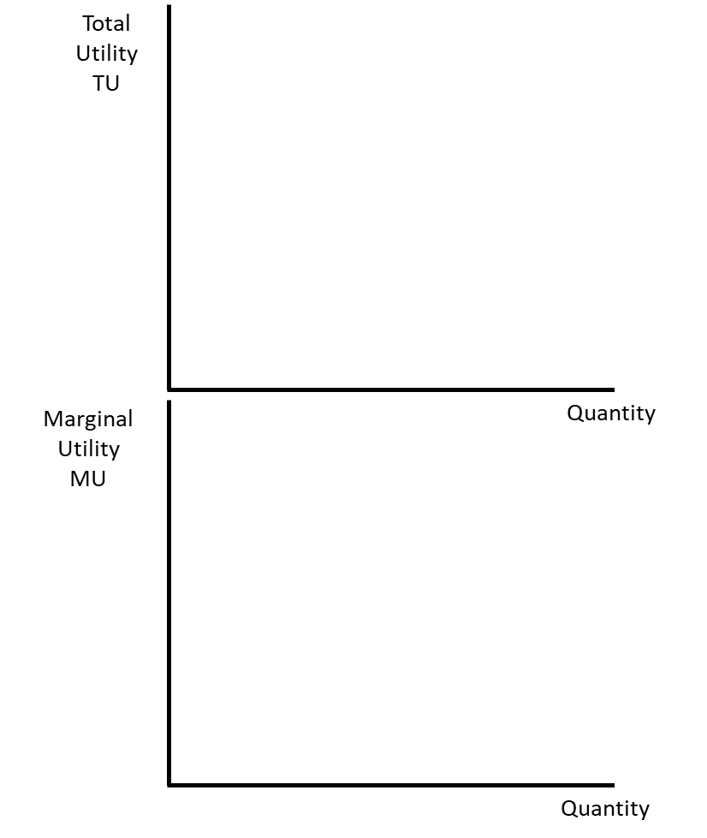Sketch graphs of your data*

|  |  |  |
| --- | --- | --- |
| **Slice** | **TU** | **MU** |
| 0 | 0 |  |
| 10 |
| 1 | 10 |
| 7 |
| 2 | 17 |
| 6 |
| 3 | 23 |
| 5 |
| 4 | 28 |
| 4 |
| 5 | 32 |
| 2 |
| 6 | 34 |
| 1 |
| 7 | 35 |
| 0 |
| 8 | 35 |
| -1 |
| 9 | 34 |
| -10 |
| 10 | 24 |
|  |

**Definition:** *Diminishing Marginal Utility*

…………………………………………….………………………………………….……….…………………………………………………………………………………..

…………………………………………….………………………………………….……….…………………………………………………………………………………..

Eventually consuming more units will cut total utility, ________________________________!

**Key Notes:** *Utility**Curves*

*Max. TU:* Occurs where MU = _______________, any more consumption and TU will start to fall

*Relationship between MU & TU:*MU gives the rate of change of TU.

…………………………………………….………………………………………….……….…………………………………………………………………………………..

…………………………………………….………………………………………….……….…………………………………………………………………………………..

…………………………………………….………………………………………….……….…………………………………………………………………………………..

*Equation: ____________________________*

# Multiple Choice Quiz – Consumer Choice and Utility Maximisation

1. Which of the following best expresses the law of diminishing marginal utility?

1. the more a person consumes of a product, the smaller becomes the total utility that he receives from its consumption.
2. the more a person consumes of a product, the smaller becomes the additional utility that he receives from consuming each additional unit.
3. the less a person consumes of a product, the smaller becomes the total utility that he receives from its consumption.
4. the less a person consumes of a product, the smaller becomes the additional utility that he receives from consuming each additional unit.

2. Human behaviour that seeks to maximize total utility is called

1. rational behaviour
2. consumer choice theory
3. marginal utility
4. substitution effect

3. Marginal utility is positive, but declining, when total utility is positive and

1. rising at an increasing rate.
2. falling at an increasing rate.
3. rising at a decreasing rate.
4. falling at a decreasing rate.

4. A budget constraint is faced by

1. consumers below the poverty line
2. consumers earning less than the average income in a given society
3. consumers whose expenditures typically exceed their income
4. all consumers, no matter what their income is

5. After eating eight chocolate chip cookies, you turn down the ninth cookie. Your refusal indicates that

1. the marginal utility for chocolate chip cookies is negative
2. the total utility for chocolate chip cookies is negative
3. the marginal utility is positive for the eighth and negative for the ninth cookie
4. the total utility was zero because you ate one cookie and refused the other

6. Which of the following is not true of the concept of "utility"?

1. utility is the amount of satisfaction a good or service provides
2. the utility received from a given good is subjective and differs from person to person
3. the utility of a product is measured by how useful it is
4. it is difficult to attach number values to the measure of utility

**Extension:**

7. How does the law of diminishing marginal utility explain why a demand curve is downward sloping?

1. as the quantity consumed decreases, marginal utility received from each successive unit decreases, so the consumer is willing to pay less for smaller quantities of the good.
2. as the quantity consumed increases, marginal utility received from each successive unit decreases, so the price the consumer is willing to pay for higher quantities will fall.
3. as the quantity consumed increases, marginal utility from each successive unit increases, so the price the consumer is willing to pay for larger quantities will rise.
4. as the quantity consumed decreases, marginal utility from each successive unit increases, so the consumer is willing to pay less for smaller quantities of the good.

8. The price of water is substantially less than the price of diamonds because

1. the marginal utility of a diamond is significantly less than the marginal utility of a gallon of water
2. the marginal utility of a diamond is significantly greater than the marginal utility of a gallon of water
3. the total utility of diamonds is greater than the total utility of water
4. diamonds have a low marginal utility

# Extension Reading: Ordinal Utility

## Utility

**Utility:** the satisfaction derived from the use of a good or service

**Cardinal numbers:** Tell 'how many' of something, they show quantity.

**Ordinal numbers:** Tell the order of how things are set, they show position or rank.

**Unit of utility:** util, often considered to be an ordinal concept meaning that the number of utils of an outcome allow us to tell whether an outcome is better or worse than another, but not by how much.

**Example:** suppose George tells us that "I prefer A to B and B to C". George's preferences can be represented by a function *u* such that:

𝑢(𝐴)=9, 𝑢(B)=8, 𝑢(C)=1

But the only meaningful message of this function is the order u(A)>u(B)>u(C), the actual cardinality of the numbers is meaningless.

Hence, George's preferences can be equally represented by the following function *v*:

v(A)=3, v(B)=2, v(C)=1

The functions u and v are ordinally equivalent – they represent George's preferences equally well.

## Assumptions of Consumer Preference Theory aka Ordinal Utility Theory

Preferences are **complete**: The consumer has ranked all available alternative combinations of commodities in terms of the satisfaction they provide him.

Assume that there are two consumption bundles *A* and *B* each containing two commodities *x* and *y*.

A consumer can unambiguously determine that one and only one of the following is the case:

A is preferred to B, written as 𝑢(A) > 𝑢(B)

B is preferred to A, written as 𝑢(B) > 𝑢(A)

A is indifferent to B, written as 𝑢(A) = 𝑢(B)

This axiom precludes the possibility that consumers can’t decide, they can make this comparison with any bundle.

Preferences are **reflexive:** This means that if *A* and *B* are identical in all respects, recognize this fact and are indifferent in comparing *A* and *B*

If A=B then 𝑢(A) = 𝑢(B)

Preferences are **transitive**

If  𝑢(A)  >  𝑢(B)  and 𝑢(B)  >  𝑢(C)  , then 𝑢(A)  >  𝑢(C) .

Also if 𝑢(A)  =  𝑢(B)  and 𝑢(B)  =  𝑢(C)  , then  𝑢(A)  =  𝑢(C) .

This is a consistency assumption.

Preferences are **continuous**

If *A* is preferred to *B* and *C* is sufficiently close to *B* then *A* is preferred to *C*.

If  𝑢(A)  >  𝑢(B)   and *C* ≈ *B*, then 𝑢(A)  >  𝑢(C) .

"Continuous" means infinitely divisible - just like there are infinitely many numbers between 1 and 2 all bundles are infinitely divisible. This assumption makes indifference curves continuous.

Preferences exhibit **strong monotonicity**

If *A* has more of both *x* and *y* than *B*, then *A* is preferred to *B*.

This assumption is commonly called the "more is better" assumption.

Behavioural Economics

# Starter: Discussion Question

**Instructions:** Consider the question individually, discuss your thoughts with a partner, share your ideas with the class

*‘Why Do People Buy Goods & Services That Hurt Them?’*

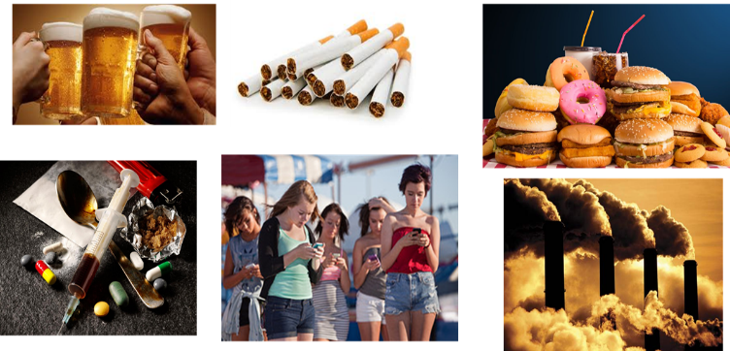

Note Space:

# Presentation 1 – Alternative Views of Consumer Behaviour

Complete the activities below so as to have a complete set of notes:

**Definition:** *Behavioural Economics*

…………………………………………….………………………………………….……….…………………………………………………………………………………..

…………………………………………….………………………………………….……….…………………………………………………………………………………..

It attempts to explain why people make apparently irrational decisions such as why people eat too much, take too little exercise, or do not save enough for retirement (market failures).

**Recap:** *Homo Economicus*

Rational choice theory uses a hypothetical model of humans who are infinitely rational and immensely intelligent, an emotionless being who can do cost-benefit analyses instantly, and is never (ever) wrong.

**Key Notes:** *Homo Sapiens*

Most of us are not infinitely rational, but rather face “bounded rationality”, with people adopting simple, intuitive “rules of thumb” (heuristics) instead of calculating optimal solutions for every decision they make.

Furthermore we are open to influences outside of those covered in standard utility theory

**Key Notes:** *Failures of RCT*

The rational decision making of economic agents fails systematically in three common ways.

*Computational Weaknesses:*

…………………………………………….………………………………………….……….…………………………………………………………………………………..

*Habitual Behaviour:*

…………………………………………….………………………………………….……….…………………………………………………………………………………..

*Social/External Influences:*

…………………………………………….………………………………………….……….…………………………………………………………………………………..

# Discussion Question: RCT or Behavioural Economics?

**Instructions:** Consider the question individually, discuss your thoughts with a partner, share your ideas with the class

*Should Economists use Rational Choice Theory or Behavioural Economics in developing models?*

|  |
| --- |
| Note Space: |

# Presentation 2 – Behavioural Biases

Complete the activities below so as to have a complete set of notes:

**Definition:** *Behavioural Biases*

…………………………………………….………………………………………….……….…………………………………………………………………………………..

**Recap:** Three common ways consumer’s rationality fails:

*Computational Weaknesses:*Problems recognising and defining the desired outcome of a choice.

*Habitual Behaviour:*Choices are made automatically based on routine rather than consideration of net benefits.

*Social/External Influences:*Factors that influence a decision outside the power of an economic agent.

**Taxonomy of Biases:** For each of the below biases, provide an example and categorise it in the three common ways consumer’s rationality fails (some can be more than one)

*Choice architecture:*Refers to a scenario in which the environment has been carefully designed to try and influence that decision.

It focuses on altering the default option – most consumers stick with a default option, so producers should think about which option they would most like consumers to use

*Example:* ……………….………………………………………….……….…………………………………………………………………………………..

*Type of Bias:* ………….………………………………………….……….…………………………………………………………………………………..

*Bounded Rationality:*The cognitive decision-making capacity of economic agents is not fully rational because:

* 1. Economic agents hold limited information.
  2. Have limited amount of time to make decisions.
  3. Have limited cognitive (brain) power to process every piece of information and consider every possibility.

The result is that economic agents aim to make satisficing choices (satisfactory and sufficient choices), rather than maximise their net benefits.

*Example:* ……………….………………………………………….……….…………………………………………………………………………………..

*Type of Bias:* ………….………………………………………….……….…………………………………………………………………………………..

*Social Norms:*Economic agents’ day-to-day behaviour in markets is often influenced by prevailing social norms or social customs.

Alongside individual and personal rules of thumb, social norms suggest conventional wisdom or common sense for economic agents to influence their behaviour.

*Example:* ……………….………………………………………….……….…………………………………………………………………………………..

*Type of Bias:* ………….………………………………………….……….…………………………………………………………………………………..

*Heuristics (“rules of thumb”):*As economic agents only have bounded rationality, they often employ “rules of thumb” in allocating their scarce resources instead of calculating optimal solutions for every decision they make.

Mental short-cuts for decision making, heuristics help make a quick, satisficing decision rather than a maximizing decision.

*Example:* ……………….………………………………………….……….…………………………………………………………………………………..

*Type of Bias:* ………….………………………………………….……….…………………………………………………………………………………..

*Herd Behaviour:*Humans are social creatures and economic agents often make decisions based in part on who is around us and the choices they make.

*Example:* ……………….………………………………………….……….…………………………………………………………………………………..

*Type of Bias:* ………….………………………………………….……….…………………………………………………………………………………..

*Commitment Contracts:* imposition of a penalty, often by oneself, should an individual fail to meet a goal

There is often a divide between intention and action especially for people with limited resolve and those vulnerable to temptation.

The imposition of the contract will cement our choices as we are keen to avoid loses.

The more public the penalty, the more likely we are to meet our goals

*Example:* ……………….………………………………………….……….…………………………………………………………………………………..

*Type of Bias:* ………….………………………………………….……….…………………………………………………………………………………..

*Priming:*Our behaviour is often subconsciously influenced by cues that affect our behaviours and prime us to make certain choices.

Consumers may be more likely to make a certain choice even though that choice might not be optimal

*Example:* ……………….………………………………………….……….…………………………………………………………………………………..

*Type of Bias:* ………….………………………………………….……….…………………………………………………………………………………..

*Anchoring:*the use of irrelevant information as a reference point for helping to make an estimate of an unknown piece of information.

Anchoring is a behavioural bias in which the use of a psychological benchmark carries a disproportionately high weight in a market participant’s decision-making process.

*Example:* ……………….………………………………………….……….…………………………………………………………………………………..

**Famous example:** the credit-card / tip system operated in New York taxis.

Under this system, credit card systems automatically suggested a 30, 25, or 20 percent tip. This caused passengers to think of 20 percent as the low tip whereas the previous average was only around 8-10 per cent. Since the installation of the credit card systems, average tips have risen to 22 percent.

*Type of Bias:* ………….………………………………………….……….…………………………………………………………………………………..

**Question:** What’s the word?

S _ _ P

# Articles Task – Finding Biases

**Instructions:**

* Read, highlight and annotate the articles
* In groups find all the behavioural biases present in the articles

**Article 1: Portion size key in tackling obesity, says study**

They say their review of 61 studies provides the "most conclusive evidence to date" that portion size affects how much we unwittingly eat. The team at the University of Cambridge also said smaller plates, glasses and cutlery helped people eat less. Experts said people were "reluctant" to leave a plate with food on it. Their data, published in 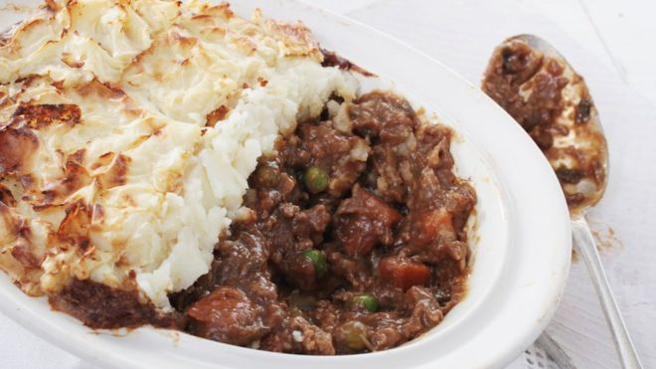the Cochrane Database of Systematic Reviews, shows that when people are offered more food they will eat it. And the team warns that in recent decades portion sizes have been increasing.

***How portion sizes have changed***

*On average between 1993 and 2013:*

* *Shepherd's pie ready meals almost doubled in size*
* *Bagels increased in size from 70g to 86g*
* *A family pack of crisps increased 50% from 100g to 150g*
* *A portion of peanuts is now 80% larger*
* *An individual chicken pie is now 40% bigger*

*Source:*[***British Heart Foundation - Portion Distortion report***](https://www.bhf.org.uk/~/media/files/publications/policy-documents/bhf_portion_distortion_oct2013.pdf)

About two in three adults in the UK are either overweight or obese, which increases the risk of heart problems, type 2 diabetes and cancer. The findings, which are based on 6,711 people taking part in a wide range of clinical trials, suggest that eliminating "large portions" could cut up to 279 calories a day out of people's diets. Dr Ian Shemilt, from Cambridge's Behaviour and Health Research Unit, told the BBC News website: "This is the most conclusive evidence to date that people consistently consume more food and drink when given larger portions, packaging or tableware.

"Consumers do have a role to play - for example, all of us can reduce the size of plates or glasses we use and put pressure on the pubs and restaurants we visit by asking for a smaller portion." The team also says government measures to force smaller packs to offer better value for money and upper limits on the size of energy-dense foods would help people lose weight. Dr Alison Tedstone, chief nutritionist at Public Health England, said: "This study clearly demonstrates that reducing portion sizes is a successful way to cut calories.

"It's important to keep an eye on portion sizes when cooking, shopping and eating out to avoid overeating and help maintain a healthy weight." Prof Brian Ratcliffe, emeritus professor of nutrition at Robert Gordon University in Aberdeen, said: "People seem to be reluctant to leave or waste food and so consume what they are served or find larger portions more attractive. “A limited number of restaurants and food outlets already offer more than one portion size with appropriate pricing differentials and this seems to be a way forward to help people to avoid overconsumption."

**Biases:**

…………………………………………….………………………………………….……….…………………………………………………………………………………..

…………………………………………….………………………………………….……….…………………………………………………………………………………..

…………………………………………….………………………………………….……….…………………………………………………………………………………..

…………………………………………….………………………………………….……….…………………………………………………………………………………..

**[](https://www.google.com/url?q=http://8tracks.com/explore/sunbathing/recent&sa=U&ved=0ahUKEwjDv-CBqLXcAhVJJVAKHbwNCV0QwW4IPDAT&usg=AOvVaw0MQkr6_q-fBXlocyTWALqw)Article 2: Avoiding the burn - how best to change sunbathers' habits**

Global skin cancer cases are on rise, but that fact is often not enough to change people's sun-worshipping behaviour. So how do you best persuade people to alter a habit of a lifetime? In Florida, USA, one in five people will suffer from skin cancer. But the southern city of Miami Beach has taken a step forward in helping people to reduce their risk of getting skin cancer when out and about. They have put 50 sunscreen dispensers out in public places, including pools and the beach with the hope that this will encourage more people to protect themselves. Residents and tourists alike will be able to use the SPF30, UVA and UVB blocking sunscreen for free. Officials hope that this will help to decrease skin cancer cases, though it will take months and years to see if the project has made a difference.

However, if past campaigns are anything to go by, the outlook is less than promising. [Studies show](http://www.ncbi.nlm.nih.gov/pubmed/15868284) that increasing people's awareness often fails to lead to a change in behaviour bounded rationality. [Even those dishing out the advice, such as doctors and nurses](http://www.ncbi.nlm.nih.gov/pubmed/12372079), are no better at being safe in the sun. "There is a gap between knowledge and behaviour," explained Dr Richard De Visser, a University of Sussex psychologist who has researched health campaigns. "For example, most smokers know the health consequences of smoking - but this does not mean that they stop smoking."

But one proven way of changing behaviour is to provide cues that trigger people to make different actions. "[The sunscreen dispensers'] visibility - even without additional messaging - could be a good cue to action," explained Dr De Visser. "If people have forgotten to put sunscreen on, or think it was too expensive to buy, then they are prompted to use it."

These small nudges can tap into the way the human brain works using mental shortcuts - known as cognitive biases. One such cognitive bias is called risk aversion, which brings out a strange quirk in human behaviour. People avoid risk (i.e. use sunscreen) when the benefits are pointed out to them bounded rationality - such as having younger looking skin. But if they're bombarded with the negatives, such as skin cancer, they are more likely to take the risk. To see how this works on the beach, US researchers handed out leaflets to see whether subtly difference wording of safe-sun messages would influence whether people used sun cream. As the theory suggests, they found that making people aware of the good things that could happen made them more likely to take the free sunscreen offered. But human behaviour is complex and other factors are also at play.

Another big focal point of successfully changing behaviour is social norms, which can be a powerful tool. The pressure to have a tan, or how friends and family act in the sun, will have big effects in changing sun cream use. Projects, such as the one in Miami Beach, could make going to the beach and using sunscreen the norm, or act as a reinforcement of the right thing to do.

**Biases:**

…………………………………………….………………………………………….……….…………………………………………………………………………………..

…………………………………………….………………………………………….……….…………………………………………………………………………………..

…………………………………………….………………………………………….……….…………………………………………………………………………………..

…………………………………………….………………………………………….……….…………………………………………………………………………………..

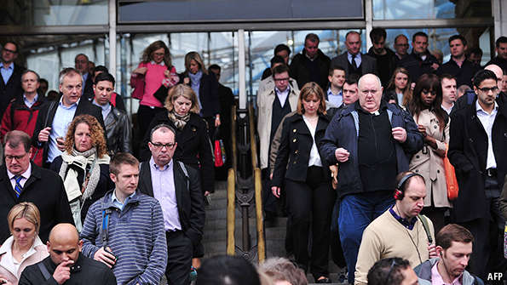**Article 3: The economics of commuting: Why tube strikes help Londoners**

SINCE 2000 London has seen around 40 strikes on the Underground. The chaos which accompanies them is a short-term drag on the capital’s economy. The Federation of Small Businesses, an industry body, estimated that the one-day strike in July cost London £300m ($462m). But a new [paper](http://www.economics.ox.ac.uk/Department-of-Economics-Discussion-Paper-Series/the-benefits-of-forced-experimentation-striking-evidence-from-the-london-underground-network), by researchers at the universities of Oxford and Cambridge, points to the long-term benefits of tube strikes.

The focus of the paper is Londoners’ commuting patterns, before and after industrial action takes place. It looks at a two-day strike in February 2014, which the National Union of Rail, Maritime and Transport Workers called in response to plans to close ticket offices and make voluntary redundancies. In that strike, some union members continued to work: the effect was that 171 out of 270 tube stations closed for the day. Some commuters were not much affected by the strike, while others were less lucky.

The authors compare the behaviour of those hit by the strike to those that were not. To do so, they gather anonymised data from Oyster cards, the payment gizmos that Londoners use to enter and leave the tube. They end up with data on about 18,000 Londoners over a 20-day period who used the Underground between 7am and 10am, amounting to more than 200m data-points.

The results are surprising. Eight in ten commuters were forced to change their commute during the strike—either because stations were closed or because congestion was unbearable. Of that group, about 5% decided to stick with it once the strike had finished.

Before the strike, it seems, many Londoners had unwittingly been taking a suboptimal route to work. The tube map, designed by Harry Beck in 1931, is unrepresentative of absolute geographical space; in his lifetime Beck was pilloried for showing Wimbledon and South Wimbledon to be miles apart, when in fact it is a short walk from one to the other. Add to that the different average speeds at which trains hurtle along—the Waterloo and City line goes at 47 km/h, compared to 15km/h on the Hammersmith and City—and it is small wonder that many commuters choose the “wrong” route.

Commuters affected by the strike, the authors find, in subsequent days enjoyed a 20-second shorter trip on a one-way commute. Over time, the authors estimate, the benefits of that shorter commute were worth more than the damage caused by the strike.

**Biases:**

…………………………………………….………………………………………….……….…………………………………………………………………………………..

…………………………………………….………………………………………….……….…………………………………………………………………………………..

…………………………………………….………………………………………….……….…………………………………………………………………………………..

…………………………………………….………………………………………….……….…………………………………………………………………………………..

# http://cdn.static-economist.com/sites/default/files/imagecache/full-width/images/print-edition/20120324_FND000_0.jpgExtension task: Nudge nudge, think think

**Instructions:**

* Read, highlight and annotate the article
* Consider the discussion questions:

*What is a ‘nudge’?*

*What examples of nudging did we see?*

**Article:**

The use of behavioural economics in public policy shows promise

“FREAKONOMICS” was the book that made the public believe the dismal science has something interesting to say about how people act in the real world. But “Nudge” was the one that got policy wonks excited. The book, first published in 2008, is about the potential for behavioural economics to improve the effectiveness of government. Behavioural economists have found that all sorts of psychological or neurological biases cause people to make choices that seem contrary to their best interests. The idea of nudging is based on research that shows it is possible to steer people towards better decisions by presenting choices in different ways.

That theory is now being put to the test. One of the book's co-authors, Cass Sunstein, has been recruited by Barack Obama to the White House. Richard Thaler, the other co-author, has been advising policymakers in several countries including Denmark, France and, above all, Britain, where David Cameron has established a Behavioural Insights Team, nicknamed the Nudge Unit.

The Nudge Unit has been running dozens of experiments and the early results have been promising*. In one trial, a letter sent to non-payers of vehicle taxes was changed to use plainer English, along the line of “pay your tax or lose your car”. In some cases the letter was further personalised by including a photo of the car in question. The rewritten letter alone doubled the number of people paying the tax; the rewrite with the photo tripled it.

Changes to language have had marked effects elsewhere, too. A study into the teaching of technical drawing in French schools found that if the subject was called “geometry” boys did better, but if it was called “drawing” girls did equally well or better. Teachers are now being trained to use the appropriate term.

Another set of trials in Britain focused on energy efficiency. Research into why people did not take up financial incentives to reduce energy consumption by insulating their homes found one possibility was the hassle of clearing out the attic. A nudge was designed whereby insulation firms would offer to clear the loft, dispose of unwanted items and return the rest after insulating it. This example of what behavioural economists call “goal substitution”—replacing lower energy use with cleaning out the attic—led to a threefold increase in take-up of an insulation grant.

All this experimentation is yielding insights into which nudges give the biggest shove. One question is whether nudges can be designed to harness existing social norms. In Copenhagen Pelle Guldborg Hansen, founder of the Danish Nudging Network, a non-profit organisation, tested two potential “social nudges” in partnership with the local government, both using symbols to try to influence choices. In one trial, green arrows pointing to stairs were put next to railway-station escalators, in the hope of encouraging people to take the healthier option. This had almost no effect. The other experiment had a series of green footprints leading to rubbish bins. These signs reduced littering by 46% during a controlled experiment in which wrapped sweets were handed out. “There are no social norms about taking the stairs but there are about littering,” says Mr Hansen.

Differences in culture can have a big impact, too. “Nudge” described an example in America, where telling high users of energy how their consumption compared with that of their neighbours prompted them to use less. This approach is now being tested in Britain. But hopes are low that it will work in France. “The French have a tendency not to comply as easily with perceived social norms the way Anglo-Saxons would,” says Olivier Oullier, a behavioural and brain scientist who advises the French government. “Telling someone in France that their neighbour is using less electricity or saving more water is not sufficient.”

Bigger tests of nudge theory are in the works. Organ donation is one area. In Denmark nudgers reckon that requiring members of the public to make a decision on whether to donate—when applying for a driving licence, say—will forcibly overcome an inclination to procrastinate over unpleasant choices. That, they hope, would lead to many more people becoming organ donors. A bill to require this is now before the Danish parliament.

Checking the box

Others focus on the role that inertia plays in decision-making, and the tendency that people have to pick the default option in a range of choices. In October new British legislation will change the default option for corporate pension plans, so that employees are automatically enrolled unless they actively choose to opt out. The hope is that this will significantly increase retirement saving. Mr Obama has proposed something similar for America's 401(k) retirement schemes, although this idea has gained little traction.

It remains to be seen how the most promising trials of nudge theory can be scaled up. Critics of big government remain suspicious of nudging: Mr Sunstein used a recent essay in the University of Chicago Law Review to endorse its less inflammatory virtues of reducing the regulatory burden and increasing government transparency. And not every policy works as planned: Mr Oullier wants the European Union to test the anti-smoking warnings it puts on cigarette packets, for instance, after research found that those who say they are most shocked by the more graphic images were also those who most craved a smoke after seeing them. But the initial signs are promising. If nothing else, the nudge revolution encourages the use by government of plain language; favours the design of policies that actually take account of real-world behaviour; and allows the testing of ideas on a small scale before wider implementation. It deserves to be pushed.

**Questions:**

*What is a Nudge?*

…………………………………………….………………………………………….……….…………………………………………………………………………………..

…………………………………………….………………………………………….……….…………………………………………………………………………………..

…………………………………………….………………………………………….……….…………………………………………………………………………………..

*What Examples of Nuding are see in the article?*

…………………………………………….………………………………………….……….…………………………………………………………………………………..

…………………………………………….………………………………………….……….…………………………………………………………………………………..

…………………………………………….………………………………………….……….…………………………………………………………………………………..

…………………………………………….………………………………………….……….…………………………………………………………………………………..

…………………………………………….………………………………………….……….…………………………………………………………………………………..

…………………………………………….………………………………………….……….…………………………………………………………………………………..

# Extension Presentation - Nudges

# Take notes. Your notes should cover the following questions:

* What is a Nudge?
* How do nudges aim to improve the rationality?

# Extension Group Task: What Nudges do you want to see in School?

**Instructions:**

* Each Group Has To Propose One Different Nudge:
* They should: Identify the systematic weakness and bias the Nudge corrects, the type of nudge, and consider any limitations to the effectiveness of their nudge.

Note Space:

# Assignment

**Section A: Short Answer Questions**

1. Most people pick a retirement savings plan and then forget about it, despite opportunities to make a higher return by switching their investments over time. This demonstrates that:

A consumers are rational.

B consumers have a tendency to stick with the ‘status quo’.

C consumers will always behave in such a way to maximise their utility.

D the costs of switching are always greater than the benefits.

[1]

2. Which statement is true?

A Other people’s behaviour has no influence over an individual’s consumption decision.

B A rational consumer never aims to maximise utility.

C Behavioural economics makes the assumption that consumers are rational.

D There are many reasons why consumers may not behave rationally.

[1]

3. It is difficult for consumers to make a fully informed consumption decision because ...

A consumers have perfect information to help them make choices.

B it is always easy to compare the prices of goods and services.

C they are strong at computation skills.

D information is not always perfect and available to consumers.

[1]

4. There are currently over 12.7 million mobile phone deals being offered within the UK with a range of options, such as pay as you go or a monthly contract, the handset included, and the number of minutes and texts included in the contract.

a) Explain why this makes it difficult for a consumer to make a rational decision.

[1]

b) Many individuals will stick with their current deal over time, despite other deals being offered which would increase their utility. Give two distinct reasons why this behaviour is often observed.

[4]

`5. In the UK, a change in legislation now means employees will automatically be enrolled in corporate pension plans unless they actively choose to opt out. Explain why this is likely to increase retirement savings.

[2]

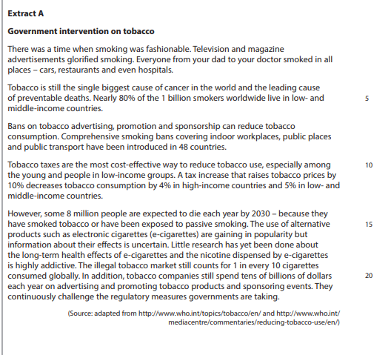**Section B: Data Response**

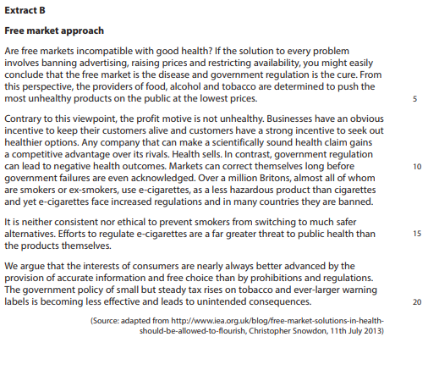

1. With reference to the information provided and your own knowledge, assess the view that tobacco consumers switching to e-cigarettes is an example of rational behaviour.

[10]

|  |  |
| --- | --- |
| **Planning Grid: Aim = 4 paragraphs - 2 KAA points (6); 2 Eval points (4)** | |
| **KAA Point 1 = signpost key point** |  |
| Application |  |
| Main concept & diagram |  |
| **Eval Point 1 = relate to your earlier point & re-read the title** |  |
| Context / evidence |  |
| **KAA Point 2 = signpost key point** |  |
| Application |  |
| Main concept & diagram |  |
| **Eval Point 2 = relate to your earlier point & re-read the title** |  |
| Context / evidence |  |

**Question:** With reference to the information provided and your own knowledge, assess the view that tobacco consumers switching to e-cigarettes is an example of rational behaviour. [10]