Trade (Business) Cycle

# Starter - Recap Question

**Instructions:** Test yourself with the below quick question

What is meant by GDP?

……………………………………………………………………………………………………………………………………………………………………………………

……………………………………………………………………………………………………………………………………………………………………………………

How do we calculate the rate of Economic Growth?

……………………………………………………………………………………………………………………………………………………………………………………

……………………………………………………………………………………………………………………………………………………………………………………

At what rate is our economy growing at currently?

……………………………………………………………………………………………………………………………………………………………………………………

……………………………………………………………………………………………………………………………………………………………………………………

# Presentation 1 – Intro to the Trade Cycle

Complete the activities below so as to have a complete set of Notes:

**Definition:** Trade Cycle

……………………………………………………………………………………………………………………………………………………………………………………

……………………………………………………………………………………………………………………………………………………………………………………

Economic activity is measured by real GDP

*Real GDP Recap:*the total value of a country’s output in a year, adjusted for inflation

*Useful approximation:*If nominal GDP growth is 5% and inflation 2%, real GDP growth is 3%

**Diagram:** Trade cycle

Label your diagram to show:

* *Actual GDP line:* shows how the actual level of output (Y) fluctuates over time
* *Trend line:* shows how the potential output of our economy is estimated to grow over time
* *The 4 Phases:* 
  + Boom: GDP above trend and fast growing
  + Recession: GDP falling – goes below trend
  + Slump: GDP is below trend and stagnant
  + Recovery: GDP rising – goes above trend
* *Output gaps*

# Presentation 2 – Phases of the Trade Cycle

Complete the activities below so as to have a complete set of Notes:

**Definitions:**

Boom

……………………………………………………………………………………………………………………………………………………………………………………

……………………………………………………………………………………………………………………………………………………………………………………

Recession

……………………………………………………………………………………………………………………………………………………………………………………

……………………………………………………………………………………………………………………………………………………………………………………

Slump

……………………………………………………………………………………………………………………………………………………………………………………

……………………………………………………………………………………………………………………………………………………………………………………

Recovery

……………………………………………………………………………………………………………………………………………………………………………………

……………………………………………………………………………………………………………………………………………………………………………………

**Table:** Complete the table with the different characteristics of each stage of the trade cycle

|  |  |  |  |  |
| --- | --- | --- | --- | --- |
|  | **Boom** | **Recession** | **Slump** | **Recovery** |
| Rate of economic growth |  |  |  |  |
| Consumer spending |  |  |  |  |
| Unemployment |  |  |  |  |
| Investment by firms |  |  |  |  |
| Inflation |  |  |  |  |

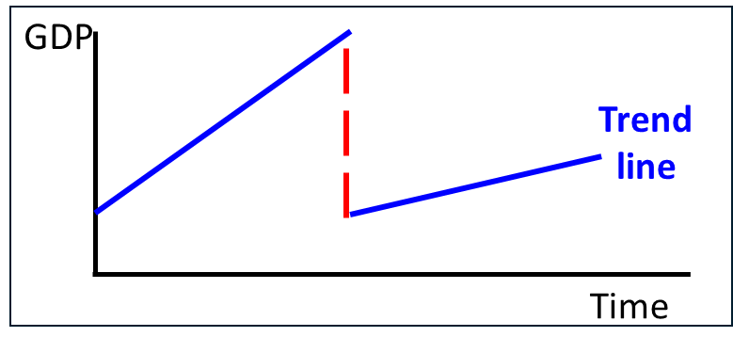*Hysteresis effect:*a prolonged slump following a deep recession can damage an economy’s potential growth rate.

Lost output maybe unrecoverable, and the trend growth rate may be slower

**Key Question:** Why does Hysteresis occur?

……………………………………………………………………………………………………………………………………………………………………………………

……………………………………………………………………………………………………………………………………………………………………………………

……………………………………………………………………………………………………………………………………………………………………………………

……………………………………………………………………………………………………………………………………………………………………………………

*The Accelerator Effect:*when an increase in GDP results in a proportionately larger rise in capital investment spending.

I.e. we often see a surge in investment when an economy is growing quite strongly.

**Key Question:** How does the accelerator effect help to explain the economic cycle?

……………………………………………………………………………………………………………………………………………………………………………………

……………………………………………………………………………………………………………………………………………………………………………………

……………………………………………………………………………………………………………………………………………………………………………………

……………………………………………………………………………………………………………………………………………………………………………………

# Chart: UK GDP Takes Major Hit From Coronavirus | StatistaData task: Recent History of UK Trade Cycle

**Instructions:** Examine the chart and answer the Questions?

What phase of the Trade cycle did the UK enter in 2008?

………………………………………………………………………

What phase or phases of the trade cycle was the UK in from 2010-2019?

………………………………………………………………………

………………………………………………………………………

What is meant by a double dip recession?

………………………………………………………………………

………………………………………………………………………

………………………………………………………………………

Did the UK witness a double dip recession at any point from 2010 to 2019?

……………………………………………………………………………………………………………………………………………………………………………………

……………………………………………………………………………………………………………………………………………………………………………………

What might have caused/prevented this?

……………………………………………………………………………………………………………………………………………………………………………………

……………………………………………………………………………………………………………………………………………………………………………………

What happened in 2020?

……………………………………………………………………………………………………………………………………………………………………………………

……………………………………………………………………………………………………………………………………………………………………………………

**Challenge:** What do you think will happen over the next year?

……………………………………………………………………………………………………………………………………………………………………………………

……………………………………………………………………………………………………………………………………………………………………………………

……………………………………………………………………………………………………………………………………………………………………………………

……………………………………………………………………………………………………………………………………………………………………………………

# MCQs

**Instructions:** Answer the below multiple-choice questions.

1. Economic growth is usually calculated from which measure:
2. the retail price index
3. real national income
4. the output of the manufacturing industry
5. consumer expenditure

Can you explain your answer?

……………………………………………………………………………………………………………………………………………………………………………………

……………………………………………………………………………………………………………………………………………………………………………………

1. Which one of the following is ***most likely*** to occur in the ***boom*** phase of an economic cycle?
   1. Rising national income, falling unemployment and a negative output gap
   2. Rising imports, rising profits and a positive output gap
   3. Rising consumption and investment expenditure and a negative output gap
   4. Excess demand, falling employment and a positive output gap

Can you explain your answer?

……………………………………………………………………………………………………………………………………………………………………………………

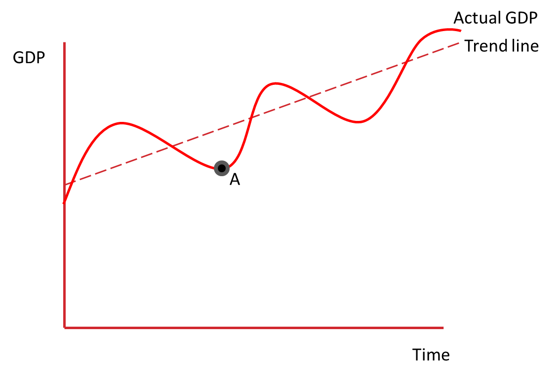……………………………………………………………………………………………………………………………………………………………………………………

1. If the economy is operating at point A, which one of the following policies is ***most likely*** to be employed by the government?
2. An increase in unemployment benefit
3. Higher interest rates
4. A reduction in income tax
5. Cutting the education budget

Can you explain your answer?

……………………………………………………………………………………………………………………………………………………………………………………

……………………………………………………………………………………………………………………………………………………………………………………