Unemployment -Causes & Impacts

# Starter - Recap Questions

**Instructions:** Test yourself with the below quick questions

What is meant by unemployment?

……………………………………………………………………………………………………………………………………………………………………………………

……………………………………………………………………………………………………………………………………………………………………………………

What is the difference between the employed, the labour force and the economically inactive?

……………………………………………………………………………………………………………………………………………………………………………………

……………………………………………………………………………………………………………………………………………………………………………………

……………………………………………………………………………………………………………………………………………………………………………………

……………………………………………………………………………………………………………………………………………………………………………………

Connect the following rates to their correct equation:

|  |  |  |  |
| --- | --- | --- | --- |
| 1) Unemployment Rate |  | A) | *E ÷ PWA* |
| 2) Employment Rate |  | B) | *U/E ÷ (U/E +E)* or  *U/E ÷ LF* |
| 3) Participation Rate |  | C) | *(E+U/E ) ÷ PWA* or  *LF ÷ PWA* |

***E*** = No. of people Employed, ***U/E*** = No. of people Unemployed, ***LF*** = Labour Force, ***PWA*** = population of working age

# Brainstorm: Why is there unemployment?

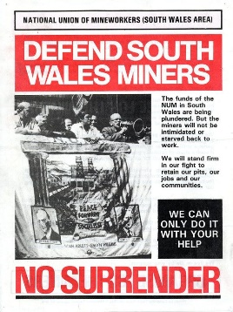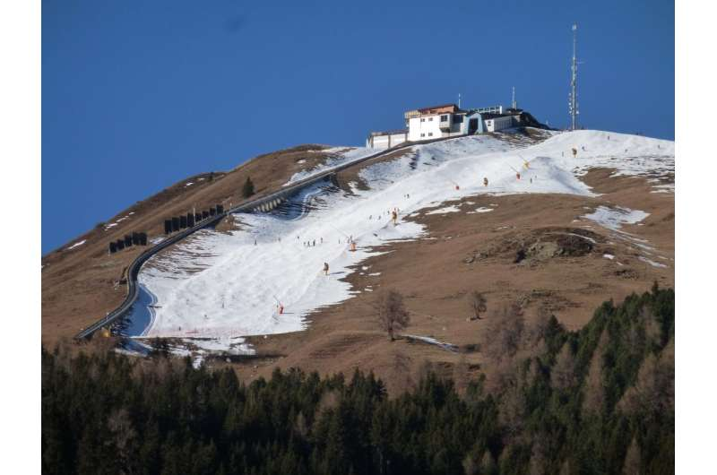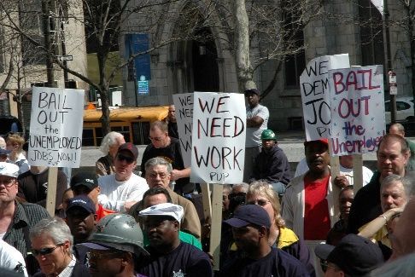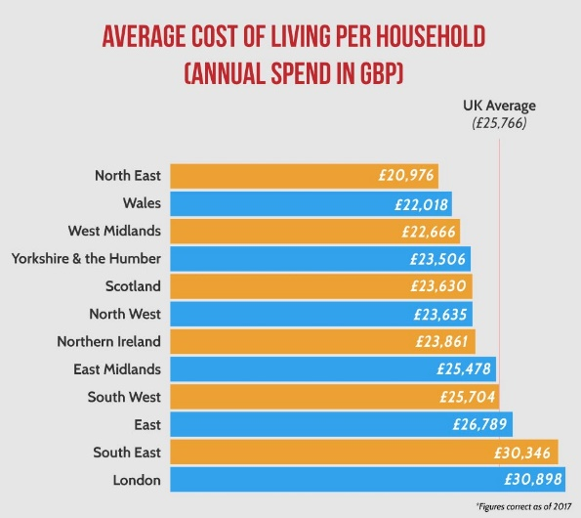**Instructions:** Look at the below prompts, what reasons can you think of as to why we see unemployment?

Note space:

# Presentation 1 - Causes of Unemployment

Complete the activities below so as to have a complete set of Notes:

**Definition:** Cyclical Unemployment

……………………………………………………………………………………………

……………………………………………………………………………………………

……………………………………………………………………………………………

……………………………………………………………………………………………

As labour is derived demand U/E is inevitable

*Diagram:* AD-AS equilibrium output is below YFE

Not all resources are being used at their maximum efficiency, including labour!

**Definition:** Structural Unemployment

……………………………………………………………………………………………………………………………………………………………………………………

……………………………………………………………………………………………………………………………………………………………………………………

*Occupational immobility:*………………………………………………………………………………………………………………………………

……………………………………………………………………………………………………………………………………………………………………….

*Causes:* Declining secondary industries & growing tertiary leads to a mismatch of skills

*E.g.* Rural wales faced very high U/E after mine closures in the 1980s, workers couldn’t retrain easily

*Geographical immobility:* ………………………………………………………………………………………………………………………………

……………………………………………………………………………………………………………………………………………………………………….

*Causes:* family and social ties as well as the financial cost of moving

*E.g.*Northern England tends to have higher U/E than Southern England as moving to areas with much higher costs of living is not an attractive prospect

**Definition:** Technological Unemployment

……………………………………………………………………………………………………………………………………………………………………………………

……………………………………………………………………………………………………………………………………………………………………………………

*Cause 1:* More and better capital raises labour productivity so less is needed

*E.g.*Farming

*Cause 2:* Labour is completely replaced, especially in routine tasks where no human judgement is needed

*E.g.*Manufacturing

**Definition:** Real-wage Unemployment

……………………………………………………………………………………………

……………………………………………………………………………………………

……………………………………………………………………………………………

……………………………………………………………………………………………

*Causes:* powerful TUs/NMW being too high/wages being sticky downwards

*Diagram:* at the wage rate W1, the quantity supplied of labour (L1) outweighs the quantity of labour demanded (L1)

There are workers willing to work at W1, but there aren’t enough jobs!

**Definition:** Seasonal Unemployment

……………………………………………………………………………………………………………………………………………………………………………………

……………………………………………………………………………………………………………………………………………………………………………………

*E.g.*Tourism workers in the off-season

**Definition:** Frictional Unemployment

……………………………………………………………………………………………………………………………………………………………………………………

……………………………………………………………………………………………………………………………………………………………………………………

*E.g.*A young person waiting to start on a graduate scheme in September having finished at university in July

**Definition:** Voluntary Unemployment

……………………………………………………………………………………………………………………………………………………………………………………

……………………………………………………………………………………………………………………………………………………………………………………

**Key Question:** Why would someone refuse a job?

……………………………………………………………………………………………………………………………………………………………………………………

……………………………………………………………………………………………………………………………………………………………………………………

……………………………………………………………………………………………………………………………………………………………………………………

……………………………………………………………………………………………………………………………………………………………………………………

# Task: Spotting types of unemployment

**Instructions:**

* Read the below cases
* Determine the type of unemployment in each case
* Discuss your answers as a class

**Cases**

1. Katie Morris is a 30 year old in Devon with a husband and two children. She works in the local hotel trade in the summer months on a casual basis but would like to work all the year round.

……………………………………………………………………………………………………………………………………………………………………………………

1. John Perry, aged 22 and living in London, was made redundant a couple of weeks ago from a furniture store which closed down. He is currently seeking work in the retail sector.

……………………………………………………………………………………………………………………………………………………………………………………

1. Manus O’Brien lives in Belfast in Northern Ireland. Aged 56, he last had a job 12 years ago working in a local factory.

……………………………………………………………………………………………………………………………………………………………………………………

1. Clare Livingstone, aged 31, lost her job 6 months ago working as a surveyor for an estate agent in Guildford in the South East of England. She is currently looking for another surveyor’s job but the local housing market is very depressed.

............................................................................................................................................................................................

1. Gavin Links, aged 40, has been out of work for 18 months. A former manager of a factory in the West Midlands, he is seeking a similar job within travelling distance of where he currently lives.

............................................................................................................................................................................................

1. Joe McDonald is a 26 year old from Cardiff. Joe does not currently have a job, however after looking in the local paper, he cannot find anything that pays above minimum wage. As Joe is currently receiving JSA, he feels that after loss of benefits and the payment of income tax it is not worth his while getting a job.

............................................................................................................................................................................................

1. Bettie Walsh, aged 58, has worked all her life on a farm milking cows. However, recently the farm owner decided to invest in some machinery which could do Bettie’s job ten times more efficiently – as a result, Bettie was made redundant.

............................................................................................................................................................................................

1. Mike works as a statistician at the insurance company Aviva. He is also a member of the Banking, Insurance and Finance Union (BIFU). Recently, Aviva offered its staff a 3% pay rise. However, with rising food and fuel prices, BIFU demanded a massive 10% for its members, and threatened strike action if Aviva did not cooperate. Eventually, the firm gave in and agreed to the 10% pay demand. However, Aviva is now making losses in some parts of its business, and has been left with no choice but to make redundancies. Accordingly, Mike has lost his job.

……………………………………………………………………………………………………………………………………………………………………………………

# Article Task: Impacts of Unemployment

**Instructions:**

* Read, highlight and annotate the article
* Answer the questions
* Discuss your answers as a class

**Article**

*‘The Overall Effects of Unemployment’*

Unemployment affects the unemployed individual and his family, not only with respect to income, but also with respect to health and mortality. Moreover, the effects linger for decades. The effects of unemployment on the economy are equally severe; a 1 percent increase in unemployment reduces the GDP by 2 percent. The criminal consequences of unemployment are mixed; in some circumstances, property-crime rates increase significantly; in other circumstances, there seems to be no effect.

Individual Consequences of Unemployment

Writing in The New York Times on "The Enduring Consequences of Unemployment," economist Binyamin Applebaum explains that the consequences for an unemployed individual are both grave and long-lasting. For example, workers who became unemployed in the severe early 1980s recession were making about 20 percent less than average 20 years later. It's also bad for your health. A 2009 Pennsylvania study found that unemployed workers died more than a year earlier than average.

Long-lasting consequences extend to the families of unemployed workers, as well. A 2008 Canadian study Applebaum cited found that the sons of unemployed workers made about 9 percent less than the sons of employed workers with similar skills.

The longer the unemployment goes on, the more severe the health consequences, with increased depression and other health issues worsening over time. In addition to the obvious loss of income, unemployed workers were found to have lost friends and self-respect.

Also, the longer the unemployment goes on it becomes more difficult for the worker to find employment again — both because employers are wary of the long-time unemployed and also because over time, unemployed workers lose job skills. The skills loss is not limited to jobs: A 2008 Swedish study found that reading comprehension skills for workers unemployed for one year dropped by 5 percent.

Social Consequences of Unemployment

One consequence of unemployment frequently commented upon is a purported increase in crime. However, a large-scale study of the issue came to mixed conclusions about the connection. as cited by Kleck, Gary; Jackson, Dylan. "What Kind of Joblessness Affects Crime? A National Case-Control Study of Serious Property Crime,” Journal of Quantitative Criminology, 2016. However, the study did confirm that persons who are unemployed for "socially unacceptable reasons" and who are also not industriously seeking employment are "significantly more likely" to commit robbery or burglary. (Robbery crimes are committed against a person, and often by violent means; burglary crimes are property crimes).

The study also found, however, that unemployed persons seeking work are neither more nor less likely to rob or burgle than are the fully employed. Somewhat counter intuitively, however, the study also found that underemployed individuals are "significantly less" likely to commit burglary, but are about as likely to commit robbery as individuals in the general population.

The correlation between joblessness and property crime was greatest among the young. The study found that joblessness increased the likelihood of burglary for persons aged 18 to 29 four times more so than for unemployed persons 30 and older.

Effects of Unemployment on the Economy

Some of the effects of unemployment are immediate and obvious. When unemployment increases, both state and federal governments pay increased unemployment benefits. These are not inconsiderable. Even in February of 2017 —with the unemployment rate hovering around 5 percent —unemployment benefits that include food benefits and Medicaid totalled $2.96 billion for the month.

Even more significant in the U.S. consumer economy are the chained consequences of these increased benefits, which require the government either to borrow money to pay these benefits, and by doing so, also deferring the costs into the future or reducing spending in other areas. This is a compensatory strategy, but it can make a bad economic situation worse. An historic 1967 paper on the relationship between unemployment and economic output by Yale economist Arthur Okun, concluded that even a 1 percent increase in unemployment reduced the U.S. GDP (Gross Domestic Product) by 2 percent, which has a multiplier effect of more than 100 percent. A 2017 paper issued by the St. Louis Fed on Okun's law — as it has come to be known — noted that this ratio "holds true 50 years later."

**Question:**

What are the impacts of unemployment on workers?

……………………………………………………………………………………………………………………………………………………………………………………

……………………………………………………………………………………………………………………………………………………………………………………

……………………………………………………………………………………………………………………………………………………………………………………

What are the impacts of unemployment on society in general?

……………………………………………………………………………………………………………………………………………………………………………………

……………………………………………………………………………………………………………………………………………………………………………………

……………………………………………………………………………………………………………………………………………………………………………………

What are the impacts of unemployment on the wider Economy?

……………………………………………………………………………………………………………………………………………………………………………………

……………………………………………………………………………………………………………………………………………………………………………………

……………………………………………………………………………………………………………………………………………………………………………………

***Challenge:***Can you think of any positive impacts of unemployment to any parties?

……………………………………………………………………………………………………………………………………………………………………………………

……………………………………………………………………………………………………………………………………………………………………………………

# Presentation 2: Costs of Unemployment

**Key Notes:**

**Elaborate:** Elaborate on the below negative impacts of unemployment

*Lower standard of living:*

……………………………………………………………………………………………………………………………………………………………………………………

……………………………………………………………………………………………………………………………………………………………………………………

*Falling sales, revenues and profits for firms:*

……………………………………………………………………………………………………………………………………………………………………………………

……………………………………………………………………………………………………………………………………………………………………………………

*Lower tax revenues:*

……………………………………………………………………………………………………………………………………………………………………………………

Government’s problem is exacerbated as there is also higher expenditure on benefits as there are more unemployed to support.

*Opportunity cost:*

……………………………………………………………………………………………………………………………………………………………………………………

*Hysteresis:*

……………………………………………………………………………………………………………………………………………………………………………………

**Elaborate:** Elaborate on the below potential positive impacts of unemployment

*Lower wage rates*

……………………………………………………………………………………………………………………………………………………………………………………

……………………………………………………………………………………………………………………………………………………………………………………

*Reduced inflationary pressure*

……………………………………………………………………………………………………………………………………………………………………………………

……………………………………………………………………………………………………………………………………………………………………………………

# Assignment

**Short-answer questions (Section A)**

1. Spain is a member of the Eurozone. In the third quarter of 2013, the unemployment rate in Spain rose to almost 30%. The most likely effect of this increase in the unemployment rate is:

A An increase in wages in the Spanish economy

B An appreciation in the value of the Euro

C An increase in the rate of inflation in Spain

D A reduction in tax receipts

[1]

1. Structural unemployment is most likely to be caused by

A A recession in the economy

B Changes in the demand for labour at different times of the year

C An increase in the number of people changing jobs

D The skills of the unemployed not matching those skills required for the available jobs

[1]

1. Which of the following is most likely to be an example of frictional unemployment?

A Gill lost her job as a television engineer two months ago and is waiting to start a new job next month

B Brian has not worked for 15 years since losing his job as a coal miner

C Hitesh lost his job as a construction worker six months ago when a recession led to a downturn in the construction industry

D Faith works in the hotel trade as a casual chef and spends November to April out of work

[1]

**Data response (Section B)**

**Extract 1: Unemployment ‘set to soar’ if economy does not recover soon**

GDP data released in July 2012 revealed that the UK economy contracted by 0.7% between April and June. This is now the third consecutive quarterly fall and the longest “double dip” recession in half a century. The situation looks unlikely to improve markedly for the rest of the year, with the Bank of England last week cutting its annual growth forecast for 2012 to zero, from 0.85%.

In August 2012, the ILO measure of UK unemployment was at 7.9% and it has remained above 6% since 2009. Moreover, in its latest report on the employment market, the Chartered Institute of Personnel and Development (CIPD) has found that one in three businesses is keeping more staff than needed to avoid losing skills, but would enforce redundancies if economic growth did not return soon. Two thirds of private sector companies told the CIPD that they would have to cut staff if the economy did not begin to recover, with large businesses more concerned about Britain’s economic outlook than smaller companies.

The opposition Labour Party suggested that the Bank of England’s report added to doubts about the government’s economic strategy of reducing the budget deficit without delaying the recovery. The Labour Party argued the strategy was already weakened by disappointing growth figures earlier this year. Rachel Reeves, opposition spokesperson, said that these figures show the government’s policies were not only causing short-term pain, but also long-term damage to the UK economy. She added that even the national infrastructure plan announced by ministers recently would not provide the expected stimulus, since most projects will not start until 2014. “We are crying out for investment that begins now,” Ms Reeves said.

**Extract 2: Exports plunge in fresh blow to economy**

The UK’s hopes of export-led growth were set back as exports fell sharply in the second quarter of 2012, highlighting the difficulty the economy faces as it tries to recover at a time of slowing global growth. In the same quarter exports of goods fell 3.1% in volume terms and the UK recorded its biggest trade deficit in 15 years.

1. With reference to Extracts 1 and 2 and your own knowledge, assess **two** possible reasons why unemployment has remained above 6% since 2009.

[10]

**Question:** With reference to Extracts 1 and 2 and your own knowledge, assess **two** possible reasons why unemployment has remained above 6% since 2009.

[10]

|  |  |
| --- | --- |
| **Planning Grid: Aim = 4 paragraphs - 2 KAA points (6); 2 Eval points (4)** | |
| **KAA Point 1 = signpost key point** |  |
| Application |  |
| Main concept & diagram |  |
| **Eval Point 1 = relate to your earlier point & re-read the title** |  |
| Context / evidence |  |
| **KAA Point 2 = signpost key point** |  |
| Application |  |
| Main concept & diagram |  |
| **Eval Point 2 = relate to your earlier point & re-read the title** |  |
| Context / evidence |  |

# Extension Task: Jobs for the Long Run

**Instructions:**

* Read, highlight and annotate the article
* Make notes for the discussion questions
* Discuss your answers as a class

**Article:**

*‘Structural unemployment also rises in recessions’*

Unemployment is high, and the longer people are unemployed the longer they are likely to stay that way. Eventually, they may become discouraged and drop out of the labour force. So what can be done? The economic infighting about whether unemployment is structural (and there's a new natural rate) or cyclical (just unemployment brought on by weak demand from the recession) is important; each requires different policy.

It's impossible to know precisely how much unemployment is structural and how much is cyclical, and probably there's some of both right now. Cyclical unemployment resulting from weak demand is amenable to expansionary government spending or monetary policy. Structural unemployment is harder to fix. Structural joblessness results from things like skills mismatches, and policy to address such mismatches is inherently longer-term in scope, involving education and encouraging innovation. Expansionary policy can't reduce structural unemployment; when that's all that's left, more expansion generates nothing but rising inflation.

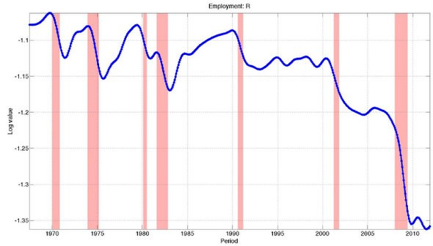Structural unemployment isn't necessarily permanent. The natural rate of unemployment tends to vary in the medium run. It can be very hard to disentangle how much unemployment is cyclical and how much is structural because each tends to increase during recessions. A recent paper by Nir Jaimovich and Henry Siu found that skill-based job loss is not a gradual process. Rather, 92% of job loss in routine-manual jobs (typically blue-collar or low-skill work) since the 1980s happened during recessions. They argue this explains jobless recoveries in such areas. Consider the figure below, which plots changes in per-capita employment in routine-manual jobs since the 1970s (the pink bars are recessions):

In contrast, employment in high skills areas rose over this period. Looking at the figure above it's hard to believe that many of these low-skill jobs are going to come back. When times are tough uncompetitive firms are under more pressure to cut costs, and such firms will struggle to scale payrolls up again in recovery. They may also use the period to invest in technology which displaces low-skill workers.

This dynamic is not unique to the last few decades. Tyler Cowen recently suggested that structural factors may help explain why unemployment was so persistent during the Depression. Even that story has an encouraging lesson. Structural unemployment did eventually fall as the economy underwent a structural change during World War II and thereafter, thanks to a large investment in human capital from programmes like the GI bill. Few would argue this justifies an end to monetary expansion. A significant component of unemployment is probably cyclical and its elimination is dependent on further monetary support. But that won't be sufficient to restore unemployment to pre recession levels. For that to happen complementary policies focused on the long run will also be necessary.

**Questions:**

What percentage of job loss in routine-manual jobs happened during recessions?

……………………………………………………………………………………………………………………………………………………………………………………

……………………………………………………………………………………………………………………………………………………………………………………

……………………………………………………………………………………………………………………………………………………………………………………

Why is there a relationship between unemployment and recessions? How is this relevant to structural unemployment?

……………………………………………………………………………………………………………………………………………………………………………………

……………………………………………………………………………………………………………………………………………………………………………………

……………………………………………………………………………………………………………………………………………………………………………………

……………………………………………………………………………………………………………………………………………………………………………………

……………………………………………………………………………………………………………………………………………………………………………………

……………………………………………………………………………………………………………………………………………………………………………………

……………………………………………………………………………………………………………………………………………………………………………………

……………………………………………………………………………………………………………………………………………………………………………………

Is structural unemployment more or less permanent that cyclical unemployment?

……………………………………………………………………………………………………………………………………………………………………………………

……………………………………………………………………………………………………………………………………………………………………………………

……………………………………………………………………………………………………………………………………………………………………………………

……………………………………………………………………………………………………………………………………………………………………………………

……………………………………………………………………………………………………………………………………………………………………………………

……………………………………………………………………………………………………………………………………………………………………………………

……………………………………………………………………………………………………………………………………………………………………………………

……………………………………………………………………………………………………………………………………………………………………………………

# Joseph Schumpeter - WikipediaExtension Task: What is Creative Destruction?

**Instructions:**

* Read, highlight and annotate the article
* Make notes for the discussion questions
* Discuss your answers as a class

**Article:**

*Creative destruction is the dismantling of long-standing practices in order to make way for innovation and is seen as a driving force of capitalism.*

Key Takeaways:

* Creative destruction describes the deliberate dismantling of established processes in order to make way for improved methods of production.
* Creative destruction is most often used to describe disruptive technologies such as the railroads or, in our own time, the internet.
* The term was coined in the early 1940s by economist Joseph Schumpeter, who observed real-life examples of creative destruction, such as Henry Ford’s assembly line.

Understanding Creative Destruction

The term creative destruction was first coined by Austrian economist Joseph Schumpeter in 1942. Schumpeter characterized creative destruction as innovations in the manufacturing process that increase productivity, describing it as the "process of industrial mutation that incessantly revolutionizes the economic structure from within, incessantly destroying the old one, incessantly creating a new one."

Basically, the theory of creative destruction assumes that long-standing arrangements and assumptions must be destroyed to free up resources and energy to be deployed for innovation. To Schumpeter, economic development is the natural result of forces internal to the market and is created by the opportunity to seek profit.

Creative destruction theory treats economics as an organic and dynamic process. This stands in stark contrast with the static mathematical models of traditional Cambridge-tradition economics. Equilibrium is no longer the end goal of market processes. Instead, many fluctuating dynamics are constantly reshaped or replaced by innovation and competition.

As is implied by the word destruction, the process inevitably results in losers and winners. Producers and workers committed to the older technology will be left stranded. Entrepreneurs and workers in new technologies, meanwhile, will inevitably create disequilibrium and highlight new profit opportunities.

In describing creative destruction, Schumpeter was not necessarily endorsing it. In fact, his work is considered to be heavily influenced by The Communist Manifesto, the pamphlet by Karl Marx and Friedrich Engels which decried the bourgeoisie for its "constant revolutionizing of production [and] uninterrupted disturbance of all social conditions."

Creative Destruction Examples

Examples of creative destruction in history include Henry Ford's assembly line and how it revolutionized the automobile manufacturing industry. However, it also displaced older markets and forced many laborers out of work.

The internet is perhaps the most all-encompassing example of creative destruction, where the losers were not only retail clerks and their employers but also bank tellers, secretaries, and travel agents. The mobile internet added many more losers, from taxi-cab drivers to mapmakers.

One industry that has seen many instances of creative destruction is that of video media entertainment. The way we watch films and television ‘on demand (as opposed to via scheduled television channels) has evolved from VHS tapes, to DVDs, to Blu-ray and now online streaming services.

The winners, beyond the obvious example of programmers, might be just as numerous. The entertainment industry was turned upside down by the internet, but its need for creative talent and product remains the same or greater. The internet destroyed many small businesses but created many new ones online.

The point, as Schumpeter noted, is that an evolutionary process rewards improvements and innovations and punishes less efficient ways of organizing resources. The trend line is toward progress, growth, and higher standards of living overall.

**Discussion Question**

*‘How can the idea of creative destruction be reconciled with structural unemployment?’*

|  |
| --- |
| Note Space: |