Externalities

# Starter: Recap Questions

**Instructions:** Test yourself with the below quick question

What is meant by Marginal Private Benefit?

…………………………………………………………………………………………………

…………………………………………………………………………………………………

What is meant by Marginal Social Benefit?

…………………………………………………………………………………………………

…………………………………………………………………………………………………

What is meant by Marginal External Benefit?

…………………………………………………………………………………………………

…………………………………………………………………………………………………

Sketch these on a diagram:

What is meant by Marginal Private Cost?

…………………………………………………………………………………………………

…………………………………………………………………………………………………

What is meant by Marginal Social Cost?

…………………………………………………………………………………………………

…………………………………………………………………………………………………

What is meant by Marginal External Cost?

…………………………………………………………………………………………………

…………………………………………………………………………………………………

Sketch these on a diagram:

# Presentation 1 – Intro to Externalities

Complete the activities below so as to have a complete set of Notes:

**Definition:** Externalities

……………………………………………………………………………………………………………………………………………………………………………………

……………………………………………………………………………………………………………………………………………………………………………………

……………………………………………………………………………………………………………………………………………………………………………………

This can result in under or over consumption/production of the good.

The spill-over can occur either when the good is made, or when the good is consumed.

**Key Notes:** Typology of Externalities

Externalities can be either positive or negative.

*Positive Externalities***:**

……………………………………………………………………………………………………………………………………………………………………………………

……………………………………………………………………………………………………………………………………………………………………………………

The quantity of the good traded in a free market is below the socially optimal.

*Negative Externalities:*

……………………………………………………………………………………………………………………………………………………………………………………

……………………………………………………………………………………………………………………………………………………………………………………

The quantity of the good traded in a free market is above the socially optimal.

Externalities can occur in production or consumption.

*Production Externalities:*

……………………………………………………………………………………………………………………………………………………………………………………

Accounted for in terms of external costs.

*Consumption Externalities:*

……………………………………………………………………………………………………………………………………………………………………………………

Accounted for in terms of external benefits.

# Task: Externality Determination

**Instructions:** For the below spill-overs, determine whether they are Positive or Negative, Consumption or Production

|  |  |  |  |  |  |  |
| --- | --- | --- | --- | --- | --- | --- |
| **Spill-over** | **Positive or Negative** | **Production or Consumption** |  | **Spill-over** | **Positive or Negative** | **Production or Consumption** |
| Air pollution from factories | - | p |  | Vehicle pollution | - | C |
| Beekeeping promoting pollination | + | P |  | Herd immunity from vaccinations | + | C |
| Collapsing fish stock | - | P |  | Methane emissions from cows | - | P |
| Company provided first-aid training | + | C/p |  | Tourist Litter | - | C |
| Second-hand smoking | - | C |  | Pollution from fertilizers | - | P |

# Task: Externality Drawing

**Instructions:** For the below spill-overs, state how you would show the externality on a diagram

**Tip:** if the spill-over occurs in production, its accounted for in costs; if it occurs in consumption its accounted for in benefits

|  |  |  |  |  |
| --- | --- | --- | --- | --- |
| **Spill-over** | **On a Diagram** |  | **Spill-over** | **On a Diagram** |
| Air pollution from factories | MSC > MPC |  | Vehicle pollution | MPB > MSB |
| Beekeeping promoting pollination | MPC > MSC |  | Herd immunity from vaccinations | MSB > MPB |
| Collapsing fish stock | MSC > MPC |  | Methane emissions | MSC > MPC |
| Company provided first-aid training | MSB > MPB |  | Tourist Litter | MPB > MSB |
| Second-hand smoking | MPB > MSB |  | Pollution from fertilizers | MSC > MPC |

# Presentation 2 – Consumption Externalities

Complete the activities below so as to have a complete set of Notes:

**Definition:** Positive Consumption externality

……………………………………………………………………………………………………………………………………………………………………………………

……………………………………………………………………………………………………………………………………………………………………………………

Spill-over gains occurring when the good is consumed

MSB>MPB, MEB is positive

**E.g.** Vaccinations

**Diagrammatic Analysis**: Positive Consumption Externality

*Complete the diagram and compare how the free-market equilibrium differs from the social optimal.*

Quantity (FM vs SO)

……………………………………………………………………………………

……………………………………………………………………………………

Price (FM vs SO)

……………………………………………………………………………………

……………………………………………………………………………………

……………………………………………………………………………………

Welfare (FM vs SO)

……………………………………………………………………………………

……………………………………………………………………………………

……………………………………………………………………………………

**Definition:** Negative Consumption externality

……………………………………………………………………………………………………………………………………………………………………………………

……………………………………………………………………………………………………………………………………………………………………………………

Spill-over losses occurring when the good is consumed

MSB<MPB, MEB is Negative

**E.g.** Smoking

**N.B.** we account these spill-over losses as reduced external benefits rather than increase external costs as they occur when the good is consumed

**Diagrammatic Analysis**: Negative Consumption Externality

*Complete the diagram and compare how the free-market equilibrium differs from the social optimal.*

Quantity (FM vs SO)

……………………………………………………………………………………

……………………………………………………………………………………

……………………………………………………………………………………

Price (FM vs SO)

……………………………………………………………………………………

……………………………………………………………………………………

……………………………………………………………………………………

Welfare (FM vs SO)

……………………………………………………………………………………

……………………………………………………………………………………

……………………………………………………………………………………

# Task: Consumption Externalities

**Instructions:** Read the extract and answer the questions

**Extract**

According to a recent market research survey done for the Tower Gym in London, pay-as-you-go members are prepared to make 1,000 gym visits per week with an entry fee of £7. However, when the entry fee falls to £4, the gym will attract 4,000 visitors per week, while at the special rate of only £1, 7,000 gym visits will be recorded in a week. This negative correlation between price and the quantity demanded reveals two things. Firstly, in relation to total market demand, it demonstrates both the income effect and the substitution effect. Secondly, and more importantly for the individual consumer, the negative correlation demonstrates the law of diminishing marginal utility. Namely, each successive gym visit will tend to give the consumer less and less utility, or satisfaction, so will only be demanded at a lower price. Accordingly, the price paid for the good will reflect the marginal benefit consumers feel they are gaining from the product.

However, when private individuals pay to go to the gym to keep fit, there are spillover effects which benefit the rest of society. For example, more people are likely to avoid health problems in later life, thus reducing the strain on NHS resources. Also, a healthier, more productive workforce taking fewer sick days off work will promote economic growth. The monetary value of these spillovers is estimated at around £0.50 per gym visit when 1,000 visits are consumed, £2 per visit when 4,000 visits are consumed and £3.50 per visit when 7,000 visits are consumed

The supply schedule should be drawn as £1 = 2,000, £4 = 4,000 & £7 = 6,000

Using the axis below, draw in and label the Marginal Private Benefit (MPB), Marginal Social Benefit (MSB) & MSC=MPC=S curves for the consumption of gym visits at Tower Gym.

Cost/Benefit (£)

10

9

8

7

6

5

4

3

2

1

|  |  |  |  |  |  |  |  |  |  |
| --- | --- | --- | --- | --- | --- | --- | --- | --- | --- |
|  |  |  |  |  |  |  |  |  |  |
|  |  |  |  |  |  |  |  |  |  |
|  |  |  |  |  |  |  |  |  |  |
|  |  |  |  |  |  |  |  |  |  |
|  |  |  |  |  |  |  |  |  |  |
|  |  |  |  |  |  |  |  |  |  |
|  |  |  |  |  |  |  |  |  |  |
|  |  |  |  |  |  |  |  |  |  |
|  |  |  |  |  |  |  |  |  |  |
| 1 2 3 4 5 6 7 8 9 10 |  |  |  |  |  |  |  |  |  |

Output (thousands of gym visits per week)

***Questions****:*

1. *Label the curves D=MPB, MSB and S=MSC=MPC.*
2. *Annotate the free market equilibrium point: Price = __________ , Quantity = __________*
3. *Remembering that the loss of welfare gain occurs where SB > SC, annotate and label the welfare loss on the diagram as a result of having such a low level of consumption.*
4. *Given the private benefits* ***and*** *the positive externalities that arise when people visit the gym, annotate the socially optimum level of price and output: Price = __________ , Quantity = __________*
5. *Briefly explain why the points you have chosen are 'socially optimum'.*

*(****Clue****: consider the impact on P & Q, the curves that intersect and also the impact on the wider economy)*

……………………………………………………………………………………………………………………………………………………………………………………

……………………………………………………………………………………………………………………………………………………………………………………

……………………………………………………………………………………………………………………………………………………………………………………

……………………………………………………………………………………………………………………………………………………………………………………

……………………………………………………………………………………………………………………………………………………………………………………

……………………………………………………………………………………………………………………………………………………………………………………

# Presentation 3 – Production Externalities

Complete the activities below so as to have a complete set of Notes:

**Definition:** Negative Production externality

……………………………………………………………………………………………………………………………………………………………………………………

……………………………………………………………………………………………………………………………………………………………………………………

MSC>MPC, MEC is positive

Spill-over losses occurring when the good is produced

**E.g.** Pollution from factories

**Diagrammatic Analysis**: Negative Production Externality

*Complete the diagram and compare how the free-market equilibrium differs from the social optimal.*

Quantity (FM vs SO)

……………………………………………………………………………………

……………………………………………………………………………………

……………………………………………………………………………………

Price (FM vs SO)

……………………………………………………………………………………

……………………………………………………………………………………

……………………………………………………………………………………

Welfare (FM vs SO)

……………………………………………………………………………………

……………………………………………………………………………………

……………………………………………………………………………………

**Definition:** Positive Production externality

……………………………………………………………………………………………………………………………………………………………………………………

……………………………………………………………………………………………………………………………………………………………………………………

MSC<MPC, MEC is negative

Spill-over gains occurring when the good is produced

**E.g.** Pollination from honey farmers’ bees

**N.B.** we account these spill-over gains as reduced external costs rather than improved external benefits as they occur when the good is produced

**Diagrammatic Analysis**: Positive Production Externality

*Complete the diagram and compare how the free-market equilibrium differs from the social optimal.*

Quantity (FM vs SO)

……………………………………………………………………………………

……………………………………………………………………………………

……………………………………………………………………………………

Price (FM vs SO)

……………………………………………………………………………………

……………………………………………………………………………………

……………………………………………………………………………………

Welfare (FM vs SO)

……………………………………………………………………………………

……………………………………………………………………………………

……………………………………………………………………………………

# Task: Production Externalities

**Instructions:** Read the extract and answer the questions

**Extract**

The Zantac Chemical Company produces industrial solvents in Liverpool, where it has a factory located just by the River Mersey. As the firm increases its output, it has to pay more for its factor inputs. For example, staff have to be paid overtime, disproportionately higher maintenance is required for its machines, and higher profits are demanded by enterprise. So the cost of producing each bottle of solvent increases with output: £1 per bottle if only one ton is produced, £3 per bottle when producing five tonnes and £5 per bottle when producing nine tonnes.

In order to minimise costs, Zantac uses a cheap waste disposal process that flushes chemical waste into a nearby river. While this clearly reduces the firm's cost of production and enables it to produce more solvents at any given price, the chemical waste also pollutes the river and reduces the amount of fish caught by the local fishing industry. Accordingly, Mersey fishermen have to stay out at sea for twice as long to catch the same quantity of fish that they did before Zantac moved into the area or, as sometimes happens, they go home with a smaller catch. All in all, the extra cost borne by the Mersey fishing industry is around 50% of Zantac's own cost of production. Consequently, fewer fish are supplied in Liverpool at any given price.

The demand schedule should be drawn as £2 = 7,500, £4 = 5,500, £6 = 3,500 & £8 = 1,500

Using the axis below, draw in and label the Marginal Private Cost (MPC) and Marginal Social Cost (MSC) curves for chemical production at Zantac.

Cost/Benefit (£)

10

9

8

7

6

5

4

3

2

1

|  |  |  |  |  |  |  |  |  |  |
| --- | --- | --- | --- | --- | --- | --- | --- | --- | --- |
|  |  |  |  |  |  |  |  |  |  |
|  |  |  |  |  |  |  |  |  |  |
|  |  |  |  |  |  |  |  |  |  |
|  |  |  |  |  |  |  |  |  |  |
|  |  |  |  |  |  |  |  |  |  |
|  |  |  |  |  |  |  |  |  |  |
|  |  |  |  |  |  |  |  |  |  |
|  |  |  |  |  |  |  |  |  |  |
|  |  |  |  |  |  |  |  |  |  |
| 1 2 3 4 5 6 7 8 9 10 |  |  |  |  |  |  |  |  |  |

Output (tonnes)

**Questions**:

1. *Label the curves MPC, MSC and D=MSB=MPB.*
2. *Annotate the free market equilibrium point: Price = ________ , Quantity = ________*
3. *Remembering that welfare losses occur where SC > SB, annotate and label the welfare loss on the diagram as a result of having such a high level of production.*
4. *Given the private cost* ***and*** *the negative externalities involved in the production of Zantac's solvents, annotate the socially optimum level of price and output: Price = ________ , Quantity = ________*
5. *Briefly explain why the points you have chosen are 'socially optimum'.*

*(****Clue****: consider the impact on P & Q, the curves that intersect and also the impact on the fishing industry)*

……………………………………………………………………………………………………………………………………………………………………………………

……………………………………………………………………………………………………………………………………………………………………………………

……………………………………………………………………………………………………………………………………………………………………………………

……………………………………………………………………………………………………………………………………………………………………………………

……………………………………………………………………………………………………………………………………………………………………………………

……………………………………………………………………………………………………………………………………………………………………………………

# Assignment

**Short-answer questions (Section A)**

1. The diagram shows a free market for vaccinations in which the current equilibrium level of output is X and price Pe.



At this level of output there is:

A An external cost

B Market failure

C An excess supply

D Government failure

[1]

1. The diagram shows the market for vaccinations. Assume there are no external costs.



Which of the following is true?

A The free market equilibrium quantity exceeds the social optimum quantity

B The area of welfare loss is XTYZ

C An increase in quantity from the free market equilibrium will lead to a net welfare gain

D At the free market equilibrium quantity, marginal social cost exceeds marginal social benefit

[1]

1. The diagram shows the market for university education. Assume there are no external costs.



Which of the following is true?

A The free market equilibrium quantity exceeds the social optimum quantity

B There is market failure at quantity Qe

C The triangle of welfare gain is XYV

D The marginal external benefit remains constant at all quantities

[1]

1. The table below shows the private and external costs for four products. Which product, **A, B, C** or **D,** has a market price which takes **least** account of negative externalities?

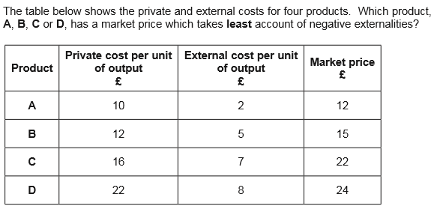

[1]

1. The diagram below shows the marginal private and social benefit (MPB and MSB) curves and the marginal private and social cost (MPC and MSC) curves for a good which generates negative externalities in production

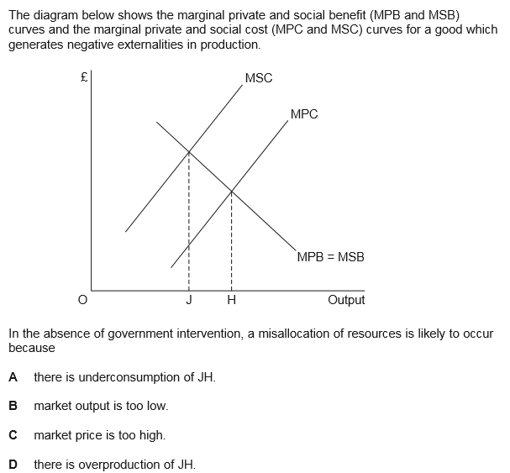

[1]

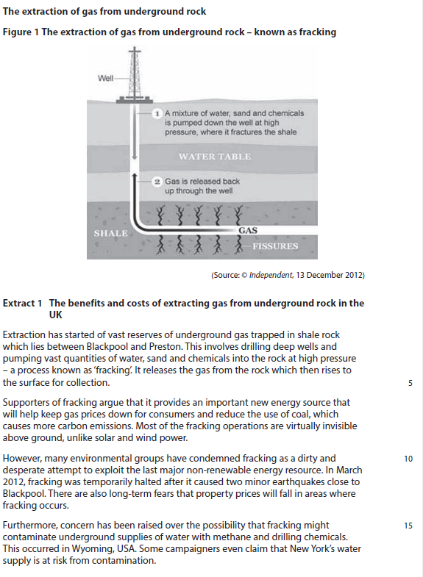**Data response (1) (Section B)**

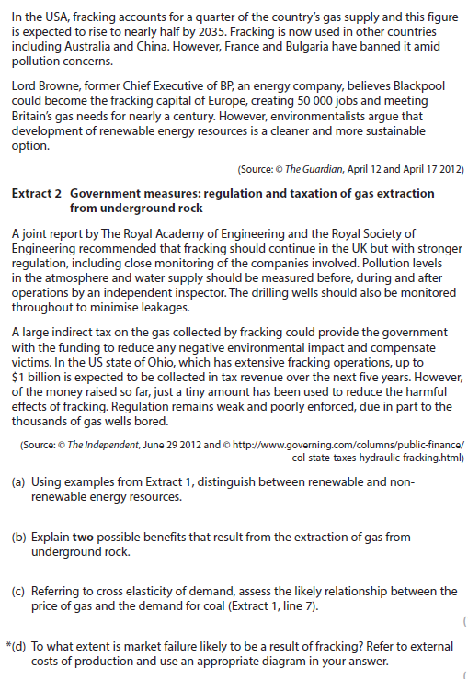

**Question**

1. To what extent is market failure likely to be a result of fracking? Refer to external costs of production and use an appropriate diagram in your answer.

[12]

**Question:** To what extent is market failure likely to be a result of fracking? Refer to external costs of production and use an appropriate diagram in your answer. [12]

|  |  |
| --- | --- |
| **Planning Grid: Aim = 4 paragraphs - 2 KAA points (8); 2 Eval points (4)** | |
| **KAA Point 1 = signpost key point** |  |
| Application |  |
| Main concept & diagram |  |
| **Eval Point 1 = relate to your earlier point & re-read the title** |  |
| Context / evidence |  |
| **KAA Point 2 = signpost key point** |  |
| Application |  |
| Main concept & diagram |  |
| **Eval Point 2 = relate to your earlier point & re-read the title** |  |
| Context / evidence |  |