Monetary Policy

# Starter – Discussion Question

**Instructions:** Discuss the below question with your group

*What is the Bank of England?*

|  |
| --- |
| Discussion notes: |

(**Tip:** consider what the BoE aims to achieve, but also the ways they might achieve this)

# Presentation 1 - Intro to Monetary Policy

Complete the activities below so as to have a complete set of Notes:

**Definition:** *Monetary Policy*

……………………………………………………………………………………………………………………………………………………………………………………

……………………………………………………………………………………………………………………………………………………………………………………

Monetary policy looks to influence primarily AD – hence it is a **Demand-side** Policy

*Deflationary Monetary Policy:*

……………………………………………………………………………………………………………………………………………………………………………………

……………………………………………………………………………………………………………………………………………………………………………………

*Reflationary Monetary Policy:*

……………………………………………………………………………………………………………………………………………………………………………………

……………………………………………………………………………………………………………………………………………………………………………………

**Definition:** *The Bank of England (BoE):*

……………………………………………………………………………………………………………………………………………………………………………………

……………………………………………………………………………………………………………………………………………………………………………………

*The Monetary Policy Committee (MPC):*a committee lead by the Governor of the BoE, who meet monthly to assess the state of the economy and decide whether to alter interest rates

*Independent of government:*To ensure no policy myopia!

*E.g.* A government might look to boost AD and output directly before an election, but that could compromise work to control inflation

**Key Notes:** *Aims of Monetary Policy*

In the UK monetary policy is mainly used to achieve stable inflation

But it has had a wider remit to target growth and increased employment of late

# File:Bank of England looking up (22573356606).jpgArticle Task: The Workings of Monetary Policy

**Instructions:**

* Read, highlight and annotate the article
* State the transmission mechanisms (processes by which Mon. Pol. affects the economy) found in the article
* ***Extension:*** State any evaluative points

**Article**

*The Bank of England explains how Monetary Policy works*

When the Bank of England changes the official interest rate it is attempting to influence the overall level of expenditure in the economy. When the amount of money spent grows more quickly than the volume of output produced, inflation is the result. In this way, changes in interest rates are used to control inflation.

The Bank of England sets an interest rate at which it lends to financial institutions. This interest rate then affects the whole range of interest rates set by commercial banks, building societies and other institutions for their own savers and borrowers. It also tends to affect the price of financial assets, such as bonds and shares, and the exchange rate, which affect consumer and business demand in a variety of ways. Lowering or raising interest rates affects spending in the economy.

A reduction in interest rates makes saving less attractive and borrowing more attractive, which stimulates spending. Lower interest rates can affect consumers’ and firms’ cash-flow – a fall in interest rates reduces the income from savings and the interest payments due on loans. Borrowers tend to spend more of any extra money they have than lenders, so the net effect of lower interest rates through this cash-flow channel is to encourage higher spending in aggregate. The opposite occurs when interest rates are increased.

Lower interest rates can boost the prices of assets such as shares and houses. Higher house prices enable existing home owners to extend their mortgages in order to finance higher consumption. Higher share prices raise households’ wealth and can increase their willingness to spend.

Changes in interest rates can also affect the exchange rate. An unexpected rise in the rate of interest in the UK relative to overseas would give investors a higher return on UK assets relative to their foreign-currency equivalents, tending to make sterling assets more attractive. That should raise the value of sterling, reduce the price of imports, and reduce demand for UK goods and services abroad. However, the impact of interest rates on the exchange rate is, unfortunately, seldom that predictable.

Changes in spending feed through into output and, in turn, into employment. That can affect wage costs by changing the relative balance of demand and supply for workers. But it also influences wage bargainers’ expectations of inflation – an important consideration for the eventual settlement. The impact on output and wages feeds through to producers’ costs and prices, and eventually consumer prices. Some of these influences can work more quickly than others. And the overall effect of monetary policy will be more rapid if it is credible. But, in general, there are time lags before changes in interest rates affect spending and saving decisions, and longer still before they affect consumer prices.

We cannot be precise about the size or timing of all these channels. But the maximum effect on output is estimated to take up to about one year. And the maximum impact of a change in interest rates on consumer price inflation takes up to about two years. So interest rates have to be set based on judgments about what inflation might be – the outlook over the coming few years – not what it is today.

**Questions**

What are the transmission mechanisms of Monetary Policy?

……………………………………………………………………………………………………………………………………………………………………………………

……………………………………………………………………………………………………………………………………………………………………………………

……………………………………………………………………………………………………………………………………………………………………………………

……………………………………………………………………………………………………………………………………………………………………………………

……………………………………………………………………………………………………………………………………………………………………………………

……………………………………………………………………………………………………………………………………………………………………………………

……………………………………………………………………………………………………………………………………………………………………………………

***Extension:*** What evaluative comments of Monetary Policy are given in the article?

……………………………………………………………………………………………………………………………………………………………………………………

……………………………………………………………………………………………………………………………………………………………………………………

……………………………………………………………………………………………………………………………………………………………………………………

……………………………………………………………………………………………………………………………………………………………………………………

……………………………………………………………………………………………………………………………………………………………………………………

……………………………………………………………………………………………………………………………………………………………………………………

……………………………………………………………………………………………………………………………………………………………………………………

# Presentation 2 – Interest Rates

Complete the activities below so as to have a complete set of Notes:

**Definitions:**

*Interest Rates:*

……………………………………………………………………………………………………………………………………………………………………………………

……………………………………………………………………………………………………………………………………………………………………………………

*For Borrowers:* The interest rate is the amount you are charged for borrowing money – a percentage of the total amount of the loan.

Interest is what you pay for the privilege. It’s a bit like hiring a car. Interest is what you pay to ‘hire’ someone else’s money.

*For Savers/Lenders:*The interest rate is the amount you receive for lending the money

When you save in a bank, you are effectively lending money to the banks, who pay to ‘hire’ your money in order to give loans to other people

*The ‘Base Rate’:*

……………………………………………………………………………………………………………………………………………………………………………………

……………………………………………………………………………………………………………………………………………………………………………………

Set by the MPC after assessing the state of the economy

*Commercial Rates:*

……………………………………………………………………………………………………………………………………………………………………………………

……………………………………………………………………………………………………………………………………………………………………………………

These rates commercial rates are determined by the base rate as well as various other factors

When the base rate increases, commercial rates would be expected to increase too

# Andrew Bailey.jpgResearch Task: MPC’s use of data

**Instructions:**

The A-Level specification requires that students understand *“the role and operation of the Bank of England’s Monetary Policy Committee”.*

You are to investigate the data used by the MPC when making decisions regarding monetary policy. In order to do this, you will need to download and read two documents:

*Andrew Bailey – Governor of the Bank of England*

1. The minutes of the most recent MPC meeting.
2. The governor’s opening remarks from the most recent (likely February) inflation report press conference.

Both of these documents can be found online via the Bank of England website:

<https://www.bankofengland.co.uk/monetary-policy-summary-and-minutes/monetary-policy-summary-and-minutes>

Then, you will need to consider carefully what data has been used by the MPC in determining monetary policy, and explain how each one affects **inflation**.

**Table:** What factors do the MPC consider when setting policy?

|  |  |  |
| --- | --- | --- |
| **Factor** | **Data/Quote** | **Effect on the price level** |
|  |  |  |
|  |  |  |
|  |  |  |
|  |  |  |
|  |  |  |
|  |  |  |

***Extension:*** Can you think of any other factors, not mentioned in the above report which might affect price level and monetary policy?

……………………………………………………………………………………………………………………………………………………………………………………

……………………………………………………………………………………………………………………………………………………………………………………

……………………………………………………………………………………………………………………………………………………………………………………

# Presentation 3a – Deflationary Monetary Policy

Complete the activities below so as to have a complete set of Notes:

**Definition:** *Deflationary Monetary Policy*

……………………………………………………………………………………………..

……………………………………………………………………………………………..

……………………………………………………………………………………………..

……………………………………………………………………………………………..

……………………………………………………………………………………………..

Used to cut price level when inflation is above target

**Elaborate:** Elaborate on the below transmission mechanisms of deflationary Monetary Policy

An increase to the base rate lead to increased commercial rates

Decreased consumption

……………………………………………………………………………………………………………………………………………………………………………………

Decreased Investment

……………………………………………………………………………………………………………………………………………………………………………………

Negative wealth effects

……………………………………………………………………………………………………………………………………………………………………………………

Decreased Net exports

……………………………………………………………………………………………………………………………………………………………………………………

**Impacts of Deflationary Monetary Policy:** Explain the impacts of deflationary Mon. Pol. on the primary macroeconomic objectives

|  |  |
| --- | --- |
| Economic Growth | Inflation |
| Unemployment | CA balance |

**However:** The magnitude of impacts will depend on the initial macroeconomic equilibrium

# Presentation 3b – Reflationary Monetary Policy

Complete the activities below so as to have a complete set of Notes:

**Definition:** *Reflationary Monetary Policy*

……………………………………………………………………………………………..

……………………………………………………………………………………………..

……………………………………………………………………………………………..

……………………………………………………………………………………………..

……………………………………………………………………………………………..

Used to raise price level when inflation is below target

**Elaborate:** Elaborate on the below transmission mechanisms of reflationary Monetary Policy

A decrease to the base rate leads to decreased commercial rates

Increased consumption

……………………………………………………………………………………………………………………………………………………………………………………

Increased Investment

……………………………………………………………………………………………………………………………………………………………………………………

Positive wealth effects

……………………………………………………………………………………………………………………………………………………………………………………

Increased Net exports

……………………………………………………………………………………………………………………………………………………………………………………

**Impacts of Reflationary Monetary Policy:** Explain the impacts of reflationary Mon. Pol. on the primary macroeconomic objectives

|  |  |
| --- | --- |
| Economic Growth | Inflation |
| Unemployment | CA balance |

**However:** The magnitude of impacts will depend on the initial macroeconomic equilibrium

# Presentation 4 – Quantitative Easing: Alternative Monetary Policy

Complete the activities below so as to have a complete set of Notes:

**Definition:** *Quantitative Easing*

……………………………………………………………………………………………………………………………………………………………………………………

……………………………………………………………………………………………………………………………………………………………………………………

Commonly the assets bought are ‘second hand’ government bonds held by financial institutions (commercial banks), who will then loan out this influx in cash, boosting aggregate demand through higher investment

**Key Question:** Why might Central Banks use Quantitative Easing?

……………………………………………………………………………………………………………………………………………………………………………………

……………………………………………………………………………………………………………………………………………………………………………………

……………………………………………………………………………………………………………………………………………………………………………………

……………………………………………………………………………………………………………………………………………………………………………………

……………………………………………………………………………………………………………………………………………………………………………………

……………………………………………………………………………………………………………………………………………………………………………………

……………………………………………………………………………………………………………………………………………………………………………………

……………………………………………………………………………………………………………………………………………………………………………………

**Elaborate:** Elaborate on the below key evaluation of *using* monetary policy?

*The effectiveness of QE can be offset by contractionary fiscal policy*

……………………………………………………………………………………………………………………………………………………………………………………

……………………………………………………………………………………………………………………………………………………………………………………

……………………………………………………………………………………………………………………………………………………………………………………

……………………………………………………………………………………………………………………………………………………………………………………

……………………………………………………………………………………………………………………………………………………………………………………

……………………………………………………………………………………………………………………………………………………………………………………

*Austerity:* The Coalition government in the UK ran a policy of austerity during the early part of the 2010s, despite desperately reflationary monetary policy

**Logic Chain:** *Workings of QE*

Complete the LCA to explain how QE is used to achieve inflation targets

Ap: Between 2008 and 2012, the BoE purchased £375bn of assets, therefore adding £375bn to the money supply in the process.

*… Leading to higher AD and increased inflation, closer to the 2.0% target*

**Useful link:** For an alternative explanation, provided by the Bank of England, follow the link below

<https://www.bankofengland.co.uk/monetary-policy/quantitative-easing>

**Elaborate:** Elaborate on the below key evaluation of *using* monetary policy?

*No Guarantee of increased lending*

……………………………………………………………………………………………………………………………………………………………………………………

……………………………………………………………………………………………………………………………………………………………………………………

……………………………………………………………………………………………………………………………………………………………………………………

……………………………………………………………………………………………………………………………………………………………………………………

……………………………………………………………………………………………………………………………………………………………………………………

……………………………………………………………………………………………………………………………………………………………………………………

……………………………………………………………………………………………………………………………………………………………………………………

……………………………………………………………………………………………………………………………………………………………………………………

# Research Task: Examples of QE

**Instructions:** Using the attached Wikipedia page, research the below instances of QE in these major economies.

<https://en.wikipedia.org/wiki/Quantitative_easing#History>

**Economies:**

Japan

*2001-2006*

……………………………………………………………………………………………………………………………………………………………………………………

……………………………………………………………………………………………………………………………………………………………………………………

……………………………………………………………………………………………………………………………………………………………………………………

*Abenomics (Dates: ______________________)*

……………………………………………………………………………………………………………………………………………………………………………………

……………………………………………………………………………………………………………………………………………………………………………………

……………………………………………………………………………………………………………………………………………………………………………………

USA

*QE1 (Dates: ______________________)*

……………………………………………………………………………………………………………………………………………………………………………………

……………………………………………………………………………………………………………………………………………………………………………………

……………………………………………………………………………………………………………………………………………………………………………………

*QE2(Dates: ______________________)*

……………………………………………………………………………………………………………………………………………………………………………………

……………………………………………………………………………………………………………………………………………………………………………………

……………………………………………………………………………………………………………………………………………………………………………………

*QE3 (Dates: ______________________)*

……………………………………………………………………………………………………………………………………………………………………………………

……………………………………………………………………………………………………………………………………………………………………………………

……………………………………………………………………………………………………………………………………………………………………………………

*QE4 (Dates: ______________________)*

……………………………………………………………………………………………………………………………………………………………………………………

……………………………………………………………………………………………………………………………………………………………………………………

……………………………………………………………………………………………………………………………………………………………………………………

UK

*2009-2012*

……………………………………………………………………………………………………………………………………………………………………………………

……………………………………………………………………………………………………………………………………………………………………………………

……………………………………………………………………………………………………………………………………………………………………………………

*2016*

……………………………………………………………………………………………………………………………………………………………………………………

……………………………………………………………………………………………………………………………………………………………………………………

……………………………………………………………………………………………………………………………………………………………………………………

*2020*

……………………………………………………………………………………………………………………………………………………………………………………

……………………………………………………………………………………………………………………………………………………………………………………

……………………………………………………………………………………………………………………………………………………………………………………

Eurozone

*2009-2011*

……………………………………………………………………………………………………………………………………………………………………………………

……………………………………………………………………………………………………………………………………………………………………………………

……………………………………………………………………………………………………………………………………………………………………………………

*2015-2016*

……………………………………………………………………………………………………………………………………………………………………………………

……………………………………………………………………………………………………………………………………………………………………………………

……………………………………………………………………………………………………………………………………………………………………………………

*2020*

……………………………………………………………………………………………………………………………………………………………………………………

……………………………………………………………………………………………………………………………………………………………………………………

……………………………………………………………………………………………………………………………………………………………………………………

# Extension reading: Government Bonds and Quantitative Easing

**Instructions:**

* Read, highlight and annotate the explanation of government bonds and their role in Quantitative Easing

**Extract:**

*What is a bond?*

In the simplest terms, a bond is an I.O.U. - this literally translates as “I owe you”, a form of debt. A bond is a form of debt contact which contains three key elements:

* Face value: the amount of money borrowed by the government (e.g. £100)
* Coupon: the interest paid on the face value of the bond each year (e.g. £5)
* Maturity date: how long until the face value is paid back (e.g. 20 years)

We can calculate the amount of money holding the bond would yield quite easily. First, the total interest is 5% of £100 each year, or £5. This is paid every year for 20 years, so the total interest paid is £100.

Finally, similar to shares, these can be freely traded *after* they were initially sold. This means there is a market for bonds. Thus, the price of a bond may differ from the face value depending upon the demand and supply of government bonds.

*Bond Yields*

The yield on a bond is, in effect, the rate of return of the bond compared to its market price. That is

$$Yield (\%)=\frac{coupon}{price}x 100$$

As the coupon must be constant (£5 every year), a change in the price changes the yield of a bond. For example, when the bond was initially issued, the price may have been £100. This means the initial yield was 5%.

However, due to the increased demand from the Bank of England pursuing Quantitative Easing, the price may increase to £150 in the secondary market. This means the new yield is 3.3%.

It is important to consider the yield as investors want to know what return they are making on an asset as a percentage of the asset price.

*Yields and Quantitative Easing*

It is not obvious why banks will lend more to individuals and firms. However, to see why, consider the following:

|  |  |  |
| --- | --- | --- |
| **Year** | **Bond yield** | **Commercial interest rate** |
| *1* | *5%* | *4%* |
| *2* | *3.3%* | *4%* |

In year 1, it is obvious that banks would prefer to buy more bonds as these yield a higher return. For example, an equivalent £100 worth of bonds and commercial lending would yield £5 and £4 profit respectively.

However, in year 2 – after in the implementation of quantitative easing, the higher price of bonds – and subsequent fall in yields – makes commercial lending more attractive. Thus, banks are more likely to lend to consumers and firms rather than simply saving.

# Presentation 5 – Evaluating Monetary Policy

Complete the activities below so as to have a complete set of Notes:

**Elaborate:** Elaborate on the below limitations of monetary Policy

*Magnitude:*

……………………………………………………………………………………………………………………………………………………………………………………

……………………………………………………………………………………………………………………………………………………………………………………

*Multiplier:*

……………………………………………………………………………………………………………………………………………………………………………………

……………………………………………………………………………………………………………………………………………………………………………………

*Stage in the Economic Cycle:*

……………………………………………………………………………………………………………………………………………………………………………………

……………………………………………………………………………………………………………………………………………………………………………………

……………………………………………………………………………………………………………………………………………………………………………………

……………………………………………………………………………………………………………………………………………………………………………………

*Time lag:*

……………………………………………………………………………………………………………………………………………………………………………………

……………………………………………………………………………………………………………………………………………………………………………………

*Conflicts with other Objectives:*……………………………………………………………………………………………………………………………………………………………………………………

……………………………………………………………………………………………………………………………………………………………………………………

*Cost-push inflation:*……………………………………………………………………………………………………………………………………………………………………………………

……………………………………………………………………………………………………………………………………………………………………………………

# Article Task: Evaluating Monetary Policy

**Instructions:**

* Read, highlight and annotate the article
* pick out the 6 main evaluative comments regarding monetary policy in the UK discussed in the article

**Article:**

*Monetary Policy in the UK: An Evaluation*

Since 1997, when New Labour got into office, the conduct of UK monetary policy has followed a ‘separation of powers’ doctrine. Namely, the Chancellor of the Exchequer sets the *inflation target* (currently at 2% ±1% using the CPI measure), but it is the Monetary Policy Committee (MPC) of the Bank of England which sets interest rates on a monthly basis to meet this target.

Before 1997, the Bank of England merely advised the Government, with the Chancellor having the final say on interest rates – the so-called ‘Ken and Eddie show’. Hence newspaper headlines were often preoccupied with speculation on ‘acrimonious debates’ between the two strong personalities of Eddie George (then Governor of the BoE) and Kenneth Clarke (then Chancellor).

*Kenneth Clarke*

*Eddie George*

For example, the New York Times on 19th September 1995 reported that *“the Bank of England backed down today in its battle with the Government over the need to raise interest rates.”*

Four months later, the International Herald Tribune reported its shock and horror that Kenneth Clarke had cut interest rates from 6.5% to 6.25%, just minutes after the release of figures showing an unexpected ***rise*** in UK inflation. Ian Amstad, an economist at Bankers Trust, summed up the speculation when he said *“it looks to me like Ken Clarke has steamrolled Eddie George on this one.”*

This was of course 1996 and the Government was thinking of its strategy for the 1997 general election.

Despite Kenneth Clarke’s rate cuts, however, the Conservative Government lost power the following year. New Labour entered office and immediately created the independent MPC. This was to act as a bulwark against political interference in what should essentially be an economic decision.

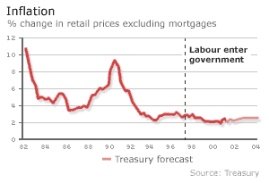It is often argued that this independence has engendered a sense of confidence in UK monetary policy. If markets and individuals believe that the MPC will intervene decisively to restrain inflation, they will modify their behaviour accordingly. For example, firms now feel more at ease to go ahead with vital investment projects, knowing that future inflation is unlikely to spiral out of control. Likewise, trade unions have toned down their wage demands (hence the damaging *wage-price spiral* has been kept at bay) and firms have not always sought to increase prices in response to higher wages. Consequently, since the creation of the MPC in 1997 the UK has sustained a period of low and stable prices, at least until the start of the financial crisis in 2008.

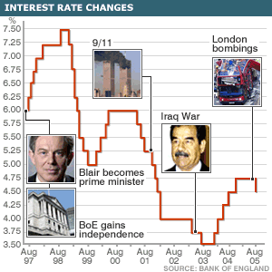One example of the MPC’s decisiveness can be seen in its response to the 9/11 terrorist attacks in 2001. This incident threatened a global slowdown in economic growth as consumer and business confidence fell dramatically. To counter this threat, the MPC immediately cut interest rates from 5.25% to 5%, hence stimulating both consumption and investment demand. But this rate cut was evidently not enough as the MPC continued cutting interest rates virtually every month, until reaching a 48 year low of 3.5% in 2003.

More recently the financial crisis, which erupted in September 2008, has seen the MPC once again responding fast to an exogenous shock. It has aggressively cut interest rates every month since September 2008 – sometimes by more than a quarter per cent at a time – until reaching a new historic low of only 0.5%.

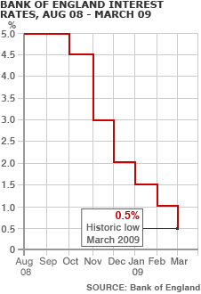It is doubtful whether fiscal policy could be so spontaneous and decisive. The need to organise a proposal for a tax cut and to present it to Parliament in the *Annual Budget* represents a huge time lag, during which time the economy may have slipped further into recession. The MPC, however, meets on a *monthly* basis. Should the economy require a boost, there is never too long to wait before another interest rate decision is to be made; should that decision not go far enough, the MPC will surely meet again in the near future to take corrective action; should there be a crisis, emergency rate changes can even be made overnight.

However, monetary policy does indeed have its own problem of time lags. Firms need time to plan and execute an investment project, so a rate cut won’t immediately take effect. Many mortgages are taken out on a fixed rate for one to three (or more) years, so a number of homeowners won’t feel the pinch of a rate rise for some time. Likewise, consumers often carry on spending despite an increase in interest rates, as it takes time to mentally register that the money would be better off in a savings account. All in all, economists reckon it takes around 18 – 24 months before a change in interest rates fully transmits into aggregate demand.

In itself, this should not really be a problem. All it means is that interest rate decisions must be made 18 – 24 months in advance. But this leads on to another problem: advance decision-making necessitates the use of forecasts. And forecasts are never perfect, especially when they look so far into the future.

This issue was brought to the fore in November 2004, when the House of Lords Economic Affairs Committee stated that the MPC’s record of forecasting inflation *“reveals systematic and persistent errors.”*

The report continued: *“The persistence of inflation below target and the continued apparent absence of strong demand factors in inflation are evidence that interest rates have been kept too high.”*

If this is the case, it is arguable that some investment demand had unnecessarily been deterred in 2004. And on this basis, we could question whether longer term economic growth has also been compromised. One sector of the economy which certainly *has* been compromised is the exporting and manufacturing communities in the North.

It has long been known that the UK hosts an imbalanced *dual economy*. While the service sector and private consumption in the South are often booming, exports and the manufacturing sector in the North are usually stagnating. The former requires higher interest rates to curb inflation while the latter requires lower rates to kick-start the local Northern economies. To make matters worse, higher interest rates attract hot money which bids up the exchange rate value of sterling. This erodes the price competitiveness of UK exports, thereby causing more unemployment in the Northern manufacturing hubs.

Of course the MPC can only deliver one interest rate at a time, and cannot target any particular sector or region. Hence the phrase *“monetary policy is a blunt instrument”.*

Frequently, this single interest rate has been suited to the demands of the South. Indeed Eddie George sparked huge controversy in October 1998 when he suggested that unemployment in the North may well be a price worth paying to maintain low inflation in the South.

The source of this problem surely comes from the narrowness of the MPC’s remit. Namely, price stability: to maintain inflation at 2% ±1%. If this is all that the MPC is going to focus on, then it is likely that UK monetary policy will bring some unintended consequences.

*Monetary Policy, the Credit Crunch and the Banking Crisis*

However, the most significant problem undermining the use of monetary policy today has got to be its lack of effectiveness since the credit crunch began in August 2007. The reasons are quite lengthy and complicated.

Between 2004 and 2006, US interest rates rose from 1% to >5%, triggering a slowdown in the US housing market. Homeowners, many of whom could barely afford their mortgage payments even when interest rates were low, began to default on their mortgages. The problem was particularly acute in the subprime market – that is, high-risk loans to people with poor or no credit history. Not surprisingly, subprime defaults rose to record levels. The impact of these defaults was felt right across the financial system as many of the mortgages had been bundled up and sold on as ‘mortgage-backed securities’ to banks and other investors around the world. Indeed such is the scale of the losses, bad debts and ‘right-downs’ that even some old established banks like Lehman Brothers and Bear Stearns went bankrupt.

The result: banks have lost confidence in the financial system. Nobody really knows who will be next to go bankrupt as a result of these non-performing ‘toxic’ securities that are on the balance sheets of so many financial institutions. Consequently, the credit markets have seized up and are refusing to lend money for fear of not having it repaid. In some cases, banks are unable to lend any further, even they want to, because of their own earlier losses.

This has plunged the UK (and many other countries around the world) into a deep recession, with a reverse multiplier effect. As firms and consumers find it harder to borrow, consumption and investment demand have both fallen. In turn, unemployment is rising as workers are being made redundant and firms are going bankrupt; this has made banks even more nervous about lending.

The traditional response to any recession caused by a lack of spending is for the Bank of England to simply lower interest rates. And this is exactly what the MPC has done. Yet the very essence of the credit crunch is that banks are afraid to lend money. So it’s not the cost of credit that is the problem, it’s the availability of credit. Hence, the commercial banks are still failing to lend to firms and consumers, despite so much ‘cheap money’ being available to them at the Bank of England.

And with rates now at an all-time low of only 0.5%, the Bank of England has had to stop depending on interest rates to reflate the economy. Instead, it started to boost the money supply through ‘quantitative easing’. This involved the Bank buying £375 billion of government and corporate bonds. Effectively, the Bank of England is lending directly to firms and the government, enabling more spending to take place with a positive multiplier effect.

Of course even before this latest initiative was announced, the government had already begun to implement an expansionary fiscal policy, for the first time in around 30 years, in response to the diminishing impact of interest rates. This latest step by the Bank of England is further evidence of how, in the wake of the subprime crisis and the ensuing credit crunch, traditional monetary policy is losing its influence on the macroeconomy.

**Evaluations of Monetary Policy**

|  |
| --- |
|  |
|  |
|  |
|  |
|  |
|  |

# Assignment

**Short-answer questions (Section A)**

1. Which one of the following is most likely to reduce inflationary pressures in an economy?

A An increase in labour productivity

B A fall in the exchange rate of the country’s currency

C A positive output gap

D A decrease in interest rates

[1]

1. In January 2009, the Bank of England set up an Asset Purchase Facility (APF) to buy high-quality assets from commercial banks, financed by the issue of Treasury bills. The main aim of this policy, known as Quantitative Easing, was to:

A Reduce the rate of inflation

B Cause an appreciation in the value of the UK pound

C Increase the money supply

D Reduce real output

[1]

**Data response (Section B)**

**Extract 1: King says inflation surge ‘short term’**

When inflation, measured by the Consumer Price Index (CPI), moves outside the tolerance of 2% + or – 1%, the Governor of the Bank of England is required to write an open letter to the Chancellor explaining the reasons for it. In February 2010 CPI inflation reached 3.5%.

In his February letter the Governor, Mr King, pointed to three factors: the rise in VAT back to its pre-recession 17.5% rate, a sharp increase in oil prices of roughly 70% over the past year, and the sharp depreciation of sterling in 2007 and 2008.

However, Mr King also stressed that inflation might eventually fall below target because of the sharp fall in consumer and investment spending and the build-up of spare capacity in the economy as labour, factories and equipment lie idle.

He noted that the Monetary Policy Committee (MPC) has already cut interest rates to 0.5% and the Bank of England has bought £200 bn of government bonds to encourage the commercial banks to increase lending.

**Extract 2: Unemployment Headlines from the Guardian, March 2010**

* Claimant count falls to 1.59 million people
* Labour Force Survey measure falls 33,000 to 2.45 million people
* But ‘economically inactive’ people rises to record 8.16 million
* Youth unemployment (16–25) reached over 20% (1 million)
* Employment level hits lowest since 2006

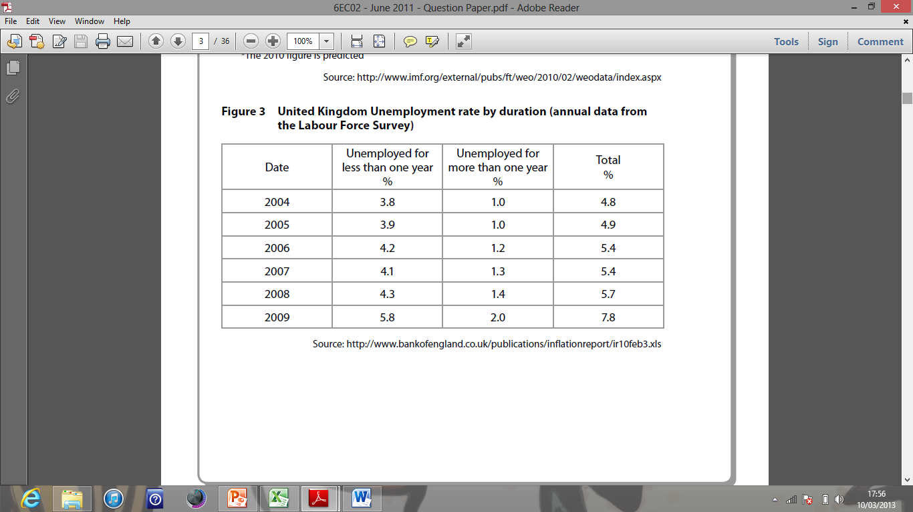**Figure 1: United Kingdom unemployment rate by duration (annual data from the labour force survey)**

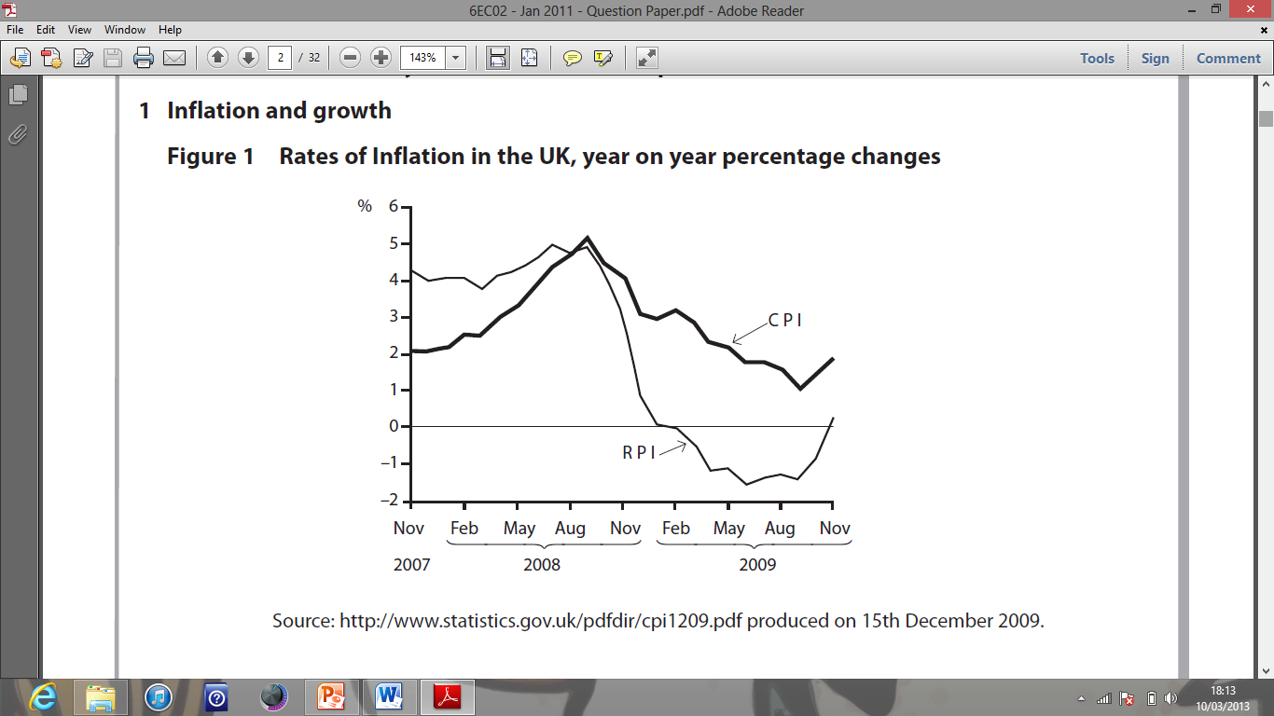**Figure 2: Rates of inflation in the UK, year on year percentage changes**

**Extract 3: Bank of England cuts UK growth forecast again**

Inflation is expected to increase in 2013. Graeme Leach, Chief Economist at the Institute of Directors, warned that the fall in global commodity prices would not continue at the same pace all year. “Brent crude oil prices have edged back up above $100 per barrel and America’s scorching summer has pushed up global corn and wheat prices sharply.” In addition to external cost pressures, some economists remain concerned that domestically generated inflation remains consistently above the 2.0% target. They point to service sector inflation, which held steady at 3.3% in June 2012. The service sector accounts for 77% of UK GDP. Some of the possible reasons for the persistently high level of inflation in this sector are that many services are not internationally tradable, face limited competition and have few opportunities to increase productivity.

For the fourth year in a row the Bank of England’s forecasts of output’s recovery to pre-recession levels have been put back another year. The Bank’s governor said that the Monetary Policy Committee “will do all it can” to bring about recovery. He did not rule out either additional purchases of gilts – known as quantitative easing – beyond the current £375bn programme, or the possibility of a further cut in the Bank’s 0.5% base rate. However, he questioned whether the latter would make much economic difference, and said it might even be counter-productive. He identified the big issue as stagnating output. Growth prospects are uncertain because the future of the Eurozone remains in doubt and UK incomes are being squeezed by falling real wages.

1. Discuss the usefulness of the information provided in Extracts 1 and 2 and Figure 1 to the MPC when making interest rate decisions.

[12]

1. With reference to Figure 2, and your own knowledge, assess the extent to which monetary policy, as conducted by the Monetary Policy Committee, has been a success.

[10]

1. Discuss the likely impact on the UK economy of the further expansionary monetary policy referred to in Extract 3. Use an aggregate demand and aggregate supply diagram in your answer.

[12]

**Essay questions (Section C)**

1. Inflation in the UK fell from 2% in December 2013 to 0% in February 2015, as measured by the Consumer Price Index.

Discuss the issues that the Monetary Policy Committee of the Bank of England might consider when seeking to achieve its inflation target.

[25]

1. To what extent might monetary policy help the UK government achieve its macroeconomic objectives?

[25]

|  |  |
| --- | --- |
| **Planning Grid: Aim = 5 paragraphs - 2 KAA points (16); 2 Eval points (9) with a conclusion** | |
| **KAA Point 1 = signpost key point** |  |
| Application |  |
| Main concept & diagram |  |
| **Eval Point 1 = relate to your earlier point & re-read the title** |  |
| Context / evidence |  |
| **KAA Point 2 = signpost key point** |  |
| Application |  |
| Main concept & diagram |  |
| **Eval Point 2 = relate to your earlier point & re-read the title** |  |
| Context / evidence |  |
| **Conclusion = judgement** |  |
| Context; what does it depend on? |  |

**Question:** 1 OR 2