Policies in a Global Context

# Starter - Discussion Question

**Instructions:**

* Individually consider the below questions
* Discuss your thoughts with a partner
* Share your ideas with the class

*What Macroeconomic policies are used in different countries?*

|  |
| --- |
|  |

# Presentation 1 - Intro to Policies in a Global Context

Complete the activities below so as to have a complete set of notes:

**Recap Definition:** *Fiscal Policy*

……………………………………………………………………………………………………………………………………………………………………………………

……………………………………………………………………………………………………………………………………………………………………………………

*Global Context:* After years of being largely passive, discretionary fiscal policy became a major tool in stabilising economies in the aftermath of the 2008 financial crisis. Many countries used it as a Keynesian tool to stimulate the economy, particularly after COVID-19.

*Example: ______________________________*

……………………………………………………………………………………………………………………………………………………………………………………

……………………………………………………………………………………………………………………………………………………………………………………

……………………………………………………………………………………………………………………………………………………………………………………

……………………………………………………………………………………………………………………………………………………………………………………

**Recap Definition:** *Monetary Policy*

……………………………………………………………………………………………………………………………………………………………………………………

……………………………………………………………………………………………………………………………………………………………………………………

*Global Context:* After years of high interest globally, rates have plummeted to near to zero in an attempt to stimulate AD around the world following the great recession and slow recovery of 2010s. Unconventional Monetary policy is being used increasingly

*Example: ______________________________*

……………………………………………………………………………………………………………………………………………………………………………………

……………………………………………………………………………………………………………………………………………………………………………………

……………………………………………………………………………………………………………………………………………………………………………………

……………………………………………………………………………………………………………………………………………………………………………………

**Recap Definition:** *Supply Side Policy*

……………………………………………………………………………………………………………………………………………………………………………………

……………………………………………………………………………………………………………………………………………………………………………………

*Global Context:* SSPs are strongly advocated to increase economic development as they include: improving education giving workers skills required in a modern economy; improve healthcare to improve life expectancy; encourage entrepreneurship to promote new businesses; and reduce discrimination encouraging increased labour force participation.

*Example: ______________________________*

……………………………………………………………………………………………………………………………………………………………………………………

……………………………………………………………………………………………………………………………………………………………………………………

……………………………………………………………………………………………………………………………………………………………………………………

……………………………………………………………………………………………………………………………………………………………………………………

**Recap Definition:** *Direct Controls*

……………………………………………………………………………………………………………………………………………………………………………………

……………………………………………………………………………………………………………………………………………………………………………………

*Global Context:* Maximum price controls (for example, controls on food prices in the developing world), minimum guaranteed prices (including national minimum wages), buffer stock schemes (Cocoa prices in Ghana and Ivory Coast) and wage controls.

*Example: ______________________________*

……………………………………………………………………………………………………………………………………………………………………………………

……………………………………………………………………………………………………………………………………………………………………………………

……………………………………………………………………………………………………………………………………………………………………………………

……………………………………………………………………………………………………………………………………………………………………………………

# Table Task: Impacts of Policies

**Instructions**

* For the below factors, determine which of four types of polices is/are most relevant, and explain how the policy/policies might affect the factor
* Give examples where you can

|  |  |  |
| --- | --- | --- |
| **Factor** | **Relevant Policy/Policies** | **Explanation** |
| Measures to reduce fiscal deficits and national debts |  |  |
| Measures to reduce poverty and inequality |  |  |
| Measures to increase international competitiveness |  |  |

**Question:** Which policies fit best with the below views of inflation (tip: consider the implications for the role of interest rates and the money supply)

*Milton Friedman’s (Monetarist) view of inflation: ‘inflation is always and everywhere a monetary phenomenon’*

……………………………………………………………………………………………………………………………………………………………………………………

……………………………………………………………………………………………………………………………………………………………………………………

*John Maynard Keynes’ (Keynesian) view of inflation: Changes in money supply perform a more passive role by increasing or decreasing to accommodate changes in the price level.*

……………………………………………………………………………………………………………………………………………………………………………………

……………………………………………………………………………………………………………………………………………………………………………………

# Presentation 2 – Problems Facing Policy Makers

Complete the activities below so as to have a complete set of notes:

**Elaborate:** Elaborate on the below problems facing policy makers

*Inaccurate information:*

……………………………………………………………………………………………………………………………………………………………………………………

……………………………………………………………………………………………………………………………………………………………………………………

For example, GDP and BoP current account figures and expectations are often revised.

*E.g.* 2012 double dip recession revised away

**Question:** *What information might be needed?*

……………………………………………………………………………………………………………………………………………………………………………………

……………………………………………………………………………………………………………………………………………………………………………………

*Risks & uncertainties:*

……………………………………………………………………………………………………………………………………………………………………………………

……………………………………………………………………………………………………………………………………………………………………………………

For example, Uncertain LR impacts of QE and negative IR, predictions of ER fluctuations are based on the health of other economies

*Inability to control external shocks:*

……………………………………………………………………………………………………………………………………………………………………………………

……………………………………………………………………………………………………………………………………………………………………………………

Fiscal prudence in times of high national debt will limit ability to use Fiscal Policy.

An already low interest rate will limit the ability to employ Monetary Policy.

Time lags might be too long for SSP to combat shock

# Causes of Venezuelaâs Hyper-InflationPolicy Task: A letter to The President of Venezuela

**Instructions:**

* Read, highlight and annotate the article
* Discuss your thoughts with a partner
* Write a letter to the president to explain the polices that they should implement to save Venezuela’s economy

**Article**

Venezuela was a powerhouse of South America in the 1990s. Former President Bill Clinton made it his first stop on a trip to the region in 1997. But inequality grew extreme. A small elite class controlled everything while the increasingly impoverished masses fumed. But Chavez’s government far overspent on welfare programs, and it fixed prices for everything. It declared farmlands state property and then abandoned them, and instead made the nation dependent on selling its oil abroad.

The crisis in Venezuela is the socioeconomic and political crisis that Venezuela has undergone since Hugo Chávez's tenure and which extended over the years into the current presidency of Nicolás Maduro. It is the worst economic crisis in Venezuela's history, and the contraction of national and per capita GDPs between 2013 and 2017 has been more severe than that of the United States during the Great Depression, or of Russia, Cuba, and Albania following the fall of communism. During the year 2016, for example, consumer prices rose 800%, the economy contracted by 18.6%, and hunger escalated to the point that the "Venezuela's Living Conditions Survey" (ENCOVI) found nearly 75 percent of the population had lost an average of at least 8.7 kg (19.4 lb) in weight due to a lack of proper nutrition. The murder rate in 2015 was 90 per 100,000 people according to the Observatory of Venezuelan Violence (compared to 5 per 100,000 in the US). In November 2017, the Economist estimated Venezuela's debt at US$105 billion and its reserves at US$10 billion.

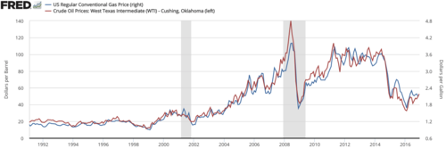The crisis has affected the average life of Venezuelans on various levels. The rise of unemployment resulted in the emergence of social movements aimed at both changing the economic and productive model, as well as questioning the political system and demanding a democratic renewal. Political corruption, scarcity of basic products, closure of companies, deterioration of productivity and competitiveness, and high dependence on oil are other problems that have also contributed to the worsening crisis. The crisis was the result of "Bolivarian Revolution" policies of the Chávez and Maduro governments and has been deepened by low oil prices. According to study published on 2018 by three Venezualan universities, almost 90% of the Venezuelan population now lives in poverty.

Chavez relied on a high oil price, which generates about 96% of its export revenues, to fund his social programme, however with a fall in the oil price this is no longer possible. A 2010 OAS report indicated achievements in addressing illiteracy, healthcare and poverty, and economic and social advances.  From China's slowdown, a steady increase in oil production from the growth of fracking and stable demand, generated a surplus of this resource that caused a drop in prices of reference crude oil, [WTI](https://en.wikipedia.org/wiki/West_Texas_Intermediate) and Brent, falling in 2014 from $100 a barrel to $50 a barrel, causing unfavourable changes in the economy of Venezuela. Due to high oil reserves, lack of policies on private property and low remittances, by 2012, of every 100 dollars, more than 90 came from oil and its derivatives. With oil prices low and the government's cash dwindling, price controls have become a huge problem. The state still subsidizes food far below normal prices to appease the poor.

Shortages in Venezuela have been prevalent following the enactment of price controls and other policies during the economic policy of the Hugo Chávez government. While the Venezuelan government "has essentially stopped" producing official inflation estimates as of early 2018, one estimation of the rate at that time was 5,220 percent. At 5,000 percent, inflation is like a hurricane. Savings are quickly wiped out. Expectations that saving will be fruitless deters people from investing, causing a recession and leading to capital flight. Nobody really knows how much their paycheck will be worth by the time they go to the store to spend it, so the entire labor system is thrown into chaos. Hyperinflation is probably one of a number of reasons why Venezuela, the country with the world’s largest oil reserves, now has starving children.

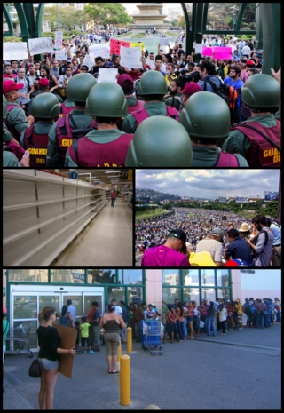At the same time, Maduro's hostility to foreign business has created a corporate exodus. Pepsi (PEP), General Motors (GM)and United (UAL) are just some of the companies that have cut back or left entirely. Unemployment in Venezuela this year could reach 25%, according to the International Monetary Fund. The benchmark interest rate in Venezuela was last recorded at 21.70 percen For several years, Maduro has had a stark choice: Pay down debts to China, Russia and foreign investors -- or buy food and medicine from abroad. Venezuela ships in food primarily from Brazil, Colombia and Mexico because the government stopped cultivating its rich farmland years ago. The crises have literally pushed Venezuela's upper and middle classes out, creating a severe brain drain. Nearly 2 million Venezuelans have left the country since 1999, according to research by Tomas Paez, a sociology professor at the Central University of Venezuela in Caracas. Venezuela is a country of only 30 million people.

Venezuela has a government set two tier exchange rate system for its national currency, the Bolivar. The Bolivar has one exchange rate for what the government determines to be ‘essential goods’ and another for ‘non-essential’ goods. Essential imported goods (food, health, education) get a a better rate of Bolivares to the U.S. Dollar than non-essential goods. While no official statistics are kept, the black market (free market) values the Bolivar at near worthless, irrespective of where the Venezuelan government sets the Bolivar exchange rate. Venezuela no longer has the option of just printing more Bolivares to pay off its debt as their currency is already near worthless. Defaulting might eliminate a source of financial stress, but would result in a further loss in confidence in the Bolivar and ensure that the Bolivar remains near worthless. Investors have long seen a default on Venezuelan sovereign debt as a question of when, not if however Maduro is trying to get creditors to agree to restructure the debt.

**Letter**

Dear President Maduro

Please find below our policy briefing and recommendations:

……………………………………………………………………………………………………………………………………………………………………………………

……………………………………………………………………………………………………………………………………………………………………………………

……………………………………………………………………………………………………………………………………………………………………………………

……………………………………………………………………………………………………………………………………………………………………………………

……………………………………………………………………………………………………………………………………………………………………………………

……………………………………………………………………………………………………………………………………………………………………………………

……………………………………………………………………………………………………………………………………………………………………………………

……………………………………………………………………………………………………………………………………………………………………………………

……………………………………………………………………………………………………………………………………………………………………………………

……………………………………………………………………………………………………………………………………………………………………………………

……………………………………………………………………………………………………………………………………………………………………………………

……………………………………………………………………………………………………………………………………………………………………………………

Yours sincerely,

………………………………………………………………………………………………….

# Presentation 3 – External Shocks

Complete the activities below so as to have a complete set of notes:

**Recap Definition:** *External Shocks*

……………………………………………………………………………………………………………………………………………………………………………………

……………………………………………………………………………………………………………………………………………………………………………………

**Elaborate:** Elaborate on the four below types of external shocks

*Supply Shocks:*

……………………………………………………………………………………………………………………………………………………………………………………

……………………………………………………………………………………………………………………………………………………………………………………

A rise in the cost of important commodities, such as __________________, can cause fuel prices to skyrocket, making it expensive to use for business purposes.

Natural disasters or weather events, such as ____________________________, can induce supply shocks, as can man-made event like wars or major terrorism incidents.

*Demand Shocks:*

……………………………………………………………………………………………………………………………………………………………………………………

……………………………………………………………………………………………………………………………………………………………………………………

An economic downturn in the economy of a major export market can create a negative shock to business investment, particularly in _______________________.

A crash in asset values, such as ___________________, can cause a negative demand shock as households react to a loss of wealth by cutting back sharply on consumption spending.

Supply shocks to consumer commodities with price inelastic demand, such as ___________________, can also lead to a demand shock by reducing consumers real incomes.

*Financial Shocks:*

……………………………………………………………………………………………………………………………………………………………………………………

……………………………………………………………………………………………………………………………………………………………………………………

*Examples:*

……………………………………………………………………………………………………………………………………………………………………………………

*Technology Shocks:*

……………………………………………………………………………………………………………………………………………………………………………………

The introduction of innovations, such as _______________________, and the resulting increase in productivity across many different occupations is an example of a positive technology shock.

**Exam technique:** Tips for Assessing Shocks

* Make good use of AD-AS analysis
* Consider SR and LR effects
* The impact of shocks will vary from country to country
* How big is the shock? How long will it last?
* Consider what policies might be used in response
* Use your Econ Knowledge keep up to date: Coronavirus

# Presentation 4a - Measures to Control Global Companies

Complete the activities below so as to have a complete set of notes:

**Recap Definition:** *Transnational Corporations*

……………………………………………………………………………………………………………………………………………………………………………………

……………………………………………………………………………………………………………………………………………………………………………………

TNCs look to grow their revenues from selling in more markets, but also lowering their average costs through accessing economies of scale.

**Key Question:** *What is the benefit of TNCs?*

……………………………………………………………………………………………………………………………………………………………………………………

……………………………………………………………………………………………………………………………………………………………………………………

……………………………………………………………………………………………………………………………………………………………………………………

……………………………………………………………………………………………………………………………………………………………………………………

**Key Notes:** *Costs of TNCs*

* Profit hungry TNCs can lead to very poor working conditions as they seek to keep costs low.
* Damage to the environment is common as TNCs often ignore local laws and natural resource can be over exploited.
* Most profits flow overseas rather than being reinvested in the local economy.
* Jobs created are insecure - If labour costs were to increase, the company may move elsewhere.

**Elaborate:** Elaborate on the below measures to control global companies

*Resource Regulations:*

……………………………………………………………………………………………………………………………………………………………………………………

……………………………………………………………………………………………………………………………………………………………………………………

……………………………………………………………………………………………………………………………………………………………………………………

*Joint Ventures:*

……………………………………………………………………………………………………………………………………………………………………………………

……………………………………………………………………………………………………………………………………………………………………………………

……………………………………………………………………………………………………………………………………………………………………………………

*Export limits:*

……………………………………………………………………………………………………………………………………………………………………………………

……………………………………………………………………………………………………………………………………………………………………………………

……………………………………………………………………………………………………………………………………………………………………………………

**Elaborate:** Elaborate on the below evaluation of measures to control TNCs

*Measures to control TNCs are hard for countries to enact.* ……………………………………………………………………………………………………………………………………………………………………………………

……………………………………………………………………………………………………………………………………………………………………………………

……………………………………………………………………………………………………………………………………………………………………………………

……………………………………………………………………………………………………………………………………………………………………………………

……………………………………………………………………………………………………………………………………………………………………………………

# Article Task: Does the new G7 tax deal go far enough?

**Instructions:**

* Read, highlight and annotate the article
* Answer the questions
* Discuss your answers as a class

**Article**

A landmark deal struck by rich nations to make multinational companies pay more tax has been criticised by campaigners for not going far enough.

G7 finance ministers meeting in London agreed to battle tax avoidance by making big companies pay more tax in the countries where they do business.

Tech giant firms likely to be impacted have welcomed the new rules.

But the charity Oxfam says an agreed 15% global minimum corporate tax rate is "far too low" to make a difference.

The deal announced on Saturday between the G7 group of wealthy nations - US, the UK, France, Germany, Canada, Italy and Japan, plus the EU - could see billions of dollars flow to governments to pay off debts incurred during the Covid crisis.

UK Chancellor of the Exchequer Rishi Sunak, who hosted the summit, said the agreement would create "a fairer tax system fit for the 21st Century".

The deal agreed in principle that multinational companies pay a minimum tax rate of at least 15% in each country they operate.

But aid charities said the agreed rate is too low and would not stop tax havens from operating.

"It's absurd for the G7 to claim it is 'overhauling' a broken global tax system by setting up a global minimum corporate tax rate that is similar to the soft rates charged by tax havens like Ireland, Switzerland and Singapore," said Oxfam's executive director Gabriela Bucher. "They are setting the bar so low that companies can just step over it."

She said the deal was unfair as it would benefit G7 states, where many of the big companies are headquartered, at the expense of poorer nations.

Alex Cobham, chief executive of the Tax Justice Network, called the deal a "turning point" but said it remained "extremely unfair".

"We've got one step of the way today - the idea of a minimum tax rate - what we need is to make sure that the benefits of that, the revenues, are distributed fairly around the world," he told the BBC.

The agreement will be considered at a meeting next month of the G20, including China and India.

Why did they want to change the rules?

Governments have long grappled with the challenge of taxing global companies operating across many countries.

That challenge has grown with the boom in huge tech corporations like Amazon and Facebook.

At the moment companies can set up local branches in countries that have relatively low corporate tax rates and declare profits there.

That means they only pay the local rate of tax, even if the profits mainly come from sales made elsewhere. This practice is called transfer pricing, it is legal and commonly done.

The deal aims to stop this from happening in two ways.

Firstly the G7 will aim to make companies pay more tax in the countries where they are selling their products or services, rather than wherever they end up declaring their profits.

Secondly, they want a global minimum tax rate so as to avoid countries undercutting each other with low tax rates.

**Questions**

What is meant by Transfer pricing?

……………………………………………………………………………………………………………………………………………………………………………………

……………………………………………………………………………………………………………………………………………………………………………………

How does it allow TNCs to avoid taxes?

……………………………………………………………………………………………………………………………………………………………………………………

……………………………………………………………………………………………………………………………………………………………………………………

How will the new policy prevent the practice of transfer pricing?

……………………………………………………………………………………………………………………………………………………………………………………

……………………………………………………………………………………………………………………………………………………………………………………

……………………………………………………………………………………………………………………………………………………………………………………

Why do critiques say that the new policy does not go far enough?

……………………………………………………………………………………………………………………………………………………………………………………

……………………………………………………………………………………………………………………………………………………………………………………

……………………………………………………………………………………………………………………………………………………………………………………

……………………………………………………………………………………………………………………………………………………………………………………

# Presentation 4b – Transfer Pricing

Complete the activities below so as to have a complete set of notes:

**Definition:** *Transfer Pricing*

……………………………………………………………………………………………………………………………………………………………………………………

……………………………………………………………………………………………………………………………………………………………………………………

It is used by TNCs as a form of tax avoidance (meaning that it is legal, unlike tax evasion).

**Key Notes:** *Workings of Transfer Pricing*

Suppose a firm produces Good X in Country A, and then transports it to Country B to make it into Good Y, which it then sells.

If Country A has a high rate of corporation tax (tax on profit) and Country B a low rate, the TNC can reduce its total taxes by putting a very high artificial price on Good X, before sending it to country B

Pre-tax profits are then reduced in Country A and increased in Country B (whilst maintaining the same pre-tax profits in total)

Thus the MNC makes a tax saving.

**Elaborate:** Elaborate on the below key example of transfer pricing

*In the UK, Starbucks paid just £4m of tax in 2019 despite raking in £387m in sales.*

……………………………………………………………………………………………………………………………………………………………………………………

……………………………………………………………………………………………………………………………………………………………………………………

……………………………………………………………………………………………………………………………………………………………………………………

……………………………………………………………………………………………………………………………………………………………………………………

**Key Question:** *How can transfer pricing be regulated?*

……………………………………………………………………………………………………………………………………………………………………………………

……………………………………………………………………………………………………………………………………………………………………………………

*Arm’s Length Principle:*

……………………………………………………………………………………………………………………………………………………………………………………

……………………………………………………………………………………………………………………………………………………………………………………

**Key Example:** *G7 June 2021*

The G7 countries recently agreed to a global minimum corporate tax rate of 15% to reduce the returns for TNCs in moving their business units.

This should hopefully reduce the practice of transfer pricing as the TNCs in these countries as there are fewer gains to be made from it.

# Assignment

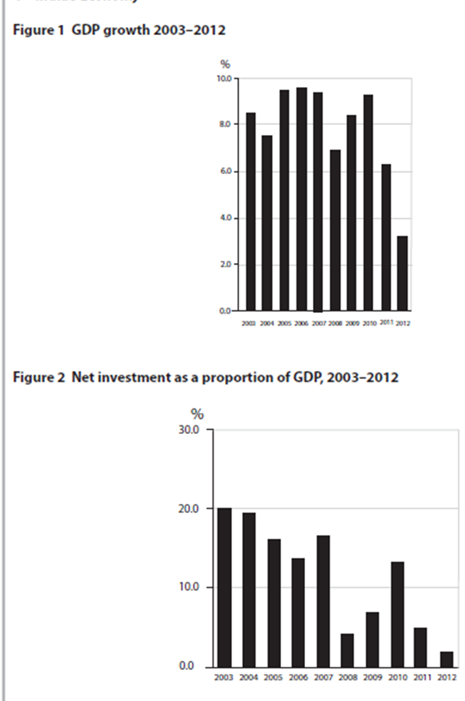**Section B (Data Response)**

**Question**

Discuss the case for the Indian government using policies to ‘stimulate domestic manufacturing’ (Extract 1, line 23) as a means of promoting sustainable economic growth [15]

**Question:** Discuss the case for the Indian government using policies to ‘stimulate domestic manufacturing’ (Extract 1, line 23) as a means of promoting sustainable economic growth [15]

|  |  |
| --- | --- |
| **Planning Grid: Aim = 4 paragraphs - 2 KAA points (9); 2 Eval points (6)** | |
| **KAA Point 1 = signpost key point** |  |
| Application |  |
| Main concept & diagram |  |
| **Eval Point 1 = relate to your earlier point & re-read the title** |  |
| Context / evidence |  |
| **KAA Point 2 = signpost key point** |  |
| Application |  |
| Main concept & diagram |  |
| **Eval Point 2 = relate to your earlier point & re-read the title** |  |
| Context / evidence |  |