Public Goods

Starter: Recap Markets and Market Failures

**Instructions:** Test yourself with the below quick questions

What is meant by a market?

……………………………………………………………………………………………………………………………………………………………………………………

……………………………………………………………………………………………………………………………………………………………………………………

What diagram explains how a market allocates resources?

……………………………………………………………………………………………

……………………………………………………………………………………………

What determines the allocation of resources in the diagram?

……………………………………………………………………………………………

……………………………………………………………………………………………

……………………………………………………………………………………………

How is the welfare of those in the market shown in this diagram?

……………………………………………………………………………………………………………………………………………………………………………………

……………………………………………………………………………………………………………………………………………………………………………………

What is meant by market failure?

……………………………………………………………………………………………………………………………………………………………………………………

……………………………………………………………………………………………………………………………………………………………………………………

What is the difference between partial and complete market failure?

……………………………………………………………………………………………………………………………………………………………………………………

……………………………………………………………………………………………………………………………………………………………………………………

# Presentation 1 – Intro to Public Goods

Complete the activities below so as to have a complete set of Notes:

**Definition:** *Public Good*

‘Where a good is both non-rivalrous and non-excludable in consumption.’

*Non-rivalrous:*

……………………………………………………………………………………………………………………………………………………………………………………

……………………………………………………………………………………………………………………………………………………………………………………

*E.g.* A pedestrian’s use of streetlights does not prevent the next pedestrian from using them too.

*Non-excludable:*

……………………………………………………………………………………………………………………………………………………………………………………

……………………………………………………………………………………………………………………………………………………………………………………

*E.g.* It is not possible to stop one person from accessing street lighting whilst others are able to use it.

**Key Question:** What is meant by the ‘Free Rider Problem’?

……………………………………………………………………………………………………………………………………………………………………………………

……………………………………………………………………………………………………………………………………………………………………………………

……………………………………………………………………………………………………………………………………………………………………………………

……………………………………………………………………………………………………………………………………………………………………………………

**Question:** What do you think the free-market equilibrium will look like for a public good?

**Definition:** *Quasi-Public Good*

……………………………………………………………………………………………………………………………………………………………………………………

……………………………………………………………………………………………………………………………………………………………………………………

**Question:** Can you think of any examples of Quasi-Public goods?

……………………………………………………………………………………………………………………………………………………………………………………

# Task: Public Good Spotter

**Instructions:**Determine whether the below goods are non-rivalrous, non-excludable and hence can be considered a public good.

|  |  |  |  |
| --- | --- | --- | --- |
| **Good** | **Rivalrous or Non-Rivalrous?** | **Excludable or Non-excludable?** | **Public good, Private good or Quasi-Public Good?** |
| Roads |  |  |  |
| Fresh water on tap |  |  |  |
| National Defence |  |  |  |
| TFL tube services |  |  |  |
| A crowded public beach |  |  |  |
| A lighthouse |  |  |  |
| Basic foodstuffs |  |  |  |

**Tip:** consider whether the good would be traded in a free-market or not

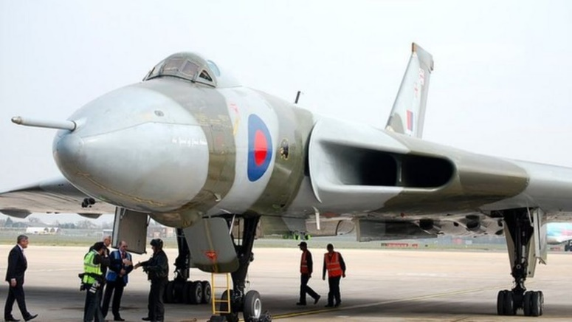Article Task: Air Shows

**Instructions:**

* Read, highlight, and annotate the article.
* Answer the key questions.
* Discuss your answers as a class.

**Article**

*‘Bob Jones Memorial Air Show urges people to buy tickets’*

People are being urged to pay to enter a Powys air show instead of watching the displays from the surrounding hillsides.

The Bob Jones Memorial Air Show in Welshpool is being held on Sunday and attracts about 5,000 visitors a year. The organisers have said they might increase the £5 entrance fee next year to compensate for those refusing to pay.

This year's air show at Welshpool airport features a former RAF Vulcan bomber, the Battle of Britain Memorial Flight and an RAF Typhoon fighter jet. But one of the organisers, Dr John Morgan, said people refusing to pay to enter the show were having an impact on its cash flow.

"It's a minority of people who watch from the hillsides," he said.

"They don't make a significant drain on the show, but they are draining it. It does start to have a real impact on the show. We need as much money as we can to help build the show. We can't stop people [watching from the hillsides] but perhaps we can make then understand that they need to come to the show and pay."

Dr Morgan said the entry fee was £5 for adults, £3 for children, while a family ticket was £15.

Last year staff from the show asked for contributions from those watching on the hills overlooking the event.

"People were not for giving much at all and it was noticeable how much copper was in the buckets we'd used and there were hardly any notes," Dr Morgan added.

"The impact of all this means that we might have to consider increasing the prices next year."

*(Date: 9 June 2013, Source: BBC NEWS, Link:* [*https://www.bbc.co.uk/news/uk-wales-mid-wales-22800389*](https://www.bbc.co.uk/news/uk-wales-mid-wales-22800389)*)*

**Questions**

Explain how the free-rider problem is in action in this article.

……………………………………………………………………………………………………………………………………………………………………………………

……………………………………………………………………………………………………………………………………………………………………………………

Can the air show be considered a public good?

……………………………………………………………………………………………………………………………………………………………………………………

……………………………………………………………………………………………………………………………………………………………………………………

**Challenge:** If air shows are a public good, why do people still pay?

……………………………………………………………………………………………………………………………………………………………………………………

……………………………………………………………………………………………………………………………………………………………………………………

# Presentation 2 – Under-Provision of Public Goods

Complete the activities below so as to have a complete set of Notes:

**Diagram:** The under-provision of public goods in the free market.

**Key Notes:** Elaborate on the below ideas.

*Private Benefits:* A public good benefits all individuals

……………………………………………………………………………………………………………………………………………………………………………………

……………………………………………………………………………………………………………………………………………………………………………………

……………………………………………………………………………………………………………………………………………………………………………………

……………………………………………………………………………………………………………………………………………………………………………………

*Costs:* No individual’s gain is sufficiently high enough for them to pay the cost for the good to be provided

……………………………………………………………………………………………………………………………………………………………………………………

*Free-market result:*

……………………………………………………………………………………………………………………………………………………………………………………

*Social Benefit:*The benefit to society of a public good exceeds that to an individual

……………………………………………………………………………………………………………………………………………………………………………………

……………………………………………………………………………………………………………………………………………………………………………………

……………………………………………………………………………………………………………………………………………………………………………………

……………………………………………………………………………………………………………………………………………………………………………………

*Social Optimum:* Occurs where the MSB is equal to the MSC (QSO)

……………………………………………………………………………………………………………………………………………………………………………………

……………………………………………………………………………………………………………………………………………………………………………………

# Assignment

**Short-answer questions (Section A)**

1. Which of the following statements about public goods is true?

[1]

A They are only provided by the price mechanism

B They involve **no** opportunity cost in their provision

C They are also known as ‘free goods’

D They are characterised by the free rider problem

1. Explain why street lighting is considered a public good.

[3]

……………………………………………………………………………………………………………………………………………………………………………………

……………………………………………………………………………………………………………………………………………………………………………………

……………………………………………………………………………………………………………………………………………………………………………………

……………………………………………………………………………………………………………………………………………………………………………………

……………………………………………………………………………………………………………………………………………………………………………………

……………………………………………………………………………………………………………………………………………………………………………………

1. Market failure arises in a free-market economy when:

[1]

A Prices fall in response to an excess supply

B Public goods are under-provided

C Firms exit a market

D Government intervention leads to a misallocation of resources

1. Which of the following forms of government intervention could help to solve the free rider problem?

[1]

A State provision of public goods

B Taxation on the consumption of public goods

C Banning the consumption of luxury goods

D Granting of subsidies to goods which yield high external costs

1. **Challenge:** If the good in the table below is a public good and Pat and Al are the only members of society, then the efficient quantity to produce is:

[1]

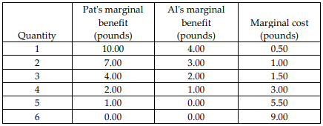A 3 units.

B 4 units.

C 6 units.

D 2 units.

**Data Response (Section A)**



With reference to Extract 2, assess whether the roads built by the KCU in Tanzania are public or private goods

[10]

............................................................................................................................................................................................

............................................................................................................................................................................................

............................................................................................................................................................................................

............................................................................................................................................................................................

............................................................................................................................................................................................

............................................................................................................................................................................................

............................................................................................................................................................................................

............................................................................................................................................................................................

............................................................................................................................................................................................

............................................................................................................................................................................................

............................................................................................................................................................................................

............................................................................................................................................................................................

............................................................................................................................................................................................

............................................................................................................................................................................................

............................................................................................................................................................................................

............................................................................................................................................................................................

............................................................................................................................................................................................

............................................................................................................................................................................................

............................................................................................................................................................................................

............................................................................................................................................................................................

............................................................................................................................................................................................

............................................................................................................................................................................................