Public Sector Finance

# Starter - Recap Questions

**Instructions:** Test yourself with the below quick question

What is meant by a budget deficit?

……………………………………………………………………………………………………………………………………………………………………………………

……………………………………………………………………………………………………………………………………………………………………………………

How is a budget deficit paid for?

……………………………………………………………………………………………………………………………………………………………………………………

……………………………………………………………………………………………………………………………………………………………………………………

What is meant by the national debt?

……………………………………………………………………………………………………………………………………………………………………………………

……………………………………………………………………………………………………………………………………………………………………………………

# Presentation 1 – Intro to Public Sector Finance

Complete the activities below so as to have a complete set of Notes:

**Definition:** *Government Budget:*

……………………………………………………………………………………………………………………………………………………………………………………

……………………………………………………………………………………………………………………………………………………………………………………

**Match-up:** Draw lines to connect each term to the correct definiton

|  |  |  |
| --- | --- | --- |
| Balanced Budget |  | When government expenditure exceeds government revenue (G>T) |
|  |  |  |
| Budget Deficit |  | When government expenditure is equal to government revenue (G=T) |
|  |  |  |
| Budget Surplus |  | When government revenue exceeds government expenditure (G<T) |

**Key Stat:** The UK government has run a budget deficit every year since 2000/01

**Key Notes:** Types of budget deficit

*Cyclical budget deficit:*

……………………………………………………………………………………………………………………………………………………………………………………

……………………………………………………………………………………………………………………………………………………………………………………

Should balance out with cyclical surpluses over the economic cycle

Occurs due to automatic stabilisers (features of the structure of modern fiscal policy which automatically act to dampen fluctuations in the Economic cycle)

*Structural budget deficit:*

……………………………………………………………………………………………………………………………………………………………………………………

……………………………………………………………………………………………………………………………………………………………………………………

Structural deficits mean that national debt will be growing over time!

Occurs due from unbalanced discretionary fiscal policy

**Definition:** *Government borrowing*

……………………………………………………………………………………………………………………………………………………………………………………

……………………………………………………………………………………………………………………………………………………………………………………

**Key Question:** How does the government borrow money?

……………………………………………………………………………………………………………………………………………………………………………………

……………………………………………………………………………………………………………………………………………………………………………………

**Definition:** *National Debt*

……………………………………………………………………………………………………………………………………………………………………………………

……………………………………………………………………………………………………………………………………………………………………………………

**Stat:** In July 2020, the UK’s national debt exceeded £2 trillion for the first time

**Data:** Label the graphs axes and titles

_____

­

**Key Note:** *The Golden Rule*

A guideline for fiscal policy states that over the economic cycle, the Government will borrow only to invest and not to fund current spending.

# https://upload.wikimedia.org/wikipedia/commons/thumb/2/28/Westminster_and_big_ben.jpg/1280px-Westminster_and_big_ben.jpgArticle Task: Britain's budget deficit - Simply red

**Instructions:**

* Read, highlight and annotate the article
* Answer the questions
* Discuss your answers as a class

**Article**

*As we approach the end of its five-year term, the British government has made surprisingly slow progress in cutting its deficit*

The mess in Britain's finances has three main causes. The first is that the crisis of 2007 arrived when the budget was in relatively poor shape. Tax receipts during the bubble years were weaker than the Treasury expected, which meant that even with the economy booming the deficit stood at close to £40bn.

The second factor was the depth and duration of the recession. Deficits tend to rise during downturns because tax receipts fall and spending on unemployment and other welfare payments rise. In Britain's case, the economy contracted by more than 6% over six successive quarters from early 2008 to late 2009. By the time growth resumed national output was 10% lower than it would have been had the economy continued to expand at its normal rate of around 2.5% a year. That punched a hole in the public finances.

Finally, the VAT holiday and help for the unemployed, designed to mitigate the effects of the recession, cost around £25bn, or around 1.5% of GDP, much smaller in relation to the size of the UK economy than the packages used to support growth in the United States or China.

Part of the deficit is deemed to be cyclical – it will disappear once the economy grows strongly. The other part, the £70bn structural element, is what the government wants to eliminate during the current parliament. The bank bailouts have little impact: the Treasury does not count money used to buy bank shares because it assumes it will get it back.

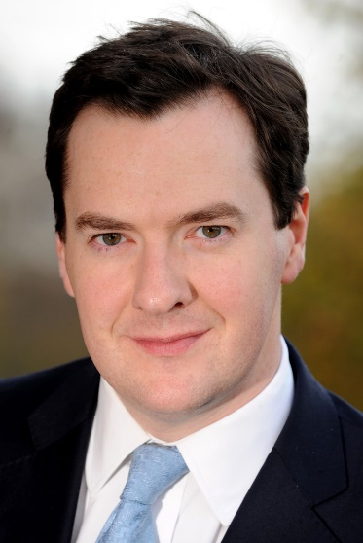When the current British government took office, chancellor George Osborne said in his first Budget that he aimed to "have debt falling and a balanced structural budget deficit by the end of this Parliament". With eight months to go before the election, the ONS announced yesterday that public sector borrowing in the first six months of the current financial year was £45.4 billion ($74.2 billion); higher than the deficit for the same period in the previous year. This seems particularly surprising, given the recovery in the economy*. The rising employment figures show that the UK workforce is active and there are questions about their desire to consume. And it raises some questions about whether there may be structural reasons why the deficit is much harder to close than before. The weakness, according to the Office for Budget Responsibility, is in part down to income tax receipts which are 0.8% lower year-on-year. Two factors may be at work; at the start of the 2013-14 tax year, the top rate of tax was cut from 50% to 45%. That undoubtedly caused some high-earners to shift their income from 2012-13 to the 2013-14 tax year. That boosted income tax receipts in the early month of last year, and has slowed the annual change now. Secondly, a lot of the new jobs being created are part-time or low-paid. Those who earn less than £10,000 do not pay income tax at all. The government does get one off receipts such as the sale of RBS sales. In June 2018 Philip Hammond restarted the sale of government owned shares in Royal Bank of Scotland, offloading a stake worth almost £2.6bn to City investors at a loss. The chancellor, through UK Financial Investments, which owns the RBS stake on behalf of the government, kickstarted the sale of 925 million shares, representing about 7.7% of the bank’s stock.

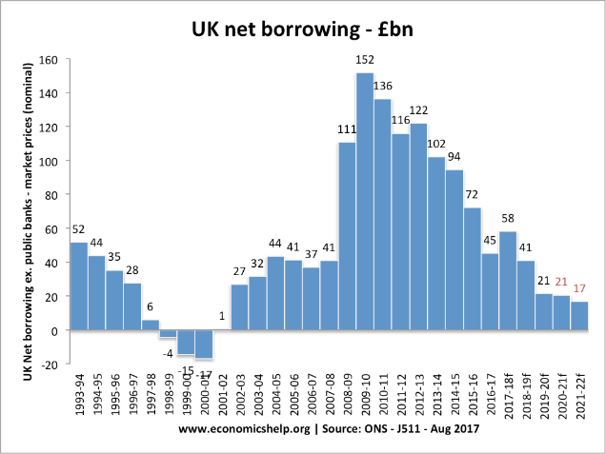So what about the cuts? Clearly, there have been big squeezes in certain areas, such as funding to local councils. The problem for the government is that it has to run fast to stand still. Here are the figures from the ONS for the first half of the year. Even with ultra-low interest rates, the interest cost in the first half of 2014 was £24 billion, compared with £14 billion in the first half of 2009, the year before the government took office. Social benefits have risen from £79 billion to £95 billion over the same period. The government has brought in the benefits cap and frozen benefits but they still have a long way to go. Take those numbers out of the totals for current expenditure and "other spending" has risen from £186 billion to £210 billion over the same period, a 12.9% nominal increase. Inflation has risen 15.1% over the last five years, so that it is a cut in real terms. But it is tough going. Total current expenditure in the first half of the year was £330 billion, compared with £279 billion in H12009. For a full year comparison, 2013 current expenditure was £637 billion, compared with £562 billion in 2009.

The big cut, of course, has been in net investment which was £32 billion in the first half of 2009 and was only £18 billion in the first half of this year. The full year numbers were £55 billion in 2009-10 and £31 billion in 2013-14 (just £26 billion in 2011-2012). In Keynesian terms, this is the wrong thing to cut since capital spending is the most likely to have a multiplier effect on the economy. Total tax receipts in the first half of the year were £302 billion, compared with £308 billion in H12013, £284 billion in H1 2012, £276 billion in H1 2011, £263 billion in H12010, and £246 billion in H12009. So on the first half figures alone, taxes are up £56 billion and current expenditure is up £51 billion over the last five years. Running to stand still, as I say.

So perhaps there is a fundamental problem. On the tax side, our more unequal society has resulted in a large proportion of revenues coming from a small number of taxpayers, both individual and corporate. The top 1% of taxpayers paid 28% of all income tax in 2013-14. The return on bank equity has fallen and this has kept the lid on bonuses; a good thing, most people may think, but bad for the taxman. Push the rate up too high and many of these people may go elsewhere; the banks they work for are largely foreign. The rest of the workforce is barely seeing any real wage growth. The net effect is that, while employment is up 5% over the last four years, income tax receipts have fallen 4% in real terms. Meanwhile the government is slashing corporate tax rates to try to attract business to the country. We should also consider the UK’s aging population in future years, especially if the UK leave the EU and the flow of young immigrants dries up. On the spending side, there is a limit to how much the government can squeeze. A commitment to preserve NHS spending in real terms has done little to protect the government from attacks on this issue by Labour, whose leader pledged to add £2.5 billion to health spending in his conference speech; pensioners have also been ring-fenced with their incomes being linked to inflation. Despite the improving picture over the course of the year, the latest figures will likely frustrate the chancellor as he prepares for the autumn budget while considering ways to pay for the £20bn annual increase in NHS spending due by 2023-24 which was promised by Theresa May earlier this year. It is easy to imagine that the deficit will not close by the end of the next Parliament either. No doubt the Chancellor is very happy that the Bank of England owns £375 billion of gilts and currently hands back the interest to the government. Imagine what the finances would like without this help.

**Questions:**

What are the causes of the UK’s budget deficit and are they structural or cyclical?

……………………………………………………………………………………………………………………………………………………………………………………

……………………………………………………………………………………………………………………………………………………………………………………

……………………………………………………………………………………………………………………………………………………………………………………

……………………………………………………………………………………………………………………………………………………………………………………

……………………………………………………………………………………………………………………………………………………………………………………

……………………………………………………………………………………………………………………………………………………………………………………

What are the discretionary fiscal policies that the government have implemented since the GFC?

……………………………………………………………………………………………………………………………………………………………………………………

……………………………………………………………………………………………………………………………………………………………………………………

……………………………………………………………………………………………………………………………………………………………………………………

……………………………………………………………………………………………………………………………………………………………………………………

……………………………………………………………………………………………………………………………………………………………………………………

……………………………………………………………………………………………………………………………………………………………………………………

# Presentation 2 – Factors affecting the size of Deficits and Debt

Complete the activities below so as to have a complete set of Notes:

**Key Note:** As debt is the accumulation of years of deficit (and the occasional surplus), the causation of the two are intrinsically linked

I.e. Factors causing higher deficits will lead to higher debts

**Elaborate:** Elaborate on the below factors affecting the size of the budget deficit, consider in terms of G and T

*Recession causing rising unemployment:*Workers lose their jobs

……………………………………………………………………………………………………………………………………………………………………………………

……………………………………………………………………………………………………………………………………………………………………………………

……………………………………………………………………………………………………………………………………………………………………………………

……………………………………………………………………………………………………………………………………………………………………………………

*The political landscape:*Conservatives vs Labour

……………………………………………………………………………………………………………………………………………………………………………………

……………………………………………………………………………………………………………………………………………………………………………………

*Economic Shocks:*Unplanned events like COVID-19 pandemic or the GFC require governments to make huge interventions in the economy

……………………………………………………………………………………………………………………………………………………………………………………

*Housing Markets:* Governments raise an important amount tax revenue from stamp duty, a tax on the sale of houses

……………………………………………………………………………………………………………………………………………………………………………………

**Key Notes:** *Further factors affecting the size of national debt*

*Rate of Interest:*Higher rates of interest will mean more has to be paid back into the future

*Government Policy:*Is the government actively trying to reduce the debt, or are they happy to borrow in accordance with the Golden rule?

# International Monetary Fund - WikipediaArticle task: Public debt - How much is too much?

**Instructions:**

* Read, highlight and annotate the article
* Make notes for the key discussion question
* Discuss your thoughts as a class

**Article**

*A new paper from the IMF suggests that countries should not pay back debt at expense of growth*

PUBLIC debt in rich countries exploded between 2007 and 2012, rising from an average of 53% of GDP to nearly 80%. Some people think this is a problem, and say that governments need to do their best to cut it. But that view has been challenged in a new paper from the International Monetary Fund, which suggests that “paying down the debt” (or in the words of George Osborne, Britain's chancellor of the exchequer, “fixing the roof while the sun is shining”) is not the most sensible approach. However many argue that austerity is self-defeating due to its impact on growth and consequently the debt:GDP ratio. This is especially true if the fiscal multiplier is large and if the spending has supply side impacts.

The IMF's economists reckon that if a government could choose between having high or low debt today, then all else equal they would (and should) choose the latter. After all, when debt is high governments have to impose unpleasant taxes to fund spending on debt-interest payments. These taxes are a drag on the economy and there is an opportunity cost to the spending on debt interest repayments. It is also inequitable that future generations bear the brunt of current spending, however this depends on how the money is spent? Some would also argue that a shrinking state encourages private sector growth (avoiding crowding out) and as private sector firms are more efficient due to the profit motive this can boost long run growth, potentially crowding in further private investment. However if an economy faces a liquidity trap, when expansionary monetary policy is ineffective due to low confidence of banks and consumers, then it is wrong to cut government spending.

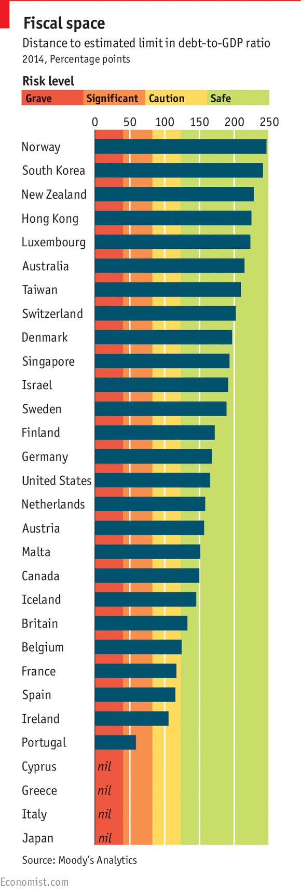But when a government is faced with a high debt load, is it better to impose austerity and pay it down, or take advantage of low interest rates and low bond yields to invest? The answer depends on the amount of “fiscal space” a government enjoys. This concept refers to the distance between a government’s debt-to-GDP ratio and an “upper limit”, calculated by Moody’s, a ratings agency, beyond which action would have to be taken to avoid default. The size of the national debt will also effect the credit rating of a country and consequently the cost of financing that debt i.e. interest payments. Too high a national debt may also imply financial instability and consequently lower inward foreign direct investment, thus slowing LRAS growth. Based on this measure, countries can be grouped into categories depending on how far their debt is from their upper threshold: safe (green), caution (yellow), significant risk (amber) and grave risk (red). It is a decent measure of how vulnerable a government’s finances are to a shock.

For those countries with no headroom (in the red or amber zone on the chart), the IMF’s paper is not much use: they need to take action to reduce their borrowing levels. But for countries well into the green zone (of which America is a star performer and Britain is a somewhat marginal case), the IMF’s analysis has a clear message: don’t worry about your debt.

For these countries, the wonks argue that the costs of raising taxes or cutting useful spending to reduce debt levels outweighs any benefits. For countries safely in the green zone, the authors present an example of a country reducing its debt from 120% to 100% of GDP. They calculate that the expected costs of the higher taxation (for instance, from the disincentives to work created by increased tax rates) are likely to outweigh the expected benefits (from the lower risk of a default in the event of a crisis) by a factor of ten.

What should such countries do instead? The best thing, the paper says, is simply to let economic growth take its course. In the long run, if the economy grows more quickly than debt, the burden of it will fall as a percentage of GDP. However if there is a structural rather than cyclical budget deficit then national debt may continue to rise, it all depends on what is growing quicker debt or GDP. We should also question if an unforeseen event has occurred, causing the government to need to borrow for example bailing out banks or in times of natural disasters.

Their analysis is necessarily simplified; they are much more concerned with long-run dynamics than the effect of borrowing on growth in the short run (which may often be the more relevant question for governments on time-limited electoral mandates). But it is a useful reminder that high public debt should not necessarily cause panic. Indeed, as previous IMF research has shown, the trajectory of debt-to-GDP ratios can matter more than their overall level. Often, the fundamental trade-offs between the costs and benefits of borrowing for investment are underplayed. Perhaps governments should take a more reasoned look at the roof before rushing in to fix it.

**Discussion Question**

*Is a rising national debt a cause for concern?*

|  |
| --- |
| Note Space |

# Presentation 3 – Impacts of Debt and Deficits

Complete the activities below so as to have a complete set of Notes:

**Pro or Con:** Determine whether the following impacts are positive or negative impacts of deficits and debt

***Extension:*** Elaborate on why each impact is positive or negative

|  |  |  |
| --- | --- | --- |
| **Impact** | **Pro or Con?** | **Elaborate** |
| Temporary deficits can protect economic welfare |  |  |
| Infrastructure investment will increase LRAS |  |  |
| Equity issue with debt burden |  |  |
| High deficits and debt will reduce investor confidence– less FDI into the UK |  |  |
| A deficit can help kick start growth in an economy, which helps pay back debt. Shrinks debt as a percentage of GDP |  |  |
| Debt interest payments need paying back in future -higher T or lower G |  |  |
| The need to borrow more leads to higher yield rates, which may reduce private sector growth |  |  |
| Can stimulate AD. A deficit can help an economy escape a liquidity trap (savings ratio is high despite low interest rate - mon. pol. is ineffective) |  |  |
| Deficits in a boom period are particularly unsustainable. They are structural deficits. |  |  |
| More borrowing may reduce a country’s credit rating. More debt servicing costs! |  |  |
| Inflation risks from increasing the money supply |  |  |

**Key evaluation of positive impacts:**

High deficits to stimulate an economy mat act as a signal that future tax rates will rise. This might lead some to start saving now, cutting C and I

**Key evaluation of negative impacts:**

If interest rate is low, borrowing may not be that costly

# Presentation 4 – Policies to Control Debt and Deficits

Complete the activities below so as to have a complete set of Notes:

**Definition:** *Fiscal Austerity*

……………………………………………………………………………………………………………………………………………………………………………………

……………………………………………………………………………………………………………………………………………………………………………………

**E.g.** Benefit freezes under Cameron’s coalition government.

Reduce bureaucracy & X-inefficiency as it encourages cost cutting by firms

Aim of removing structural deficit

**Elaborate:** Elaborate on the below policies

*Supply Side Reform*

……………………………………………………………………………………………………………………………………………………………………………………

……………………………………………………………………………………………………………………………………………………………………………………

*Use of automatic stabilisers:*

……………………………………………………………………………………………………………………………………………………………………………………

……………………………………………………………………………………………………………………………………………………………………………………

……………………………………………………………………………………………………………………………………………………………………………………

……………………………………………………………………………………………………………………………………………………………………………………

*Inflation:*

……………………………………………………………………………………………………………………………………………………………………………………

……………………………………………………………………………………………………………………………………………………………………………………

**Definition:** *Default on debt*

……………………………………………………………………………………………………………………………………………………………………………………

……………………………………………………………………………………………………………………………………………………………………………………

**However:** Doing this will make it very difficult to borrow in future and a government would have to offer very high interest rates

# Debate Task: Austerity

**Instructions:**

* Read, highlight and annotate the below stimulus material
* In your team plan arguments for your side of the debate, and counter-arguments for the other point of view
* Debate as a class

**Debate Motion**

*‘This house believes that the Coalition Government was right to pursue a policy of Austerity from 2010’*

My side are arguing:__________________________________

**Stimulus**

**Arguments in Favour:**

1. Reducing debt in long run interests of economy – helps to keep UK taxes lower
2. Shrinking state encourages private sector growth
3. High opportunity cost from £billions on debt interest
4. Cutting deficits increases investor confidence – attracts FDI into the UK
5. Upturn of cycle is time for government to borrow less – ahead of another downturn

**Arguments Against:**

1. Austerity is self-defeating e.g. increase in welfare payments & lower growth (fiscal dividend/debt:GDP)
2. Government bond yields are low – a time to invest more
3. Infrastructure investment will increase AD and LRAS
4. Wrong to cut spending when economy is in liquidity trap
5. Economic growth is needed to pay back the debt and fiscal austerity makes this harder to achieve

|  |
| --- |
| Note Space: |

# Assignment

**Section C (Essay)**

To what extent is a rising national debt a problem for the UK economy

[25]

To what extent is a rising national debt a problem for the UK economy [25]

|  |  |
| --- | --- |
| **Planning Grid: Aim = 5 paragraphs - 2 KAA points (16); 2 Eval points (9) with a conclusion** | |
| **KAA Point 1 = signpost key point** |  |
| Application |  |
| Main concept & diagram |  |
| **Eval Point 1 = relate to your earlier point & re-read the title** |  |
| Context / evidence |  |
| **KAA Point 2 = signpost key point** |  |
| Application |  |
| Main concept & diagram |  |
| **Eval Point 2 = relate to your earlier point & re-read the title** |  |
| Context / evidence |  |
| **Conclusion = judgement** |  |
| Context; what does it depend on? |  |