Taxation

# Starter - Recap Question

**Instructions:** Test yourself with the below quick question

What is an indirect tax?

……………………………………………………………………………………………………………………………………………………………………………………

……………………………………………………………………………………………………………………………………………………………………………………

What is a direct tax?

……………………………………………………………………………………………………………………………………………………………………………………

……………………………………………………………………………………………………………………………………………………………………………………

What taxes do you know?

……………………………………………………………………………………………………………………………………………………………………………………

……………………………………………………………………………………………………………………………………………………………………………………

***Extension:*** How might taxes changes in future?

……………………………………………………………………………………………………………………………………………………………………………………

……………………………………………………………………………………………………………………………………………………………………………………

……………………………………………………………………………………………………………………………………………………………………………………

# Presentation 1 – Intro to Taxation

Complete the activities below so as to have a complete set of Notes:

**Definition:** *Direct taxation*

……………………………………………………………………………………………………………………………………………………………………………………

……………………………………………………………………………………………………………………………………………………………………………………

**E.g.** Direct taxes include income tax, inheritance tax, national insurance contributions, capital gains tax, and corporation tax (a tax on company profits)

The burden of a direct tax cannot be passed on, and is paid by the individual or organisation that it is levied on

**Definition:** *Indirect taxation*

……………………………………………………………………………………………………………………………………………………………………………………

……………………………………………………………………………………………………………………………………………………………………………………

**E.g.** Indirect taxes include excise duties on fuel, cigarettes and alcohol and Value Added Tax (VAT) on many different goods and services

Producers may be able to pass on an indirect tax, depending on price elasticity of demand and supply

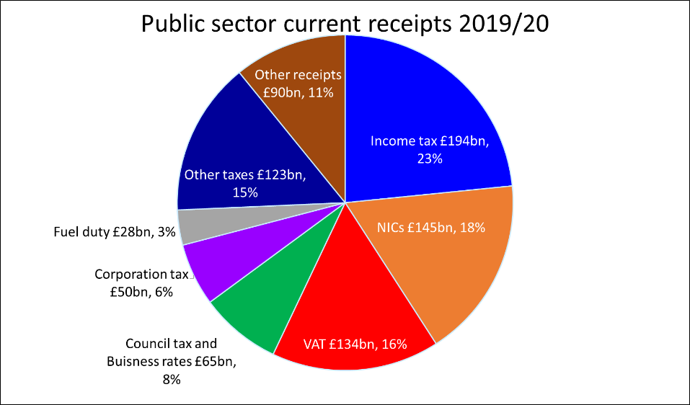**Data:** UK tax receipts 2019/20

(Source: House of Commons Library)

Which is the biggest direct tax by revenue?

……………………………………………………………………………………

Which is the biggest indirect tax by revenue?

……………………………………………………………………………………

**Definition:** *Tax rate*

……………………………………………………………………………………………………………………………………………………………………………………

*Average tax rate (ATR):* The proportion of the total amount of income that is taken as tax

Equation: __________________________

*Marginal tax rate (MTR):*The proportion of each additional unit of income that is taken as a given tax

Equation: __________________________

**Elaborate:** Elaborate on how marginal tax rates vary with income for different types of taxes

*Progressive tax:*The MTR rises as income rises, causing a rise in the ATR as incomes rise

……………………………………………………………………………………………………………………………………………………………………………………

……………………………………………………………………………………………………………………………………………………………………………………

*Examples:* Income tax in the UK (basic and higher rates)

Key Question:How do we justify use of progressive taxes?

*Reduce Inequality:*

……………………………………………………………………………………………………………………………………………………………………………………

……………………………………………………………………………………………………………………………………………………………………………………

*Diminishing Marginal Utility of Money:*

……………………………………………………………………………………………………………………………………………………………………………………

……………………………………………………………………………………………………………………………………………………………………………………

*Altruism:*

……………………………………………………………………………………………………………………………………………………………………………………

……………………………………………………………………………………………………………………………………………………………………………………

*Proportional tax (AKA Flat tax):* The MTR is constant hence a constant ATR

……………………………………………………………………………………………………………………………………………………………………………………

……………………………………………………………………………………………………………………………………………………………………………………

*Example:* Payroll tax in the US, Employees and employers both pay 6.2%

This tax is considered flat because it imposes the same percentage on all wage earners.

Key Benefit: Proportional taxes theoretically stimulate the economy by encouraging people to work more as there's no tax penalty for earning more.

*Regressive tax:*The MTR falls as incomes rise, causing a fall is ATR as incomes rise

……………………………………………………………………………………………………………………………………………………………………………………

……………………………………………………………………………………………………………………………………………………………………………………

*Examples:* Excise duties on tobacco and alcohol

Key Question:If these regressive taxes impacts the poorest the most, why use them?

*Efficient:*

……………………………………………………………………………………………………………………………………………………………………………………

……………………………………………………………………………………………………………………………………………………………………………………

*Correct Market Failure:*

……………………………………………………………………………………………………………………………………………………………………………………

……………………………………………………………………………………………………………………………………………………………………………………

*Offset:*

……………………………………………………………………………………………………………………………………………………………………………………

……………………………………………………………………………………………………………………………………………………………………………………

# Steve Forbes by Gage Skidmore.jpgVideo Task: Is a Flat Tax the Stimulus Americans Need?

**Instructions:**

* Watch the video
* Answer the questions
* Discuss your answers as a class

**Video**

<https://www.forbes.com/sites/steveforbes/2020/10/01/is-a-flat-tax-the-stimulus-americans-need/?sh=c937701761b0>

**Questions**

Why is the policy proposed by Steve Forbes not truly a flat tax?

……………………………………………………………………………………………………………………………………………………………………………………

……………………………………………………………………………………………………………………………………………………………………………………

What are some the key benefits of this tax policy?

……………………………………………………………………………………………………………………………………………………………………………………

……………………………………………………………………………………………………………………………………………………………………………………

……………………………………………………………………………………………………………………………………………………………………………………

……………………………………………………………………………………………………………………………………………………………………………………

***Extension:*** What might be some further benefits to this policy unmentioned in the video?

……………………………………………………………………………………………………………………………………………………………………………………

……………………………………………………………………………………………………………………………………………………………………………………

……………………………………………………………………………………………………………………………………………………………………………………

How does Steve Forbes use positive and normative statements in his speech?

……………………………………………………………………………………………………………………………………………………………………………………

……………………………………………………………………………………………………………………………………………………………………………………

What might be some issues of this policy?

……………………………………………………………………………………………………………………………………………………………………………………

……………………………………………………………………………………………………………………………………………………………………………………

……………………………………………………………………………………………………………………………………………………………………………………

……………………………………………………………………………………………………………………………………………………………………………………

# Presentation 2a –Taxation in the UK: Income Tax

Complete the activities below so as to have a complete set of Notes:

**Definition:** *Income Tax*

……………………………………………………………………………………………………………………………………………………………………………………

How much income tax you pay in each tax year depends on how much you are earning, and the tax bands your salary falls under.

**Definition:** *Personal Allowance*

……………………………………………………………………………………………………………………………………………………………………………………

Currently this amount is £12570, individuals only pay tax on the income above this amount.

*Progressive tax:* After that, different marginal tax rates come into play

**Key Notes:** Different marginal tax ratea of UK income tax

*Basic Rate:* __________________ to __________________- income taxed at marginal rate of 20%

*E.g.* An individual earning £13,570 would pay £200 income tax (20% of the £1000 above £12,570)

ATR = 1.5%

*Higher Rate:* __________________ to __________________- income taxed at marginal rate of 40%

*E.g.* An individual on £60,000 would pay £11,432 income tax (0% on the first £12,570; 20% on next the £37,700; 40% on the final £9730)

ATR = 19.1%

*Additional Rate:* Above __________________- income taxed at marginal rate of 45%

*E.g.* An individual on £160,000 would pay £51,932 income tax (0% on the first £12,570; 20% on next the £37,700; 40% on the next £99,730; 45% on the final £10,000)

ATR = 32.5%

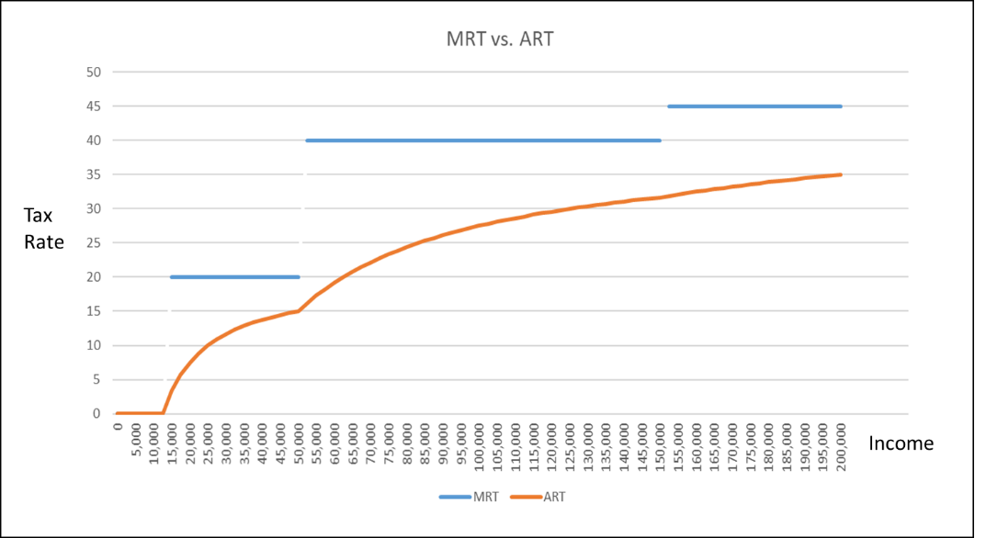**Graphically**

As the ART curve is a continuous function, there is never any instances where earning a higher salary before tax will give you less salary after tax

# Task: Income Tax Calculations

**Instructions:** Calculate how much income tax should be paid on the below salaries and give the ART

*£10,000*

……………………………………………………………………………………………………………………………………………………………………………………

ART: _________

*£20,000*

……………………………………………………………………………………………………………………………………………………………………………………

……………………………………………………………………………………………………………………………………………………………………………………

……………………………………………………………………………………………………………………………………………………………………………………

ART: _________

*£75,000*

……………………………………………………………………………………………………………………………………………………………………………………

……………………………………………………………………………………………………………………………………………………………………………………

……………………………………………………………………………………………………………………………………………………………………………………

……………………………………………………………………………………………………………………………………………………………………………………

ART: _________

*£250,000*

……………………………………………………………………………………………………………………………………………………………………………………

……………………………………………………………………………………………………………………………………………………………………………………

……………………………………………………………………………………………………………………………………………………………………………………

……………………………………………………………………………………………………………………………………………………………………………………

ART: _________

*£1,000,000*

……………………………………………………………………………………………………………………………………………………………………………………

……………………………………………………………………………………………………………………………………………………………………………………

……………………………………………………………………………………………………………………………………………………………………………………

……………………………………………………………………………………………………………………………………………………………………………………

ART: _________

# Presentation 2b –Taxation in the UK: VAT

Complete the activities below so as to have a complete set of Notes:

**Definition:** *VAT*

……………………………………………………………………………………………………………………………………………………………………………………

……………………………………………………………………………………………………………………………………………………………………………………

The standard rate of VAT has been 20% since 2011

*However:* Certain products have lower rates of VAT.

**Key Notes:** Different *Rates of VAT*

*Reduced rate:* A lower rate of VAT of __________ is applied to certain items so as not to impede their consumption as significantly

*E.g.* Children’s car seats and home energy

Additionally, a ‘VAT holiday’ was given to businesses in hospitality and tourism, charging them 5% to mitigate the impacts of COVID-19 on the industry

*Zero-rated VAT:* 0% VAT is charged on certain items, meaning the government doesn’t tax its sale but does allow credits for the value-added tax paid on inputs.

*E.g.* Most Foodstuffs, New homes, books, newspapers and magazines, children’s clothes, water and sewerage services, prescription medicines , supplies to charities, cycle helmets

In March 2020, VAT on feminine hygiene products was lowered from 5% to 0%, removing ‘tampon tax’

*Exempt from VAT:* If a good or business is “exempt,” the government doesn’t tax the sale of the good, but producers cannot claim a credit for the VAT they pay on inputs to produce it.

*E.g.* Rent on domestic dwellings, private education, health service, postal services, burial and cremation, Small traders below the turnover limit for VAT registration

**Technical Point:** VAT is assessed on the value added to a product at each point in the cycle of production and distribution.

It is still a consumption tax because it is ultimately borne by the consumer, who pays a fixed percentage of the final sale price of a product.

However, VAT is not collected in full from the final seller of the product.

The seller deducts from its VAT liability (the tax on the value it adds to the product) the amount of tax it has paid to other VAT-registered business further up the chain.

VAT is therefore collected fractionally from different businesses.

# Task: VAT Chain

**Instructions:** Calculate how much VAT is paid at each stage of production

‘Claire buys a greetings card for £5’

How much of this £5 that Claire spends goes to VAT? ____________________________

‘The shop paid the card maker £4 for the card’

What was the value the shop added? ____________________________

What amount of the total VAT that Claire paid is paid by the shop? ____________________________

‘*The card maker paid a supplier £2 for the paper used to make the card’*

What was the value the card maker added? ____________________________

What amount of the total VAT that Claire paid is paid by the card maker? ____________________________

*‘The supplier paid £1.50 to a paper mill for the paper’*

What was the value the supplier added? ____________________________

What amount of the total VAT that Claire paid is paid by the supplier? ____________________________

*‘The paper mill paid £0.50 to a lumberjack for the wood used to make the paper’*

What was the value added by the paper Mill? ____________________________

What amount of the total VAT that Claire paid is paid by the paper mill? ____________________________

*‘The Lumber paid £0.10 to a landowner for cutting down their tree’*

What was the value added by the Lumber Jack? ____________________________

What amount of the total VAT that Claire paid is paid by Lumber Jack? ____________________________

‘*The landowner paid nothing for the tree that had grown in land they inherited’*

What was the value added by the landowner? ____________________________

What amount of the total VAT that Claire paid is paid by landowner? ____________________________

# Jaffa cake.jpgDiscussion Task: Is a Jaffa Cake a biscuit or a cake?

**Instructions:**

* Read, highlight and annotate the article
* Answer the questions
* Discuss your answers as a class

**Article**

Is a Jaffa Cake a cake, or a biscuit? It took a case in court to come up with a full answer.

Under UK law, VAT on cakes and biscuits is set at 0%. However, crucially, the law states that if a biscuit is partly or wholly covered in chocolate then it is to be taxed at the standard rate. HMRC clearly defines the difference as follows:

*“The significance of the borderline between cakes and biscuits is that a cake is zero-rated even if it is covered in chocolate, whereas a biscuit is standard-rated if wholly or partly covered in chocolate or some product similar in taste and appearance.”*

**Question**

What do you think a Jaffa Cake is?

……………………………………………………………………………………………………………………………………………………………………………………

What might McVities (the manufacturers of Jaffa Cakes) argue a Jaffa cake is?

……………………………………………………………………………………………………………………………………………………………………………………

……………………………………………………………………………………………………………………………………………………………………………………

How might they try to prove this?

……………………………………………………………………………………………………………………………………………………………………………………

……………………………………………………………………………………………………………………………………………………………………………………

**Extension:** Devise an estimate of the figure that you think McVities’ would be willing to pay lawyers to convince the courts of their point of view?

……………………………………………………………………………………………………………………………………………………………………………………

……………………………………………………………………………………………………………………………………………………………………………………

……………………………………………………………………………………………………………………………………………………………………………………

……………………………………………………………………………………………………………………………………………………………………………………

……………………………………………………………………………………………………………………………………………………………………………………

# Presentation 3 - Impacts of Changing Taxes

Complete the activities below so as to have a complete set of Notes:

**Elaborate:** Elaborate on the below impacts of changing taxes

*Incentives to work:* Cuts to income tax will increase the incentive to work by increasing the opportunity cost of not working, as working less means foregoing a greater post tax income (the income effect outweighs the substitution effect).

……………………………………………………………………………………………………………………………………………………………………………………

……………………………………………………………………………………………………………………………………………………………………………………

E.g. Since 1979, UK governments have systematically cut income taxes. The basic rate has fallen from 33% to its current rate of 20%, and the higher rate falling from 83% to its current rate of 40%

Although there is now an ‘additional rate’ of 45p, which was introduced in a deficit reduction strategy

*However:* There is no hard evidence for the link between income tax and incentives.

……………………………………………………………………………………………………………………………………………………………………………………

……………………………………………………………………………………………………………………………………………………………………………………

……………………………………………………………………………………………………………………………………………………………………………………

……………………………………………………………………………………………………………………………………………………………………………………

E.g. Nordic countries have high taxes and welfare benefits but have similar rates of growth compared to lower tax and government spending countries like US and UK.

*Tax Revenues:* The link between tax rates and government revenue is shown by the Laffer curve.

**Diagram:** *The Laffer curve*

Diagram:

The Laffer curveimplies there is a given rate of tax that generates the highest revenue.

At a tax rate of 0%, the government obviously collects no tax revenue.

Revenue increases with tax rate up to a point, t*, after which tax revenue falls even with an increase in tax rates.

Higher tax rates discourages people from working harder and also encourages tax evasion/avoidance.

A 100% tax rate means no incentive to work at all, so the government again receives no revenue.

*Optimal tax rate:*It is difficult to determine the optimal rate of tax, t*, to maximise revenue.

……………………………………………………………………………………………………………………………………………………………………………………

……………………………………………………………………………………………………………………………………………………………………………………

……………………………………………………………………………………………………………………………………………………………………………………

*Political Implications:*The Laffer curve has been used to justify lowering tax rates.

……………………………………………………………………………………………………………………………………………………………………………………

……………………………………………………………………………………………………………………………………………………………………………………

……………………………………………………………………………………………………………………………………………………………………………………

*Income distribution:* A progressive tax system will increase the equality of income distribution, as more money is proportionally taken from the rich than from the poor, whilst a regressive system will decrease income equality.

……………………………………………………………………………………………………………………………………………………………………………………

……………………………………………………………………………………………………………………………………………………………………………………

……………………………………………………………………………………………………………………………………………………………………………………

However: One problem with using tax to redistribute income is that it does not give the poor anything, so the system needs to be supported with benefits.

*FDI:* Lower corporation tax rates will attract higher levels of FDI, as more retained profit provides a higher level of return.

However (1): The problem with this is that it can be a ‘race to the bottom’ where countries have to continue to lower their taxes in order to make them the lowest to encourage investment

……………………………………………………………………………………………………………………………………………………………………………………

……………………………………………………………………………………………………………………………………………………………………………………

However (2): Tax rates are likely to be only one thing a firm will consider when investing.

……………………………………………………………………………………………………………………………………………………………………………………

……………………………………………………………………………………………………………………………………………………………………………………

……………………………………………………………………………………………………………………………………………………………………………………

*Real output, employment and price level:*Some taxes affect AD whilst others affect AS.

There will be changes to macroeconomic equilibrium and we can analyse the results diagrammatically

Changes to direct taxes will…

……………………………………………………………………………………………………………………………………………………………………………………

Changes to indirect taxes will…

……………………………………………………………………………………………………………………………………………………………………………………

*However:*There can be long term implications too as discussed prior.

For example, increased income tax may discourage people from working if income tax is too high and firms may cut investment if corporation taxes are increased.

Therefore, LRAS may shift inwards as well as AD.

*Trade balance***:** Again, the impact depends on the tax.

Lower direct taxes will boost disposable incomes/retained profits, increasing demand for imports as they are normal goods, and worsening a trade deficit

The increase in M might be particularly significant for the UK as in YED terms imports tend to be luxury goods

Lower indirect taxes will cut the cost of producing domestic goods. This boosts SRAS, lowering the prices and improving price competitiveness, thus increasing exports and improving the trade balance.

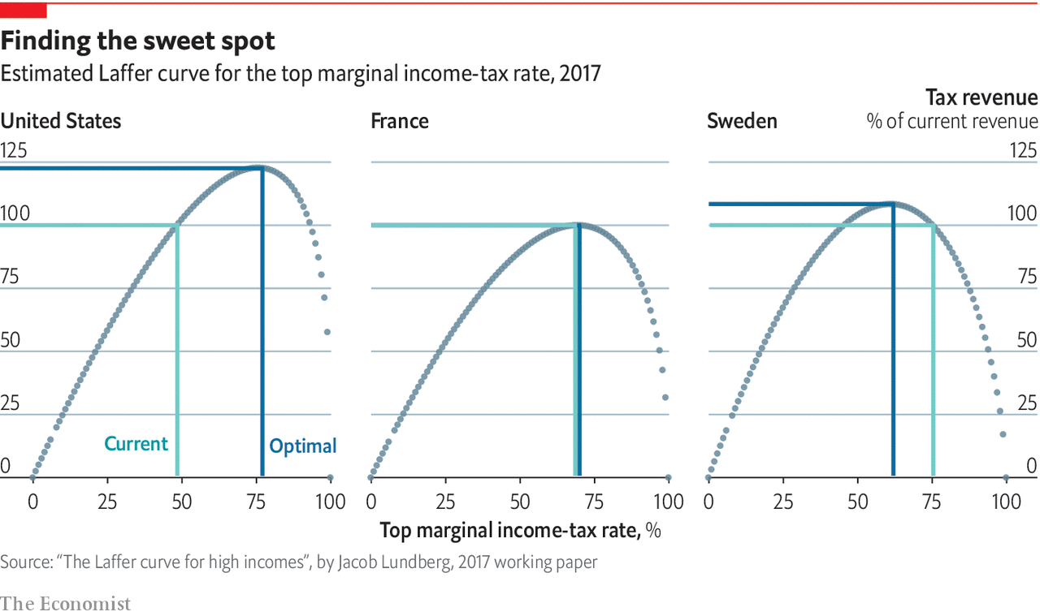

# Article Task: Can countries lower taxes and raise revenues?

**Instructions:**

* Read, highlight and annotate the article
* Answer the questions
* Discuss your answers as a class

**Article**

RARELY has a dinner-table scribbling created such a legacy. In 1974 Arthur Laffer, an economist, sketched a simple diagram on the back of a napkin to illustrate a truism of tax policy. Set income-tax tax rates to zero and governments will not collect any revenue. Set them to 100%, and they will also collect nothing because people will have little incentive to work. Somewhere in between lies a sweet spot where government revenues are maximised. From this simple proof, it follows that when tax rates are very high, it might be possible both to lower tax rates and raise revenues. Tax cuts might thus pay for themselves, and more.

Mr Laffer’s scribbling caught on. Some 45 years later some 15,000 journal articles mention the “Laffer curve” in their title. Today President Donald Trump will award the Presidential Medal of Freedom, America's highest civilian honour, to Mr Laffer—an adviser to Mr. Trump’s 2016 presidential campaign and co-author of the book “Trumponomics”. In its announcement of the event, the White House described Mr Laffer as “one of the most influential economists in American history.”

Budget hawks might disagree. Supply-side economists have long used the Laffer curve to justify tax cuts, including Ronald Reagan’s in 1981 and George W. Bush’s in 2001. Both resulted in lower revenues. In December 2017 Mr Trump’s administration cut income taxes across the board, and slashed the corporate-tax rate from 35% to 21%. At the time, Steven Mnuchin, America’s treasury secretary, argued that the plan would “pay for itself” and even “pay down debt”.‬ But the promised revenues have yet to materialise. Federal tax revenues actually fell in 2018. The Congressional Budget Office, a government watchdog, now reckons that the national debt will hit 95% of GDP by 2027, up from 89% two years ago before the tax cuts.

America is not the only country that appears to be on the wrong side of Mr Laffer’s curve. A paper published in 2017 by Jacob Lundberg, an economist at Timbro, a Swedish free-market think-tank, estimates Laffer curves for 27 OECD countries. Using data on Sweden’s income distribution and assumptions about how taxpayers respond to different tax rates, Mr Lundberg found that, even though five countries in his sample have top income-tax rates that exceed their revenue-maximising levels, only Sweden could meaningfully boost revenue by cutting tax rates on high-income earners. Most countries, in other words, appear to have set their highest tax rates at or below the optimal rate suggested by the Laffer curve.

This may explain why many economists are so critical of Mr Laffer’s supply-side policies. In 2012 the Initiative on Global Markets, a research centre at the University of Chicago’s Booth School of Business, asked a panel of 40 economic experts whether a cut in income-tax rates in America would raise enough revenue to pay for itself in five years. Not one of them agreed. Richard Thaler, winner of last year's Nobel prize in economics, responded simply “That's a Laffer!”.

**Questions:**

What does the Laffer Curve show?

……………………………………………………………………………………………………………………………………………………………………………………

……………………………………………………………………………………………………………………………………………………………………………………

Why is its shape an open downwards parabola?

……………………………………………………………………………………………………………………………………………………………………………………

……………………………………………………………………………………………………………………………………………………………………………………

……………………………………………………………………………………………………………………………………………………………………………………

Why is the maximum amount of tax revenue at different levels of tax rate in different countries?

……………………………………………………………………………………………………………………………………………………………………………………

……………………………………………………………………………………………………………………………………………………………………………………

……………………………………………………………………………………………………………………………………………………………………………………

……………………………………………………………………………………………………………………………………………………………………………………

……………………………………………………………………………………………………………………………………………………………………………………

Will the Laffer Curve change over time? If so, why?

……………………………………………………………………………………………………………………………………………………………………………………

……………………………………………………………………………………………………………………………………………………………………………………

……………………………………………………………………………………………………………………………………………………………………………………

……………………………………………………………………………………………………………………………………………………………………………………

……………………………………………………………………………………………………………………………………………………………………………………

……………………………………………………………………………………………………………………………………………………………………………………

# Assignment

**Section B (Data response – exam style question)**

**Extract 1:**

The Conservatives are "a lower tax party", Theresa May has insisted, amid speculation her party may raise taxes if they win the general election. Speaking in Dudley, she said Labour's "natural instinct" was to raise tax. But the prime minister would not say whether she would keep her party's 2015 manifesto pledge of no rises in VAT, national insurance or income tax. The shadow chancellor, John McDonnell, accused the government of planning "a tax bombshell". Liberal Democrat and former business secretary Sir Vince Cable said Mrs May was now "at war" with her Chancellor Philip Hammond over tax. Mr Hammond said on Friday there should be "flexibility to manage the system" of taxation. Shadow chancellor John McDonnell said the chancellor was facing a £2bn gap in his budget following the government's decision not to go through with an increase in the rate of National Insurance contributions for the self-employed. "He's recognising he's got problems in the economy, he's got problems in the budgeting that he's done and as a result of that there will be tax rises under a Conservative government if they are re-elected. "Philip Hammond admitted yesterday that taxes would have to rise, no doubt due to Theresa May's hard Brexit that could leave anything up to a £100bn Brexit black hole in the public finances," he said.

The Tory part are still planning to reduce the rate to below 15% - five points lower than its current 20% rate. That would give the UK the lowest corporation tax of any major economy. Mr Osborne said the cut was part of his plans to build a "super-competitive economy" with low tax rates. In March, the chancellor said corporation tax would fall to 17% by 2020. Politicians argue it is important for "Britain to "get on with it" to prove to investors that the country was still "open for business". Shadow chancellor John McDonnell said the proposal was "counter-productive". He told the BBC the tax cut would not create the business investment that the UK needed. He said it was "not constructive" to be "offering up Britain as a tax haven" to Europe and warned this could hit taxpayers.

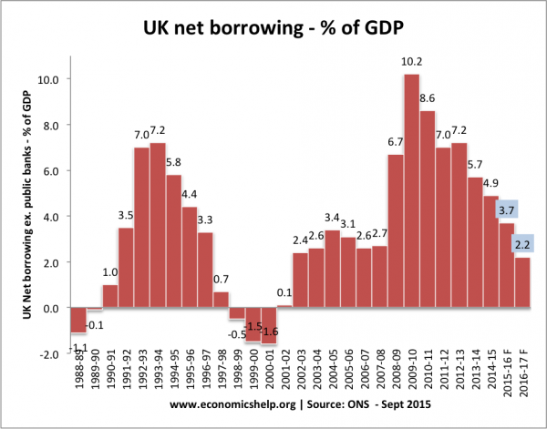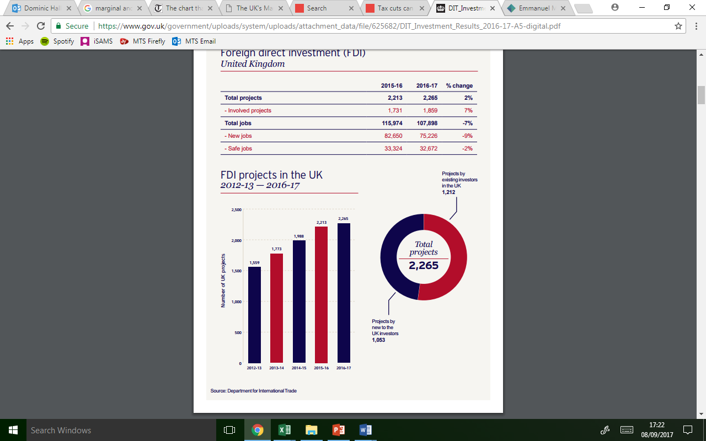

**Extract 2**

Emmanuel Macron, the French president, has unveiled proposals for tax and spending cuts, public sector job losses and investment just days after pledging to woo British businesses to France. Macron, 39, an ex-banker who hopes to entice City banks to relocate to Paris, promised a substantial reduction in corporation tax to 25pc from its current 33.3pc. “These conditions will help to attract talented professionals and jobs to France,” Mr Macron’s economics advisor, Jean Pisani-Ferry, said. Asked if Mr Macron would loosen France’s notoriously rigid labour laws, Mr Pisani-Ferry told the Telegraph: “We will introduce more flexibility and give companies more leeway to negotiate individual agreements with staff.” More Blair than Thatcher, Mr Macron’s reforms stop short of the shock-and-awe measures proposed by his rival, François Fillon, the conservative candidate, who wants to cut more than half a million public sector jobs and cut public spending by €100bn. By comparison, Mr Macron promised to reduce public spending by €60bn and cut 120,000 public sector jobs. “I don’t believe in a purge and and in fixing the country against people’s will,” said Mr Macron, who has never held elected office. Mr Fillon’s “brutal cuts that blindly eat into state spending” would do more harm than good, he claimed.

**Question:** Evaluate whether the UK government should lower the tax burden on firms and individuals [15]

|  |  |
| --- | --- |
| **Planning Grid: Aim = 4 paragraphs - 2 KAA points (9); 2 Eval points (6)** | |
| **KAA Point 1 = signpost key point** |  |
| Application |  |
| Main concept & diagram |  |
| **Eval Point 1 = relate to your earlier point & re-read the title** |  |
| Context / evidence |  |
| **KAA Point 2 = signpost key point** |  |
| Application |  |
| Main concept & diagram |  |
| **Eval Point 2 = relate to your earlier point & re-read the title** |  |
| Context / evidence |  |

**Question:** Evaluate whether the UK government should lower the tax burden on firms and individuals [15]

Extension Task: Buy, Borrow, Die – How the mega-rich avoid paying taxes

**Instructions:**

* Watch the video and make notes
* Explain the three stages in the ‘Buy, Borrow, Die’ method of tax avoidance

**Video**

<https://www.bbc.co.uk/news/av/world-us-canada-59687946>

|  |
| --- |
| Note Space: |

**Question:** Explain the three steps of the process below

*Buy*

……………………………………………………………………………………………………………………………………………………………………………………

……………………………………………………………………………………………………………………………………………………………………………………

……………………………………………………………………………………………………………………………………………………………………………………

……………………………………………………………………………………………………………………………………………………………………………………

*Borrow*

……………………………………………………………………………………………………………………………………………………………………………………

……………………………………………………………………………………………………………………………………………………………………………………

……………………………………………………………………………………………………………………………………………………………………………………

……………………………………………………………………………………………………………………………………………………………………………………

*Die*

……………………………………………………………………………………………………………………………………………………………………………………

……………………………………………………………………………………………………………………………………………………………………………………

……………………………………………………………………………………………………………………………………………………………………………………

……………………………………………………………………………………………………………………………………………………………………………………