Perfect Competition

# Starter: Discussion Question

**Instructions:**

* Individually consider the below questions
* Discuss your thoughts with a partner
* Share your ideas with the class

*What is meant by competition?*

|  |
| --- |
|  |

# Presentation 1 – Intro to market structure

Complete the activities below so as to have a complete set of notes:

**Definition:** *Market Structure*

……………………………………………………………………………………………………………………………………………………………………………………

……………………………………………………………………………………………………………………………………………………………………………………

Market structure is an important determining factor of the level of competition in an industry

**Definition:** *Competition*

……………………………………………………………………………………………………………………………………………………………………………………

……………………………………………………………………………………………………………………………………………………………………………………

**Diagram:** *The Market Structure Continuum*

|  |
| --- |
|  |

**Key Notes:** *Characteristics of a market structure:*

The number of sellers and the number of buyers in a market

The ease of which new firms can enter and leave the market (barriers to entry and exit)

The extent to which goods in the market are similar (homogeneity vs differentiation)

The extent to which all firms in the market share the same knowledge

The extent to which the actions of one firm will affect another firm (interdependence)

# Task: competitive or uncompetitive

**Instructions:** For the below pairs of scenarios, determine which one you think describes a more competitive or less competitive market structure

Number of sellers (firms)

Lots of sellers: MORE COMPETITIVE or LESS COMPETITIVE

Few sellers: MORE COMPETITIVE or LESS COMPETITIVE

Number of buyers (customers):

Lots of buyers: MORE COMPETITIVE or LESS COMPETITIVE

Few buyers: MORE COMPETITIVE or LESS COMPETITIVE

Barriers to entry:

High barriers to entry: MORE COMPETITIVE or LESS COMPETITIVE

Low barriers to entry: MORE COMPETITIVE or LESS COMPETITIVE

Barriers to exit:

High barriers to exit: MORE COMPETITIVE or LESS COMPETITIVE

Low barriers to exit: MORE COMPETITIVE or LESS COMPETITIVE

Similarity of products for sale:

Homogenous (identical): MORE COMPETITIVE or LESS COMPETITIVE

Differentiated: MORE COMPETITIVE or LESS COMPETITIVE

Information

Perfect information: MORE COMPETITIVE or LESS COMPETITIVE

Imperfect information: MORE COMPETITIVE or LESS COMPETITIVE

# Presentation 2 – Intro to Perfect Competition

Complete the activities below so as to have a complete set of notes:

**Definition:** *Perfect Competition*

……………………………………………………………………………………………………………………………………………………………………………………

……………………………………………………………………………………………………………………………………………………………………………………

**Elaborate:** Assumptions of Perfect Competition

*Many buyers, many sellers:*

……………………………………………………………………………………………………………………………………………………………………………………

……………………………………………………………………………………………………………………………………………………………………………………

Therefore all firms are price takers (Firms accept the prevailing market price, horizontal AR curve)

*No entry or exit barriers:*

……………………………………………………………………………………………………………………………………………………………………………………

……………………………………………………………………………………………………………………………………………………………………………………

Firms can also exit the industry without cost (i.e. no sunk costs) and they are assumed to have perfectly mobile factors of production

There is also equal access to technology (links to perfect knowledge)

*Homogeneous goods:*

……………………………………………………………………………………………………………………………………………………………………………………

……………………………………………………………………………………………………………………………………………………………………………………

All goods are exactly the same

*Perfect information:*

……………………………………………………………………………………………………………………………………………………………………………………

……………………………………………………………………………………………………………………………………………………………………………………

Can easily find the lowest possible price and therefore buy from the cheapest supplier

Again, this means all firms are price takers

*Profit maximisation:*

……………………………………………………………………………………………………………………………………………………………………………………

……………………………………………………………………………………………………………………………………………………………………………………

Although in the long run, this will only provide them with normal profits

# A picture containing text, outdoor, sidewalk, platform Description automatically generatedCase Study Task: The Internet

**Instructions:**

* Read, highlight and annotate the case studies
* Determine whether the assumptions of perfect competition fit in the industries

**The internet and perfect competition**

* Advances in web technology have made markets more competitive. It has reduced [barriers to entry](http://www.tutor2u.net/blog/index.php/economics/tagged/tag/barriers+to+entry/) for firms wanting to compete with well-established businesses – for example specialist toy retailers are better able to battle for market share with the dominant retailers such as ToysRUs and Wal-Mart.
* One of the most important aspects of the internet is the ability of consumers to find information about prices for many goods and services. There are an enormous number of [price comparison sites](http://paler.com/price_comparison.html) in the UK covering everything from digital cameras to package holidays, car insurance to CDs and jewellery.
* That said the price comparison web sites themselves have come under criticism. For example the sites offering to compare hundreds of different motor insurance policies or mortgage products draw information from the insurance and mortgage brokers but might use limiting assumptions about the different types of consumers looking for the best price – the result is a range of prices facing the consumer that don’t accurately reflect their precise needs – and consumers may only realise this when, for example, they make a claim on an insurance policy bought over the internet which turns out not to provide the specific cover they needed.
* And in the market for price comparison sites there is monopoly power too! Moneysupermarket.com currently has around 40% of the overall comparison site market, with Confused.com its nearest rival with a share of about 10%.

**The impact of the internet** - (N.B. AN OLD ARTICLE BUT STILL HAS RELEVANCE IN TERMS OF ASSUMPTIONS)

Frictions in cyberspace: Retailing on the Internet, it is said, is almost perfectly competitive. Really?

The explosive growth of the Internet promises a new age of perfectly competitive markets. With perfect information about prices and products at their fingertips, consumers can quickly and easily find the best deals. In this brave new world, retailers' profit margins will be competed away, as they are all forced to price at cost.

Or so we are led to believe. And yes, studies do show that online retailers tend to be cheaper than conventional rivals, and that they adjust prices more finely and more often. But they also find that price dispersion (the spread between the highest and lowest prices) is often as wide on the Internet as it is in the shopping mall—or even wider. Moreover, the retailers with the keenest prices rarely have the biggest sales.

Such price dispersion is usually a sign of market inefficiency. In an ideal competitive market, where products are identical, customers are perfectly informed, there is free market entry, a large number of buyers and sellers and no search costs, all sales are made by the retailer with the lowest price. So all prices are driven down to marginal cost. Search costs on the Internet might be expected to be lower and online consumers to be more easily informed about prices. So price dispersion online ought to be narrower than in conventional markets. But it does not seem to be.

A recent paper*, by Michael Smith and Erik Brynjolfsson of the Massachusetts Institute of Technology's Sloan School of Management and Joseph Bailey of the University of Maryland, looks at the main research on this topic. One study it cites, by Mr Bailey, finds that price dispersion for books, CDs and software is no smaller online than it is in conventional markets. Another, by Messrs Brynjolfsson and Smith, finds that prices for identical books and CDs at different online retailers differ by as much as 50%, and on average by 33% for books and 25% for CDs. A third, by Eric Clemons, Il-Horn Hann and Lorin Hitt of the University of Pennsylvania's Wharton School, finds that prices for airline tickets from online travel agents differ by an average of 28%.

There are many possible reasons for this price dispersion. One is that the studies are not comparing like with like. Not so. Even after controlling for differing arrival and departure times or connections, the study of online travel agents finds that prices for airline tickets vary by an average of 18%. The study of books and CDs deliberately focuses on physically identical products. Indeed, it finds that pricier retailers offer service terms, such as flexible returns rules, that are no better—and sometimes worse—than cheaper ones.

Convenience could also explain the price dispersion. Some websites offer better search tools, product reviews and samples, such as book chapters or audio clips. But in a frictionless market, consumers could use these services to choose what they want to buy and then buy from the cheapest site. So such services would explain price dispersion only if there were significant search or switching costs online.

For all the talk about the Internet eliminating search costs, a prominent site may be as important to online retailers as it is to conventional ones. Why else do web retailers spend a fortune advertising their web addresses on Internet portals, such as Yahoo!, as well as in the conventional media? Search engines are not always much use: Yahoo!'s book retailer section lists 6,219 sites. Searching for online bookstores at Altavista returns 5,173,884 possibly relevant web pages. So, rather than rooting out the cheapest deal, most consumers go directly to Amazon.com or CDnow, even though, the research shows, they charge 7-12% more on average than such lesser-known retailers as Books.com and CD Universe.

Switching between online retailers can also be costly. Many sites have loyalty programmes. Moreover, once consumers are familiar with a site, they may be reluctant to try another, especially when their usual site is customised to suit them, for instance through “one-click” shopping.

Search and switching costs are clearly important. But perhaps the biggest reason for price dispersion is that consumers are willing to pay a premium to shop at sites that they trust. According to the paper, even people who use “shopbots”, or computer programs that search many websites for the best deal, usually buy from the market leader—even if it is not quoting the lowest prices. A trusted brand may be more important on the Internet than on the high street, since online consumers pay upfront and cannot be sure whether or when their purchases will be delivered.

For all these reasons, some online retailers are able to charge more than others. Moreover, individual retailers can discriminate in their pricing. For, as well as enabling consumers to collect better information about prices, the Internet allows retailers to gather better information about consumers. Online retailers can more easily offer different consumers different prices, since customers do not know what price others are being quoted.

The study of online travel agents, for instance, found that the lowest-priced and the highest-priced sites were owned by the same company. But the pricier one was easier to use, allowing the parent company to charge busy customers more.

Consider too a site such as Shopping.com, where shoppers can either pay list prices or bid less in an auction. On average, bidders get lower prices. But they have to spend time placing bids and monitoring the auction's progress, and they may not end up with the goods. Shopping.com can thus discriminate between bargain hunters and regular customers.

To be fair, the Internet is still in its infancy. The degree of price dispersion may fall as consumers become cannier. But it is a good bet that retailers will come up with new wheezes too, and that those with strong brands will retain their pricing power. Perfect competition is some way off.

**Questions**

Do these assumptions fit in the e-commerce industry?

* **Many sellers**

……………………………………………………………………………………………………………………………………………………………………………………

……………………………………………………………………………………………………………………………………………………………………………………

*……………………………………………………………………………………………………………………………………………………………………………………*

* **Many individual buyers**

*……………………………………………………………………………………………………………………………………………………………………………………*

*……………………………………………………………………………………………………………………………………………………………………………………*

*……………………………………………………………………………………………………………………………………………………………………………………*

* **Perfect freedom of entry and exit from the industry**

*……………………………………………………………………………………………………………………………………………………………………………………*

*……………………………………………………………………………………………………………………………………………………………………………………*

*……………………………………………………………………………………………………………………………………………………………………………………*

* **Homogeneous products**

*……………………………………………………………………………………………………………………………………………………………………………………*

*……………………………………………………………………………………………………………………………………………………………………………………*

*……………………………………………………………………………………………………………………………………………………………………………………*

* **Perfect knowledge**

*……………………………………………………………………………………………………………………………………………………………………………………*

*……………………………………………………………………………………………………………………………………………………………………………………*

*……………………………………………………………………………………………………………………………………………………………………………………*

* **Perfectly mobile factors of production**

*……………………………………………………………………………………………………………………………………………………………………………………*

*……………………………………………………………………………………………………………………………………………………………………………………*

*……………………………………………………………………………………………………………………………………………………………………………………*

* **No externalities**

*……………………………………………………………………………………………………………………………………………………………………………………*

*……………………………………………………………………………………………………………………………………………………………………………………*

*……………………………………………………………………………………………………………………………………………………………………………………*

# Presentation 3 – Equilibria of Perfect Competition

Complete the activities below so as to have a complete set of notes:

**Definition:** *Short run equilibrium of Perfect Competition*

……………………………………………………………………………………………………………………………………………………………………………………

……………………………………………………………………………………………………………………………………………………………………………………

|  |
| --- |
| Market Firm |

All firms individually produce at the point where their individual MC meets the MR curve (q).

Each firm sells at the same price (p) but each individual firm’s q will vary based on their costs

**Question:** Is this equilibrium:

Allocatively efficient?

……………………………………………………………………………………………………………………………………………………………………………………

Productively efficient?

……………………………………………………………………………………………………………………………………………………………………………………

Dynamically efficient?

……………………………………………………………………………………………………………………………………………………………………………………

**Definition:** *Long run equilibrium of Perfect Competition*

……………………………………………………………………………………………………………………………………………………………………………………

……………………………………………………………………………………………………………………………………………………………………………………

|  |
| --- |
| Market Firm |

The profits made in the short run attracts new firms to join the market increasing supply, cutting market price.

This continues until all firms are selling at the lower price P1, the lowest point of their AC curves, making only normal profits into the long run

No more firms want to join as they’d make a loss (market price would fall below min AC)

**Question:** Is this equilibrium:

Allocatively efficient?

……………………………………………………………………………………………………………………………………………………………………………………

Productively efficient?

……………………………………………………………………………………………………………………………………………………………………………………

X-inefficient?

……………………………………………………………………………………………………………………………………………………………………………………

Dynamically efficient?

……………………………………………………………………………………………………………………………………………………………………………………

# MCQs

1) Perfect competition is an industry with

A) Many firms producing goods that differ somewhat.

B) Many firms producing identical goods.

C) A few firms producing identical goods.

D) A few firms producing goods that differ somewhat in quality.

2) The price elasticity of demand for any particular perfectly competitive firm's output is:

A) infinite.

B) equal to zero.

C) less than 1.

D) 1.

3) In perfect competition, the price of the product is determined where the industry:

A) Elasticity of supply equals the industry elasticity of demand.

B) Fixed cost is zero.

C) Average variable cost equals the industry average total cost.

D) Supply curve and industry demand curve intersect.

4) The diagram portrays a total revenue curve for a perfectly competitive firm. Curve A is straight because the firm

A) wants to maximize its profits.

B) faces constant returns to scale.

C) is a price taker.

D) has perfect information.

5) In perfect competition, the marginal revenue of an individual firm

A) Equals the price of the product.

B) Is positive but less than the price of the product.

C) Exceeds the price of the product.

D) Is zero.

# Presentation 4 – Market Shocks in Perfect Competition

Complete the activities below so as to have a complete set of notes:

**Analysis:** Shocks to either supply or demand will affect the market price

Changes to market price will effect firms’ profits (or losses) and incentivise firms to either enter or leave the market

From assuming a start at the long run equilibrium we can analyse the impacts of market shocks

**Diagrams:** From the description draw two diagrams for the short and lng run equilibria in a perfectly competitive market when there is a *FALL IN MARKET DEMAND*

*Short run:*The fall in demand means the market price is now below the minimum average costs firm can operate at.

Firms now make a loss

|  |
| --- |
| Market Firm |

*Long run:*the presence of sub normal profits in the market incentivises firms to leave, decreasing supply

Falling supply raises prices

This continues until the firms make only normal profit again, and no more firms wish to leave

|  |
| --- |
| Market Firm |

**Descriptions:** From the diagrams below, describe the price and profit outcomes for the short and long run equilibria in a perfectly competitive market when there is a *RISE IN MARKET DEMAND*

*Short run:*

……………………………………………………………………………………………………………………………………………………………………………………

……………………………………………………………………………………………………………………………………………………………………………………

……………………………………………………………………………………………………………………………………………………………………………………

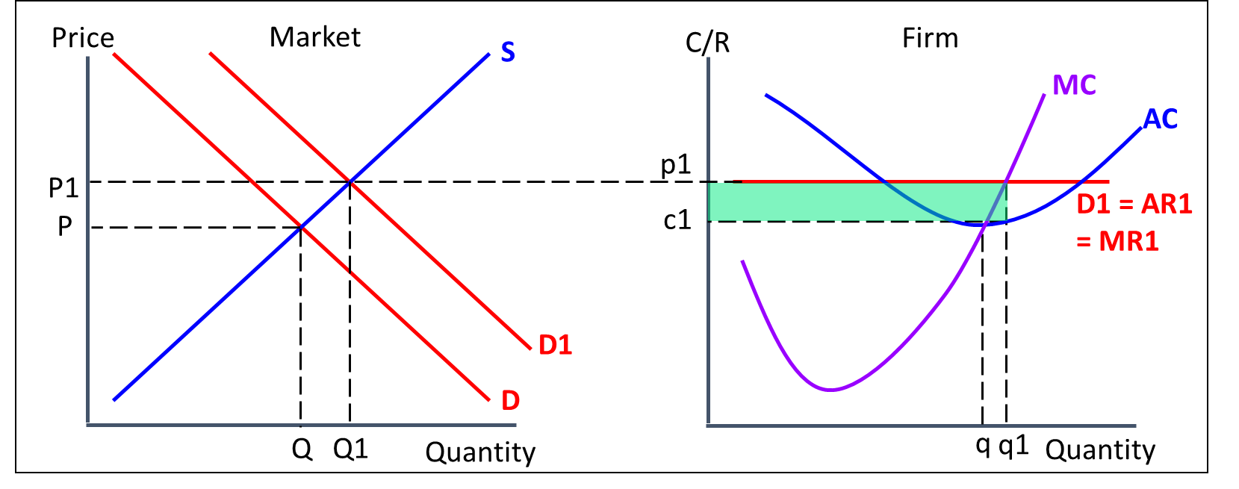

*Long run:*

……………………………………………………………………………………………………………………………………………………………………………………

……………………………………………………………………………………………………………………………………………………………………………………

……………………………………………………………………………………………………………………………………………………………………………………

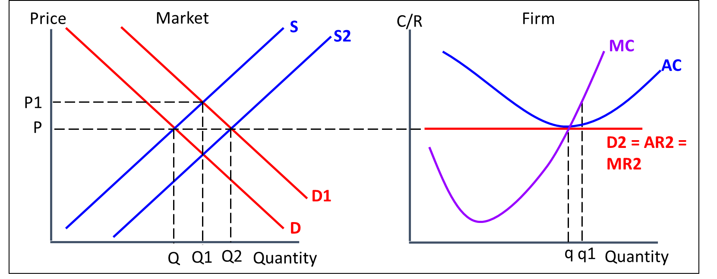

# Presentation 5 – Evaluating Perfect Competition

Complete the activities below so as to have a complete set of notes:

**Rationale:** Perfect Competition is a hypothetical market structure that doesn’t really exist in practice

This is because it based on some pretty extreme assumptions

**Link Task:** Match the assumption with the relevant evaluative comment

|  |  |  |
| --- | --- | --- |
| Many buyers and sellers |  | Obstacles to entry like patents, intellectual property laws, tight control of key inputs are common in the real world but all ignored by the perfectly competitive model.  Some sunk costs, such as search costs, are impossible to avoid even with the spread of low-cost digital/web technology platforms.  Rare for entry and exit in an industry to be costless – there are very few industries that are perfectly contestable. |
|  |  |  |
| No barriers to entry and exit |  | Goods are often similar but rarely do multiple firms simultaneously produce goods that are perfectly identical.  In the real world markets are often dominated by differentiated / branded products (non-price competition). No rational firm would not try to differentiate. |
|  |  |  |
| Homogenous goods |  | There are always information gaps facing consumers, especially for highly complex products.  Even for simple products do consumers ever really know *everything* about them.  This means consumers can’t be perfectly rational and are often be influenced by advertising. |
|  |  |  |
| Perfect information |  | Rarely will there ever be so many firms in a market that none have any price setting power. |

**Key Question:** Why do we still care about perfectly competitive markets if they don’t really exist?

……………………………………………………………………………………………………………………………………………………………………………………

……………………………………………………………………………………………………………………………………………………………………………………

……………………………………………………………………………………………………………………………………………………………………………………

……………………………………………………………………………………………………………………………………………………………………………………

……………………………………………………………………………………………………………………………………………………………………………………

……………………………………………………………………………………………………………………………………………………………………………………

# Assignment:

**SECTION A - SAQs**

1. The diagram illustrates a firm operating under conditions of perfect competition in the short run.
2. State **three** characteristics of perfect competition.

[3]

……………………………………………………………………………………………………………………………………………………………………………………

……………………………………………………………………………………………………………………………………………………………………………………

……………………………………………………………………………………………………………………………………………………………………………………

……………………………………………………………………………………………………………………………………………………………………………………

1. Annotate the diagram to how the industry will change as it reaches the long run.

[2]

1. A firm selling microchips is operating under conditions of perfect competition. The market price is below the firm’s average variable costs. The immediate response of this firm will be to

[1]

A raise its price

B shut down

C reduce output and cut its price

D keep its price and output unchanged

E cut its price and increase output

1. A firm operating under conditions of perfect competition is making supernormal profits. Assuming all else is constant, explain the likely impact on this firm’s output and price in the long run. Illustrate your answer with an appropriate diagram.

[4]

……………………………………………………………………………………………………………………………………………………………………………………

……………………………………………………………………………………………………………………………………………………………………………………

……………………………………………………………………………………………………………………………………………………………………………………

……………………………………………………………………………………………………………………………………………………………………………………

……………………………………………………………………………………………………………………………………………………………………………………

……………………………………………………………………………………………………………………………………………………………………………………

1. A large number of small bakeries in a competitive industry are taken over and combined to form a single monopoly supplier. Assuming **constant average costs**, explain the likely impact on price and output. Illustrate your answer with an appropriate diagram.

[4]

……………………………………………………………………………………………………………………………………………………………………………………

……………………………………………………………………………………………………………………………………………………………………………………

……………………………………………………………………………………………………………………………………………………………………………………

……………………………………………………………………………………………………………………………………………………………………………………

……………………………………………………………………………………………………………………………………………………………………………………

……………………………………………………………………………………………………………………………………………………………………………………

1. Firms are leaving a perfectly competitive industry. This suggests that for these firms:

[1]

A average revenue exceeds marginal revenue

B marginal revenue exceeds average revenue

C average fixed cost exceeds average revenue

D average variable cost exceeds average revenue

E average costs equal average revenue

1. Supernormal profits being made by a perfectly competitive firm in the short run would disappear in the long run because of

[1]

A freedom of entry into this market

B firms engaging in large scale advertising

C differentiated goods

D allocative inefficiencies

E high sunk costs

**SECTION C - Essay**

1. To what extent would perfect competition in all markets maximise economic efficiency? [25]

|  |  |
| --- | --- |
| **Planning Grid: Aim = 5 paragraphs - 2 KAA points (16); 2 Eval points (9) with a conclusion** | |
| **KAA Point 1 = signpost key point** |  |
| Application |  |
| Main concept & diagram |  |
| **Eval Point 1 = relate to your earlier point & re-read the title** |  |
| Context / evidence |  |
| **KAA Point 2 = signpost key point** |  |
| Application |  |
| Main concept & diagram |  |
| **Eval Point 2 = relate to your earlier point & re-read the title** |  |
| Context / evidence |  |
| **Conclusion = judgement** |  |
| Context; what does it depend on? |  |

**Question:** To what extent would perfect competition in all markets maximise economic efficiency? [25]