Business Growth

# Starter – Research Task

**Instructions:** Choose a firm you know (gold notes for originality), use the internet and your own knowledge to answer the below questions?

*My Chosen firm is:* …………………………….…………………………………

What does this firm produce?

……………………………………………………………………………………………………………………………………………………………………………………

……………………………………………………………………………………………………………………………………………………………………………………

……………………………………………………………………………………………………………………………………………………………………………………

How does this firm make its output?

……………………………………………………………………………………………………………………………………………………………………………………

……………………………………………………………………………………………………………………………………………………………………………………

……………………………………………………………………………………………………………………………………………………………………………………

……………………………………………………………………………………………………………………………………………………………………………………

How does this firm sell its output?

……………………………………………………………………………………………………………………………………………………………………………………

……………………………………………………………………………………………………………………………………………………………………………………

……………………………………………………………………………………………………………………………………………………………………………………

Who does it sell its output to?

……………………………………………………………………………………………………………………………………………………………………………………

……………………………………………………………………………………………………………………………………………………………………………………

Who owns this firm?

……………………………………………………………………………………………………………………………………………………………………………………

……………………………………………………………………………………………………………………………………………………………………………………

Who manages this firm?

……………………………………………………………………………………………………………………………………………………………………………………

……………………………………………………………………………………………………………………………………………………………………………………

How ‘big’ is this firm (consider different ways of measuring a firms size)?

……………………………………………………………………………………………………………………………………………………………………………………

……………………………………………………………………………………………………………………………………………………………………………………

……………………………………………………………………………………………………………………………………………………………………………………

……………………………………………………………………………………………………………………………………………………………………………………

……………………………………………………………………………………………………………………………………………………………………………………

……………………………………………………………………………………………………………………………………………………………………………………

How has this firm grown to where it is today?

……………………………………………………………………………………………………………………………………………………………………………………

……………………………………………………………………………………………………………………………………………………………………………………

……………………………………………………………………………………………………………………………………………………………………………………

……………………………………………………………………………………………………………………………………………………………………………………

Why might the firm want/not want to be a this size?

……………………………………………………………………………………………………………………………………………………………………………………

……………………………………………………………………………………………………………………………………………………………………………………

……………………………………………………………………………………………………………………………………………………………………………………

……………………………………………………………………………………………………………………………………………………………………………………

***Extension:*** How will this firm’s size change into the future?

……………………………………………………………………………………………………………………………………………………………………………………

……………………………………………………………………………………………………………………………………………………………………………………

……………………………………………………………………………………………………………………………………………………………………………………

……………………………………………………………………………………………………………………………………………………………………………………

|  |
| --- |
| Note space (for interesting observations from peers’ research): |

# Presentation 1 – Types of Firms

Complete the activities below so as to have a complete set of Notes:

**Definition:** *Firm*

……………………………………………………………………………………………………………………………………………………………………………………

……………………………………………………………………………………………………………………………………………………………………………………

**Key Question:** What is the difference between private and public sector firms?

……………………………………………………………………………………………………………………………………………………………………………………

……………………………………………………………………………………………………………………………………………………………………………………

……………………………………………………………………………………………………………………………………………………………………………………

……………………………………………………………………………………………………………………………………………………………………………………

**Key Notes:** Four main structures of private firms to consider

*Sole Trader:*

……………………………………………………………………………………………………………………………………………………………………………………

……………………………………………………………………………………………………………………………………………………………………………………

They are simple to form and operate, and may enjoy greater flexibility of management, fewer legal controls, and fewer taxes.

*However:*The business owner is personally liable for all debts incurred by the business; if the business fails, the debts of the business will be paid using the owner’s assets.

*Partnership:*

……………………………………………………………………………………………………………………………………………………………………………………

……………………………………………………………………………………………………………………………………………………………………………………

Each partner shares the profits, losses, and management of the business, and each partner is personally and equally liable for debts of the partnership.

Formal terms of the partnership are usually contained in a written partnership agreement.

They tend to be small-medium sized business, with a few exceptions such as legal and accounting firms.

*Private Limited Companies (Ltd):*

……………………………………………………………………………………………………………………………………………………………………………………

……………………………………………………………………………………………………………………………………………………………………………………

The personal finances of any shareholders are protected by limited liability (i.e. their liabilities are limited to the value of their shares).

Most medium and large companies in the UK are private limited companies (LTDs).

Ownership shares in private companies cannot be offered to the general public, but are exchanged through private sales.

*Public Limited Companies (PLC):*

……………………………………………………………………………………………………………………………………………………………………………………

……………………………………………………………………………………………………………………………………………………………………………………

However, shares in a public company can be freely sold and traded to the general public and their shares can be listed on a stock exchange. They are the only type of company allowed to raise capital from this type of public investment.

**Key Question:** How do not-for-profit firms differ from for-profit firms?

……………………………………………………………………………………………………………………………………………………………………………………

……………………………………………………………………………………………………………………………………………………………………………………

……………………………………………………………………………………………………………………………………………………………………………………

……………………………………………………………………………………………………………………………………………………………………………………

# Discussion Task: Reasons for Growth

**Instructions:**

* Consider the below stimulus material and discussion question.
* Discuss your ideas with your partner.
* Share your ideas with the class

**Discussion Question:**

*Why do some firms grow while others remain small?*

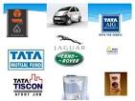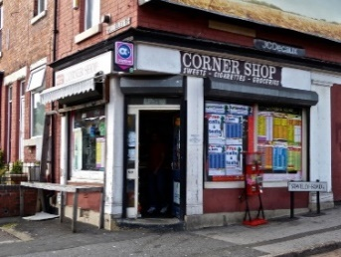I.e. Why do some industries e.g. supermarkets see several large firms dominating, whereas the hairdressing industry has many more small firms?

|  |
| --- |
| Note Space: |

# Presentation 2 – Why are Firms Different Sizes?

Complete the activities below so as to have a complete set of Notes:

**Elaborate:** Elaborate on the below reasons to be LARGE

*Profit Motive:*Some firms haver a desire to increase sales, if profitable to do so.

……………………………………………………………………………………………………………………………………………………………………………………

*Economies of scale (‘Cost Motive’):*Average cost falls as firms grow large

……………………………………………………………………………………………………………………………………………………………………………………

……………………………………………………………………………………………………………………………………………………………………………………

*Entry barriers (or ‘Market Power Motive’):*Firms may want to grow so they are able to create barriers to prevent new firms entering a market

……………………………………………………………………………………………………………………………………………………………………………………

……………………………………………………………………………………………………………………………………………………………………………………

*Risk Motive (‘Economies of Scope’):* Larger firms can diversify their production and/or sales so that falling salesin one market can be compensated by stronger demand in another sector

……………………………………………………………………………………………………………………………………………………………………………………

**Elaborate:** Elaborate on the below reasons to remain SMALL

*Limited cost advantages:*EoS may be small relative to market size & diseconomies of scale can set in.

……………………………………………………………………………………………………………………………………………………………………………………

……………………………………………………………………………………………………………………………………………………………………………………

*Barriers to growth:* Some firms will encounter barriers to prevent them growing.

……………………………………………………………………………………………………………………………………………………………………………………

……………………………………………………………………………………………………………………………………………………………………………………

*Low barriers to entry:* There may be little to stop a new firm from starting, which acts to limit how much market share existing firms can develop.

……………………………………………………………………………………………………………………………………………………………………………………

……………………………………………………………………………………………………………………………………………………………………………………

……………………………………………………………………………………………………………………………………………………………………………………

……………………………………………………………………………………………………………………………………………………………………………………

*Filling a niche:*Customers may prefer a more personal service, which can only be provided by a small owner-managed firm.

……………………………………………………………………………………………………………………………………………………………………………………

……………………………………………………………………………………………………………………………………………………………………………………

……………………………………………………………………………………………………………………………………………………………………………………

# *Lucky Tesco shoppers have walked away with hundreds of pounds worth of bargains*Article Task: Tesco Growth

**Instructions:**

* Read, highlight and annotate the article
* List all the different ways of measuring how a firm can grow that are stated in the article
* ***Extension:*** List any other ways of measuring how a firm could grow
* Discuss your findings as a class

**Article**

*Can Tesco grow again in Britain?*

Tesco's results are a story in two parts. There remains momentum behind the group's overseas businesses and group sales in total rose more than 7% to a mind-boggling £72bn.

But the core of the group in the UK is in the doldrums, with trading profit falling 1% to £2.5bn. There will be worse to come, because this year's profits will be reduced by the £600m of increased overheads to revitalise the UK stores, which includes the salaries of 8,000 new shop staff.

Which is why Tesco is agreeing with City analysts that in the current year, group profits will barely increase at all, even with further growth in Asia and Eastern Europe, and an expected reduction in losses at the group's controversial US business, Fresh and Easy.

Can the chief executive, Philip Clarke - who took over a year ago - restore momentum?

His analysis, he tells me, of what went wrong is that Tesco invested too little in its existing stores and even took money out of those shops, in part to finance the growth overseas. The implication is that with its 30% market share, Tesco took its British customers for granted. So he is spending money to improve customer service, make the stores friendlier, and tailor the product range to what local people say they want (via the data they provide in their use of loyalty cards).

There will be fewer new stores - new selling space is being cut from 2.4m square feet to 1.5m square feet this year, a reduction of almost 40%. Or to put another way, there been a bit of a shift away from getting bigger to getting better - which includes a so-called "refresh" of 430 existing stores, at a cost of £400m, to make them rather less clinical and intimidating. Also, there will be a big expansion of what will be available over the internet, to 80,000 lines by Christmas, compared with 40,000 now.

And Tesco is posing a direct challenge to Amazon, by increasing to 200,000 lines the products that other retailers can offer through Tesco's online marketplace. Make no mistake: this is a turning point for Tesco and - given the group's market share and influence - arguably for the British consumer economy too.

Under its two previous leaders, Ian Maclaurin and Terry Leahy, Tesco went from challenger in the early 1990s to twice the size of its nearest UK competitor, by cutting prices and a whole series of innovations in product ranges and store design. For years it was not only the biggest store group by far in the UK but also the most admired and - arguably - the most feared.

Businesses have a lifecycle. There are very few examples of companies maintaining the kind of growth in mature industries that Tesco achieved. And once the growth ends, as Marks & Spencer and Sainsbury demonstrated in the 1990s, restoring it will certainly not be easy, and may prove impossible.

**List**

|  |
| --- |
| Measures of growth from the article |
| ***Extension:*** Further measures of growth |

# Presentation 3 – Types of Growth

Complete the activities below so as to have a complete set of Notes:

**Definition:** *Business Growth*

……………………………………………………………………………………………………………………………………………………………………………………

……………………………………………………………………………………………………………………………………………………………………………………

**Key Notes:** Two way firms can grow:

1. Selling more to their existing customers
2. Selling to new customers, i.e. expanding into new product markets or new geographical markets

**Definition:** Organic growth

……………………………………………………………………………………………………………………………………………………………………………………

……………………………………………………………………………………………………………………………………………………………………………………

This can be funded through retained profit, borrowing money from banks (debt) or issuing shares (equity).

**Definition:** *External Growth*

……………………………………………………………………………………………………………………………………………………………………………………

……………………………………………………………………………………………………………………………………………………………………………………

Two methods of External Growth

**Mergers:** Two firms agreeing to join together; and

**Acquisitions:** AKA takeovers, One firm buying another; may be amicable or hostile

**Elaborate:** Elaborate on the three types of integration for External Growth

*Horizontal Integration:*The joining of two firms in the same industry and at the same stage of production.

……………………………………………………………………………………………………………………………………………………………………………………

*Vertical Integration:*The joining of two firms in the same industry but at different stages of production. This may be:

*Backward vertical integration:*Taking over a firm in a preceding stage of production (closer to the raw material or further away from the end user).

……………………………………………………………………………………………………………………………………………………………………………………

*Forward vertical integration:*Taking over a firm in the next stage of production (further from the raw material or closer to the end user).

……………………………………………………………………………………………………………………………………………………………………………………

*Conglomerate Integration:*The joining of two firms in unrelated industries.

……………………………………………………………………………………………………………………………………………………………………………………

……………………………………………………………………………………………………………………………………………………………………………………

……………………………………………………………………………………………………………………………………………………………………………………

# Task: External Growth examples

**Instructions:** Classify each of the following scenarios as either horizontal (HI), vertical (BVI or FVI) or conglomerate integration (CI):

1. In 2001, Hewlett-Packard took over Compaq. The combined entity was expected to make annual cost savings of $2.5 billion. Part of this came from bulk purchase discounts on CPUs bought from Intel and AMD (as HP would now require almost twice as many of these chips).

Type of integration: ___________________________

1. In 1977, PepsiCo acquired Pizza Hut. One year later it took over Taco Bell. Then in 1986, PepsiCo paid $840m to acquire KFC. The three fast-food chains gave PepsiCo 30,000 retail outlets worldwide, all of which were all guaranteed to stock Pepsi drinks.

Type of integration: ___________________________

1. In 2002, EasyJet took over Go! Airlines in order to rapidly expand its own operations and to boost its share of the low-cost air travel market.

Type of integration: ___________________________

1. In 1995 a bitter takeover battle began between Granada Media Group and Trusthouse Forte, which at the time was still partly owned, but completely controlled by the Forte family. Shareholders were disappointed with the firm’s poor performance and, especially, the fact that the company’s CEO, Sir Rocco Forte, had not paid them any dividends for a number of years. The Granada Media Group managed to convince Trusthouse Forte’s shareholders that Sir Rocco was managing the firm poorly and that if they did not sell their shares, the share price would fall even further. Conversely, if they agreed to sell their shares to Granada, they would be paid a substantial premium, over and above the current market price, and that this would enable Granada to turn Forte around. Within two months, enough Trusthouse Forte shareholders had sold their shares to give Granada a controlling stake in the firm as well as its various brands like the Travelodge hotels and Little Chef restaurants.For Granada – a TV production company – the acquisition of Forte was a useful way to spread their risks and to ensure they would continue to make profits even in the face of a recession, which would reduce their TV advertising revenues.

Type of integration: ___________________________

1. In 1998, Daimler-Benz merged with Chrysler. The deal gave Daimler access to Chrysler’s technologies and manufacturing processes. In addition, Chrysler, an established US car manufacturer, had easier access to the EU market through Daimler’s extensive European distribution network (e.g. through the numerous Mercedes Benz dealerships).

Type of integration: ___________________________

1. The News Corporation, largely owned and controlled by Rupert Murdoch, acquired 20th Century Fox soon after launching the Sky Movies channel. The merger meant that Sky had exclusive access to 20th Century Fox movies and could use this as a unique selling point when trying to increase its number of subscribers.

Type of integration: ___________________________

1. In 1994, the US media giant Viacom bought the Blockbuster Video chain. Viacom owns a range of TV and satellite channels, from MTV to CBS, as well as TV production and distribution companies, such as Spelling Television. It also operates in the movie production and distribution industry, owning Paramount Pictures and Paramount Home Entertainment.

Type of integration: ___________________________

1. Heinz has acquired a number of farms in the UK, where the firm now grows a range of vegetables. This has enabled the firm to guarantee the highest quality tomatoes for its flagship product ‘Heinz Tomato Ketchup’ as well as reserving the best quality vegetables for its range of tinned soups.

Type of integration: ___________________________

1. In 2008 Lloyds TSB acquired Halifax Bank of Scotland (HBOS) to form the Lloyds Banking Group, one of the UK’s largest financial institutions. Before the merger, Lloyds TSB only had a 9% share of the mortgage market, with HBOS having 21%. The combined entity now controls 30% of the mortgage market and has significant market power to decide interest rates on the high street.

Type of integration: ___________________________

1. P&O Ferries has acquired a number of ports around the world, including the Port of Genoa in Italy. This has given the firm guaranteed slots for docking its ferries into this popular tourist destination. And at popular times that will appeal to holiday makers and ensure that P&O’s ferries are always full.

Type of integration: ___________________________

1. During the 1980s, Whitbread, the brewers, purchased a stake in Pizza Hut (UK) Ltd which they ran as a joint venture with PepsiCo. In addition, Whitbread acquired other well-known brands such as Beefeater and TGI Friday’s, as well as Costa Coffee and even the David Lloyd Leisure Centre. This ensures that Whitbread will continue to see strong sales and profits even if society becomes more health conscious and avoids eating junk food.

Type of integration: ___________________________

Presentation 4 – Impacts of Expansion through M&A

Complete the activities below so as to have a complete set of Notes:

**Table:** Determine whether each impact is an advantage or disadvantage, *to society in general,* of expansion through M&A, and explain why.

|  |  |  |
| --- | --- | --- |
| **Impact** | **Advantage or Disadvantage?** | **Explanation** |
| Economies of scale – cost reductions as output increases e.g. purchasing power EoS |  |  |
| Reduces competition - Higher prices, less choice & less R&D investment |  |  |
| Vertical integration means there are savings in terms of not having to pay ‘3rd party’ profits. |  |  |
| Economies of scope - using the fixed assets of one firm to produce output for the other firm |  |  |
| Increased barriers to entry - FVI may lead new entrants to be denied access to outlets for its products; BVI may mean new entrants find it difficult to secure a source of supply of materials or products. |  |  |
| Synergies – combined output > separate output e.g. incremental R&D output |  |  |
| Diseconomies of scale - Co-ordination and control costs rise with size |  |  |
| Monopsony power - merged firms may have power to dictate terms of business to suppliers, or keep wages below the competitive level |  |  |
| Rationalisation – cost reduction e.g. one CFO needed |  |  |

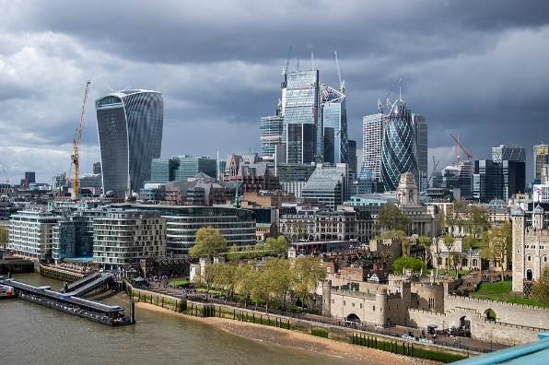Article Task: When Mergers Fail

**Instructions:**

* Read, highlight and annotate the article
* Make notes to answer the discussion questions
* Discuss your answers as a class

**Article**

*Why do up to 90% of Mergers and Acquisitions Fail?*

According to collated research and a recent Harvard Business Review report, the failure rate for mergers and acquisitions (M&A) sits between 70 percent and 90 percent. That is a remarkably high figure, but when you consider the range of business, IT and cultural factors that occur during the average merger or acquisition it is not that surprising.

**It’s known as the winner’s curse.** When companies merge, most of the shareholder value created is likely to go not to the buyer but to the seller. Indeed, on average, the buyer pays the seller all of the value generated by a merger, in the form of a premium of from 10 to 35 percent of the target company’s preannouncement market value. The fact is well established, but the reasons for it are less clear. Our exploration of postmerger integration efforts points to the main source of the winner’s curse: the fact that the average acquirer materially overestimates the synergies a merger will yield. These synergies can come from economies of scale and scope, best practice, the sharing of capabilities and opportunities, and, often, the stimulating effect of the combination on the individual companies. However, it takes only a very small degree of error in estimating these values to cause an acquisition effort to stumble. The winners curse is particularly significant when M&A’s take place as a response to tough trading conditions that may signal a weak economic outlook.

So often the synergies are propounded around technical knowhow, such as complementary products or market access. This may be sound in theory, but the execution so often fails because it requires extra efforts from all employees in both companies. An example is the epic failure of the when [eBay](http://ebay.co.uk/) decided to buy Skype for $2.6 billion in 2005, only to sell the company four years later for $1.9 billion. Apparently, it didn’t work out because [eBay](http://ebay.co.uk/) and Skype were unable to integrate their technological systems successfully. They should also try to anticipate common “dis-synergies” (such as the loss of customers and difficulties reconciling different service terms) and consider raising their estimates of onetime costs.

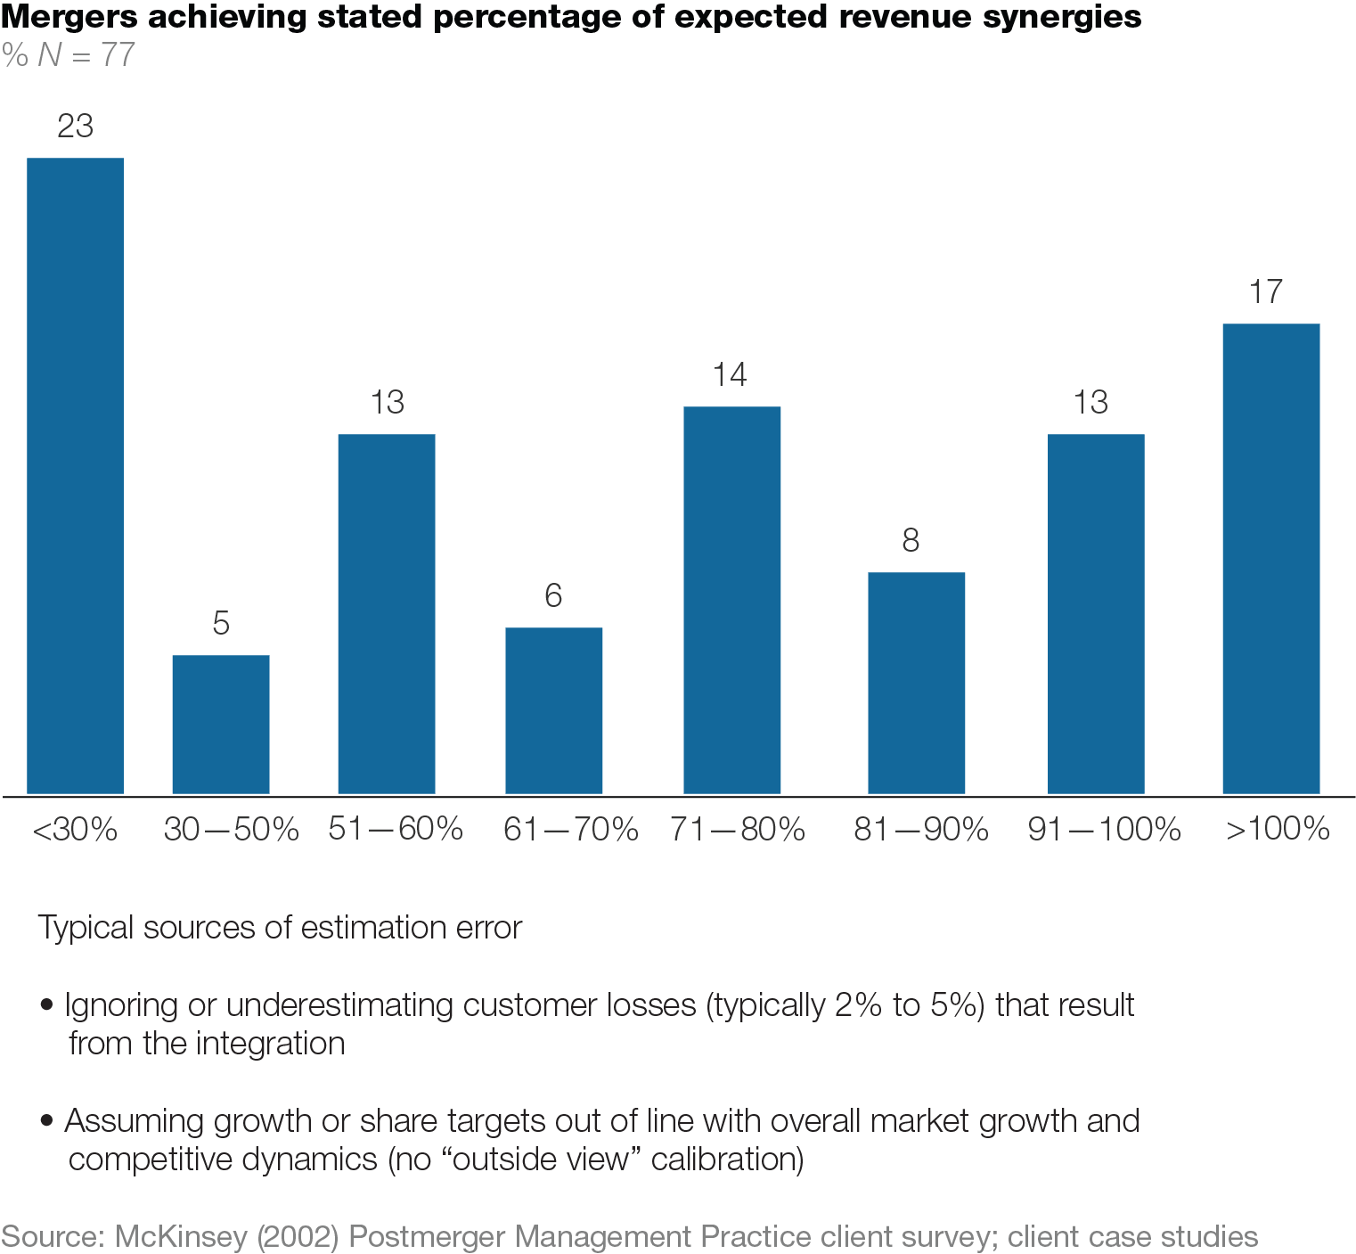Above all, to gain synergies, as with most gains for M&A’s there needs to be change. Change is difficult, especially in large companies. [British Airways](http://britishairways.com/) only really shook off the BEA vs. BOAC divide for the 1970s when it moved to Terminal 5 in 2007. Change integration for full synergistic gain can only happen by creating the framework that is practical and that allows people to work in happily. Deal teams often make simplistic and optimistic assumptions about how long it will take to capture synergies and how sustainable they will be. As a result, important deal metrics, such as near-term earnings and cash flow accretion, can end up looking better than they deserve, which leads companies to overestimate the net present value of synergies substantially.

A conclusion accepted today, after decades of research, is that only stockholders of the acquired company profit, whereas the stockholders of the acquiring firm do not, on the average, receive any benefit from the merger. The main reason for failures, according to this perspective, is that the acquiring company pays a premium that reaches above the value of the acquired company. This premium is generally so high that even successful management activities after the acquisition do not provide return on investment and do not remedy the valuation “error.” The capital market identifies this mistake and responds in the change of the stock price. For example, the stocks of AOL declined in the first 24 hours after the acquisition of Time Warner was announced. The assumption was that the price paid for Time Warner was very high and not justifiable. Its stocks continued to decline for many months after the acquisition. It should be noted though that the capital market’s valuation makes mistake in many cases, such as the Daimler-Chrysler merger. In that case, the stock price rose immediately after the merger announcement. However, 2 years following it, the stock value declined to 50 percent of its value at the time of the merger. Given that the purchases are often may through borrowing there is also a large financial cost of funding takeovers alongside the problem of paying too much.

There only needs to be one HR, finance, IT, manufacturing, and marketing function. When Orange merged with [T-Mobile](http://t-mobile.co.uk/) in 2010 there was talk of £545m back office savings. This number is not trivial and behind this will be vast amounts of disruption. Look what happened when NTL bought Virgin or when Barclays bought Woolwich. There was chaos and huge customer frustrations as the service levels fell during the merging of functions. That said the back office savings are usually the most reliable source of upside in an M&A.

The brands are often ignored by the M&A planners because they fail to fully understand what makes up brands and their equity. The same should not be true of the boards but none the less, how often have we seen M&A’s where very strong brands are swept aside by the name of the new owner. This can be disastrous and destroy value and indeed simply throw away existing and loyal customers. All brands should be respected and invested in where they have current and future value. Customers often value the bespoke service that they get from a small business and this can be damaged through M&A.

As important as the need for clear vision and due diligence before a merger is a clear strategy after it. As every employee knows full well, mergers tend to mean job losses. No sooner is the announcement out than the most marketable and valuable members of staff send out their résumés. Unless they learn quickly that the deal will give them opportunities rather than pay-offs, they will be gone, often taking a big chunk of shareholder value with them.  Clashing cultures can be the undoing of the deal unless a proper culture adoption, harmonisation or change programme is in place. This needs managing well with strong champions. Culture is a great enabler but it can be the hidden destroyer. One option is to start afresh. This involves setting aside the cultures of the two organisations involved and creating a new culture for the new organisation. This approach proved highly successful in the merger of Glaxo Wellcome and SmithKline Beecham in 2000 forming GlaxoSmithKline (GSK). Both organisations decided to engage their combined workforce in a process of defining and instilling a new vision and new set of values for GSK that everyone could sign up to. Nearly fourteen years later, the company is not only a huge commercial success but is also recognised around the world as one of the best companies to work for

Above all, personal chemistry matters every bit as much in mergers as it does in marriage. It matters most at the top. No company can have two bosses for long. So one boss must accept a less important role with good grace. After many months of damaging dithering, Citibank's John Reed eventually made way for Sandy Weill of Travelers.

The fact that mergers so often fail is not, of itself, a reason for companies to avoid them altogether. But it does mean that merging is never going to be a simple solution to a company's problems. And it also suggests that it would be a good idea, before they book their weddings, if managers boned up on the experiences of those who have gone before.

**Discussion Questions**

What are the causes of a high percentage of M&A failing?

|  |
| --- |
| Note Space: |

***Extension:*** What can be done to make a merger more likely to be successful?

|  |
| --- |
| Note Space: |

Presentation 5 – Demergers

Complete the activities below so as to have a complete set of Notes:

**Definition:** *Demerger*

……………………………………………………………………………………………………………………………………………………………………………………

……………………………………………………………………………………………………………………………………………………………………………………

**Elaborate:** Elaborate on the following reasons for Demergers

*Lack of synergies:*

……………………………………………………………………………………………………………………………………………………………………………………

……………………………………………………………………………………………………………………………………………………………………………………

*Price:*

……………………………………………………………………………………………………………………………………………………………………………………

……………………………………………………………………………………………………………………………………………………………………………………

*Focussed Companies:*

……………………………………………………………………………………………………………………………………………………………………………………

……………………………………………………………………………………………………………………………………………………………………………………

**Elaborate:** Elaborate on the followingimpacts of demergers on different stakeholders

*Business:*

……………………………………………………………………………………………………………………………………………………………………………………

……………………………………………………………………………………………………………………………………………………………………………………

*However:* They may also become more vulnerable to larger firms and technological change.

*Workers:*

……………………………………………………………………………………………………………………………………………………………………………………

……………………………………………………………………………………………………………………………………………………………………………………

*However:*some people may lose their jobs, as firms become more focussed or efficient.

*Consumers:*

……………………………………………………………………………………………………………………………………………………………………………………

……………………………………………………………………………………………………………………………………………………………………………………

*However:*They could also lose out if firms increase prices to cover new costs

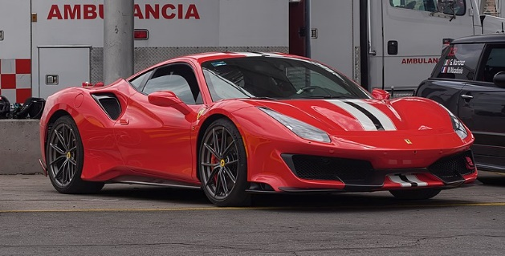Article Task: Ferrari's Flotation

**Instructions:**

* Read, highlight and annotate the article
* Answer the questions
* Discuss your answers as a class

**Article**

*Conscious uncoupling - Why the demerger of the luxury carmaker from Fiat Chrysler makes sense*

Owning a Ferrari is the dream of many a petrol-head, but for most drivers the Italian supercars are priced well beyond their reach. Next year owning part of the company may be a more realistic prospect. Fiat Chrysler Automobiles (FCA) said on October 29th that it would spin off Ferrari in 2015, listing 10% of the company in New York, and distributing the rest of its shares to the Italian-American carmaker’s current investors. Sergio Marchionne, FCA’s rumpled boss, said that it was time for the two car companies to pursue “separate paths”.

Keeping road space between the two companies has always been a concern for Mr Marchionne, who feared that the Ferrari brand might lose some of its sparkle if its relationship with mass-market Fiat appeared too close. Yet he had long denied that Ferrari would be put up for sale. By distributing the firm to shareholders and floating a small portion of the company he makes good on his pledge while raising cash to pay debts and to finance his plans to turn around FCA. On the same day the company also revealed that it would raise $2.5 billion through a sale of convertible bonds to put towards the goal of selling 7m cars by 2018, 60% more than this year.

Drawing closer to the size of Volkswagen and Toyota is an over-ambitious goal. Europe’s car market is recovering only slowly after a prolonged slump. America’s boom is running out of gas and sales will grow only moderately in coming years. China’s economy is spluttering. Car markets in Russia and Latin America are also sagging.

But splitting Ferrari apart from FCA makes sense. One is a mass-market carmaker and the other a luxury brand that makes huge profits partly by selling merchandise—around a fifth from selling baseball caps and the like emblazoned with Ferrari’s prancing horse.

Investors have broadly welcomed the news that Ferrari would follow its own route, giving FCA’s share price a boost. They seem to agree that Ferrari as a standalone company would have a far better chance of being valued as a luxury brand, rather than merely as a carmaker, and would be worth far more as a result. But it is a tricky balancing act: Mr Marchionne reportedly wanted to produce 10,000 cars a year—and fell out with Luca de Montezemolo, who quit as chairman in September after 23 years at Ferrari over his desire to cut production to 7,000. Ferrari could make lots more cars to rake in cash and cut long waiting lists, but it would then run the risk of denting its exclusivity. Selling fewer cars than the market demands, however, may prove a tough sell to impatient shareholders once it has become a separate company.

**Questions**

How did FCA and Ferrari demerge?

……………………………………………………………………………………………………………………………………………………………………………………

……………………………………………………………………………………………………………………………………………………………………………………

Why did FCA look to demerge themselves with Ferrari?

……………………………………………………………………………………………………………………………………………………………………………………

……………………………………………………………………………………………………………………………………………………………………………………

……………………………………………………………………………………………………………………………………………………………………………………

……………………………………………………………………………………………………………………………………………………………………………………

***Extension:*** What might be the future impacts on the various Ferrari *stakeholders* of this demerger?

……………………………………………………………………………………………………………………………………………………………………………………

……………………………………………………………………………………………………………………………………………………………………………………

……………………………………………………………………………………………………………………………………………………………………………………

……………………………………………………………………………………………………………………………………………………………………………………

……………………………………………………………………………………………………………………………………………………………………………………

……………………………………………………………………………………………………………………………………………………………………………………

Presentation 6 – The Divorce between Ownership and Control

Complete the activities below so as to have a complete set of Notes:

**Definition:** *The Divorce Between Ownership and Control*

……………………………………………………………………………………………………………………………………………………………………………………

……………………………………………………………………………………………………………………………………………………………………………………

**Definition:** *Principal-Agent Problem*

……………………………………………………………………………………………………………………………………………………………………………………

……………………………………………………………………………………………………………………………………………………………………………………

This dilemma exists in circumstances where agents are motivated to act in their own best interests, which are contrary to those of their principals.

**Key Notes:** *The divorce between ownership and control in context*

The owners of a company (shareholders) want to maximise the company’s profits, but management simply want to maximise their pay and perks of work (e.g. company cars, first class flights), and perhaps work a little less hard.

This are costly for the firm and therefore reduce the profits for shareholders

**Solutions:** Elaborate on the following mechanisms to align the interests of the agent with those of the principal

*Piece rates/commissions:*

……………………………………………………………………………………………………………………………………………………………………………………

*Stock options*

……………………………………………………………………………………………………………………………………………………………………………………

……………………………………………………………………………………………………………………………………………………………………………………

……………………………………………………………………………………………………………………………………………………………………………………

*Profit Sharing*

……………………………………………………………………………………………………………………………………………………………………………………

*Bonuses*

……………………………………………………………………………………………………………………………………………………………………………………

*Efficiency wages*

……………………………………………………………………………………………………………………………………………………………………………………

*CEO Bonds*

……………………………………………………………………………………………………………………………………………………………………………………

……………………………………………………………………………………………………………………………………………………………………………………

*Payment in shares*

……………………………………………………………………………………………………………………………………………………………………………………

……………………………………………………………………………………………………………………………………………………………………………………

*Threats of termination*

……………………………………………………………………………………………………………………………………………………………………………………

……………………………………………………………………………………………………………………………………………………………………………………

Article Task: Enron

**Instructions:**

* Read, highlight and annotate the article
* Answer the questions
* Discuss your answers as a class

**Article**

Enron's predecessor was the Northern Natural Gas Company, which was formed in 1932, in Omaha, Nebraska. It was reorganized in 1979 as the main subsidiary of a holding company, InterNorth which was a diversified energy and energy related products company. InterNorth was a major business for natural gas production, transmission and marketing as well as for natural gas liquids and was an innovator in the plastics industry.

Before its bankruptcy on December 2, 2001, Enron employed approximately 20,000 staff and was one of the world's major electricity, natural gas, communications, and pulp and paper companies, with claimed revenues of nearly $111 billion during 2000. Fortune Magazine had also named Enron "America's Most Innovative Company" for six consecutive years.

Prior to collapse, Enron had created offshore entities, units which were used for tax avoidance in order to increase the profitability of the business. This provided ownership and management with full freedom of currency movement, and full anonymity, which would hide losses that the company was taking.

These entities made Enron look more profitable than it actually was, and created a dangerous spiral in which each quarter, Directors would have to perform more and more complex financial deception to create the illusion of $billions in profits while the company was actually losing money. This practice drove up their share price to very high levels, at which point the executives began to work on insider information and trade millions of dollars worth of Enron shares.

The Directors and other executives at Enron knew about the offshore accounts that were hiding losses for the company; however the investors knew nothing of this. Chief Financial Officer Andrew Fastow led the team which created the offshore companies, and manipulated the deals to provide himself, his family, and his friends with hundreds of millions of dollars in guaranteed revenue, at the expense of the corporation he worked for and its shareholders.

In August of 2000, Enron's share price hit its highest value of $90. At this point Enron executives, who possessed insider information on the hidden losses, began to sell their shares. At the same time, the general public and Enron's investors were told to buy the shares. Executives told the investors that the share price would continue to climb until it reached the $130 to $140 range. Secretly, however, they were unloading their own shares. As executives sold their shares, the price began to drop. Investors were told to continue buying or hold steady if they already owned Enron because the share price would rebound in the near future. Kenneth Lay's strategy for responding to Enron's continuing problems was in his demeanour. As he did many times, Lay would issue a statement or make an appearance to calm investors and assure them that Enron was headed in the right direction.

By August 15, 2001, Enron's share price had fallen to $42. Many of the investors still trusted Lay and believed that Enron would rule the market. They continued to buy or hold their Enron shares and lost more money every day. As October closed, the share price had fallen to $15. Many saw this as a great opportunity to buy Enron stock because of what Kenneth Lay had been telling them in the media. Their trust and optimism proved greatly misplaced.

Enron's European operations filed for bankruptcy on November 30, 2001, and it sought Chapter 11 protection in the U.S. two days later on December 2. At the time, it was the biggest bankruptcy in U.S. history, and it cost 4,000 employees their jobs. Lay has been accused of selling over $70 million worth of shares at this time, which he used to repay cash advances on lines of credit. He sold another $20 million worth of shares in the open market.

Also, Lay's wife, Linda, has been accused of selling 500,000 Enron shares totalling $1.2m on November 28, 2001. The money earned from this sale did not go to the family but rather to charitable organisations, which had already received pledges of contributions from the foundation. Records show that Mrs. Lay placed the sale order sometime between 10:00 and 10:20 AM. News of Enron's problems, including the millions of dollars in losses they had been hiding went public about 10:30 that morning, and the share price soon fell to below one dollar.

Former Enron executive Paula Rieker has been charged with criminal insider trading. Rieker obtained 18,380 Enron shares for $15.51 a share. She sold that stock for $49.77 a share in July 2001, a week before the public was told what she already knew about the $102 million loss.

**Questions**

1) Briefly explain what is meant by the term ‘divorce between ownership and control’.

……………………………………………………………………………………………………………………………………………………………………………………

……………………………………………………………………………………………………………………………………………………………………………………

2) Explain the cause of the divorce between ownership and control?

……………………………………………………………………………………………………………………………………………………………………………………

……………………………………………………………………………………………………………………………………………………………………………………

3) Give four possible consequences of the divorce between ownership and control (i.e. ways in which directors’ interests are served at the expense of shareholder profits).

……………………………………………………………………………………………………………………………………………………………………………………

……………………………………………………………………………………………………………………………………………………………………………………

……………………………………………………………………………………………………………………………………………………………………………………

……………………………………………………………………………………………………………………………………………………………………………………

4) What is ‘insider trading’?

……………………………………………………………………………………………………………………………………………………………………………………

……………………………………………………………………………………………………………………………………………………………………………………

5) Using examples and data from the case study, explain a) how Enron executives carried out insider trading; and b) how this insider trading was an example of the Principal-Agent Problem.

……………………………………………………………………………………………………………………………………………………………………………………

……………………………………………………………………………………………………………………………………………………………………………………

……………………………………………………………………………………………………………………………………………………………………………………

……………………………………………………………………………………………………………………………………………………………………………………

……………………………………………………………………………………………………………………………………………………………………………………

……………………………………………………………………………………………………………………………………………………………………………………

6) ***Extension:*** Evaluate whether the principle-agent problem is more likely to occur in a small or large business

……………………………………………………………………………………………………………………………………………………………………………………

……………………………………………………………………………………………………………………………………………………………………………………

……………………………………………………………………………………………………………………………………………………………………………………

……………………………………………………………………………………………………………………………………………………………………………………

……………………………………………………………………………………………………………………………………………………………………………………

……………………………………………………………………………………………………………………………………………………………………………………

# Assignment

**Short-answer questions (Section A)**

1. In September 2012 the 250-year-old UK toy shop chain Hamleys was taken over by French toy retailer Groupe Ludendo for a reported £60 million.
   1. State what type of integration this is.

[1]

* 1. Explain **one** problem that may be faced by Groupe Ludendo following the takeover.

[2]

1. ArcelorMittal is the world’s biggest steelmaker. It uses a large quantity of coal in its production process. In October 2011 it made a bid to acquire Macarthur Coal in Australia.
   1. State what type of integration this is.

[1]

* 1. Explain **one** likely motive for ArcelorMittal’s takeover bid.

[2]

1. In 2010 the assets of ROK, a building maintenance firm, were acquired by Balfour Beatty, which also maintains buildings as part of its operations. This type of integration of business assets is:

A Privatisation

B Backwards vertical

C Forwards vertical

D Horizontal

[1]

1. In November 2010, the Indian poultry and Pharmaceutical company Venky’s bought Blackburn Rovers Football Club in the UK for £23 million. One likely motive for this takeover was to benefit from:

A Technical economies of scale

B Diversification

C Forward vertical integration

D Increased market share

[1]

1. Reliance Industries Ltd (RIL) is an energy group which refines oil into petrol in India. In 2002 it merged with a crude oil extraction firm. What might be RIL’s reason for this merger?

A To gain from the benefits of horizontal integration

B To gain from the benefits of backward vertical integration

C To gain from the benefits of forward vertical integration

D To gain from the benefits of conglomerate integration

[1]

1. In May 2009 the German airline Deutsche Lufthansa AG took over Austrian Airlines. Which of the following was the most likely motive for this takeover?

A To avoid diseconomies of scale

B To gain from falling long run average costs

C To avoid an investigation by the Competition Commission

D To reduce contestability

[1]

**Data response (Section B)**

**The Pharmaceutical Industry**

**Figure 1: Global Pharmaceutical Companies by market capitalisation, March 2009, $bn**

**Extract 1: Merck’s manoeuvres**

In recent times there has been a series of mergers between pharmaceutical companies. Merck, a US company, has agreed to take over Schering-Plough; Pfizer is acquiring Wyeth; and Roche, a Swiss pharmaceutical company, is paying $46.8bn for 44% of Genentech, an American firm.

Big drugs companies hope mergers and takeovers will solve their various problems: the lack of new blockbuster drugs coming through their research pipelines; competition from generic (non-brand name) drugs as patents expire, the global economic crisis, and an over-dependence on sales in America, where health-care reforms are likely to reduce profit margins. However, the evidence suggests that many of the supposed benefits of pharmaceutical mega-mergers fail to materialise: bigger firms are no better at innovation, and are often worse. But bosses are pressing ahead anyway.

The main attraction of buying Schering-Plough is that Merck will double (to 18) the number of drugs it has in late-stage development. Merck will also strengthen its international and over-the-counter sales, both areas where Schering is strong (70% of its revenues come from outside America). In addition, Mr Clark promises that there will be cost savings of $3.5 billion a year after 2011. But this sounds unlikely, given that both companies are already cutting costs heavily. And if the two firms’ research teams are so complementary and do not overlap much, as Merck claims, who is going to get sacked?

The deal does at least answer critics who complained that Merck was not acting as vigorously as competitors in buying rivals and moving into new markets. But it also represents a change in strategy for Merck, which unlike many of its competitors has stayed on the sidelines during the industry’s previous waves of mega-mergers. Instead, the company has always preferred to grow by developing new products in its laboratories. The task for Mr Clark, who will become boss of the new company, will be to make the deal go smoothly, despite his lack of experience with big mergers.

Source: Adapted from ‘Merck’s manoeuvres’ published in *The Economist*, 13 March 2009.

**Extract 2: Letter from the Consumers Union to Federal Trade Commission in the USA**

Dear Sir:

On behalf of the Consumers Union, we urge you to review carefully the competitive and innovation consequences of the proposed Pfizer-Wyeth pharmaceutical company mergers. Our members consistently tell us that high and ever-rising health care costs are a major household fear, and high brand name prescription drug prices are a particular concern.

We urge the Federal Trade Commission to review this proposed merger and its impact on

* long-run competition in the pharmaceutical industry and its likely impact on drug prices;
* innovation and the development of new, breakthrough drugs.

The merger will result in thousands of employee redundancies. What percent of those lay-offs are in research and development, and are those lay-offs strictly in areas where the two companies were duplicating research, or are new and unique lines of research being terminated?

We are faced with continual abuses of good public policy by many in the industry. For example, some firms use payments to buy delays in the entry of competitive generic drugs into the market.

We hope that you will consider a major study of the entire pharmaceutical industry. Why are prices for consumers so high, why has the breakthrough drug pipeline slowed down, and what policies should we pursue as a nation to encourage the more rapid discovery of affordable medicines? Is this merger between Pfizer and Wyeth good or bad for the goal of affordable, new, life-saving drugs?

Thank you for your consideration of these views.

Sincerely,

William Vaughan

Health Policy Analyst

Consumers Union

Source: http://www.consumersunion.org/pub/campaignprescriptionforchange/009344.html.

1. Discuss the extent to which further mergers and takeovers in the pharmaceutical industry are in the best interests of consumers and employees.

[15]

**Essay questions (Section C)**

1. “The benefits of growth to businesses are so great that no business should aim to remain small”.

Explain and critically examine this statement.

[25]

|  |  |
| --- | --- |
| **Planning Grid: Aim = 5 paragraphs - 2 KAA points (16); 2 Eval points (9) with a conclusion** | |
| **KAA Point 1 = signpost key point** |  |
| Application |  |
| Main concept & diagram |  |
| **Eval Point 1 = relate to your earlier point & re-read the title** |  |
| Context / evidence |  |
| **KAA Point 2 = signpost key point** |  |
| Application |  |
| Main concept & diagram |  |
| **Eval Point 2 = relate to your earlier point & re-read the title** |  |
| Context / evidence |  |
| **Conclusion = judgement** |  |
| Context; what does it depend on? |  |

**Question:** “The benefits of growth to businesses are so great that no business should aim to remain small”. Explain and critically examine this statement. [25]