# Specialisation & Division of Labour

# Starter: A Good Rugby Team

**Instructions:**

* Look at the images.
* Consider the discussion question

*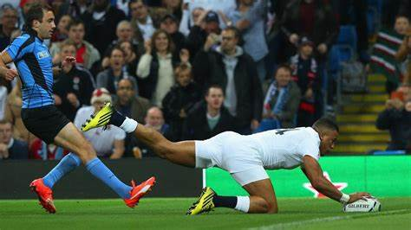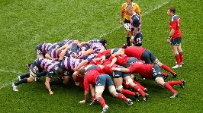What makes a good rugby team?*

|  |
| --- |
| Note Space |

# Presentation 1 - Intro to Specialisation & DoL

Complete the activities below so as to have a complete set of notes:

**Definition:** *Specialisation*

............................................................................................................................................................................................

............................................................................................................................................................................................

**Definition:** *Division of Labour*

............................................................................................................................................................................................

**Elaborate:** *For the below levels of specialisation, offer two new examples.*

Specialisation happens at all levels of economic activity:

Specialisation within firms (Teachers, teach. Cleaners, clean.)

............................................................................................................................................................................................

Specialisation between firms (Ford, cars. Greggs, bakery.)

............................................................................................................................................................................................

Specialisation between regions of a country (London, finance.)

............................................................................................................................................................................................

Specialisation between countries (Germany, machinery; Columbia, Coffee)

............................................................................................................................................................................................

**Key Notes:** *The Pin Factory* (fill in the gaps)

Adam Smith’s archetypal description of the impacts of the division of labour.

The pin making process can be split into _____ distinct steps, including the packaging the pins

Adam Smith visited a pin factory employing _____ men who produced _____ pins per day

If these workers did every step themselves, he reckoned they could each produce _____ pins per day.

The specialisation replaces up to ______ pin makers!

Labour productivity (output per person per day) in the factory is almost ______ times that of individual pin makers!

# Discussion Task: Specialisation in Practice

**Instructions:**

* With a partner discuss how the factor inputs used by the following parties might be specialised
* Compare your ideas with the rest of the class as a class afterwards

|  |  |  |  |  |
| --- | --- | --- | --- | --- |
| Factor of production | Holiday Resort | A Football club | A Dentists | The UK Government |
| **Land** |  |  |  |  |
| **Capital** |  |  |  |  |
| **Enterprise** |  |  |  |  |
| **Labour** |  |  |  |  |

Discussion Task: Specialisation – Good or Bad?

**Instructions:**

* Consider the discussion question, discuss your thoughts with a partner, share your ideas with the class

*What are the advantages and disadvantages of specialisation?*

|  |
| --- |
| Note Space: |

# Presentation 2 – Pros and Cons of the DoL

Complete the activities below so as to have a complete set of notes:

**Elaborate:** Elaborate on the below *PROS* of the Division of Labour and Specialisation

*Increased output per worker:*People become proficient through constant repetition of a task.

............................................................................................................................................................................................

*Lower cost per unit:*greater productivity means increased input to output ratio (productive efficiency).

............................................................................................................................................................................................

*Lower prices for consumers:*due to lower costs causing gains in economic welfare.

............................................................................................................................................................................................

*Increased international Trade:* Surplus output can then be traded internationally.

............................................................................................................................................................................................

............................................................................................................................................................................................

**Elaborate:** Elaborate on the below *CONS* of the Division of Labour and Specialisation

*Falling productivity:*Unrewarding work is repetitive and requires little skill.

............................................................................................................................................................................................

*Quality issues*

............................................................................................................................................................................................

*Absenteeism*

............................................................................................................................................................................................

*High worker turnover:*Many people may choose to move to less boring jobs.

............................................................................................................................................................................................

*Little training:* Firms have limited incentive to train workers.

............................................................................................................................................................................................

*Low Choice*

............................................................................................................................................................................................

*Over-reliance*

............................................................................................................................................................................................

# Article Task: Evaluating specialisation and trade

**Instructions:**

* Each group has an assigned article.
* In your Group you must read your article and complete the following tasks:

1. Explain the purpose of the article. What is going on?

2. Find all the Advantages of specialisation from trade

3. Find all the Disadvantages of specialisation from trade

* Each group relays their findings to the rest of the class.

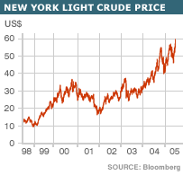

**Article 1: Specialisation: An Evaluation** (Source: Missing)

Today, there are very few economists who would dispute the benefits of trade: for countries to specialise in those products in which they have a comparative advantage will surely boost total world output and, therefore, living standards. However, can specialisation itself be a source of disadvantage?

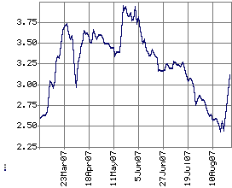The first thing to note is that specialisation makes a country reliant upon one or two products for its export revenues and, therefore, some of its income and employment. Accordingly, problems arise when prices fluctuate, as is often the case with commodities that are actively traded on organised exchanges. Take oil, for instance. While crude prices are currently at an all time high of $70+ per barrel, the oil-producing countries will never forget the devastating events of 1998. At the time, new oil-producing countries like Russia began pumping more crude into the market, while an unusually hot summer in Europe and North America depressed oil demand. The result was a sharp price drop to only $10 per barrel. For a country like Saudi Arabia, which relies on oil for up to 90% of its export earnings, the slump caused severe domestic disruption, with a fall in national income and an inevitable rise in unemployment.

**World Coffee Prices ($)**

Of course the extent of the disadvantage will depend on the magnitude of the price fluctuations. More recently, oil prices seem to have stabilised at around $70 to $75 per barrel and are unlikely to fall very far below this. However, there are other commodities for which price volatility does seem to be a permanent feature of the market. Coffee is a good example, where wild price fluctuations in the first half of 2007 alone have been particularly conspicuous. The inevitable result has been severe disruption and hardship to Latin American economies, which depend on coffee markets for much of their income and employment.

Then there is the problem of depletion. For example, oil reserves are fast dwindling as there hasn’t been any recent discovery of oil fields, while demand from China and India remains strong, and is sure to outstrip supply well into the foreseeable future. Should the Middle Eastern oil-producing countries continue to rely on oil for their income and employment, there will surely come a time when their labour and capital sits unemployed, with no product to mine.

However, there are two counter-arguments. Firstly, the problem of depletion only applies to *non-renewable* resources like oil, natural gas, copper and gold. Hence countries that specialise in *renewable* resources (tropical fruit in the Caribbean or Latin America) or those specialising in manufactured goods (China) or indeed in services (UK and Hong Kong) cannot suffer the problem of depletion. Secondly, whether depletion is a real threat depends on the current level of reserves. For Saudi Arabia, there is still over 264 billion barrels of proven oil reserves, providing 66 years of output; other countries like Iraq and Kuwait have over 100 years of oil reserves. For these countries, the problem of depletion is not so urgent, hence they *can* safely specialise in oil for the time being. However, Qatar, another Middle Eastern economy which relies heavily on oil, has less than 37 years of oil reserves. So we may argue that Qatar’s economy would be well advised to diversify into other sectors and industries before it’s too late.

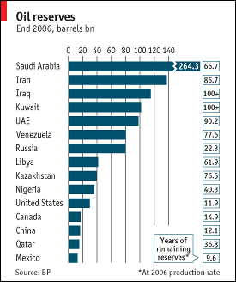Perhaps a more urgent problem for the oil-producing nations is the development of long-term oil substitutes. So far, the plastics industry has discovered numerous plant-based extracts that can be used instead of crude oil in the manufacture of plastic. At the moment, there is a race amongst automobile manufacturers to commercialise the first ‘alternative fuel’ car. Should this become a reality, the demand curve for crude oil will shift so far to the left that loss of income and unemployment in the oil-producing countries will be inevitable.

Of course, the general problem of changes in demand is not limited to the oil industry: *any* change in tastes and fashions can have negative consequences for countries specialising in one product. Take the tea picking industry, for instance. Since the rise of the ‘coffee culture’ in Western Europe, and particularly in the UK, world demand for tea has fallen and this has led to a loss of income and greater unemployment in countries like Sri-Lanka. Of course China and India also have major tea-picking industries. But since they have been diversifying into manufacturing and services, the impact of a (relatively) declining tea-picking sector has been limited, so their economy continues to grow at a rapid pace.

However, specialisation can also bring problems in relation to goods in which a country does *not* specialise. Again, the oil industry provides a good case study.

As a result of the ongoing Yom Kippur war (between Israel and Egypt, Syria), the Arab members of OPEC decided in 1973 to cut oil supplies to all countries supporting Israel. This included the United States and many of its allies in Western Europe.

The result was a quadrupling of oil prices which boosted the costs of production for firms all over the world. Output fell drastically as it became inefficient for many factories to keep running with such high energy costs; loss of income and unemployment was unavoidable.

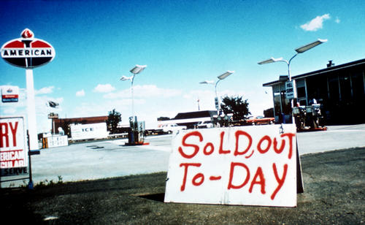For the average Westerner there were other, more immediate consequences. Petrol had to be rationed, leading to long queues at petrol stations. Fights often broke out as motorists competed to buy petrol. Before noon, many petrol stations had to close down for the day and put up a ‘Sold Out’ sign. The disruption to Western economies was unprecedented and made them realise the problems of relying heavily on such a volatile part of the world for such an important commodity. Of course, the same argument also applies to other commodities. And it is this desire to avoid ‘being held to ransom’ by unstable foreign governments that deters Western economies from giving up their agricultural sector. The capacity to produce food is too fundamental to leave in the hands of other countries

These all illustrate the importance of not taking specialisation too far. While there are clear benefits in terms of higher world output, consumption and living standards, countries which ‘put all their eggs in one basket’ can also find themselves with little to fall back on when economic circumstances change.

**Questions:**

1. Explain the purpose of the article. What is going on?

............................................................................................................................................................................................

……………………………………………………………………………………………………………………………………………………………………………………..

............................................................................................................................................................................................

……………………………………………………………………………………………………………………………………………………………………………………..

……………………………………………………………………………………………………………………………………………………………………………………..

2. Find all the Advantages of specialisation from trade

............................................................................................................................................................................................

……………………………………………………………………………………………………………………………………………………………………………………..

............................................................................................................................................................................................

……………………………………………………………………………………………………………………………………………………………………………………..

……………………………………………………………………………………………………………………………………………………………………………………..

3. Find all the Disadvantages of specialisation from trade

............................................................................................................................................................................................

……………………………………………………………………………………………………………………………………………………………………………………..

............................................................................................................................................................................................

……………………………………………………………………………………………………………………………………………………………………………………..

……………………………………………………………………………………………………………………………………………………………………………………..

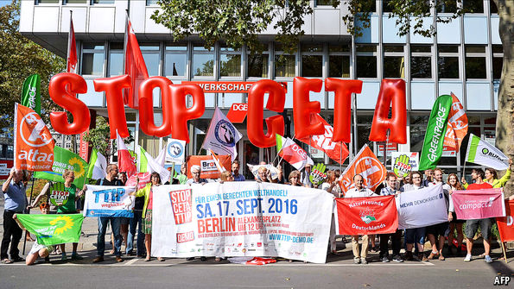**Article 2: Fortress mentality** (Source: [Fortress mentality | The Economist](https://www.economist.com/europe/2016/09/15/fortress-mentality))

A MOVEMENT is sweeping across Germany. Its followers say delightedly that it reminds them of the peace protests in the 1980s. At stake today, they claim, is nothing less than democracy itself: multinational companies—especially American ones—are trying to foist their wares on helpless European consumers. These behemoths, the protesters warn, could feed Europeans food that is genetically modified or even toxic, and sue into submission democratic European governments that pass laws the corporate honchos dislike.

Energised by this dystopian vision, more than 100,000 demonstrators are expected on September 17th at protests in Berlin, Hamburg, Leipzig, Munich, Cologne, Frankfurt and Stuttgart. Their slogan: “Stop CETA and TTIP!” CETA is a free-trade agreement with Canada which the European Union has been negotiating since 2009, slated to be signed next month. TTIP is its bigger sibling, a trade deal with America that has been in talks since 2013. Last month a truck delivered 125,000 signatures in 70 boxes to the supreme court in Karlsruhe to file a case against CETA, the largest such petition ever in Germany.

The activists’ biggest bugbear is the sort of arcane legal instrument that is hard to fit on a protest banner: the treaties’ provision for “investor-state dispute settlement” (ISDS). This allows firms that invest abroad to sue governments that make decisions which damage their interests. The suits are usually heard by private arbitrators. Germany has already agreed to this in some 130 other bilateral trade agreements. Negotiators have moved to accommodate the protesters, partly at Mr Gabriel’s urging: in CETA private arbitration has been replaced by public investment courts, and the EU wants to do the same in TTIP, though America has not agreed. But the courts are not good enough for anti-trade activists, who think the whole idea of ISDS gives foreign firms a veto over democracy. Reduction in sovereignty

The activists’ other fear concerns environmental, product and labour standards. Most Germans assume that their standards are stricter than anything in North America. In 2013, the first year of the TTIP negotiations, the country was in a media-fuelled panic over chlorinated chicken, which America was allegedly planning to export en masse into German supermarkets. Lately, the anxiety has shifted to genetically modified foods. Opponents worry that the trade deals will replace the EU’s “precautionary principle”, under which products must be proved safe before they are sold, with North America’s approach, which waits for proof that a product is harmful before banning it. Environment, Reduction in sovereignty

Missing from the German debate is any sense of the advantages of free trade. Trade would make consumers, including German ones, better off, as it would create more choice. It would help firms stay competitive, allowing greater competing against other global firms, with harmonised standards. Ensuring that global norms are set in Europe and North America—rather than, say, China. And there would be geopolitical benefits from tying Western societies closer together at a time of threats from Russia and the Middle East.

The protesters on September 17th will brush these advantages aside and focus only on the risks. Some are motivated by anti-Americanism. But most oppose the trade talks as remnants of “a certain philosophy and era” that predates the 2008 financial crisis, says Ernst-Christoph Stolper of Friends of the Earth Germany, one of the organisers of the demonstrations. Convinced that this “neoliberal” worldview has since been debunked, he says, Germans will march because they distrust markets, firms and globalisation.

**Questions:**

1. Explain the purpose of the article. What is going on?

............................................................................................................................................................................................

……………………………………………………………………………………………………………………………………………………………………………………..

............................................................................................................................................................................................

……………………………………………………………………………………………………………………………………………………………………………………..

……………………………………………………………………………………………………………………………………………………………………………………..

2. Find all the Advantages of specialisation from trade

............................................................................................................................................................................................

……………………………………………………………………………………………………………………………………………………………………………………..

............................................................................................................................................................................................

……………………………………………………………………………………………………………………………………………………………………………………..

……………………………………………………………………………………………………………………………………………………………………………………..

3. Find all the Disadvantages of specialisation from trade

............................................................................................................................................................................................

……………………………………………………………………………………………………………………………………………………………………………………..

............................................................................................................................................................................................

……………………………………………………………………………………………………………………………………………………………………………………..

……………………………………………………………………………………………………………………………………………………………………………………..

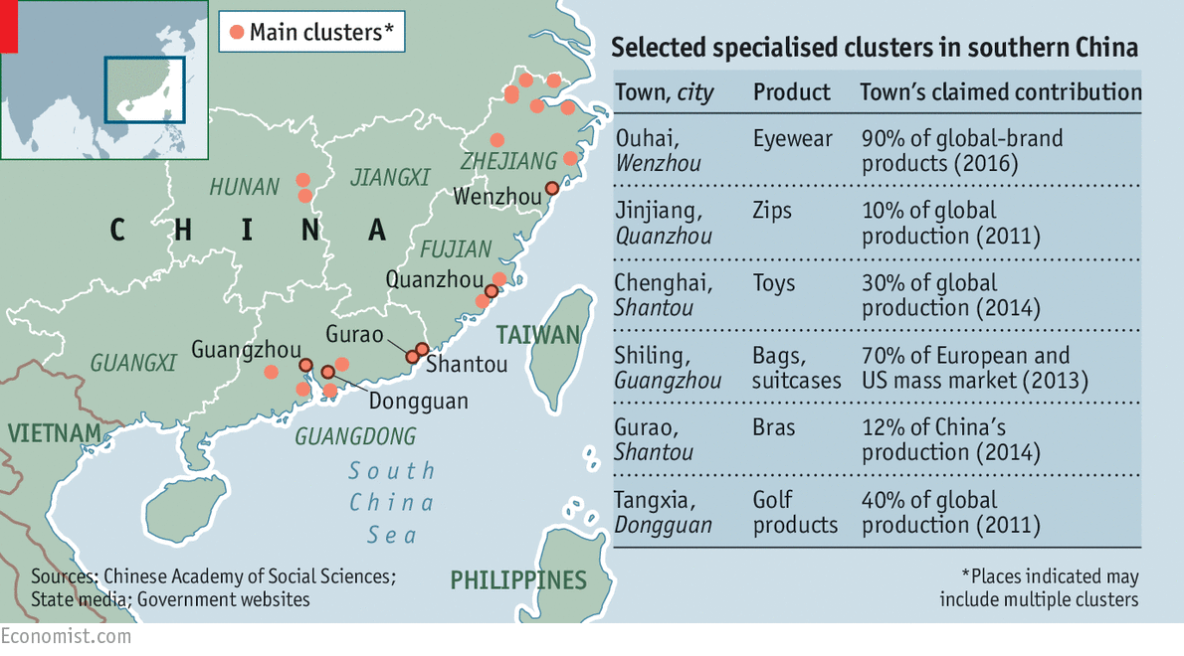**Article 3: Bleak times in bra town** (Source: [Bleak times in bra town | The Economist](https://www.economist.com/china/2016/04/16/bleak-times-in-bra-town))

A pyramid of bras stands beside each worker at the Honji Underwear factory in Gurao, a town in the southern province of Guangdong. The workshop resounds with the clack-clack of sewing machines as employees repeat their single, assigned task before passing the garment on to the next person on the production line. Most of the 22,000 thickly padded bras made here each day are destined for shops in China. In this “Town of Underwear”, as the local government likes to call it, there are thousands of similar factories. Gurao produces 350m bras and 430m vests and pairs of knickers a year for sale at home and abroad. Undies account for 80% of its industrial output.

During the past three decades of rapid economic growth, one-industry towns like Gurao and Chendian sprang up along China’s eastern seaboard, often in what were once paddyfields. With investment from Hong Kong and Taiwan, and a huge influx of migrant labour from China’s interior, they fuelled the country’s export boom. There are now more than 500 such towns, making products such as buttons, ties, plastic shoes, car tyres, toys, Christmas decorations and toilets (see map).

All this growth has had an environmental cost. In 2010 Greenpeace, an NGO, reported that fabric-dyeing plants in Gurao had severely polluted the water, making it unfit to drink. But the bra-makers of Gurao are far more worried about foreign competition than foreign eco-warriors.

Officials in Gurao insist that the town can overcome its difficulties by upgrading its technology and using machines instead of people. But attracting the capital and skill to transform Gurao may be more difficult than the daring step taken by a local entrepreneur in 1982 when he opened its first bra factory, at a time when private enterprise was still frowned on in China.

Even China’s largest underwear manufacturers have always found it hard to get long-term commitments from buyers. That has made them reluctant to spend on research or technology. Some factories in Gurao are upgrading, for example by making seamless laser-cut underwear and using new, more comfortable, materials to underwire bras. But most remain low-tech and labour-intensive.

Moreover, the town has specialised in low-skilled labour, which moves from one job to another, sewing the same part of the bra as they did in the previous factory. This makes labour dependent on local textile mills, with most not completing high school leaving them ill-equipped to retrain for jobs in service industries. With wages have risen by 12% a year since 2001, foreign competition from countries with cheaper labour, such as Thailand and Vietnam, are increasingly out-competing Chinese mills for work.

Some of the one-product boomtowns could fade away, leaving little behind but the concrete shells of empty factories and polluted soil. Locals are worried that their way-of-life will fade away, as people move to where jobs are more plentiful. Gurao and other such places have generated extraordinary wealth in once dirt-poor parts of the country. But to thrive in the future, they will need to look beyond the bare necessities.

**Questions:**

1. Explain the purpose of the article. What is going on?

............................................................................................................................................................................................

……………………………………………………………………………………………………………………………………………………………………………………..

............................................................................................................................................................................................

……………………………………………………………………………………………………………………………………………………………………………………..

2. Find all the Advantages of specialisation from trade

............................................................................................................................................................................................

……………………………………………………………………………………………………………………………………………………………………………………..

............................................................................................................................................................................................

……………………………………………………………………………………………………………………………………………………………………………………..

……………………………………………………………………………………………………………………………………………………………………………………..

3. Find all the Disadvantages of specialisation from trade

............................................................................................................................................................................................

……………………………………………………………………………………………………………………………………………………………………………………..

............................................................................................................................................................................................

……………………………………………………………………………………………………………………………………………………………………………………..

……………………………………………………………………………………………………………………………………………………………………………………..

# Presentation 3 – Functions of Money

Complete the activities below so as to have a complete set of notes:

**Key Notes:** *Specialisation requires trade*

People can only specialise in the production of one good or service if they can exchange/trade their good or service to fulfil their needs and wants for the goods and services they do not produce.

If people can’t trade their output they won’t have a very good quality of life – most will die!

**Definition:** *Bartering*

............................................................................................................................................................................................

*But:* This is costly as you must spend time searching for people willing to exchange with you.

*E.g.* A person with a kettle who wants a hammer must find someone with a hammer who wants a kettle.

A **__________________________________**________ is required.

**Key Question:** *Why has money developed?*

............................................................................................................................................................................................

……………………………………………………………………………………………………………………………………………………………………………………..

............................................................................................................................................................................................

**Elaborate:** Elaborate on the four functions of money

*A Medium of Exchange:* Money can be used to buy goods and services

……………………………………………………………………………………………………………………………………………………………………………………..

............................................................................................................................................................................................

……………………………………………………………………………………………………………………………………………………………………………………..

*A Measure of Value/Unit of Account:* Money allows the value of something to be expressed in an understandable way, and in a way that allows the value of items to be compared.

……………………………………………………………………………………………………………………………………………………………………………………..

............................................................................................................................................................................................

*A Store of Value:*This can refer to any asset whose “value” can be used now or used in the future. This means that people can save now to fund spending at a later date.

……………………………………………………………………………………………………………………………………………………………………………………..

*A Method of Deferred Payment:*Money is a unit of account across time, expressing the value of a debt.

……………………………………………………………………………………………………………………………………………………………………………………..

............................................................................................................................................................................................

Discussion Task: Good Money

**Instructions:**

* With a partner discuss how well the below items satisfy the four functions of money
* Compare your ideas with the rest of the class as a class afterwards

|  |  |  |  |  |
| --- | --- | --- | --- | --- |
| Item | Medium of exchange | Measure of Value | Store of Value | Method of Deferred Payment |
| **Shells** |  |  |  |  |
| **Primitive coins (e.g. the Shekel)** |  |  |  |  |
| **Paper Money** |  |  |  |  |
| **Digital currency** |  |  |  |  |
| **Bitcoin** |  |  |  |  |

# Task: Functions of Money –Missing Words

**Instructions:**

* Fill in the gaps using the missing words

1. **_____________** money whose value comes from the tradable good of which it is made. It is objects that have value in themselves as well as for use as money.
2. **____________**In economics, currency is a generally accepted medium of exchange. These are usually the coins and banknotes of a particular government, which comprise the physical aspects of a nation's money supply.
3. **_____________** the rate between two currencies is the rate at which one currency will be exchanged for another.
4. ______________ a currency whose value is not derived from any intrinsic value or guarantee that it can be converted into a valuable commodity (such as gold).
5. **_________________** Sometimes called a pegged exchange rate, a type of exchange rate regime wherein a currency's value is matched to the value of another single currency or to a basket of other currencies, or to another measure of value, such as gold.
6. **_____________________** a type of exchange rate regime wherein a currency's value is allowed to fluctuate according to the foreign exchange market.
7. **__________** An intermediary used in trade to avoid the inconveniences of a pure barter system, such as money.
8. **____________**a generally accepted means of exchange and measure of value
9. **___________** The total amount of money available in an economy at a specific time.
10. **___________**An asset such as money or gold that is purchased or accepted as payment for goods and services for its ability to purchase other assets in the future without rapidly losing its purchasing power.
11. **_______________**a standard monetary unit of measurement of value/cost of goods, services, or assets.
12. When money is used to intermediate the exchange of goods and services, it is performing a function as a _____________________. This avoids the need for the double coincidence of wants
13. A _____________________________________________ is a standard numerical unit of *measurement of the market value* of goods, services, and other transactions.
14. To act as a ___________________________, money must be able to be reliably saved, stored, and retrieved. In this case, the value of the money must also remain stable over time.
15. Money can also function as a _____________________________________________ .which means that its status as legal tender allows it to function for the discharge of debts.

**Missing words:**

*Store of value, store of value. medium of exchange, money supply, currency, commodity money, exchange rate, standard of deferred payment,  floating exchange rate, unit of account, Fixed Exchange rate, money, Fiat money, medium of exchange, unit of account / measure of value*

# Assignment

**Short-answer questions (Section A)**

1. Explain **one** disadvantage that a sandwich making firm may experience from the division of labour on its production line.

[2]

1. Which of the following is the most likely consequence of an increase in the division of labour in the production of beauty products?

A A decrease in the total revenue of beauty product manufacturers

B Decreased use of specialised manufacturing equipment

C A decrease in the cost per unit of beauty products

D A shift in demand for beauty products

[1]

1. When money is used a medium of exchange:

A Barter or swapping of goods is likely to become more common

B Trade is likely to increase

C The relative prices of goods never change

D Specialisation and division of labour become more difficult

[1]

1. The use of money as a medium of exchange enables an economy to

A Operate outside of its PPF

B Increase production of public goods

C Prevent market failure

D Benefit from specialisation and the division of labour

[1]

**Data response (Section B)**

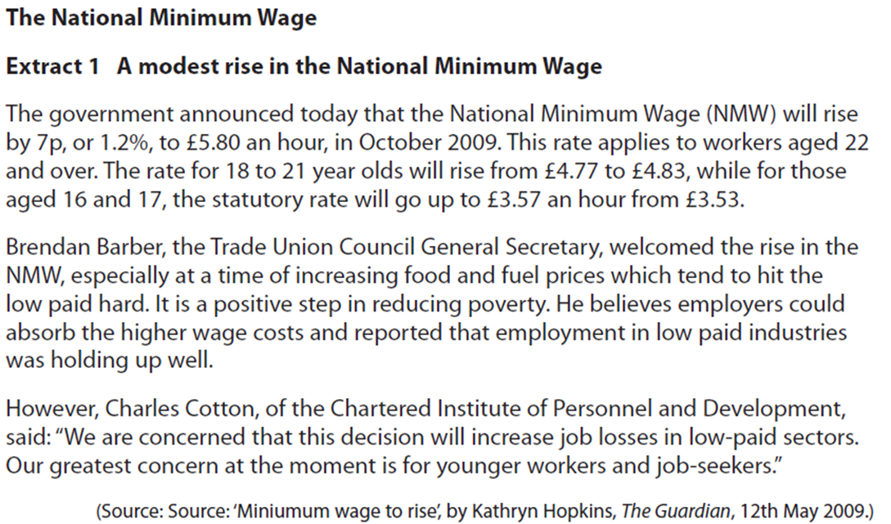Extract:

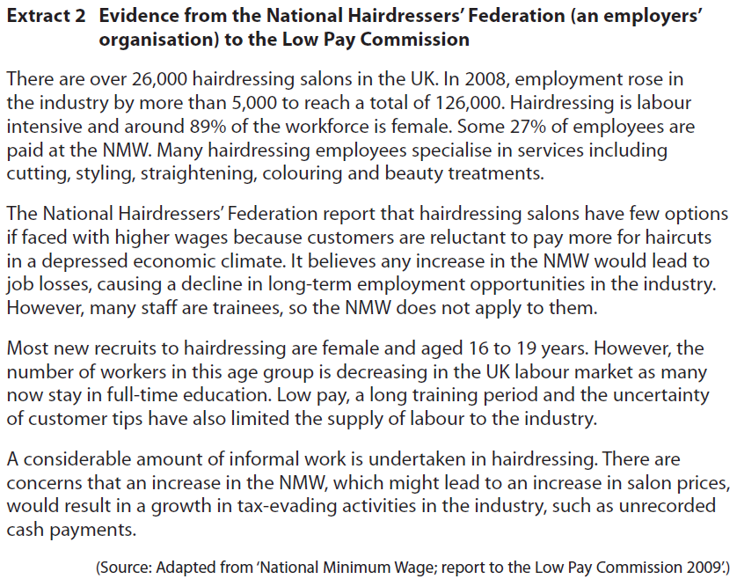

Question:

Assess the likely benefits of division of labour to hairdressing salons.

[10]

Structure:

1. Definitions
2. First paragraph for or against depending on your view (structure- first sentence should directly answer the question, explanation and then example)
3. First evaluative paragraph which goes against your previous points (structure- signposted and directly answers the question, explanation and then example)
4. Second Paragraph For Or Against Depending On Your View (structure- first sentence should directly answer the question, explanation and then example)
5. Second Evaluative Paragraph Which Goes Against Your Previous Points (structure- signposted and directly answers the question, explanation and then example)

Answer Space

……………………………………………………………………………………………………………………………………………………………………………………..

……………………………………………………………………………………………………………………………………………………………………………………..

……………………………………………………………………………………………………………………………………………………………………………………..

……………………………………………………………………………………………………………………………………………………………………………………..

……………………………………………………………………………………………………………………………………………………………………………………..

……………………………………………………………………………………………………………………………………………………………………………………..

……………………………………………………………………………………………………………………………………………………………………………………..

……………………………………………………………………………………………………………………………………………………………………………………..

……………………………………………………………………………………………………………………………………………………………………………………..

……………………………………………………………………………………………………………………………………………………………………………………..

……………………………………………………………………………………………………………………………………………………………………………………..

……………………………………………………………………………………………………………………………………………………………………………………..

……………………………………………………………………………………………………………………………………………………………………………………..

……………………………………………………………………………………………………………………………………………………………………………………..

……………………………………………………………………………………………………………………………………………………………………………………..

……………………………………………………………………………………………………………………………………………………………………………………..

……………………………………………………………………………………………………………………………………………………………………………………..

……………………………………………………………………………………………………………………………………………………………………………………..

……………………………………………………………………………………………………………………………………………………………………………………..

……………………………………………………………………………………………………………………………………………………………………………………..

……………………………………………………………………………………………………………………………………………………………………………………..

……………………………………………………………………………………………………………………………………………………………………………………..

……………………………………………………………………………………………………………………………………………………………………………………..

……………………………………………………………………………………………………………………………………………………………………………………..

……………………………………………………………………………………………………………………………………………………………………………………..

……………………………………………………………………………………………………………………………………………………………………………………..

……………………………………………………………………………………………………………………………………………………………………………………..

……………………………………………………………………………………………………………………………………………………………………………………..

……………………………………………………………………………………………………………………………………………………………………………………..

……………………………………………………………………………………………………………………………………………………………………………………..

……………………………………………………………………………………………………………………………………………………………………………………..

……………………………………………………………………………………………………………………………………………………………………………………..

……………………………………………………………………………………………………………………………………………………………………………………..

……………………………………………………………………………………………………………………………………………………………………………………..

……………………………………………………………………………………………………………………………………………………………………………………..

……………………………………………………………………………………………………………………………………………………………………………………..