Supply of Labour

Starter: Discussion Question
Instructions:
- Individually consider the below discussion question.
- Discuss your thoughts with a partner
- Share your ideas with the class
How does the supply of lawyers and nurses differ? Why might this be case?
Note Space:

Presentation 1 - Intro to Supply of Labour
Complete the activities below so as to have a complete set of notes:
Definition: Supply of Labour
……………………………………………………………………………………………………………………………………………………………………………………
……………………………………………………………………………………………………………………………………………………………………………………

Key Notes: Supply of labour can be considered across three levels
Individual S_{L}: The ____________________________________ that an individual labourer is willing and able to supply at a given wage rate.

Industry S_{L}: The ___________________________________willing and able to work in a given occupation or industry at each given wage rate.

National S_{L}: The ______________________________is defined as the number of people either in work or actively seeking paid employment and available to start work.
Diagram: The industry and national labour supply curves have the same shape – upward sloping.
This is because a higher wage is required to attract more people into an industry/the labour force.
Additional workers have a higher disutility from joining the industry/labour force that must be compensated with higher wages.
Reservation Wage: The lowest wage rate at which a worker would be willing to accept (hence SL doesn’t start at the origin).
N.B. We examine the individual labour supply curve later.

Presentation 2 – Factors affecting National Labour Supply
Complete the activities below so as to have a complete set of notes:
General Note: The national labour supply is based on factors that affect the size of the labour force - the pool of people who are working or are willing and able to work.
Brainstorm: Factors affecting national labour supply

Factors affecting national labour supply

Supplement your brainstorm with any extra factors from the presentation.
Extension: Add real world examples that illustrate your factors in practice.

Presentation 3 – Factors affecting Industry Labour Supply
Complete the activities below so as to have a complete set of notes:
General Note: The labour supply for an industry is based on factors that affect the how attractive that industry is to work in, and also how easy the industry is to join.
Brainstorm: Factors affecting industry labour supply

Factors affecting Industry labour supply

Supplement your brainstorm with any extra factors from the presentation.
Extension: Add real world examples that illustrate your factors in practice.

Definition: Net Advantage
……………………………………………………………………………………………………………………………………………………………………………………
……………………………………………………………………………………………………………………………………………………………………………………
First coined by Adam Smith.


Article Task: UK Teachers in Short Supply
Instructions:
- Read, highlight and annotate the article
- Answer the key question
- Discuss your answers as a class
Article
A new report warns that there is a substantial risk that teacher recruitment targets will not be met this year across a large range of secondary subjects, including English, a subject that usually meets its target. It also worryingly shows that there are recruitment challenges in other subjects that tend to recruit well, including geography and art.
The Teacher Labour Market in England Annual Report 2022, published by the National Foundation for Educational Research (NFER) and funded by the Nuffield Foundation, also projects that there will be a recruitment shortfall in persistent shortage subjects, such as physics, which is estimated to be recruiting at less than 20% of the level required to meet its target. It also reveals that subjects including maths, chemistry, computing, design and technology and modern foreign languages, will continue to have recruitment challenges this year.
The latest cohort of initial teacher training applicants will not start teaching in schools until September 2023, giving the Government and schools a window of time to plan and take action. Without action to address teacher recruitment and retention, shortages may increasingly come to negatively impact on pupils’ education and learning.
Commenting on the report, NFER School Workforce Lead, Jack Worth said:
“The evidence seems clear that teacher supply challenges across subjects are re-emerging after two years of having eased due to the pandemic. Tackling this effectively requires policy action to improve the financial and non-financial attractiveness of teaching.
“Improving the competitiveness of teachers’ pay is important for both recruiting and retaining teachers, but while the Government has proposed pay increases for teachers, the increases seem insufficient on their own to address the emerging recruitment and retention challenges.
“Ensuring teachers’ workloads are manageable could be an important part of a strategy to improve supply by reducing the numbers of teachers leaving, but our analysis indicates that teacher workload remains a significant issue as more than half of full-time teachers perceive that they work too many hours.
“Support for trainees and early-career teachers from their experienced colleagues as they begin their careers is another important non-financial factor for retention. However, our survey data shows that schools’ capacity for offering training placements remains squeezed, and senior leaders’ key concern is the burden on school staff to provide support for trainees.”
Cheryl Lloyd, Education Programme Head at the Nuffield Foundation said:
“More substantial interventions are needed to encourage applicants to initial teacher training courses including physics, maths and modern foreign languages. Addressing the ongoing shortfalls in teacher training applications should be a priority to ensure students can benefit from specialist teaching in these subjects and that schools across the country can offer a breadth of course options to their students. This report also highlights that recruitment challenges are becoming more widespread, with a reduction in applicant numbers for teacher training in subjects which have typically recruited well in the past, including English, geography and art.”
The research also finds that teacher retention rates, which had improved substantially in 2020 during the pandemic, due to economic uncertainty and lockdown, also appeared to be returning towards pre-pandemic levels in 2021, due to the returning wider labour market opportunities.
Teachers’ real-terms pay is now lower than a decade ago, whereas the pay of similar individuals in other professions is around the same as in 2010/11 in real terms. This loss of competitiveness in teacher pay is likely to have contributed, at least in part, to increasing leaving rates and the supply challenges that developed during the 2010s. Increasing the competitiveness of teacher pay faster than pay in the rest of the economy is likely to increase both recruitment and retention, but the overall increase in teacher pay proposed by the Government over the next two years is the same rate as pay is expected to rise in the rest of the economy.
Further findings from the report show:
- In February 2022, the number of Initial Teacher Training (ITT) applications are 23% lower than in February 2021.
- Teachers continue to work longer hours than similar individuals in other professions during term time and are more likely to want to work fewer hours.
- Schools’capacity to mentor trainees and new teachers is likely to remain under strain due to a range of pressures. This could be linked to the increased demand for schools’ mentoring capacity as a result of the Early Career Framework (ECF) national rollout, which began in September 2021.
The report also makes the following recommendations:
- The Government should maintain the London teacher pay premium at its current level to avoid exacerbating teacher shortages in London schools.
- The Government should take action to ensure schools have sufficient long-term mentoring capacity to support the increasing numbers of trainees and new teachers entering the system.
- Reducing teacher workload and supporting teacher well-being should remain a high priority for the Government.
Key Question: According to the article, why is the supply of teachers declining? Can you think of any more reasons?
Note Space:
Extension: What else could be done to boost supply?
……………………………………………………………………………………………………………………………………………………………………………………
……………………………………………………………………………………………………………………………………………………………………………………
……………………………………………………………………………………………………………………………………………………………………………………
……………………………………………………………………………………………………………………………………………………………………………………
……………………………………………………………………………………………………………………………………………………………………………………

Presentation 4 – Wage Elasticity of Supply
Complete the activities below so as to have a complete set of notes:
Definition: Wage Elasticity of Supply (WES)
……………………………………………………………………………………………………………………………………………………………………………………
……………………………………………………………………………………………………………………………………………………………………………………
Equation:
The factors that affect WES are similar to those that affect PES.

Elaborate: Elaborate on the below factors affecting WES
Skills & Education Requirements: The more complicated the skills and the higher, or longer to achieve, the qualifications required, the more inelastic the supply.
……………………………………………………………………………………………………………………………………………………………………………………
……………………………………………………………………………………………………………………………………………………………………………………

Vocation: If the workers in the industry feel a ‘calling to their job’, such as nursing, supply will be more inelastic.
……………………………………………………………………………………………………………………………………………………………………………………
……………………………………………………………………………………………………………………………………………………………………………………

Time period: In the short run, the supply curve of labour tends to be inelastic as it takes time for people to respond to changes in relative wages.
……………………………………………………………………………………………………………………………………………………………………………………
……………………………………………………………………………………………………………………………………………………………………………………

Thought Exercise: How long would you work?
Instructions:
- Consider the hourly wage rates in the table below
- Determine how many hours you would work per day at each wage rate
- Sketch that information on a graph
Table:
Hourly Wage (£) | Average Hours Worked Per Day
5
10
15
25
50
100
500
1000
5000

Diagram: A graph of ____________________________ against _______________________

Presentation 5 – Factors affecting Individual Labour Supply
Complete the activities below so as to have a complete set of notes:
General Note: To understand what affects the individual labour supply, we must first understand two different counteracting effects which determine how many hours and individual would be willing to work for.
Definition: Substitution Effect
……………………………………………………………………………………………………………………………………………………………………………………
……………………………………………………………………………………………………………………………………………………………………………………
……………………………………………………………………………………………………………………………………………………………………………………
They substitute leisure for work.
A positive correlation between income and work.

Definition: Income Effect
……………………………………………………………………………………………………………………………………………………………………………………
……………………………………………………………………………………………………………………………………………………………………………………
……………………………………………………………………………………………………………………………………………………………………………………
This is due to workers needing fewer hours to meet a target income which they then spend on items with positive YED.
A negative correlation between income and work.

Diagram: The Individual labour supply curve is ‘backward-bending’ in shape.
Rising wages lead an individual to increase their labour supply at low wage rates due to the substitution effect outweighing the income effect.
As wages, and therefore income, continues to increase, the income effect grows in significance.
At some point the income effect outweighs the substitution effect
Increased wages mean that workers can actually work less hours for the same income, as they choose to consumer more leisure (i.e. work less).

Key Question: What determines the point where an individual’s income effect dominates their substitution effect?
……………………………………………………………………………………………………………………………………………………………………………………
……………………………………………………………………………………………………………………………………………………………………………………
……………………………………………………………………………………………………………………………………………………………………………………

Assignment
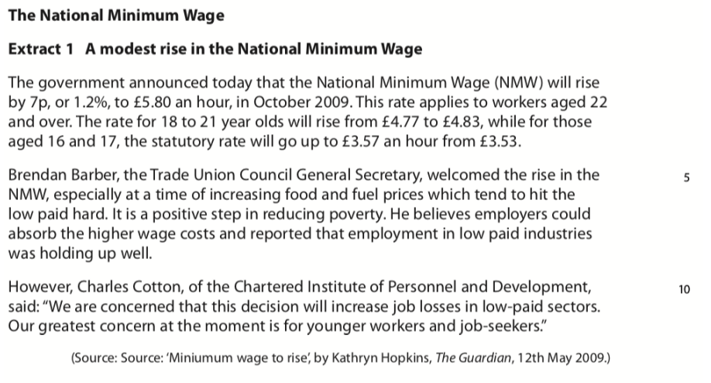
Section B (Data Response)

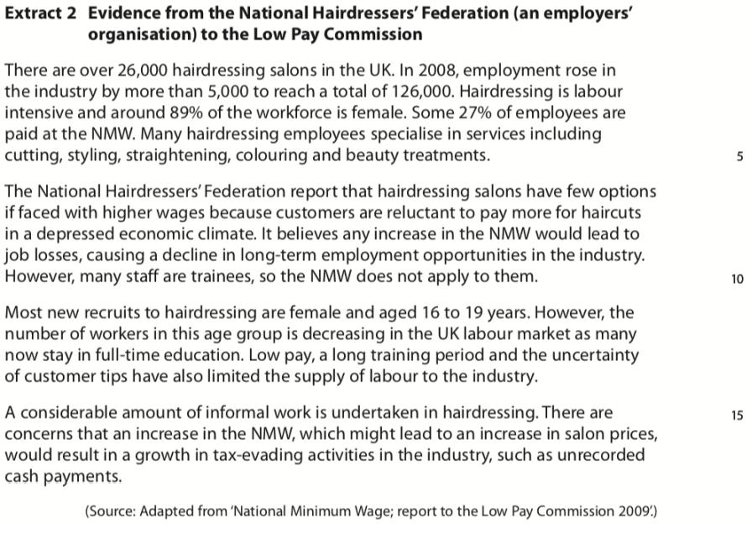

Question
Apart from National minimum wage, discuss the factors which might influence the supply of labour to hairdressing.

Question: Apart from National minimum wage, discuss the factors which might influence the supply of labour to hairdressing. [12]
Planning Grid: Aim = 5 paragraphs - 2 KAA points (8); 2 Eval points (4)
KAA Point 1 = signpost key point
Application
Main concept & diagram

Eval Point 1 = relate to your earlier point & re-read the title
Context / evidence
KAA Point 2 = signpost key point
Application
Main concept & diagram

Eval Point 2 = relate to your earlier point & re-read the title
Context / evidence

