Terms of Trade

# Starter – Table task

**Instructions:** Complete the table for the below goods from the perspective of the UK.

|  |  |  |  |  |
| --- | --- | --- | --- | --- |
|  | **Oil** | **PlayStation 5s** | **Bentley Continentals** | **GSK Pharmaceuticals**  **GSK Logo linking to the homepage** |
| Is the PED of this good likely to be elastic or inelastic? |  |  |  |  |
| Is this good imported or exported by the UK? |  |  |  |  |
| If the price of this good went up, would the quantity demanded fall by proportionally more or proportionally less? |  |  |  |  |
| What would happen to the **value** of X/M as a result of this price increase? |  |  |  |  |
| What would happen to the UK’s balance of trade as a result of the price increase? |  |  |  |  |

# Presentation 1 – Intro to Terms of Trade

Complete the activities below so as to have a complete set of Notes:

**Definition:** *Terms of Trade*

……………………………………………………………………………………………………………………………………………………………………………………

……………………………………………………………………………………………………………………………………………………………………………………

*Equation:*

Whilst, at first glance, this can seem confusing, it can be simply explained as a measure of the number of exports an economy must sell per import it can purchase.

**Key Notes:** *Importance of Terms of Trade*

ToT can be used as ***one*** measure of a country's trade competitiveness.

Rise in the price of X/Fall in the price of M → ______ ToT, _______ Living standards, **BUT** _______competitiveness.

Fall in the price of X/Rise in the price of M → ______ ToT, _______ Living standards, **BUT** _______competitiveness.

**Elaborate:** Elaborate on the key limitation of ToT analysis

*Improvements and deteriorations in ToT are not inherently good or bad.*

……………………………………………………………………………………………………………………………………………………………………………………

……………………………………………………………………………………………………………………………………………………………………………………

……………………………………………………………………………………………………………………………………………………………………………………

……………………………………………………………………………………………………………………………………………………………………………………

# Table Task: Terms of Trade calculations

**Instructions:** Complete the data for this hypothetical nations terms of trade.

|  |  |  |  |  |  |
| --- | --- | --- | --- | --- | --- |
| Year | Index of average export prices | Index of average import prices | Calculation | Terms of Trade | Improvement or deterioration? |
| 1999 | 90 | 85 |  |  |  |
| 2000 | 95 | 85 |  |  |  |
| 2001 | 120 | 100 |  |  |  |
| 2002 | 130 | 110 |  |  |  |
| 2003 | 115 | 115 |  |  |  |
| 2004 | 108 | 105 |  |  |  |
| 2005 | 100 | 100 |  |  |  |
| 2006 | 102 | 100 |  |  |  |
| 2007 | 106 | 105 |  |  |  |
| 2008 | 108 | 110 |  |  |  |
| 2009 | 108 | 120 |  |  |  |
| 2010 | 118 | 140 |  |  |  |

**Recap Question:** What is the equation which converts raw data into index figures?

*Equation:*

# Presentation 2 – Factors Affecting Terms of Trade

Complete the activities below so as to have a complete set of Notes:

**Elaborate:** Elaborate on how these factors affect the ToT

Short-run causes

*1. Demand & Supply of Exports and Imports*

……………………………………………………………………………………………………………………………………………………………………………………

……………………………………………………………………………………………………………………………………………………………………………………

……………………………………………………………………………………………………………………………………………………………………………………

*2. Relative inflation rates:*

……………………………………………………………………………………………………………………………………………………………………………………

……………………………………………………………………………………………………………………………………………………………………………………

……………………………………………………………………………………………………………………………………………………………………………………

*3. Exchange rates Movements*

……………………………………………………………………………………………………………………………………………………………………………………

……………………………………………………………………………………………………………………………………………………………………………………

……………………………………………………………………………………………………………………………………………………………………………………

Long-run causes

*1. Income*

……………………………………………………………………………………………………………………………………………………………………………………

……………………………………………………………………………………………………………………………………………………………………………………

……………………………………………………………………………………………………………………………………………………………………………………

*Prebisch–Singer hypothesis:*The observation that the prices of primary commodities decline relative to those of manufactured goods over time, causing the terms of trade of primary-product-based economies to deteriorate (more on this later).

*2. Productivity*

……………………………………………………………………………………………………………………………………………………………………………………

……………………………………………………………………………………………………………………………………………………………………………………

……………………………………………………………………………………………………………………………………………………………………………………

*3. Technology*

……………………………………………………………………………………………………………………………………………………………………………………

……………………………………………………………………………………………………………………………………………………………………………………

# http://cdn.static-economist.com/sites/default/files/imagecache/original-size/images/print-edition/20140329_AMC602.pngArticle Task: Latin America-Life after the commodity boom

**Instructions:**

* Read, highlight and annotate the article
* Answer the questions
* Discuss your answers as a class

**Article**

*Instead of the crises of the past, mediocre growth is the big risk—unless productivity rises*

ONE morning last month Louis Dreyfus, a big commodity-trading house, formally opened a new $10m storage depot in the Peruvian port of Callao. Two of its six bunkers were piled high with 55,000 tonnes of fine brown dust covered by white tarpaulins—copper and zinc concentrate, awaiting blending and shipment. The warehouse is “a bet that Peruvian mining will continue to be competitive and that the prices Peruvian commodity miners face will remain high,” says Gonzalo Ramírez, a Dreyfus manager. That looks like a sound wager. Blessed with high-grade ores and cheap energy, Peru’s output of copper—already the world’s third-largest—will more than double in the next three years, thanks to the opening of several low-cost mines.

But rather than marking a new dawn, this burst of investment comes at the twilight of the great commodity boom occasioned by the greater demand from the industrialisation of China and India. By providing an unprecedented boost to the region’s terms of trade (the ratio of the price of its exports to that of its imports), this handed many Latin American countries a bounteous decade.

No longer. Oil and gas excluded, export commodity prices are down by a quarter from their level of 2011, with prices of minerals falling by more than those of foodstuffs. After growing by an average of 4.3% in 2004-11, the region’s economies managed just 2.6% last year. Hopes of acceleration this year are being dashed as currency strength nosedives. Brazil has had to raise interest rates sharply to contain a sudden burst of imported inflation, and is unlikely to beat its 2013 growth of 2.3%. Mexico, although less commodity-driven than South America, is unlikely to do much better. Data suggest that Chile is growing at its slowest rate for four years. Even Peru, along with Panama the region’s star economy of the past decade, felt the cold draft: it expanded at 5% in 2013, down from an average of 7% since 2005.

However, the picture is more nuanced than that. Rising imported inflation from more expensive imports relative to export revenues, should in the interim provide a stoppage to falling export prices. If the price of extraction rises because machine tool imports into Latin America become more expensive then commodity prices will stabilize.

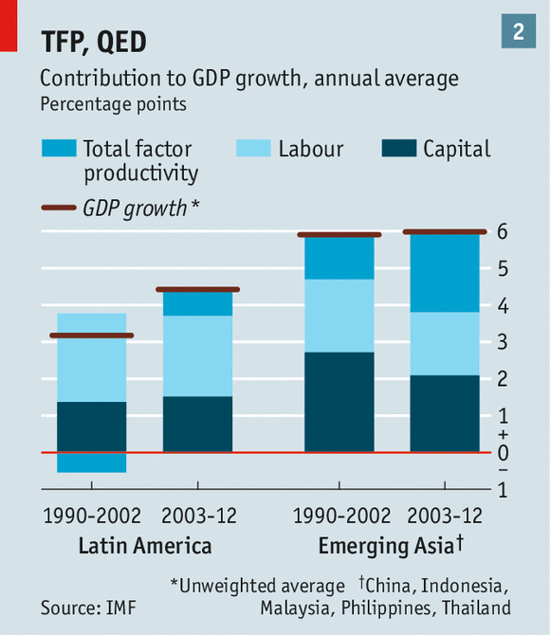Some industries are also hoping for central banks to support the purchasing power of domestic currencies in a bid to limit the impact of weakening currencies, and allow their businesses time to respond to changing market conditions. Although floating exchange rates and inflation-targeting by more-or-less independent central banks mean that many countries will adjust by allowing their currencies to depreciate without triggering a downward spiral of inflation and devaluation. There is acceptance among many central bankers to raise interest rates and increase the attractiveness of investing in domestic currency. This will increase the value of local money, boosting the price of exports.

The biggest threat to financial stability is a sharp slowdown in foreign demand, notably China. Miguel Castilla, Peru’s economy minister, notes that commodity prices are still above their average of the past ten years. Were China’s growth rate to dip below 7%, that would soon change. But he stresses that Peru, like Chile and Colombia, has scope to respond with fiscal and monetary measures.

More than economic instability, the worry for Latin America is low growth—the risk that 3% has become the new norm. Mr Werner notes that the halt in the rise in the region’s terms of trade has itself knocked a percentage point off growth, increasing the cost of importing machine tools and technology for further productivity growth. With full employment, and with the labour force and domestic credit both expanding less rapidly, Latin America must look more to productivity improvements to boost GDP. And that is its Achilles heel.

Productivity has improved a bit, but still lags behind Asia’s (see chart 2). The reasons for this shortfall date back many years. Although Latin Americans have more education than in the past, international tests show that they still do not learn enough in school. Mr de la Torre points, too, to a relative lack of innovation by Latin American firms of all sizes, to poor transport networks and to a lack of competition, especially in services.

Another big handicap is the large informal economy. In Peru, no less than 61% of the workforce works in the informal sector, according to the statistics agency. “It was an escape valve when Peru was a poor country, but it’s a problem now,” says Piero Ghezzi, the minister for production.

To see why, take Mexico, where around half the workforce is informal. A new report by McKinsey, a consultancy, finds that, astonishingly, Mexican workers have become less productive over the past three decades despite numerous economic reforms. Output per worker fell from $18.30 an hour (in purchasing-power-parity terms) in 1981 to $17.90 in 2012.

The reason, McKinsey argues, is that Mexico has a dual economy. Productivity at large, modern firms, which are integrated into the world economy, has risen by 5.8% a year since 1999. But the productivity of small businesses (with ten or fewer workers), many of which are informal, declined from 28% of that of large firms (with 500 or more workers) in 1999 to just 9% in 2009. And small firms account for a big (42%) and growing share of the workforce.

Fixing the productivity problem is far more complicated than slashing the fiscal deficit. Assembling land, permits and finance for infrastructure projects can take many years in Latin America. Education reforms take a similar time to have an effect. Informality is a complex issue, as much cultural as economic.

But governments can no longer afford to put off reforms indefinitely. The risk the region faces is not the financial crises of old but rather the clash between low growth and the aroused expectations of growing middle classes. As the mass protests last June in Brazil suggest, it is a clash that could be politically explosive.

**Questions**

What factors that influence ToT in the short run are discussed? Explain why they effect the ToT.

……………………………………………………………………………………………………………………………………………………………………………………

……………………………………………………………………………………………………………………………………………………………………………………

……………………………………………………………………………………………………………………………………………………………………………………

……………………………………………………………………………………………………………………………………………………………………………………

……………………………………………………………………………………………………………………………………………………………………………………

……………………………………………………………………………………………………………………………………………………………………………………

What factors that influence ToT in the long run are discussed? Explain why they effect the ToT.

……………………………………………………………………………………………………………………………………………………………………………………

……………………………………………………………………………………………………………………………………………………………………………………

……………………………………………………………………………………………………………………………………………………………………………………

……………………………………………………………………………………………………………………………………………………………………………………

……………………………………………………………………………………………………………………………………………………………………………………

……………………………………………………………………………………………………………………………………………………………………………………

If exports are price elastic and the terms of trade are improving, explain what will happen to the export revenue calculated by the current account?

……………………………………………………………………………………………………………………………………………………………………………………

……………………………………………………………………………………………………………………………………………………………………………………

……………………………………………………………………………………………………………………………………………………………………………………

……………………………………………………………………………………………………………………………………………………………………………………

……………………………………………………………………………………………………………………………………………………………………………………

If exports are price inelastic and the terms of trade are improving, what will happen to the export revenue calculated by the current account?

……………………………………………………………………………………………………………………………………………………………………………………

……………………………………………………………………………………………………………………………………………………………………………………

……………………………………………………………………………………………………………………………………………………………………………………

……………………………………………………………………………………………………………………………………………………………………………………

……………………………………………………………………………………………………………………………………………………………………………………

If imports are price elastic and the terms of trade are deteriorating, what will happen to import expenditure as calculated by the current account?

……………………………………………………………………………………………………………………………………………………………………………………

……………………………………………………………………………………………………………………………………………………………………………………

……………………………………………………………………………………………………………………………………………………………………………………

……………………………………………………………………………………………………………………………………………………………………………………

……………………………………………………………………………………………………………………………………………………………………………………

If imports are price inelastic and the terms of trade are deteriorating, what will happen to import expenditure as calculated by the current account?

……………………………………………………………………………………………………………………………………………………………………………………

……………………………………………………………………………………………………………………………………………………………………………………

……………………………………………………………………………………………………………………………………………………………………………………

……………………………………………………………………………………………………………………………………………………………………………………

……………………………………………………………………………………………………………………………………………………………………………………

# Presentation 3 – Terms of Trade and the Balance of Trade

Complete the activities below so as to have a complete set of Notes:

**Key Consideration:** The effect of changes in the ToT on the balance of payments on the current account depends upon the PED of a nation’s exports and imports.

**Table Task:** Exports, Imports, PED, Terms of Trade and the Balance of Trade.



|  |  |  |  |  |
| --- | --- | --- | --- | --- |
|  | **PED**  (elastic or inelastic) | **Price Change**  (increase or decrease) | **Terms of Trade** (improve or deteriorate) | **Current Account Balance** (improve or deteriorate) |
| Exports | Elastic |  |  |  |
|  |  |  |
| Inelastic |  |  |  |
|  |  |  |
| Imports | Elastic |  |  |  |
|  |  |  |
| Inelastic |  |  |  |
|  |  |  |

***Extension*** How could changes to the ToT affect the other macroeconomic objectives?

|  |
| --- |
| Note Space: |

# Article Task: The Terms of Trade for Developing Nations

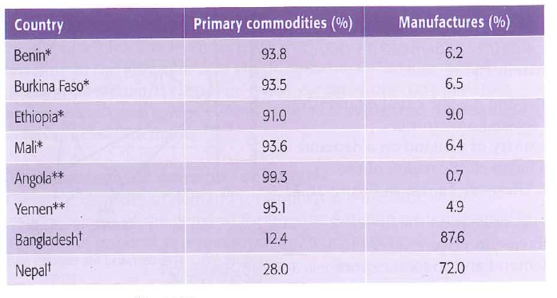**Instructions:**

Table 1

* Read, highlight and annotate the article
* Answer the questions
* Discuss your answers as a class

**Article**

Study the tables.

Table 1 shows the share of primary commodities and manufactures (manufactured goods) in total merchandise exports for selected LEDCs in 2008. Now look at table 2 which shows real commodity prices for petroleum and other commodities for the period 2000 -2010. It uses index numbers with the base year being 2005

There are a few observations to be drawn from these tables. The first is obvious, that not every LEDC is the same, they may share similar characteristics but their economies may be dominated by the production of very different goods and services.

*Table* 2

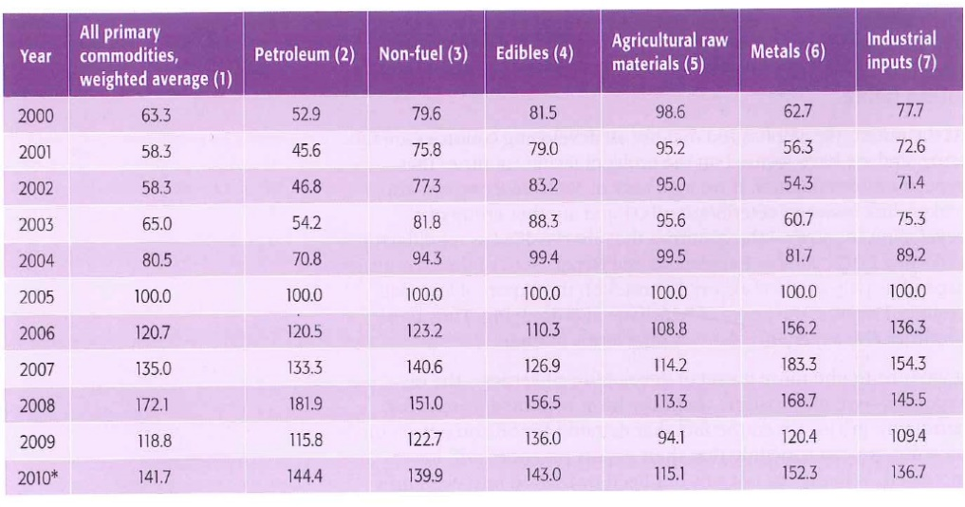The second observation concerns the countries marked with an * in table 1. These countries’ exports are dominated by unprocessed primary commodities such as metals, petrol and agricultural raw materials. If you look again at the index of prices of edibles, non-fuels, metals and agricultural raw materials in table 2 you will notice that they have fluctuated substantially in a ten-year period. These commodity prices tend to be quite volatile. As a result, primary commodity exporting countries are quite vulnerable to circumstances beyond their control. The fact that export revenues can fluctuate significantly can make it difficult for governments to plan effectively for the future.

In addition, prior to 2000 there was a long-run downward trend in commodity prices for many years caused by:

1. Substantial increases in the supply of commodities mainly caused by improvements in technology.
2. Synthetic replacements for many natural products (e.g. acrylic for cotton) have contributed to the slow down in the growth of demand for the natural products.
3. Protectionism of agricultural markets in rich world economics (E.U. and USA for example) has in many cases led to overproduction of agricultural products in these countries which have then been dumped on to the world market with hefty subsidies.

Therefore, developing countries have been caught in a trap where average price levels for their main exports declined in the long run. This depresses the real value of their exports and worsens the terms of trade: a greater volume of exports have to be given up to finance essential imports of raw materials, components and fixed capital goods. And as the demand for many primary products is inelastic, then a fall in their price will lead to a fall in export revenue and this will have obvious negative implications for a developing country’s balance of trade.

**Questions**

What is meant by a primary product?

……………………………………………………………………………………………………………………………………………………………………………………

……………………………………………………………………………………………………………………………………………………………………………………

Explain the long term trends in primary product prices.

……………………………………………………………………………………………………………………………………………………………………………………

……………………………………………………………………………………………………………………………………………………………………………………

……………………………………………………………………………………………………………………………………………………………………………………

How will this impact the ToT for countries who export primary products?

……………………………………………………………………………………………………………………………………………………………………………………

……………………………………………………………………………………………………………………………………………………………………………………

……………………………………………………………………………………………………………………………………………………………………………………

What are the long-term impacts of this change in ToT for these nations?

……………………………………………………………………………………………………………………………………………………………………………………

……………………………………………………………………………………………………………………………………………………………………………………

……………………………………………………………………………………………………………………………………………………………………………………

……………………………………………………………………………………………………………………………………………………………………………………

What other issues of predominantly focussing on primary industries are alluded to?

……………………………………………………………………………………………………………………………………………………………………………………

……………………………………………………………………………………………………………………………………………………………………………………

……………………………………………………………………………………………………………………………………………………………………………………

**Extension:** How might developing nations position themselves to ensure sustainable development into the future?

……………………………………………………………………………………………………………………………………………………………………………………

……………………………………………………………………………………………………………………………………………………………………………………

……………………………………………………………………………………………………………………………………………………………………………………

……………………………………………………………………………………………………………………………………………………………………………………

……………………………………………………………………………………………………………………………………………………………………………………

# Presentation 4 – The Prebisch-Singer Hypothesis

Complete the activities below so as to have a complete set of Notes:

**Definition:** *Prebisch–Singer hypothesis*

……………………………………………………………………………………………………………………………………………………………………………………

……………………………………………………………………………………………………………………………………………………………………………………

……………………………………………………………………………………………………………………………………………………………………………………

*Impact:*Developing countries (who tend to be primary-product based) need to sell greater quantities of exports to buy the same amount of imports.

This is bad for living standards and development and leads to widening inequality between developed and developing nations.

**Key Question:** *Why do the prices of primary products decline relative to manufactured goods?*

……………………………………………………………………………………………………………………………………………………………………………………

……………………………………………………………………………………………………………………………………………………………………………………

……………………………………………………………………………………………………………………………………………………………………………………

……………………………………………………………………………………………………………………………………………………………………………………

……………………………………………………………………………………………………………………………………………………………………………………

……………………………………………………………………………………………………………………………………………………………………………………

**Key Notes:** *Policy advice*

Developing countries should look to cash in on their natural resources now, and use the revenue for purchasing capital imports to diversify their exports (E.g.Dubai).

# Assignment

**SECTION A**

1. UK terms of trade improved from 99.7 index points in January 2016 to 102.4 index points in October 2016.
2. Explain how a country’s terms of trade are calculated.

[2]

1. Which one of the following is most likely to cause an increase in a country’s terms of trade?

[1]

**A** A depreciation of the exchange rate

**B** Low relative inflation rates

**C** High relative labour costs

**D** High relative productivity rates

1. Explain **one** impact on the UK economy of an improvement in its terms of trade.

[2]

1. The chart below shows an index of Brazil’s terms of trade.



1. Calculate Brazil’s terms of trade for November 2014 from the following information:

Index of export prices: 148.5 Index of import prices: 134.1

You are advised to show your working.

[2]

1. Explain what may have happened to Brazil’s import and export prices to cause the change in the terms of trade shown from May 2014 to November 2014.

[2]

1. The change in Brazil’s terms of trade shown between May 2014 and October 2014 is most likely to cause:

[1]

A a decrease in competitiveness of Brazil’s goods and services

B an increase in Brazil’s fiscal surplus

C an increase in the competitiveness in Brazil’s goods and services

D a decrease in inequality in Brazil

**SECTION C**

1. From July 2016 to December 2016, Argentina’s terms of trade worsened by 6.1%, while Brazil’s terms of trade improved by 21.6%.
2. Assess the factors that cause a worsening of a country’s terms of trade.

[25]

1. Evaluate the effects of a significant improvement in a country’s terms of trade on the achievement of its macroeconomic objectives.

[25]

**Question Choice:** A or B

|  |  |
| --- | --- |
| **Planning Grid: Aim = 5 paragraphs - 2 KAA points (16); 2 Eval points (9) with a conclusion** | |
| **KAA Point 1 = signpost key point** |  |
| Application |  |
| Main concept & diagram |  |
| **Eval Point 1 = relate to your earlier point & re-read the title** |  |
| Context / evidence |  |
| **KAA Point 2 = signpost key point** |  |
| Application |  |
| Main concept & diagram |  |
| **Eval Point 2 = relate to your earlier point & re-read the title** |  |
| Context / evidence |  |
| **Conclusion = judgement** |  |
| Context; what does it depend on? |  |